**ReHyb Dataset Description**

1. **About the dataset**

The dataset was recorded on 22 June at ITR-TUM as a part of the ReHyb project. The goal of the dataset is to study stroke patient’s behaviour and detect compensatory behaviour through inverse optimal control. It consists of reaching motions to a goal location by human participants, drawing a circle and manipulating an object. The human participants also mimic the compensatory behaviour of stroke patients. For this, the participants wore an elbow splint that locked their elbow movement.

For each task, the participant sits on a platform wearing the markers and the elbow splint. The tasks require the use of the right arm only while sitting at all times. At the beginning of each trial, the participant places the arm in roughly the same starting position as shown in Figure 2. The participants are asked to perform the tasks at a comfortable speed and as naturally as possible. After the completion of each trial, the participant returns to the same starting pose. Each trial is recorded for a fixed duration of 10s.

The experiment consists of 5 task types. Each task is divided into 2 parts: 10 trials of healthy movement (H), and 10 trials of compensatory movement (C). The trials are recorded in the same order, 10 healthy trials followed by 10 compensatory trials, for each participant. The compensatory movement is recorded by locking the elbow splint at 90 deg[1].

|  |  |  |  |  |  |
| --- | --- | --- | --- | --- | --- |
| **Task Type** | **Duration** | **Healthy Reps** | **Compensated Reps** | **Filename** | **Remarks** |
| Reaching Motion 1 | 10s | 10 | 10 | RM1_Healthy_00XX  RM1_Comp_00XX | Reach for the goal object, touch, and move back to the starting position. |
| Reaching Motion 2 | 10s | 10 | 10 | RM2_Healthy_00XX  RM2_Comp_00XX | Same as above, but different goal object position. |
| Moving an object | 10s | 10 | 10 | MO1_Healthy_00XX  MO1_Comp_00XX | Reach for the goal object, grasp it, and move it from position A to B |
| Hand-to-mouth movement | 10s | 10 | 10 | HM_Healthy_00XX  HM_Comp_00XX | Grasp an object, and take it near the mouth, and return to the starting position |
| Drawing a circle | 10s | 5 | 5 | DC_Healthy_00XX  DC_Comp_00XX | Draw a circle, grasping the object in hand, of Diameter of 40 cm, in a horizontal plane[2]. The distance between the centre of the circle and the sternum was roughly 610 mm[3]. |

For the reaching motions and the moving object tasks, the goal is placed at a distance such that bending of the torso is forced for locked elbow, thus enabling capture of compensation. The positions of the goal object could be found in the respective CSV files.

1. **Marker Set**

We use roughly 26 markers in each experiment. Sometimes, a smaller number of markers are used if a body segment is not required to be recorded. For example, in reaching an object, we do not record the position and orientation of the head[4]. Following is the exhaustive maker set that we used.

* 4- pronation-supination (markers placed on a wearable glove)
* 4- lower arm (placed on the elbow splint)
* 4- upper arm (placed on the elbow splint)
* 3- sternum (markers placed on wrap around bands)
* 3- back (markers placed on wrap around bands, for sternum tracking redundancy)
* 3- head (markers placed on wrap around bands)
* 1- C7
* 2- lower torso (markers placed on wrap around bands)
* 1- goal object (marker placed on top of a cylindrical object)
* 1- elbow

A glove is used for pronation-supination, as shown in Figure 1. Marker cluster attached to a glove for pronation-supination. Participants wear an elbow-splint, that can lock the elbow at a predefined angle. By locking the elbow, the participants can mimic the compensatory movement with the same constraints in each trial, thus ensuring behavioural consistency.

Since a large number of participants are involved, it is difficult to manually identify the markers across trials and participants. We therefore resort to marker clusters that can be worn as a glove or as a band. An advantage of this is that the marker structure for each body segment remains same across all trials and all participants, thus making it easier to obtain joint angles from the motion capture data. For this experiment, we therefore did not place the markers at anatomical body locations, as is usually the case (except for the elbow and C7).

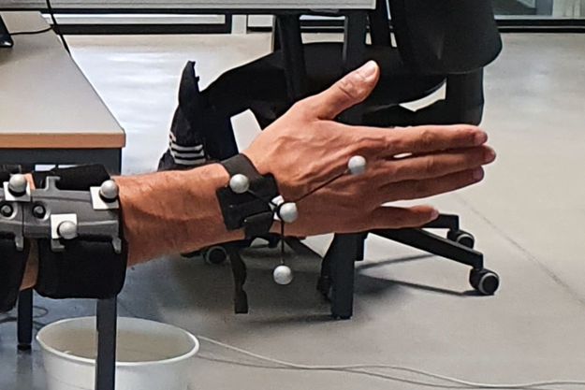

Figure 1. Marker cluster attached to a glove for pronation-supination

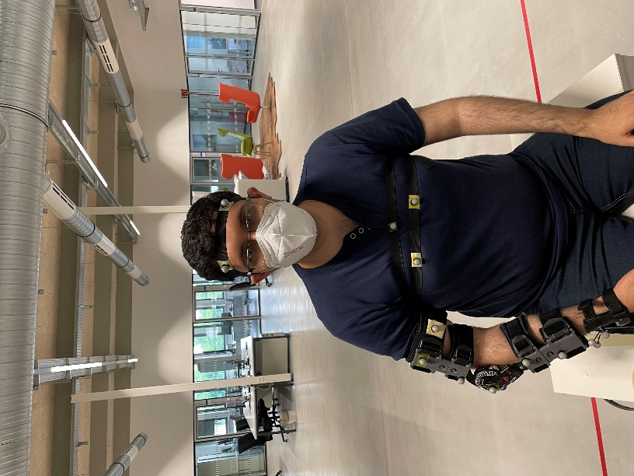

Figure . Marker placement

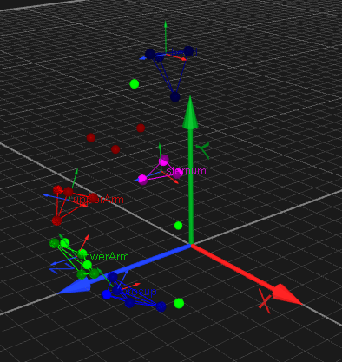

Figure . Qualisys data visualization

1. **Understanding the dataset**

The example dataset consists of 10 csv files (2[5] for each task) that contain the time stamps, joint angles, coordinates of objects and body parts. The header of the CSV file and its description is shown in the table below.

|  |  |
| --- | --- |
| Labels | Description |
| time | time stamp of data trial [sec] |
| torso_tx | x coordinate of torso [mm] |
| torso_ty | y coordinate of torso [mm] |
| torso_tz | z coordinate of torso [mm] |
| lumbar_extension | lumbar extension [deg] |
| lumbar_bending | lumbar bending [deg] |
| lumbar_rotation | lumbar rotation [deg] |
| arm_flex_r | right shoulder flexion [deg] |
| arm_add_r | right shoulder adduction [deg] |
| arm_rot_r | right shoulder internal/external rotation [deg] |
| elbow_flex_r | right elbow flexion [deg] |
| pro_sup_r | right arm pronation supination [deg] |
| end_eff_tx | right end effector (hand) x coordinate [mm] |
| end_eff_ty | right end effector (hand) y coordinate [mm] |
| end_eff_tz | right end effector (hand) z coordinate [mm] |
| goal_tx | goal object x coordinate [mm] |
| goal_ty | goal object y coordinate [mm] |
| goal_tz | goal object z coordinate [mm] |
| elbow_tx | right elbow x coordinate [mm] |
| elbow_ty | right elbow y coordinate [mm] |
| elbow_tz | right elbow z coordinate [mm] |
| mouth_tx[6] | mouth x coordinate [mm] |
| mouth_ty | mouth y coordinate [mm] |
| mouth_tz | mouth z coordinate [mm] |

**Understanding the angle coordinates**

The zero-pose is shown in Figure 4. In this pose, all the angle coordinates are zero. Figure 4 also shows the alignment of reference frames with the body segments. Note that the static pose that we followed for the recording is NOT the zero-pose. A static pose[7] is required to orient the reference frames of each body segment properly. Figure 5. shows the static pose that we used. For the static pose, the upper arm, the lower arm, and the palm was confined to a vertical plane. The data was captured from the motion capture system for 10s. This recording was thereafter used to properly align the reference frame in MoCap software according to the reference frames shown in Figure 4.

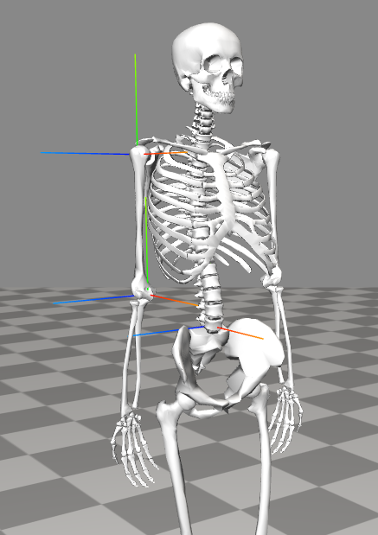

Figure 4. the zero-pose (all coordinates are zero) [OpenSim]

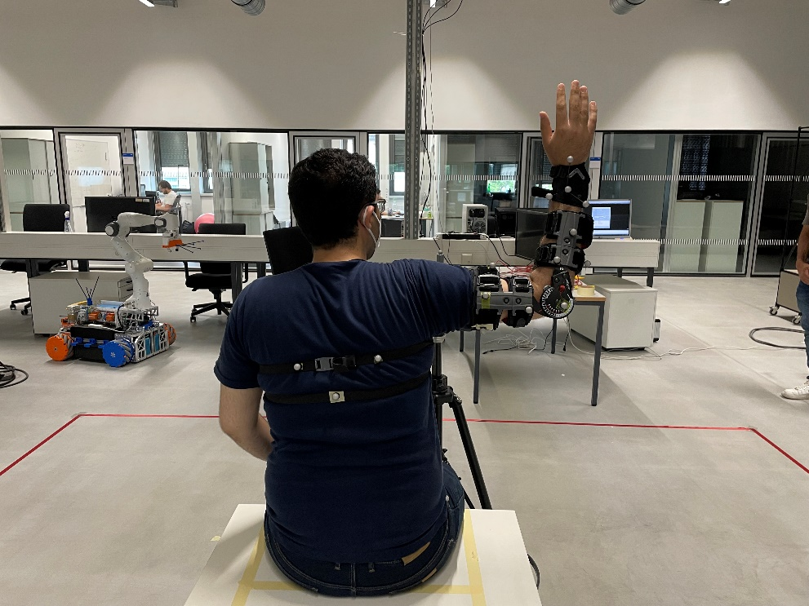

Figure . Static Pose

1. The participant wears the elbow-splint for healthy data recording too. In this case, the elbow splint is not locked, and the elbow is free to move.
2. The starting pose for this is different from the other tasks. In case of drawing of circle, the participant rests his hand on the table (no gravity compensation) at the starting point of the circle.
3. Distance was taken from the centroid of the triangle formed from the markers on the sternum.
4. We use the markers on the head to obtain the coordinates of the mouth for the task consisting of hand-to-mouth movement.
5. 1 for healthy and 1 for compensated movement
6. Only present in the CSV files for hand-to-mouth movement [HM_<>_00XX.csv]
7. We did not use the T-pose as a static pose. The T-pose makes it difficult to effectively isolate the pronation-supination and shoulder rotation angles.