**ASIAN SCHOOL OF MANAGEMENT AND TECHNOLOGY**

[**Affiliated to Tribhuvan University]**



**ASSIGNMENT: KIT LAB REPORT OF MICROPROCESSOR**

**Submitted By Submitted To:**

**Name: Manalika Shrestha Er. Manoj Giri**

**Roll No: 13 ____________________**

**Program: B.Sc. CSIT**

**Submission Date: / /2080**

**Registration No:**

**Kathmandu, Nepal**

**Table of contents Page**

|  |  |
| --- | --- |
| **1.** **WAP to add 56h and 37h and store the sum in memory address 8050h.** | **3** |
| **2.** **WAP to add two number stored in 8050h and store sum in 8052h.** | **4** |
| **3.** **WAP to subtract 37h from 52h and store the difference in memory address 8050.** | **5** |
| **4.** **WAP to find the difference of number stored in location 9050 and 9051 and stored the difference in 9052.** | **6** |
| **5.** **WAP to find greater number between two numbers stored in location 8050 and 8051 and stored the bigger number in memory address 9050.** | **7** |
| **6.** **WAP a program to find a given number is positive or negative and if negative stored in location 8051 and positive in 8050.** | **8** |
| **7.** **WAP to find a given number is even or odd and if even store in location 9050h and if odd store in 9051h.** | **10** |
| **8.** **WAP to add two 16 bits numbers.** | **12** |
| **9.** **WAP to add two numbers stored in location 8000 and 8001 and store the sum in 8003 and carry in 8002.** | **13** |
| **10.** **WAP to multiply two number stored in location 8002 and 8003 and stored the product in 8084.** | **14** |
| **11.** **WAP to find quotient and remainder and store quotient at location 8050 and remainder at location 8051.** | **15** |
| **12.** **Find compliment of a number store in the location 9051and store its compliment in location 9052.** | **17** |
| **13.** **Find compliment 2’s of a number stored in location 8050 and store its compliment at location.** | **18** |
| **14.** **Find the greatest number out of 10 number stored from location 9010 and number stored the greatest number at location 9060.** | **19** |
| **15.** **Find the greatest number out of 10 number stored from location 9010 and store the smallest at location 9060.** | **21** |
| **16.** **WAP to copy 10 data from memory location 8050 to new memory location 9050.** | **23** |
| **17.** **WAP to generate 10 even numbers.** | **25** |
| **18.** **WAP to generate 10 odd number.** | **26** |
| **19.WAP to count even number or odd number out of 10 number and store even number in location 8050H and odd number in location 8060H.** | **27** |
| **20.WAP to sort given 10 numbers from memory location 8200H in ascending order.** | **29** |

**1.Write a program to add 56H and 37H and store the sum in memory address 8050H.**

MVI A, 56H

ADI 37H

STA 8050H

HLT

**OUTPUT:**

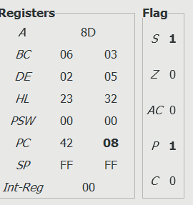

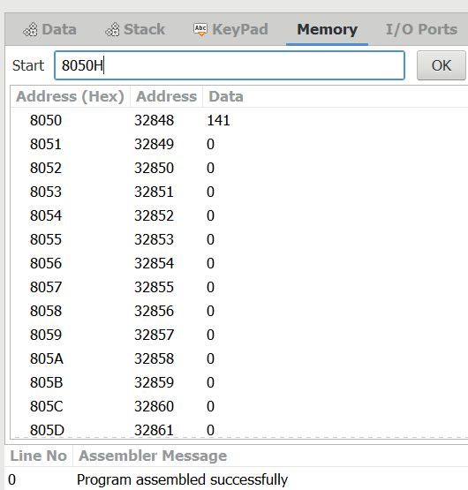

**2.Write a program to add two number store in 8050H and 8051H and store the sum in 8052H.**

LDA 8050H

MOV H, A

LDA 8051H

ADD H

MOV L, A

MVI A, 00

MOV H, A

SHLD 8052H

HLT

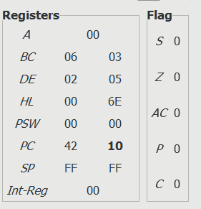**OUTPUT:** 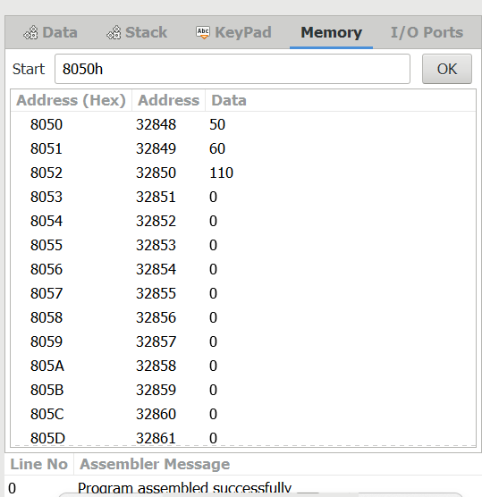

**3.Write a program to subtract 37H from 52H and store the difference in memory address 8050.**

MVI A, 52H

SUI 37H

STA 8050

HLT

OUTPUT:

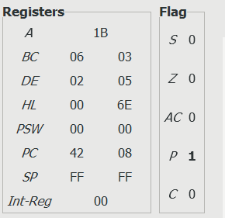

|  |
| --- |
|  |

**4.Write a program to find the difference of number stored in location 9050 and 9051 and stored the difference in 9052.**

LDA 9050

M0V B, A

LDA 9051

SUB B

STA 9052

HLT

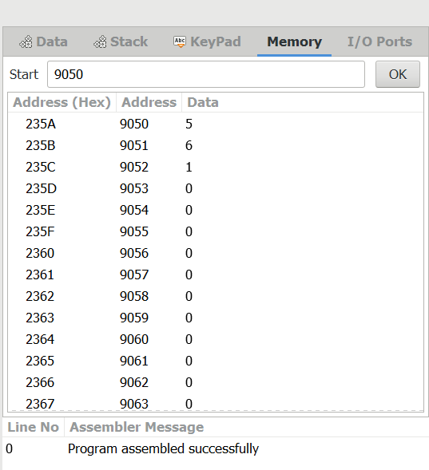 OUTPUT:

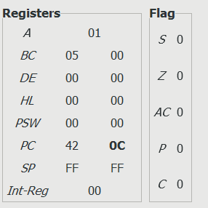

**5.Write a program to find greater number between two number stored in location 8050H and 8051H and stored the bigger number in memory address 9050H.**

LDA 8050H

MOV B, A

LDA 8051

CMP B

JNC GREATER

MOV A, B

GREATER: STA 9050

HLD

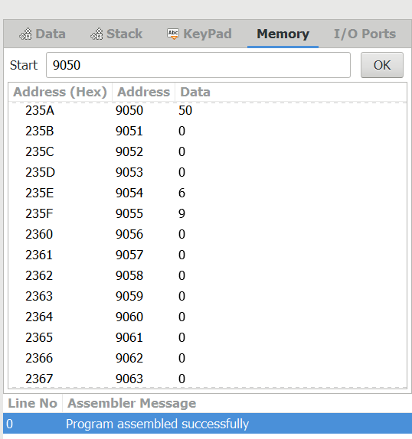OUTPUT:

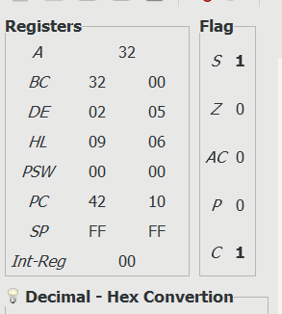

**6. Write a program to find a given number is positive or negative and if positive store in location 8050 if negative store in 8051.**

LDA 9050H

MOV B, A

RAL

JC NEGATIVE

MVI A,00H

RAR

MOV A, B

STA 8050H

NEGATIVE: MOV A, B

STA 8051H

HLT

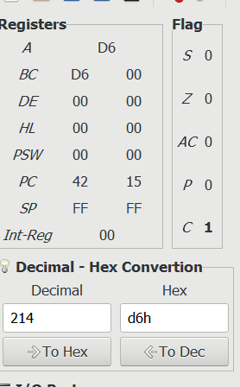**OUTPUT:**

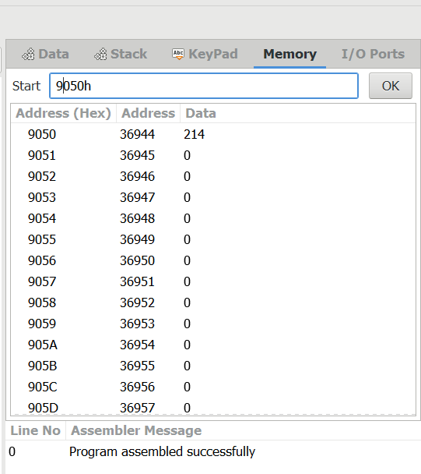

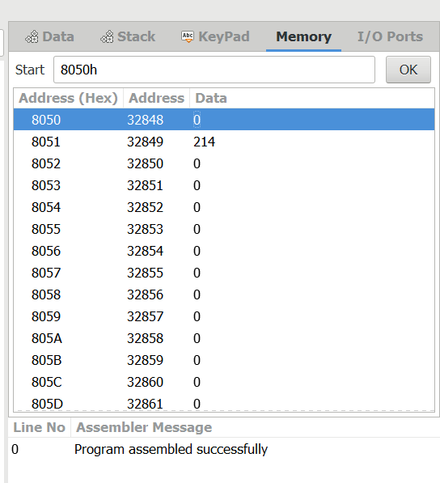

**7.Write a program to find a given number is even or odd and if even stored in location 9050H and if odd stored in 9051H.**

LDA 8050H

ANI 01H

JZ EVEN

MVI A, 01H

STA 9050H

EVEN: MVI A, 00H

STA 9050H

HLT

**OUTPUT:**

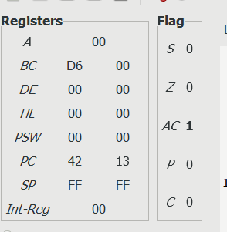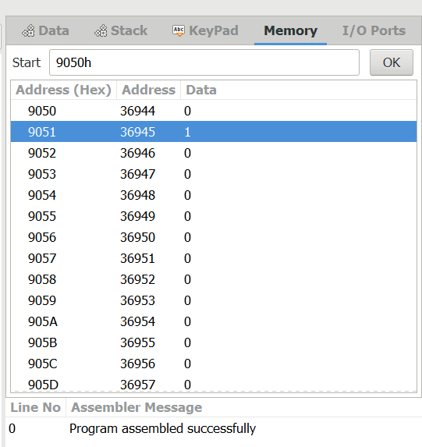

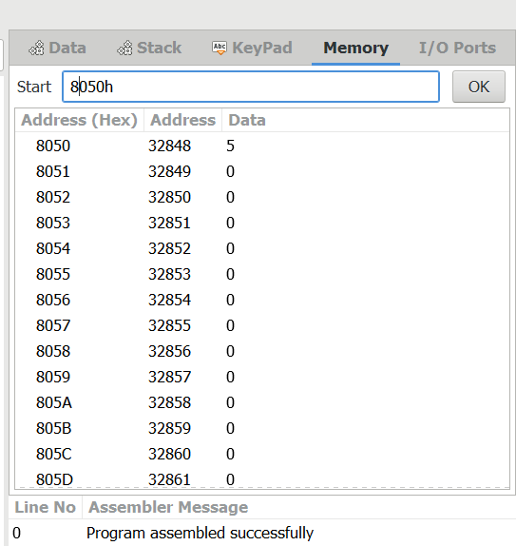

**8.Write a program to add two 16 bits numbers stored in location 9050,9051 and 9052,9053 and then stored the sum in 9054 and 9055.**

LHLD 9050

XCHG

LHLD 9052

DAD D

MVI C,00H

JNC LOOP

INR C

LOOP: SHLD 9054

MOV A, C

STA 9056

HLT

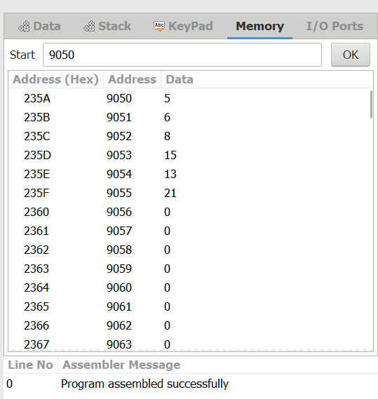**OUTPUT:**

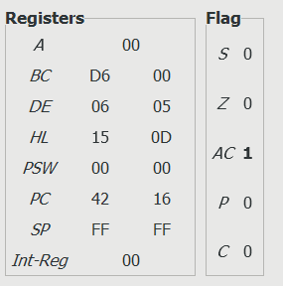

**9.Write a program to add two number stored in location 8000 and 8001 store the sum of addition in 8003 and carry in 8002.**

MVI C,00

LDA 8000H

MOV B, A

LDA 8001H

ADD B

STA 8003H

INR C

MOV A, C

STA 8002H

HLT

**OUTPUT:**

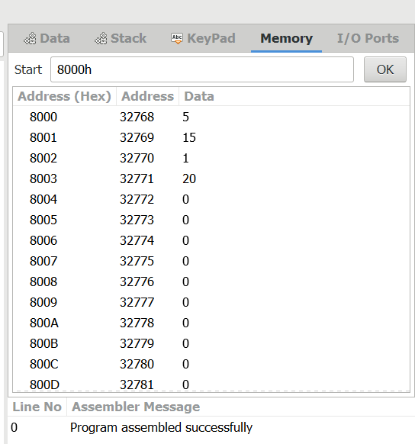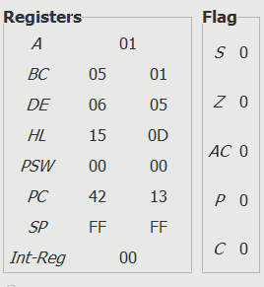

**10. WAP to multiply two number stored in location 8002 and 8003 and stored the product in 8084.**

LDA 8000

MOV D, A

LXI H, 8003

MOV C, M

BACK: DCR C

JZ SKIP

ADD D

JMP BACK

SKIP: STA 8004

HLT

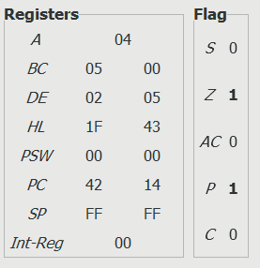**OUTPUT:**

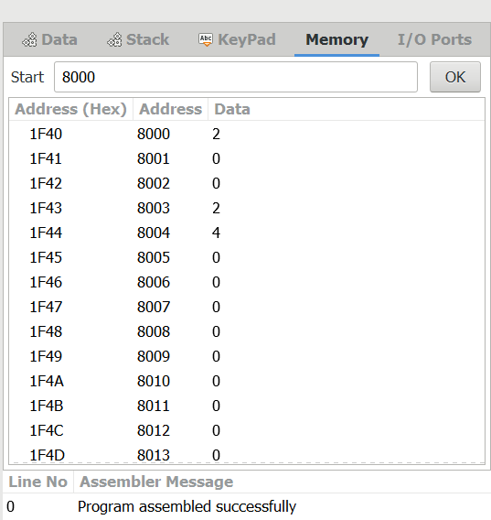

**11.WAP to find quotient and remainder and store quotient at location 8050 and remainder at location 8051.**

LXI H,8000

MOV B, M

MVI C,00

INX H

MOV A, M

NEXT: CMP B

JC LOOP

SUB B

INR C

JMP NEXT

LOOP: STA 8081

MOV A, C

STA 8050

HLT

**OUTPUT:**

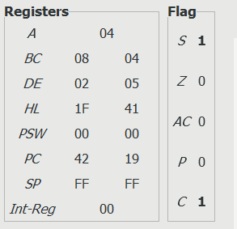

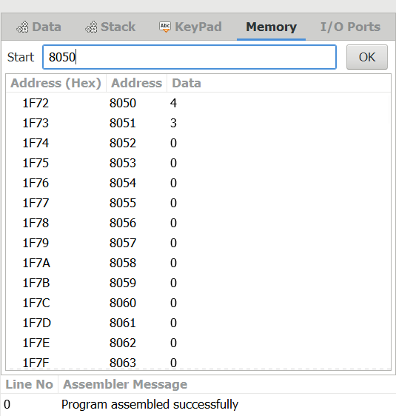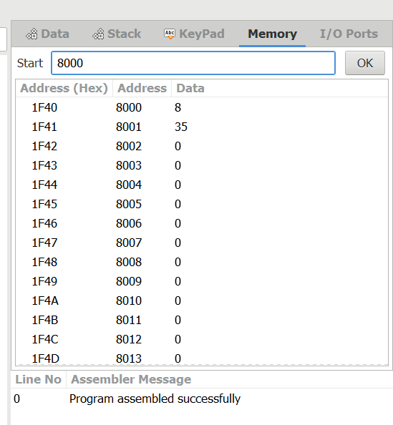

**12. Find compliment of a number store in the location 9051and store its compliment in location 9052.**

LDA 9051

CMA

STA 9052

HLT

**OUTPUT:**

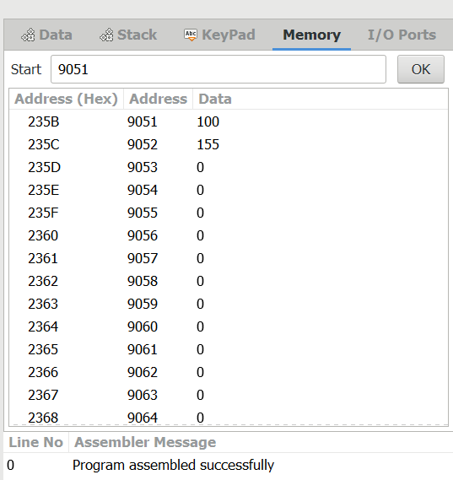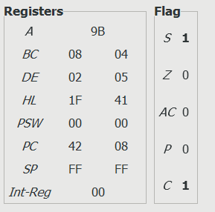

**13. Find compliment 2’s of a number stored in location 8050 and store its compliment at location.**

LDA 8050

CMA

INR A

STA 8051

HLT

**OUTPUT:**

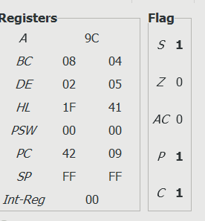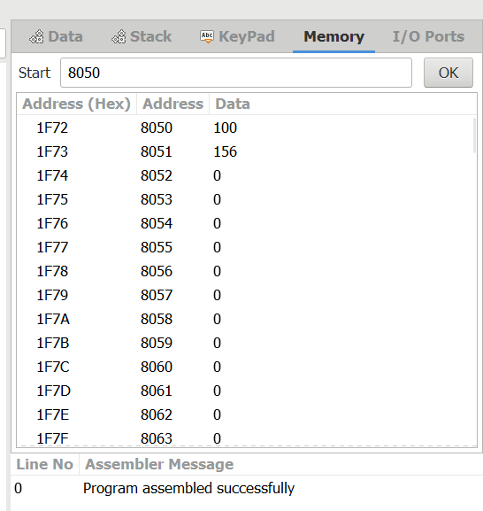

**14. Find the greatest number out of 10 number stored from location 9010 and number stored the greatest number at location 9060.**

LXI H,9010

MOV C, M

INX H

DCR C

MOV A, M

Skip: INX H

CMP M

JNC LOOP

MOV A, M

LOOP: DCR C

JNC Skip

STA 9060

HLT

**OUTPUT:**

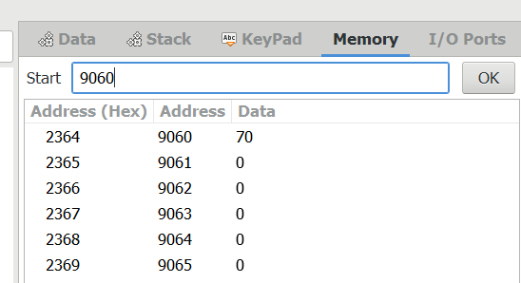

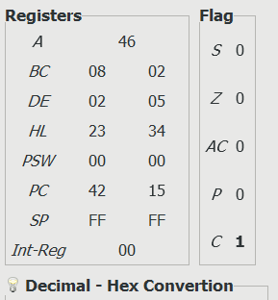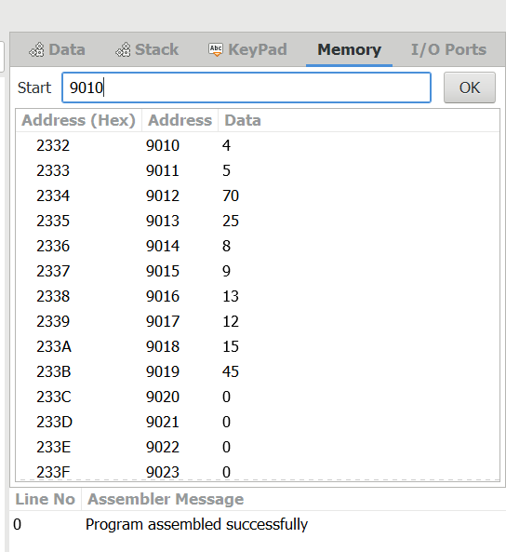

**15.Find the smallest number out of 10 number stored from location 9010 and store the smallest at location 9060.**

LXI H, 9010

MOV C, M

INX H

MOV B, M

DCR C

LOOP: INX H

MOV A, M

CMP B

JNC Skip

MOV B, A

Skip: DCR C

JNZ LOOP

LXI H,9060H

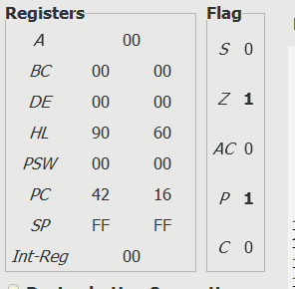MOV M, B

HLT

**OUTPUT:**

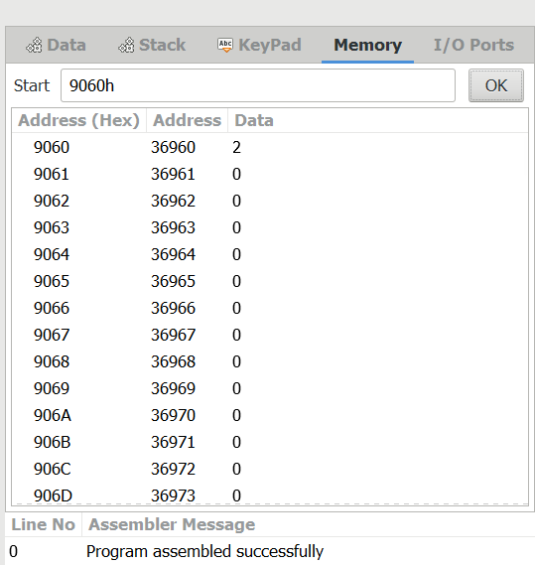

**16. WAP to copy 10 data from memory location 8050 to new memory location 9050.**

LXI H,8050H

LXI D,9050H

MVI B,10H

LOOP:MOV A, M

STAX D

INX H

INX D

DCR B

JNZ LOOP

HLT

**OUTPUT:**

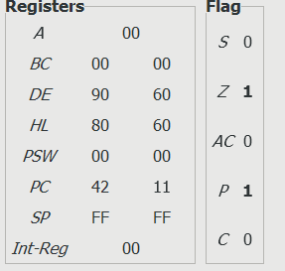

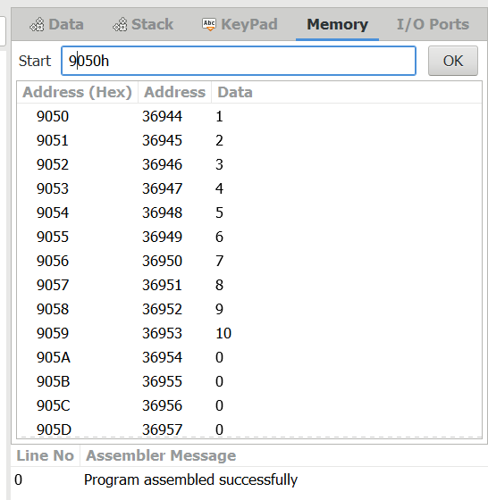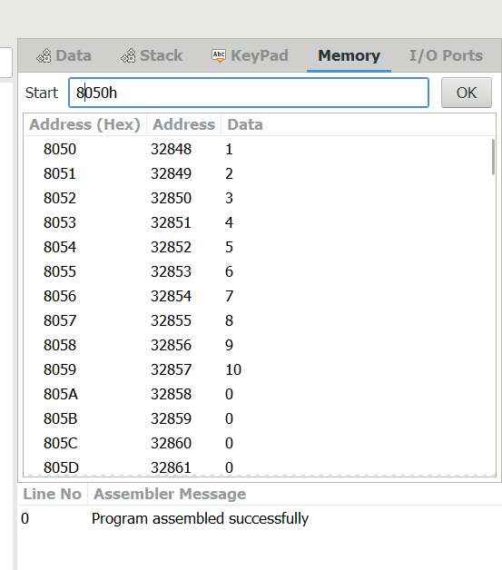

**17. WAP to generate 10 even numbers.**

MVI A,00H

MVI B,02H

MVI C, 0AH

LXI H,9200H

LOOP: ADDB

MOV M, A

INX H

DCR C

JNZ LOOP

HLT

**OUTPUT**:

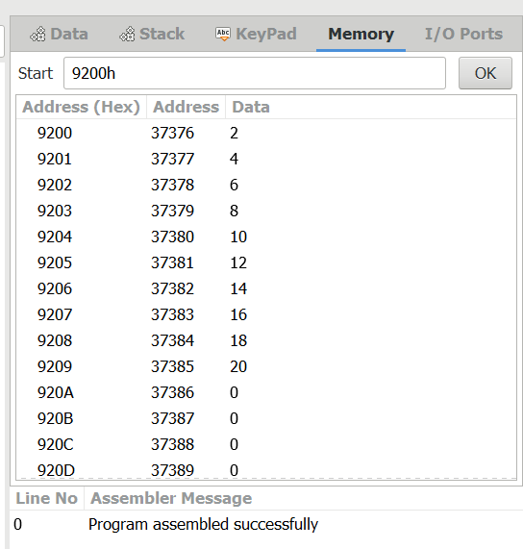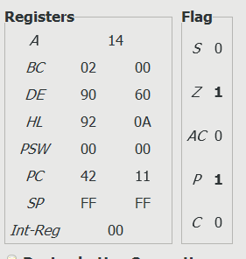

**18. WAP to generate 10 odd number.**

MVI A,01H

MVI B,02H

MVI C,0AH

LXI H, 9050H

LOOP: ADD B

MOV M, A

INX H

DCR C

HLT

**OUTPUT:**

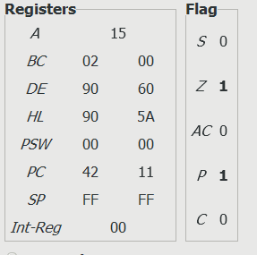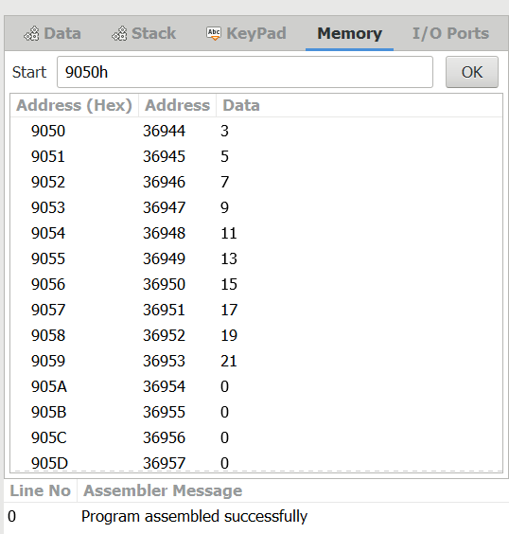

**19.WAP to count even number or odd number out of 10 number and store even number in location 8050H and odd number in location 8060H.**

LXI H,8000H

MOV C, M

MVI B,00H

MVI D,00H

LOOP2: INX H

MOV A, M

RAR

JC LOOP1

INR B

JMP LOOP3

LOOP1: INR D

LOOP3: DCR C

JNZ LOOP2

MOV A, B

STA 8050h

MOV A, D

STA 8060h

HLT

**OUTPUT:**

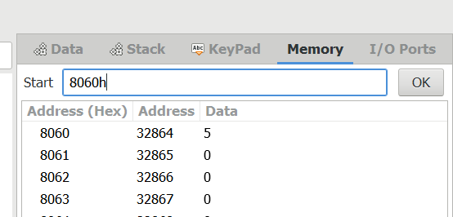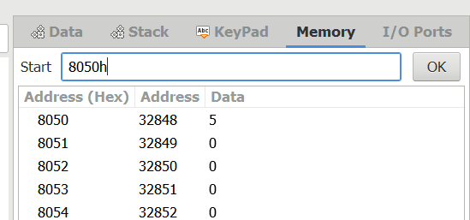

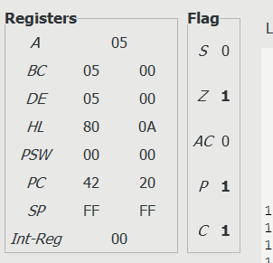

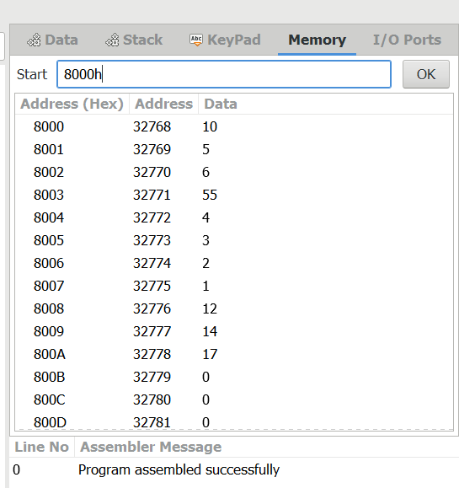

**20.WAP to sort given 10 numbers from memory location 8200H in ascending order.**

MVI B, 09

START: LXI H, 8200H

MVI C,0AH

BACK: MOV A, M

INX H

CMP M

JNC SKIP

MOV D, M

MOV M, A

DCX H

MOV M, D

INX H

SKIP: DCR C

JNZ BACK

DCR B

JNZ START

HLT

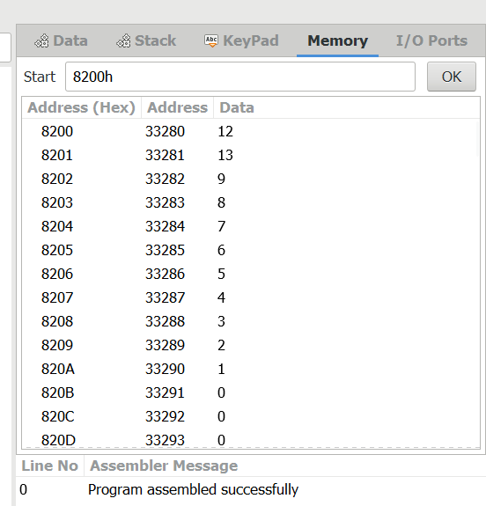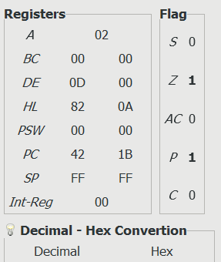**OUTPUT:**