strongest small battery duration - Google Search
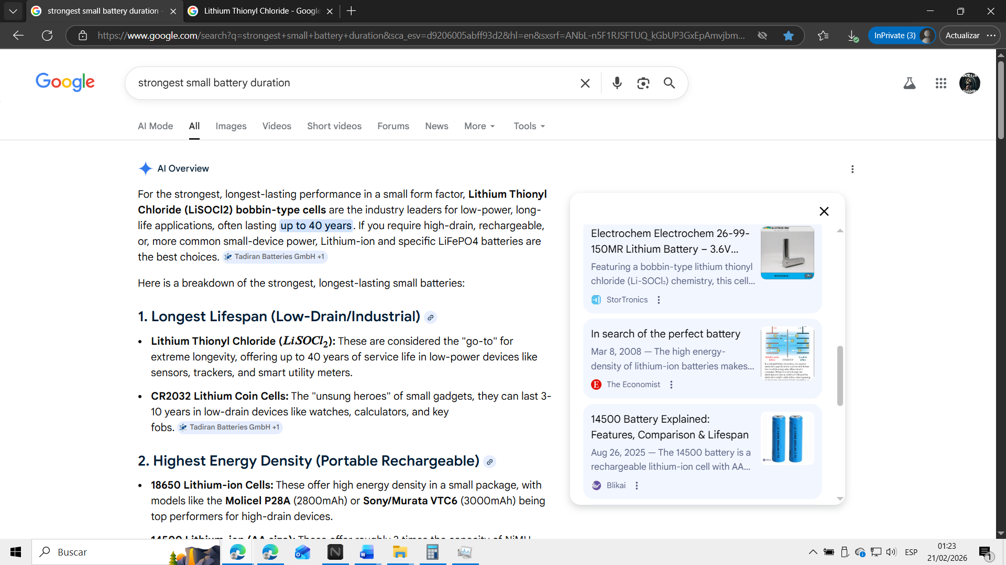
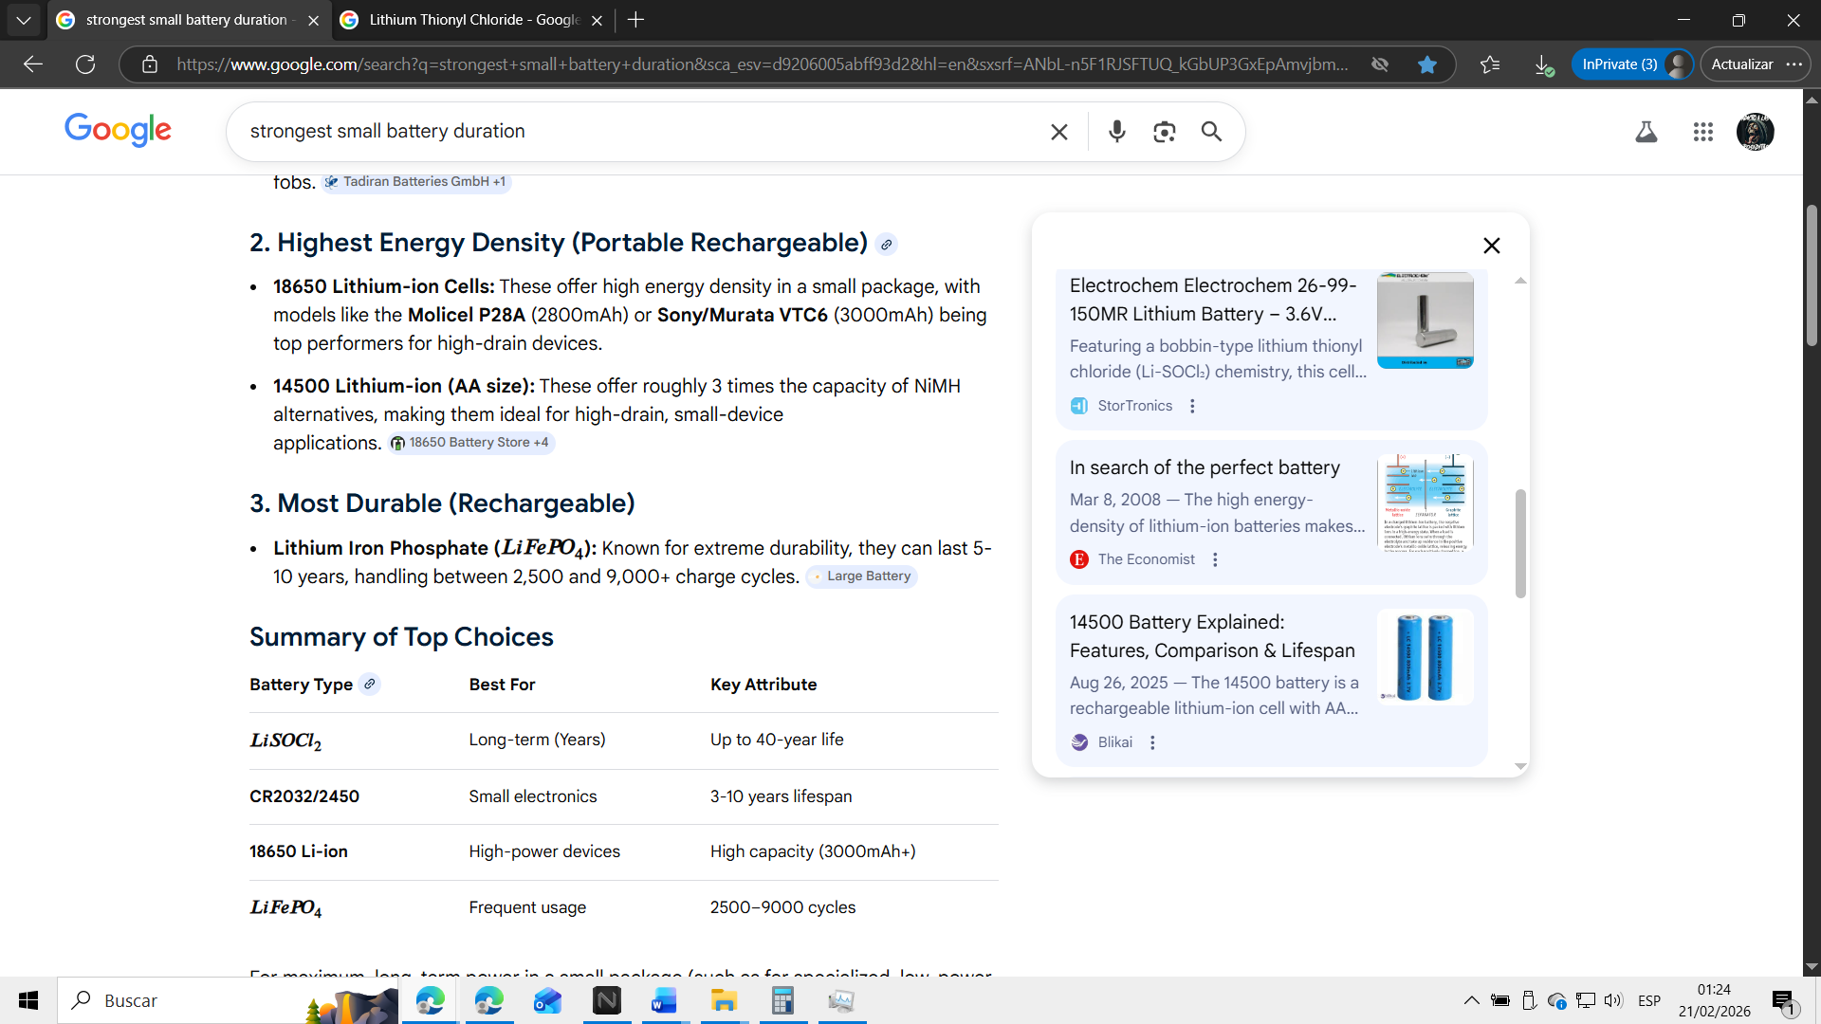
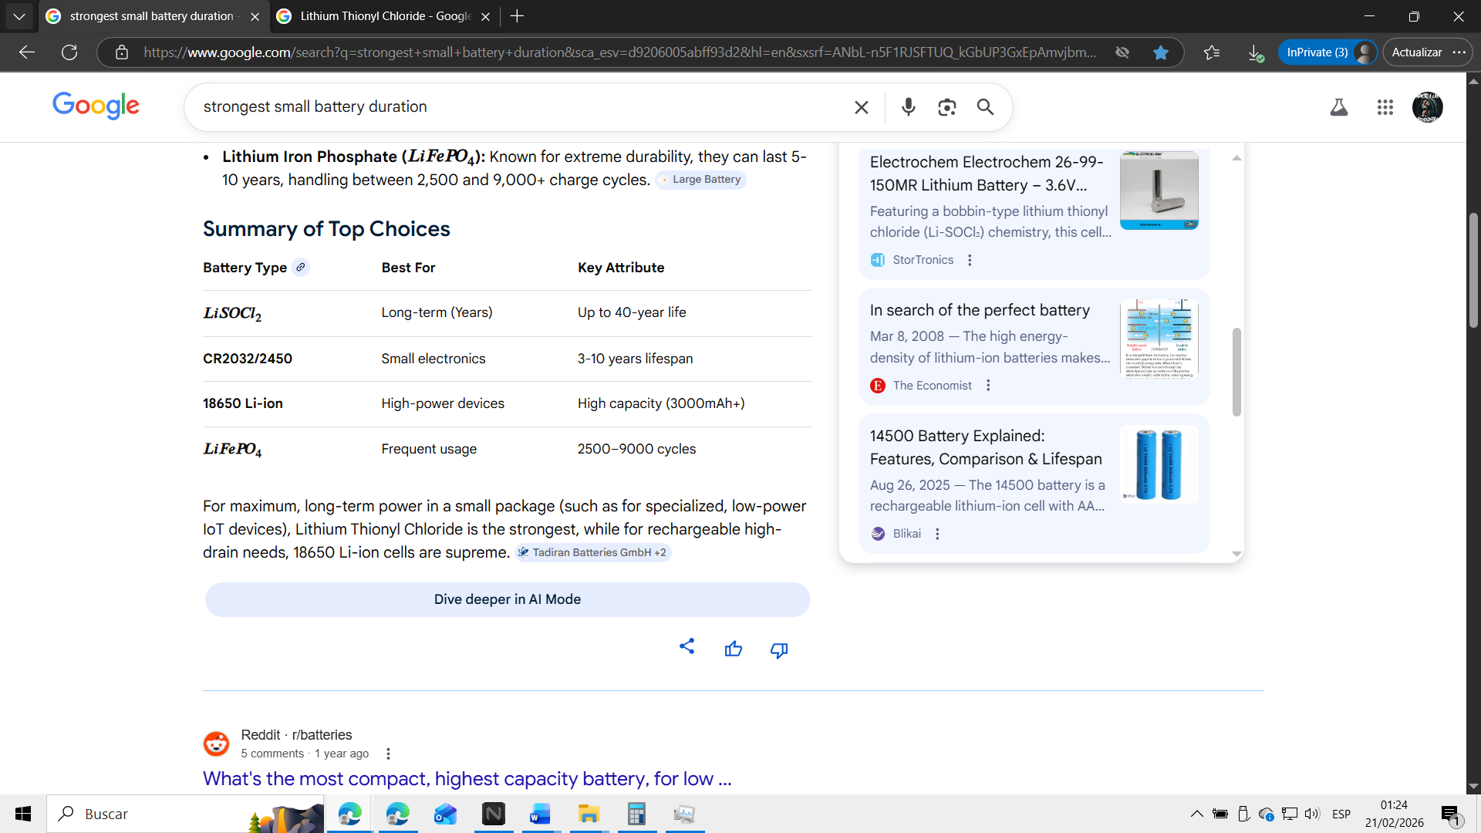
https://tadiranbatteries.de/long-life-battery-industrial-applications/#:~:text=What%20type%20of%20battery%20has,considered%20to%20be%20long%2Dlasting.
https://www.18650batterystore.com/pages/best-18650-battery-guide#:~:text=Best%20All%20Around%2018650%20Battery,greatness%20in%20high%20drain%20devices.
https://www.large-battery.com/blog/rechargeable-battery-lasts-long-comparison/#:~:text=Batteries%20left%20unused%20for%20long,Typical%20Lifespan
https://aimdynamics.com/3-volt-battery-life#:~:text=CR2025%20batteries%20akin%20to%20CR2032,years%20under%20everyday%20usage%20conditions.
https://www.reddit.com/r/batteries/comments/1pvee2o/best_battery_for_toy_that_runs_through_them_very/#:~:text=The%20best%20battery%20is%20Lithium,to%20re%2Dcharge%20the%20cells.&text=You'd%20be%20surprised.,without%20a%20hands%20on%20:D
https://stortronics.com/lithium-batteries/electrochem-26-99-150mr-lithium-battery-3-6v-8-5ah-high-energy-cell-pre-order/#:~:text=Featuring%20a%20bobbin%2Dtype%20lithium%20thionyl%20chloride%20(Li%2DSOCl%E2%82%82),for%20long%2Dlife%2C%20low%2Ddrain%20applications%20in%20extreme%20environments.
https://www.economist.com/technology-quarterly/2008/03/08/in-search-of-the-perfect-battery#:~:text=The%20high%20energy%2Ddensity%20of%20lithium%2Dion%20batteries%20makes,$7%20billion%20market%20for%20portable%2C%20rechargeable%20batteries.
https://www.blikai.com/blog/featured-products/14500-battery-explained-features-comparison-lifespan#:~:text=The%2014500%20battery%20is%20a%20rechargeable%20lithium%2Dion,efficiency%2C%20and%20safety%20for%20modern%20high%2Ddrain%20devices.
https://www.ebay.com/itm/293965197730#:~:text=Summarized%20Features%20and%20Benefits:%20Li%2Dion%2014500%20cylindrical,and%20lower%20weight%20than%20other%20rechargeable%20batteries.
https://liionwholesale.com/products/imren-imr-14500-700mah-button-top-battery
https://www.pkcellpower.com/news/revolutionizing-power-the-synergy-of-hybrid-pulse-capacitors-and-lisocl2-batteries/#:~:text=LiSOCl2%20batteries%20are%20renowned%20for%20their%20high,ability%20to%20operate%20in%20extreme%20temperature%20ranges.
https://7802750.fs1.hubspotusercontent-na1.net/hubfs/7802750/White%20Papers%20and%20Guides/Batteries/Lumafield%20Battery%20Report.pdf#:~:text=Within%20the%20lithium%2Dion%20battery%20space%2C%2018650%20cells,packs%2C%20powering%20everything%20from%20vapes%20to%20vehicles.

