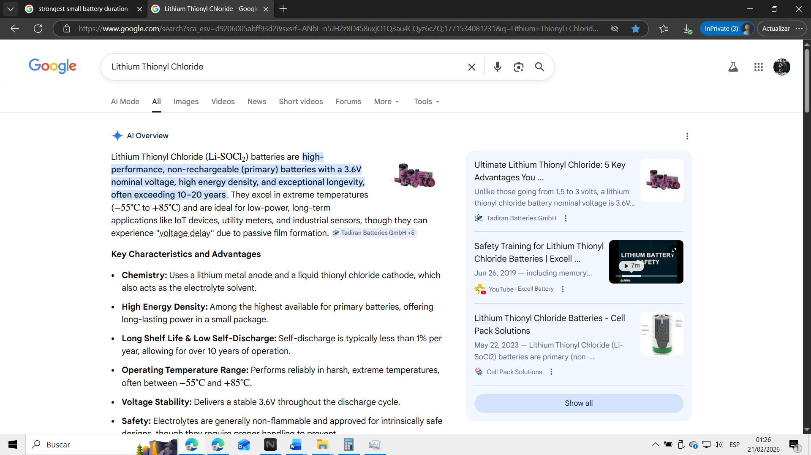
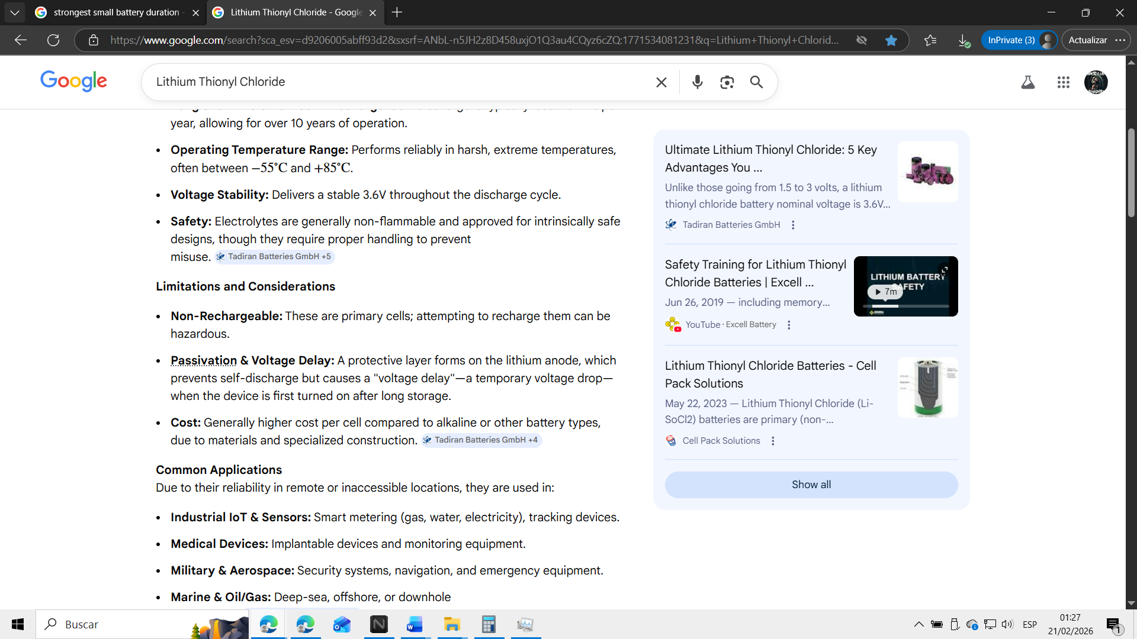
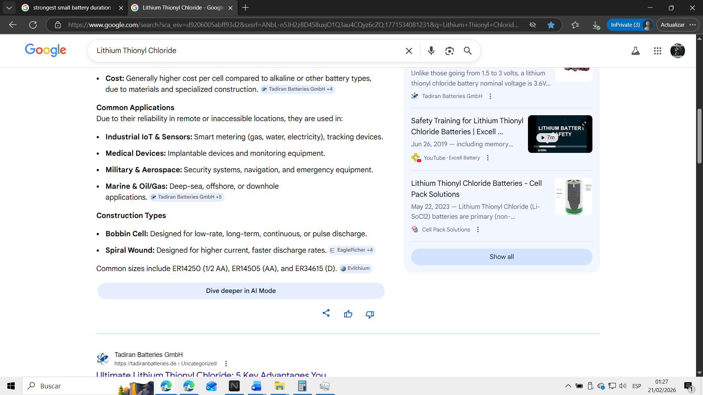
https://tadiranbatteries.de/lithium-thionyl-chloride/#:~:text=Unlike%20those%20going%20from%201.5,on%20the%20usage%20and%20environment.
https://www.youtube.com/watch?v=acmwiqoow8w&t=176
https://cellpacksolutions.co.uk/news/products/lithium-thionyl-chloride-batteries/#:~:text=Lithium%20Thionyl%20Chloride%20(Li%2DSoCl2,them%20to%20power%20your%20application.
https://www.eaglepicher.com/technology/battery-chemistries/lithium-thionyl-chloride-battery/#:~:text=Years%20of%20low%2Drate%2C%20continuous,Lithium%20Thionyl%20Chloride%20Battery%2C%20Primary
https://batteryspecialists.com.au/collections/lithium-thionyl-chloride-batteries#:~:text=Lithium%20Thionyl%20Chloride%20Battery%20Information,Thionyl%20Chloride%20Battery%20%2D%20Bobbin%20Type
https://syscor.com/technology/lisocl2-batteries
https://tadiranbatteries.de/li-socl2-batteries/#:~:text=Lithium%20thionyl%20chloride%20is%20non,%2C%20sensors%2C%20and%20industrial%20equipment.
https://saft.com/en/energizing-iot/reflecting-our-lithium-thionyl-chloride-webinar-what-we-learned#:~:text=Lithium%20thionyl%20chloride%20(Li%2DSOCl)%20batteries%20are%20well%2Dsuited,Marine%20environments%20*%20Signaling%20or%20tracking%20devices
https://www.jauch.com/blog/en/advantages-and-special-features-of-lithium-thionyl-chloride-batteries/#:~:text=Advantages%20and%20Special%20Characteristics%20of%20Lithium%20Thionyl%20Chloride%20Batteries,-by%20Marketing%20Team&text=Lithium%20thionyl%20chloride%20batteries%20(Li,chemistry%20are%20briefly%20presented%20below.
https://www.evlithium.com/li-socl2-battery/#:~:text=Lithium%20Thionyl%20Chloride%20SOCl2%20Battery,LTC%2D3PN%20Li%20Thionyl%20Chloride%20%E2%80%A6
https://tadiranbatteries.de/lithium-thionyl-chloride-battery-packs/#:~:text=Can%20lithium%20thionyl%20chloride%20battery,of%20according%20to%20local%20regulations.
https://www.youtube.com/watch?v=VUbAw--XLmI&t=2
https://www.youtube.com/watch?v=Cae-bhGtyHQ&t=4
https://lojasbeirario.com.br/Lithium-Thionyl-Chloride-Batteries-3-6V-9000mAh-For-Industrial/453046#:~:text=IMPORTANT%20SAFETY%20NOTE:%20These%20are%20primary%20batteries%2C,so%20please%20don't%20even%20think%20about%20it!
https://www.sciencedirect.com/science/article/pii/S2352152X21010951#:~:text=The%20model%20is%20currently%20built%20and%20trained,constant%20current%20or%20constant%20current%2Dwave%20form%20discharge.
https://sparqtechnology.com/wp-content/uploads/2024/07/Lithium-Thionyl-Chloride-A4-1_2.pdf#:~:text=Bobbin%20cells%20should%20be%20utilized%20when%20performance,self%2Ddischarge%20rate%20are%20necessary%20for%20certain%20applications.

