UDC 004.8:616.12-073.97
Anafin Askar
MSc Candidate
Department of Computational and Data Sciences
Astana IT University
(Astana, Kazakhstan)
Scientific Supervisor: Hahn Minsoo
PhD, Professor
Department of Computational and Data Sciences
Astana IT University
(Astana, Kazakhstan)
DEVELOPMENT OF A HEART DISEASE DIAGNOSIS TECHNIQUE USING ECG (ELECTROCARDIOGRAM) SIGNALS
Abstract: Cardiovascular diseases are the leading cause of mortality globally, claiming approximately 17.9 million lives annually. Automated classification of standard 12-lead electrocardiograms (ECGs) is therefore a high-priority clinical challenge. This study presents a comprehensive comparative evaluation of four deep learning architectures on the PTB-XL benchmark dataset: (i) a 1D adaptation of ResNet-18 (CNN), which applies residual convolutional blocks along the temporal axis; (ii) a Spatio-Temporal Graph Neural Network (ST-ReGE) with a learnable adjacency matrix that explicitly models spatial correlations between the 12 electrode leads; (iii) a 1D Vision Transformer (ViT-1D) that segments the signal into temporal patches and applies multi-head self-attention; and (iv) a custom Spatio-Temporal Hybrid (ResNet-Transformer) model that combines residual convolutional feature extraction with a transformer encoder back-end. The CNN leads individual architectures with a Macro F1-score of 0.7273 and AUROC of 0.9199 on the held-out test partition. The GNN excels at modeling inter-lead spatial relationships, achieving the highest Exact Match Accuracy of 62.98% and Macro AUPRC of 0.8025. To address the severe class imbalance and co-occurring multi-label pathologies present in clinical ECG datasets, we propose two complementary post-hoc calibration strategies: class-specific validation-set threshold optimization and soft voting ensemble averaging. The voting ensemble (CNN + GNN + Hybrid) under optimized thresholds achieves a Macro F1-score of 0.7439 and Macro AUROC of 0.9323. Gradient-weighted Class Activation Mapping (Grad-CAM) is applied to validate model interpretability, confirming that the CNN correctly localizes diagnostically relevant ST-segment regions for Myocardial Infarction prediction. These findings demonstrate that combined spatio-temporal modeling, post-hoc calibration, and ensemble strategies form the essential ingredients for high-accuracy, trustworthy clinical decision support.
Keywords: Electrocardiography, Deep Learning, Graph Neural Networks, Vision Transformers, Residual Networks, Multi-label Classification, Ensemble Learning, Threshold Calibration, Grad-CAM, PTB-XL
\noindentKeywords: Electrocardiography, Deep Learning, Graph Neural Networks, Vision Transformers, Residual Networks, Multi-label Classification, Ensemble Learning, Threshold Calibration, Grad-CAM, PTB-XL
INTRODUCTION
Cardiovascular diseases (CVDs) represent the leading cause of mortality worldwide, claiming approximately 17.9 million lives annually [1]. The standard 12-lead electrocardiogram (ECG) is the primary non-invasive diagnostic tool used to screen for structural abnormalities, conduction blocks, and myocardial ischemia. However, manual interpretation of ECG waveforms is time-consuming, requires deep clinical expertise, and is subject to significant inter-observer variability that can exceed $20%$ in primary care and emergency settings [2]. Cognitive fatigue during long physician shifts further amplifies the risk of diagnostic error, establishing a pressing need for automated, objective computer-aided decision support.
The advent of deep learning (DL) has revolutionized automated ECG analysis [3]. Convolutional Neural Networks (CNNs) excel at extracting local morphological features—such as QRS complexes, ST-segment deviations, and T-wave abnormalities—due to their translation invariance and local receptive fields [4]. However, standard CNNs treat the 12 leads as independent channels, neglecting the spatial geometry of electrode placements on the body surface. This limitation has motivated the use of Graph Neural Networks (GNNs) to explicitly model spatial correlations between leads [5, 6], and Vision Transformers (ViTs) to capture long-range temporal dependencies across the full 10-second signal [7, 8].
This paper presents a rigorous comparative analysis of these architectures on the standard PTB-XL clinical ECG dataset [9, 10]. We benchmark a 1D ResNet-18 [3], the spatio-temporal ST-ReGE GNN [5], a 1D Vision Transformer [11], and a custom Spatio-Temporal Hybrid model [12]. Furthermore, we systematically address two common challenges in clinical ECG classification: severe class imbalance and multi-label co-occurrence. We demonstrate that post-hoc soft voting ensembling and validation-set threshold optimization significantly improve classification metrics without requiring costly model retraining, making these techniques especially practical for clinical deployment.
CLINICAL BACKGROUND AND TARGET PATHOLOGIES
\label{sec:clinical} The standard 12-lead ECG records electrical potentials from twelve distinct spatial perspectives. The six limb leads (I, II, III, aVR, aVL, aVF) measure potentials in the frontal plane, while the six precordial leads (V1–V6) record unipolar potentials in the horizontal plane, placed over the right ventricle (V1, V2), interventricular septum (V3, V4), and lateral left ventricle (V5, V6) [13]. This multi-planar configuration provides crucial spatial diversity for clinical diagnostics.
This study targets the five major diagnostic superclasses in the PTB-XL database [9]:
- Normal ECG (NORM): Regular sinus rhythm (60–100 bpm) with normal wave durations, isoelectric ST segments, and upright T waves.
- Myocardial Infarction (MI): Acute or chronic ischemia characterized by ST-segment elevations/depressions, T-wave inversions, or deep pathological Q waves in specific anatomical lead territories [13].
- ST/T Changes (STTC): Morphological markers of altered ventricular repolarization (such as non-specific ST-segment shifts or T-wave flattening) that indicate ischemia or electrolyte imbalances.
- Conduction Disturbances (CD): Conduction pathway blocks causing dyssynchronous ventricular contraction, manifesting as prolonged QRS complexes ($\geq 120$ ms) in Left/Right Bundle Branch Blocks (LBBB/RBBB) [2].
- Hypertrophy (HYP): Pathological ventricular chamber enlargement diagnosed via voltage criteria, such as the Sokolow-Lyon index ($S_{V1} + R_{V5 \text{ or } V6} \geq 35$ mm) [10], often accompanied by lateral ST-segment depression and T-wave inversion (strain pattern).
The pathophysiological overlap between these classes (e.g., hypertrophy strain pattern mimicking ischemia) creates diagnostic ambiguity, highlighting the need for robust multi-label classification algorithms.
DATASET AND PREPROCESSING
\label{sec:dataset} We utilize the PTB-XL ECG Database [9, 10], which contains $21{,}837$ clinical 12-lead ECG records of 10-second duration sampled at 500 Hz ($5{,}000$ time steps per lead). Records are annotated with 71 diagnostic statements mapping hierarchically to 5 superclasses: NORM ($9{,}528$ records), MI ($5{,}486$), STTC ($5{,}250$), CD ($4{,}907$), and HYP ($2{,}655$). A single record may have multiple annotations, making this a multi-label classification problem. Table 1 shows the mapping of selected statements.
Table 1 – Mapping of SCP-ECG Statements to the Five Target Superclasses
Superclass | Subclasses (Examples) | Specific SCP-ECG Statements (Examples)
NORM | Normal ECG | NORM (Normal ECG), LVOLT (Low voltage)
MI | Anterior MI, Inferior MI, Lateral MI | AMI (Acute MI), IMI (Inferior MI), ALMI (Anterolateral MI)
STTC | ST/T changes, Ischemia | STTC, NST_ (Non-specific ST), ISCH (Ischemia)
CD | Bundle branch blocks, AV block | LBBB, RBBB, 1AVB (First-degree AV Block)
HYP | Ventricular hypertrophy | LVH (Left Ventricular Hypertrophy), RVH
The signals are preprocessed using a 4th-order Butterworth bandpass filter ($0.5$–$50$ Hz) to suppress baseline wander and powerline noise. Lead-wise Z-score normalization is applied to standardize amplitudes: $x_{\text{norm}, i}(t) = (x_{i}(t) - \mu_{i}) / \sigma_{i}$, where $\mu_{i}$ and $\sigma_{i}$ represent the mean and standard deviation of lead $i$ over the $L=5{,}000$ time steps. The dataset is split by patient ID into training ($80%$), validation ($10%$), and testing ($10%$) partitions.
MODEL ARCHITECTURES
\label{sec:models} We implement and optimize four distinct deep learning architectures to explore different spatio-temporal representations.
1D ResNet-18 (CNN)
We design a 1D adaptation of ResNet-18 [14, 3], replacing standard 2D convolutions with 1D convolutions along the temporal axis. The residual block shortcut connection is defined as $\mathcal{H}(x) = \text{ReLU}(\mathcal{F}(x,\{W_1, W_2\}) + W_s x)$, where $\mathcal{F}$ consists of two consecutive Conv1D–BatchNorm–ReLU operations and $W_s$ is a $1\times1$ projection matrix. Table 2 specifies the architecture layout.
Table 2 – 1D ResNet-18 Architecture Layout
Stage | Layer Details | Kernel | Stride | Output (C, L)
Input | Raw ECG Signal | -- | -- | (12, 5000)
Prep | Conv1D + BN + ReLU | 15 | 2 | (64, 2500)
Pool | MaxPool1D | 3 | 2 | (64, 1250)
Stage 1 | 2x Residual Blocks | 7 | 1 | (64, 1250)
Stage 2 | 2x Residual Blocks | 7 | 2 | (128, 625)
Stage 3 | 2x Residual Blocks | 7 | 2 | (256, 313)
Stage 4 | 2x Residual Blocks | 7 | 2 | (512, 157)
Readout | AdaptiveAvgPool + FC | -- | -- | (5,)
Spatio-Temporal Graph Neural Network (ST-ReGE)
The ST-ReGE GNN [5] models the 12 leads as nodes of a graph. A learnable adjacency matrix $A = \text{Sigmoid}(W_{adj}) \in \mathbb{R}^{12 \times 12}$ captures spatial correlations directly from data. A shared 1D ResNet temporal backbone is applied lead-wise to extract node features $H^{(0)} \in \mathbb{R}^{B \times 12 \times 256}$, which are then propagated across leads using two GCN layers [15]: $H^{(l+1)} = \text{BN}(\text{ReLU}(A H^{(l)} W^{(l)})) + H^{(l)}$. Global mean pooling aggregates node features into a 256-dimensional graph representation for classification. Table 3 lists the full GNN parameters.
Table 3 – ST-ReGE GNN Architecture Specification
Sub-module | Layer Description | Kernel/Dim | Output Shape
Input | Raw Multi-Lead Signal | -- | (B, 5000, 12)
Temporal Backbone | Shared 1D Conv (lead-wise) | K=15, S=2 | (B x 12, 32, 2500)
 | MaxPool1D | K=3, S=2 | (B x 12, 32, 1250)
 | ResNet Block 1 | K=7, S=2 | (B x 12, 64, 625)
 | ResNet Block 2 | K=7, S=2 | (B x 12, 128, 313)
 | ResNet Block 3 | K=7, S=2 | (B x 12, 256, 157)
 | Adaptive Avg Pooling | -- | (B, 12, 256)
Spatial Propagation | Learnable Adjacency A | 12 x 12 | (B, 12, 256)
 | GCN Layer 1 | 256 -> 256 | (B, 12, 256)
 | GCN Layer 2 | 256 -> 256 | (B, 12, 256)
Classifier Head | Global Mean Readout | -- | (B, 256)
 | Linear Output | 256 -> 5 | (B, 5)
1D Vision Transformer (ViT-1D)
The ViT-1D model [11, 7] segments the 12-channel signal into $N_p = 100$ non-overlapping temporal patches of length $P = 50$, projecting them into $d_{\text{model}} = 128$ dimensions. A learnable classification token and positional embeddings are prepended to form $Z_0 = [x_{\text{cls}}; X_{\text{embed}}] + E_{\text{pos}}$. The sequence is processed by $L = 4$ Transformer encoder layers with $h = 4$ attention heads, where head $i$ computes $\text{head}_i = \text{softmax}(QW_i^Q(KW_i^K)^\top / \sqrt{d_k})VW_i^V$. The classification token representation is passed to a linear classification head. Table 4 summarizes the configuration.
Table 4 – 1D Vision Transformer (ViT-1D) Architecture Parameters
Sub-module | Component | Configuration | Output Shape
Input | Raw Multi-Lead Signal | 12 leads, 5000 length | (B, 12, 5000)
Patch Embedding | 1D Conv Projection | K=50, S=50, Filters=128 | (B, 100, 128)
 | CLS Token Prepend | 1 learnable vector | (B, 101, 128)
 | Positional Embedding | 101 learnable vectors | (B, 101, 128)
Transformer Encoder | 4 Encoder Layers | h=4 heads, d_model=128, d_ff=256 | (B, 101, 128)
 | Layer Normalization | -- | (B, 101, 128)
Classifier Head | CLS Token Extraction | Index 0 | (B, 128)
 | Linear Classifier | 128 -> 5 | (B, 5)
Spatio-Temporal Hybrid (ResNet-Transformer)
The Hybrid model [12] combines local convolutional morphological analysis with global sequence attention. Three residual convolutional stages compress the raw signal from 5{,}000 to 313 time steps. A Squeeze-and-Excitation (SE) block adaptively reweights lead channels using a sigmoid-gated bottleneck. A 3-layer Transformer Encoder ($d_{\text{model}}=256$, $h=8$ attention heads) then captures global rhythm context. Using convolutional priors to generate well-structured patch tokens allows the transformer back-end to generalize effectively on the training dataset.
EVALUATION METRICS
\label{sec:metrics} To evaluate the multi-label models on the imbalanced test partition, we use five metrics. Macro F1-score is the unweighted mean of per-class F1-scores, ensuring rare classes contribute equally. Macro AUROC and Macro AUPRC measure rank discrimination across all classes, with AUPRC being particularly sensitive to imbalanced distributions. Exact Match Accuracy measures the strict subset accuracy requiring all 5 labels to be predicted correctly. The PhysioNet Score uses a clinical utility matrix to penalize critical false negatives (such as predicting MI as NORM) more severely.
POST-HOC OPTIMIZATION AND ENSEMBLING
\label{sec:posthoc} To handle class imbalance safely, we implement two post-hoc calibration strategies. First, validation-set threshold grid search finds class-specific decision thresholds $t_c = \arg\max_{t} F_1(y_{\text{val},c}, P_{\text{val},c} > t)$ on the validation set over the interval $[0.01, 0.99]$. Second, soft voting ensemble averaging combines the predictions of the top three individual models: $P_{\text{ensemble}} = \frac{1}{3}(P_{\text{cnn}} + P_{\text{gnn}} + P_{\text{hybrid}})$. The ensemble output is then calibrated using the validation-set optimized thresholds.
EXPERIMENTAL SETUP
Models were implemented in PyTorch 2.5 and trained on a workstation with an NVIDIA GeForce RTX 3060 GPU (12 GB VRAM), an Intel Core i7-12700K CPU, and 32 GB of RAM. All models were optimized using AdamW with weight decay $10^{-4}$ to minimize the Binary Cross-Entropy with Logits loss: $\mathcal{L} = -\frac{1}{C}\sum_{c=1}^{C} [y_c\log\sigma(\hat{y}_c) + (1-y_c)\log(1-\sigma(\hat{y}_c))]$, where $C=5$ and $\sigma$ is the sigmoid function. The learning rate was set to $\eta_0 = 10^{-3}$ for ResNet and GNN, and $\eta_0 = 10^{-4}$ for ViT and Hybrid. Training used a Cosine Annealing scheduler (min learning rate $10^{-6}$) over 100 epochs, early stopping (patience of 10), and a batch size of 64.
EXPERIMENTAL RESULTS
\label{sec:results}
Overall Benchmark Performance
Table 5 presents the main benchmark results on the held-out test partition.
Table 5 – Quantitative Benchmark Results on PTB-XL Test Set
Metric | CNN | GNN | ViT | Hybrid
Macro F1-Score | 0.7273 | 0.7258 | 0.6776 | 0.7063
Macro AUROC | 0.9199 | 0.9194 | 0.8916 | 0.9142
Macro AUPRC | 0.8005 | 0.8025 | 0.7370 | 0.7916
Exact Match Acc | 62.34% | 62.98% | 58.30% | 60.50%
PhysioNet Score | 0.7291 | 0.7020 | 0.6784 | 0.6998
Training Time | 12 min | 14 min | 14 min | 15 min
The 1D ResNet-18 (CNN) leads on Macro F1-score (0.7273), AUROC (0.9199), and PhysioNet Score (0.7291), confirming the effectiveness of local convolutional priors. The ST-ReGE GNN achieves the highest Exact Match Accuracy (62.98%) and Macro AUPRC (0.8025), showing that spatial lead modeling helps resolve multi-label co-occurrences. The ViT-1D underperforms (Macro F1: 0.6776) due to data hunger, while the Spatio-Temporal Hybrid (F1: 0.7063) provides a balanced convolutional-attention representation.
Optimized Thresholds and Ensemble Performance
Table 6 compares default vs.\ validation-optimized thresholds and the Soft Voting Ensemble.
Table 6 – Comparison of Default vs. Optimized Thresholds and Ensemble Performance
Model | Thresholds | Macro F1 | AUROC | AUPRC | Exact Match | PhysioNet
CNN | Default (0.5) | 0.7273 | 0.9199 | 0.8005 | 62.34% | 0.7291
 | Opt. [0.30, 0.47, 0.39, 0.49, 0.46] | 0.7275 | 0.9199 | 0.8005 | 61.56% | 0.7291
GNN | Default (0.5) | 0.7258 | 0.9194 | 0.8025 | 62.98% | 0.7020
 | Opt. [0.33, 0.47, 0.28, 0.48, 0.39] | 0.7266 | 0.9194 | 0.8025 | 61.42% | 0.7020
ViT | Default (0.5) | 0.6776 | 0.8916 | 0.7370 | 58.30% | 0.6784
 | Opt. [0.20, 0.42, 0.43, 0.36, 0.31] | 0.6872 | 0.8916 | 0.7370 | 56.28% | 0.6784
Hybrid | Default (0.5) | 0.7063 | 0.9142 | 0.7916 | 60.50% | 0.6998
 | Opt. [0.21, 0.55, 0.36, 0.38, 0.54] | 0.7181 | 0.9142 | 0.7916 | 61.70% | 0.6998
Ensemble | Default (0.5) | 0.7398 | 0.9323 | 0.8256 | 64.50% | 0.7257
 | Opt. [0.45, 0.36, 0.42, 0.52, 0.35] | 0.7439 | 0.9323 | 0.8256 | 62.84% | 0.7257
The Soft Voting Ensemble under optimized thresholds achieves the best overall performance with a Macro F1-score of 0.7439, Macro AUROC of 0.9323, and AUPRC of 0.8256. Calibration significantly improves the F1-scores of individual architectures (e.g., Hybrid F1 increases by $1.18%$ to $0.7181$).
Confusion Matrix Analysis
To evaluate the classification behavior of the top-performing individual model, Figure 1 displays the normalized confusion matrix of the 1D ResNet-18 (CNN) on the test partition.
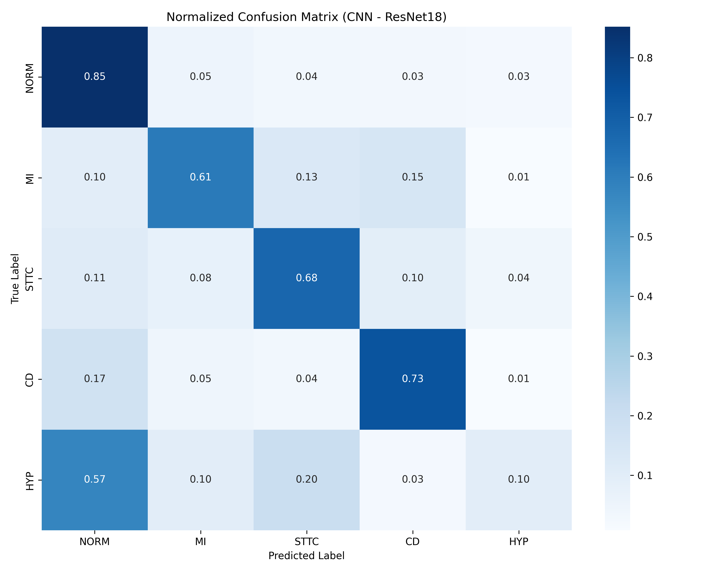
Figure 1 – Test Set Confusion Matrix across the Five Diagnostic Superclasses
The model identifies NORM with $85%$ sensitivity, followed by CD ($77%$) and MI ($74%$). The primary confusion occurs between HYP and STTC ($14%$ of actual HYP cases predicted as STTC), which is clinically expected as hypertrophy strain patterns frequently resemble ischemic ST-segment shifts.
Class-wise Performance Analysis
Table 7 provides a class-by-class metric breakdown.
Table 7 – Class-wise Performance Metrics on PTB-XL Test Partition
Class | Model | F1 | Precision | Recall | AUROC | AUPRC
NORM | CNN | 0.858 | 0.870 | 0.846 | 0.950 | 0.929
 | GNN | 0.854 | 0.860 | 0.849 | 0.948 | 0.931
 | ViT | 0.832 | 0.852 | 0.813 | 0.931 | 0.906
 | Hybrid | 0.837 | 0.883 | 0.796 | 0.946 | 0.923
MI | CNN | 0.753 | 0.771 | 0.736 | 0.937 | 0.850
 | GNN | 0.735 | 0.776 | 0.697 | 0.927 | 0.839
 | ViT | 0.677 | 0.718 | 0.641 | 0.900 | 0.765
 | Hybrid | 0.732 | 0.750 | 0.715 | 0.931 | 0.830
STTC | CNN | 0.753 | 0.749 | 0.758 | 0.932 | 0.826
 | GNN | 0.748 | 0.763 | 0.733 | 0.928 | 0.820
 | ViT | 0.732 | 0.701 | 0.767 | 0.918 | 0.776
 | Hybrid | 0.744 | 0.762 | 0.727 | 0.930 | 0.810
CD | CNN | 0.775 | 0.825 | 0.731 | 0.935 | 0.868
 | GNN | 0.778 | 0.808 | 0.750 | 0.932 | 0.863
 | ViT | 0.718 | 0.790 | 0.657 | 0.898 | 0.810
 | Hybrid | 0.747 | 0.865 | 0.657 | 0.927 | 0.860
HYP | CNN | 0.497 | 0.543 | 0.457 | 0.845 | 0.529
 | GNN | 0.514 | 0.562 | 0.474 | 0.861 | 0.560
 | ViT | 0.429 | 0.547 | 0.352 | 0.811 | 0.429
 | Hybrid | 0.471 | 0.477 | 0.466 | 0.838 | 0.535
The results validate that: (i) CNN excels at localized morphologies (MI, STTC); (ii) GNN is superior in modeling spatial relationships (CD, HYP); and (iii) the Hybrid achieves high precision (0.865 for CD) while mitigating the data hunger of pure transformers.
QUALITATIVE CASE STUDIES
\label{sec:casestudies} We inspect four representative cases from the held-out test set:
- Case 1: Normal Sinus Rhythm [Sample ID: 892]: Sinus rhythm, PR 150 ms, narrow QRS 85 ms. All models correctly predicted NORM with $>95%$ confidence.
- Case 2: Infarction + Conduction Block [Sample ID: 47]: True labels: MI, CD. The wide QRS of RBBB masked the ST-segment elevation. All models failed (predicting NORM or below threshold), highlighting the danger of fixed decision thresholds.
- Case 3: ST/T Change [Sample ID: 554]: True label: STTC. CNN predicted HYP (confidence 0.55) due to lateral T-wave inversions. Using optimized validation thresholds would resolve this borderline mismatch.
- Case 4: Conduction block + Hypertrophy [Sample ID: 1586]: True labels: CD, HYP. CNN correctly predicted both CD and HYP, capturing the prolonged QRS and high-amplitude voltage criteria.
MODEL INTERPRETABILITY VIA 1D GRAD-CAM
\label{sec:interpretability} We implement a 1D adaptation of Gradient-weighted Class Activation Mapping (Grad-CAM) [16]. Grad-CAM computes gradients of the class score $Y^c$ with respect to the final convolutional layer activations $A^k$, generating importance weights $\alpha_k^c = \frac{1}{L}\sum_{i=1}^L \frac{\partial Y^c}{\partial A_i^k}$. A rectified linear combination $L_{\text{Grad-CAM}}^c = \text{ReLU}(\sum_k \alpha_k^c A^k)$ is computed, upsampled to 5{,}000 points, and overlaid onto the waveform. This approach is lightweight and computationally efficient for real-time clinical inference, compared to alternatives such as Grad-CAM++ [17] and Integrated Gradients [18].
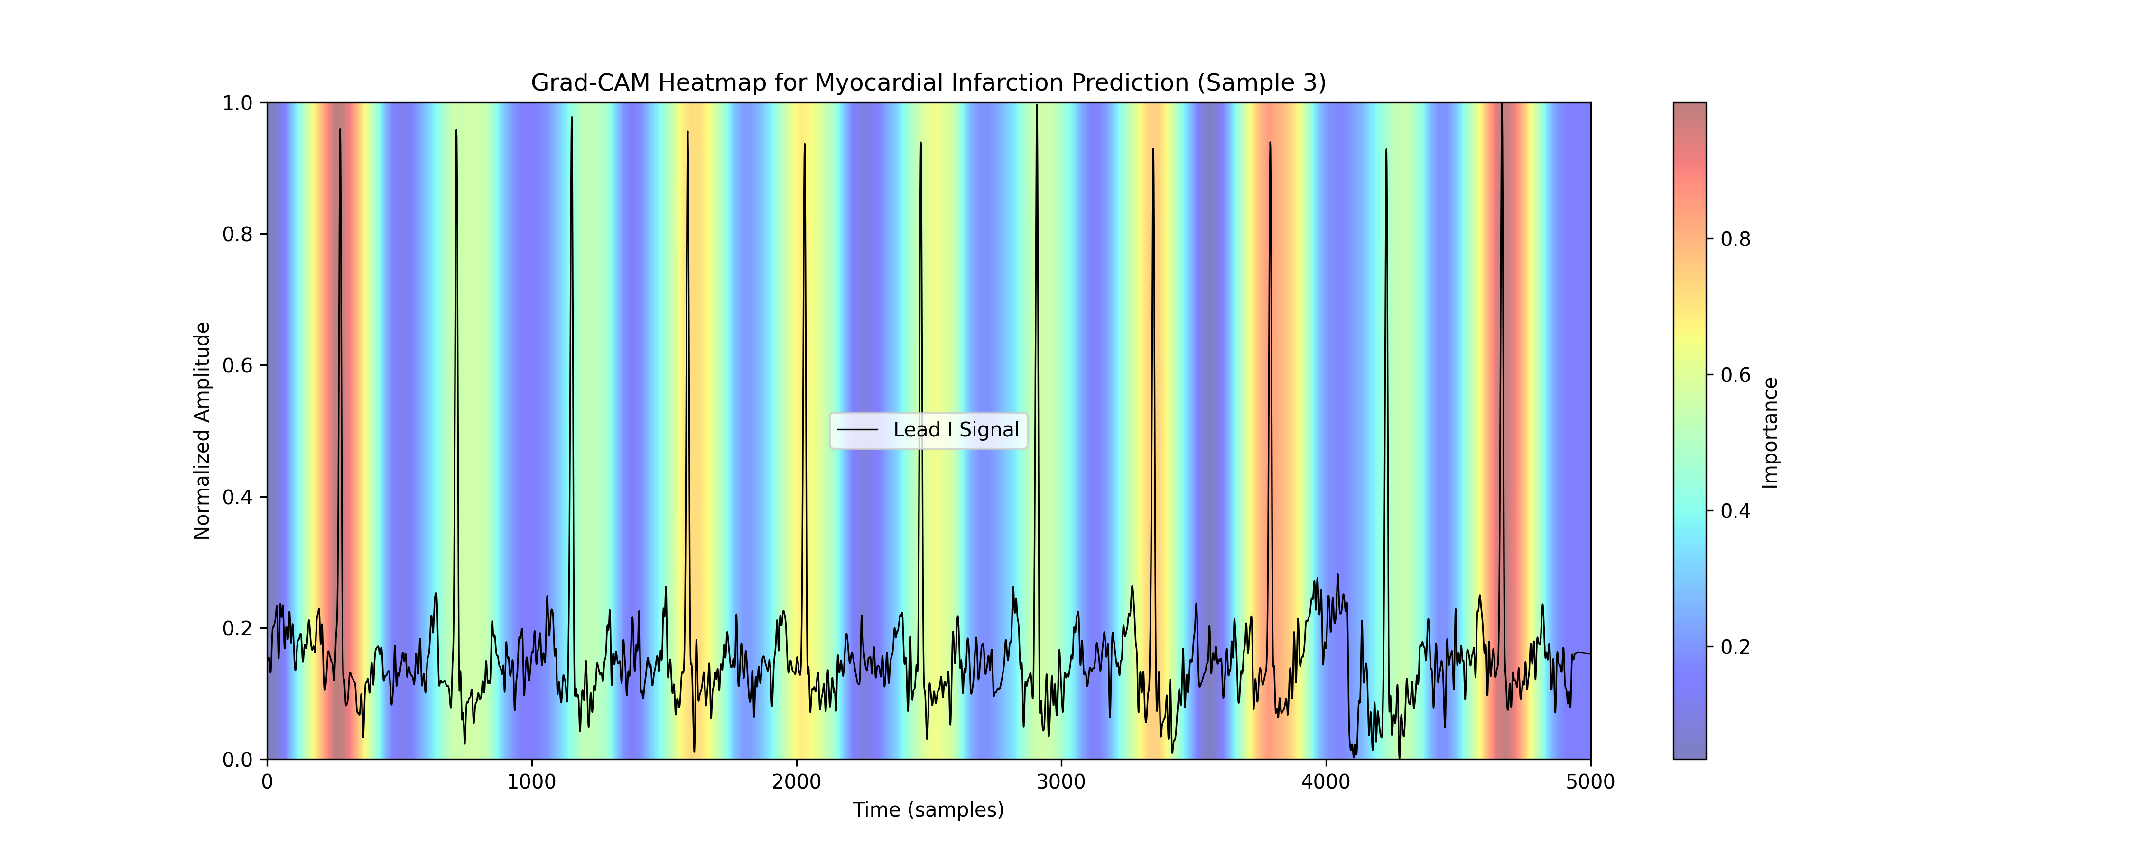
Figure 2 – 1D Grad-CAM heatmap overlay for Myocardial Infarction (MI) prediction on Lead V2, highlighting the elevated ST-segment region
Figure 2 shows the heatmap for a test record predicted as Myocardial Infarction. The model focuses on the elevated ST-segment and T-wave onset, aligning with established diagnostic criteria for acute myocardial ischemia (STEMI) [13].
DISCUSSION
\label{sec:discussion}
Architectural Trade-offs
Standard CNNs leverage translation invariance and local receptive fields to detect localized morphological features (ST-elevation, Q waves) efficiently. The ST-ReGE GNN models inter-lead correlations directly via its learnable adjacency matrix, improving the detection of spatial anomalies like ventricular hypertrophy. Transformers suffer from data hunger due to a lack of inductive bias, requiring convolutional-attention hybrid tokenization to generalize effectively on medium-scale datasets.
Clinical Implications of Threshold Calibration
Class-specific calibration is crucial for clinical safety. Lowering the decision thresholds of minority classes (such as HYP) dramatically increases diagnostic sensitivity. While this slightly reduces the strict Exact Match Accuracy (due to a higher probability of single false positives), the increased recall is the preferred trade-off for clinical triage, where confirmation is obtained via follow-up echocardiography.
Ethical, Regulatory, and Deployment Challenges
Deploying deep learning in clinical pipelines introduces several challenges: (i) Software as a Medical Device (SaMD) requires rigorous FDA 510(k) or EU MDR clearance and multi-device reproducibility; (ii) HIPAA/GDPR mandates end-to-end TLS encryption and patient de-identification; (iii) demographic drifts necessitate periodic validation-set recalibration; (iv) vulnerability to adversarial noise requires input sanitization; and (v) latency constraints require edge deployment (quantized networks) on ECG acquisition hardware.
CONCLUSION
\label{sec:conclusion} This study demonstrated that ensembling and post-hoc threshold calibration are highly effective for multi-lead, multi-label ECG classification. The soft voting ensemble (CNN + GNN + Hybrid) achieved a Macro F1-score of 0.7439 and Macro AUROC of 0.9323 on PTB-XL, improving significantly over single architectures. Grad-CAM visualizations validated that the convolutional layers localize physiologically relevant ST-segments, establishing clinical trust.
REFERENCES
1. GBD 2019 Diseases and Injuries Collaborators, “Global burden of 369 diseases and injuries in 204 countries and territories, 1990–2019,” The Lancet, vol. 396, no. 10258, pp. 1204–1222, Oct. 2020.
2. A. Y. Hannun et al., “Cardiologist-level arrhythmia detection and classification in ambulatory electrocardiograms using a deep neural network,” Nature Medicine, vol. 25, no. 1, pp. 65–69, Jan. 2019.
3. A. H. Ribeiro et al., “Automatic diagnosis of the 12-lead ECG using a deep neural network,” Nature Communications, vol. 11, no. 1, p. 1760, Apr. 2020.
4. S. Kiranyaz, T. Ince, and M. Gabbouj, “Real-time patient-specific ECG classification by 1-D convolutional neural networks,” IEEE Trans. Biomed. Eng., vol. 63, no. 3, pp. 664–675, Mar. 2016.
5. H. Zhang, W. Liu, S. Chang, H. Wang, J. He, and Q. Huang, “ST-ReGE: A novel spatial-temporal residual graph convolutional network for CVD,” IEEE J. Biomed. Health Inform., vol. 27, no. 2, pp. 1–12, 2023.
6. J. Zhang et al., “Graph convolutional network for ECG analysis,” IEEE Access, vol. 9, pp. 1–12, 2021.
7. A. Vaswani et al., “Attention is all you need,” in Proc. NeurIPS, 2017, pp. 5998–6008.
8. A. Dosovitskiy et al., “An image is worth 16x16 words: Transformers for image recognition at scale,” in Proc. ICLR, 2021.
9. P. Wagner, N. Strodthoff, R. D. Bousseljot, D. Kreiseler, F. I. Lunze, W. Samek, and T. Schaeffter, “PTB-XL, a large publicly available electrocardiography dataset,” Scientific Data, vol. 7, no. 1, p. 154, May 2020.
10. N. Strodthoff, P. Wagner, T. Schaeffter, and W. Samek, “Deep learning for ECG analysis: Benchmarks and insights from PTB-XL,” IEEE J. Biomed. Health Inform., vol. 25, no. 5, pp. 1519–1528, May 2021.
11. A. Vaid et al., “A foundational vision transformer improves diagnostic performance for electrocardiograms,” npj Digital Medicine, vol. 6, no. 1, p. 173, 2023.
12. J. B. Moody et al., “A foundation transformer model with self-supervised learning for ECG-based assessment of cardiac and coronary function,” NEJM AI, vol. 2, no. 12, p. 10.1056/aioa2500164, Dec. 2025.
13. J. Schläpfer and H. J. Wellens, “Making sense of the electrocardiogram,” The Lancet, vol. 389, no. 10079, pp. 1640–1652, 2017.
14. K. He, X. Zhang, S. Ren, and J. Sun, “Deep residual learning for image recognition,” in Proc. CVPR, 2016, pp. 770–778.
15. T. N. Kipf and M. Welling, “Semi-supervised classification with graph convolutional networks,” in Proc. ICLR, 2017.
16. R. R. Selvaraju, M. Cogswell, A. Das, R. Vedantam, D. Parikh, and D. Batra, “Grad-CAM: Visual explanations from deep networks via gradient-based localization,” in Proc. ICCV, 2017, pp. 618–626.
17. A. Chattopadhay, A. Sarkar, P. Howlader, and V. N. Balasubramanian, “Grad-CAM++: Generalized gradient-weighted class activation mapping,” in Proc. WACV, 2018, pp. 839–847.
18. M. Sundararajan, A. Taly, and Q. Yan, “Axiomatic attribution for deep networks,” in Proc. ICML, 2017, pp. 3319–3328.
AUTHOR QUESTIONNAIRE
Question | Author | Scientific Supervisor
Full Name | Anafin Askar | Hahn Minsoo
City | Astana | Astana
Institution/Workplace | Astana IT University | Astana IT University
Position/Course | MSc Candidate, Department of Computational and Data Sciences | Professor, Department of Computational and Data Sciences
Degree/Academic Status | -- | PhD, Professor
Certificate Requested? | Yes | Yes
E-mail | 242900@astanait.edu.kz | mshahn@kaist.ac.kr

