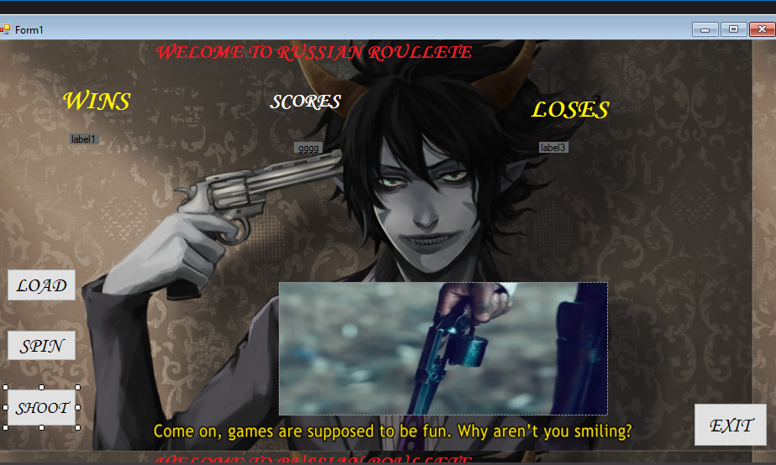

RUSSIAN ROULLETE

# INTRODUCTION

# This assignment involves Russian Roullete with Gun,

I added some buttons, labels and picture box (GIF). Buttons like LOAD, SPIN and FIRE and I described their functions.

The program runs like this:-

## LOAD BUTTON

# When you click on the load button then bullets will loaded into the chamber of a revolver. Loading chamber of revolver GIF will appear on the form1.

SPIN BUTTON

# After clicking on the button SPIN BUTTON chamber will start spinning to create a random place where the bullet is with a 1 in 6 chance. You can see the spinning GIF chamber on the form1.

SHOOT BUTTON

When you will click the SHOOT BUTTON ,a GIF of shooting gun will appear on the form .you will pull the trigger repeatedly until the gun fires through to the number of where the bullet is stored.