1. Data

Foursquare venue data will be leveraged in order to help build new clusters of neighborhoods which could potentially replace the present administrative divisions of Bucharest. First step is to define the city’s limits and select data for venues inside the city. We will use a grid of small neighborhoods within the city in order to make the calls for venues.

Next step will be to clean the data of potential duplicates and create a new dataset which includes information about the types of venues present within each artificial neighborhood created. See below image for a visualization of the artificial “neighborhoods” created.

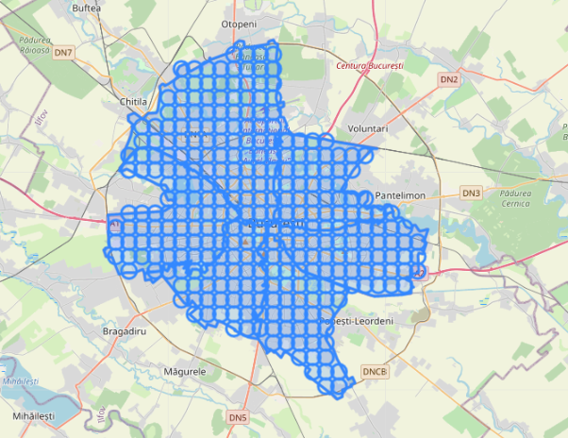

Each circle represents an artificial neighborhood which will contain information about venues present within it. These neighborhoods will then be used together with their location data in order to be clustered and create new “sectors” for the city.