1. Introduction
2. Background

Bucharest, the capital of Romania is currently divided into 6 administrative units, called sectors (“sectoare” in Romanian). Each sector has its own mayor and council who are responsible over local affairs (secondary streets, parks, cleaning services, for example). After World War I, each administrative unit of Bucharest (called “culori” at that time), was first given its own mayor and council. The current divisions of sectors of this city date back to august 1979, and there is an incentive to redefine they way Bucharest is divided, as the territories encompass diverse neighborhoods which translate into diverse needs hard to tackle by the local administrations.

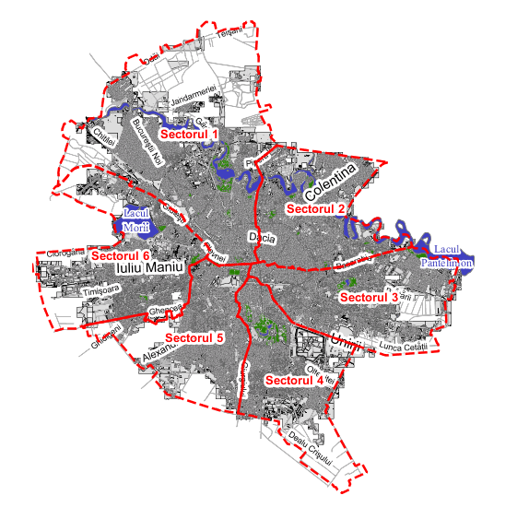

1. Problem

The problem of dividing a territory into coherent divisions demands taking into account a large number of factors regarding what venues are present in the district, what kinds of services are operating and at what level of quality, etc. These factors, if correctly used, will create useful territorial divisions reflecting local needs. Organizing the administration of the city in smaller, more representative units is a necessity at this point, although the question begged by this initiative is how do we do this and take into account enough factors to make it efficient?

My goal is to use machine learning algorithms to try to divide the territory of Bucharest in a more efficient way, with neighborhoods defined by the types of restaurants, parks, museums etc present. Making the divisions based upon the types of venues which can be found within the territory, will ensure a more accurate depiction of local’s needs.