Syed Mohammad Askari Abidi | 7178458
Syed.abidi@edu.unifi.it
A Distributed Web-Based Human Resource Management System
Built with Go (backend) and React (frontend)
Final Project — Distributed Programming for Web, IoT, and Mobile Systems
University of Florence
SyncHR
Documentation, Test Cases & Deployment Guide
Submitted to: Professor Letterio Galletta
Table of Contents
Project Overview 3
Core Features 3
System Architecture 4
High-Level Architecture 4
Backend Architecture (Go) 4
The WebSocket Hub (Real-Time Layer) 4
Frontend Architecture (React) 5
Database Schema 5
Technology Stack 6
Backend 6
Frontend 6
Infrastructure 6
Feature Walkthrough 7
Employee Dashboard 7
Apply Leave 8
My Leave Requests 9
View Payslip 9
HR Dashboard — Leave Requests 10
HR Dashboard — Attendance Report 11
HR Dashboard — Employee Directory 11
HR Dashboard — Send Notification 12
Real-Time Notification Bell 12
API Reference 12
Authentication & Users 12
Attendance 13
Leave 13
Payslip, Holidays & Notifications 13
Compile & Run Instructions 14
Option A — Docker (Recommended) 14
Option B — Manual Setup (Native Development) 15
Step 1 — Database 15
Step 2 — Backend 15
Step 3 — Frontend 15
Creating Accounts 15
Deployment 15
Test Cases 16
Authentication 16
Authorization (RBAC) 17
Attendance 17
Leave Management 18
Real-Time Notifications (WebSocket) 19
Payslip 19
Known Issues Surfaced By Testing 19
Running the Automated Test Suite 20
References 20

Project Overview
SyncHR is a distributed, web-based Human Resource Management System that lets employees check in and out, apply for and track leave, and view payslips, while HR managers review and approve leave requests, browse attendance day-by-day, manage the employee directory, and push instant notifications to the whole workforce.
The system is built as two independently deployable services — a Go REST API backend and a React single-page application frontend — communicating over HTTP and WebSocket, backed by a PostgreSQL database. (RESTful API Design Best Practices and Guidelines, n.d.)

Core Features
- Authentication — registration, login, JWT sessions, role-based routing (Employee vs HR Manager).
- Attendance — check in/out with a live running session timer; employees browse their own attendance by date; HR browses every employee’s attendance by date with month navigation and day tabs.
- Leave management — employees apply for leave against a real balance and track status; HR reviews, approves, or rejects requests with notes; balances are deducted automatically on approval.
- Payslips — employees view monthly payslips with a full earnings/deductions’ breakdown.
- Employee directory — HR can search and browse all employees and reset an employee’s password (HR-mediated reset).
- Real-time notifications — leave apply/approve/reject events and HR-authored announcements persisted to the database and pushed live over a WebSocket connection to anyone online, with a notification bell showing an unread count on both dashboards.

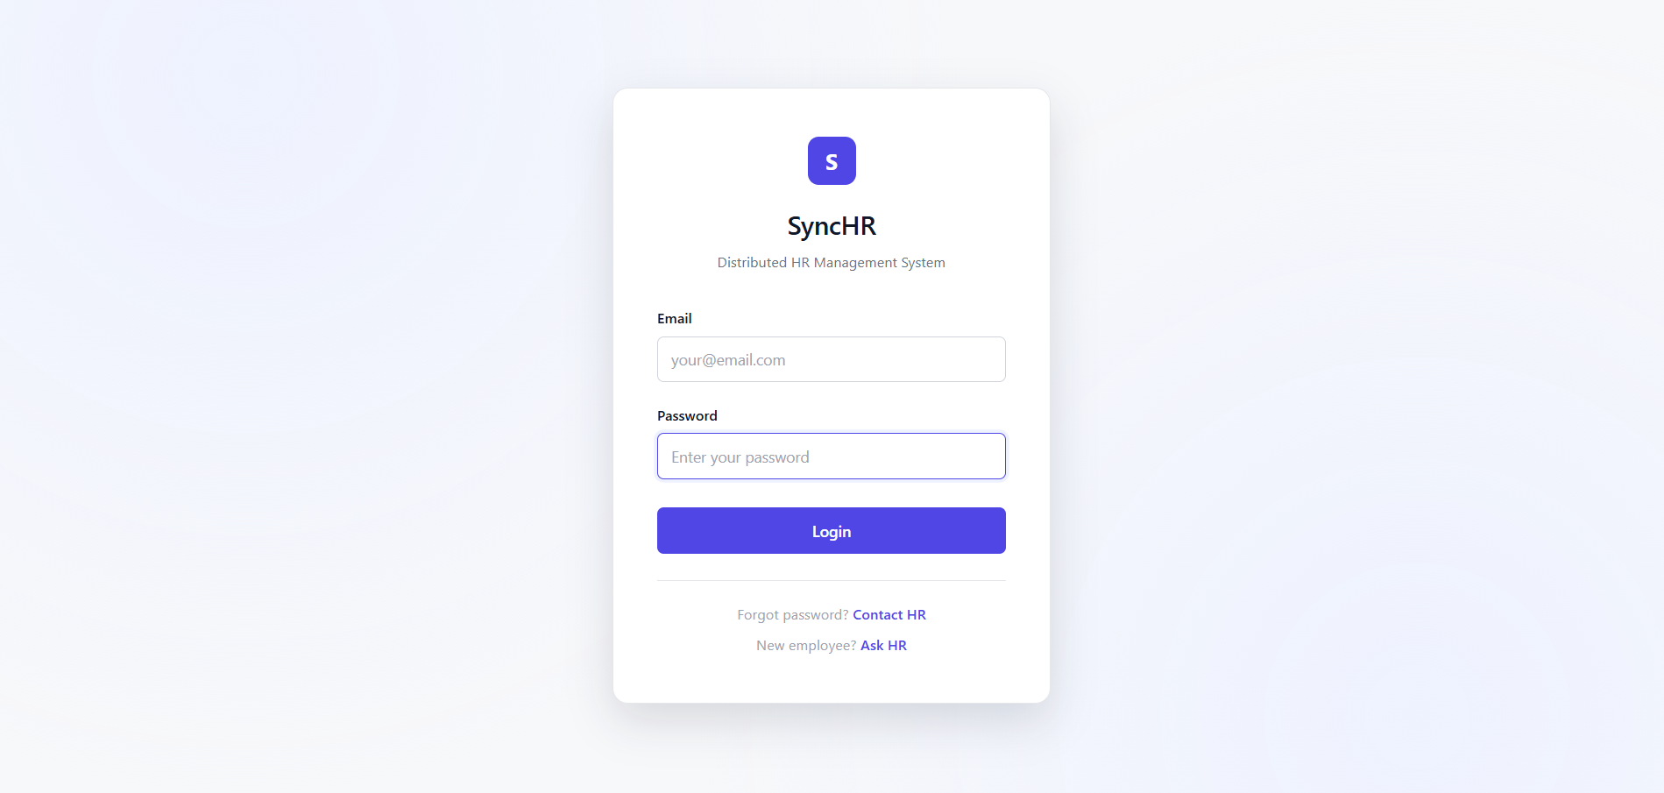

System Architecture

High-Level Architecture
SyncHR follows a client-server architecture with three tiers:
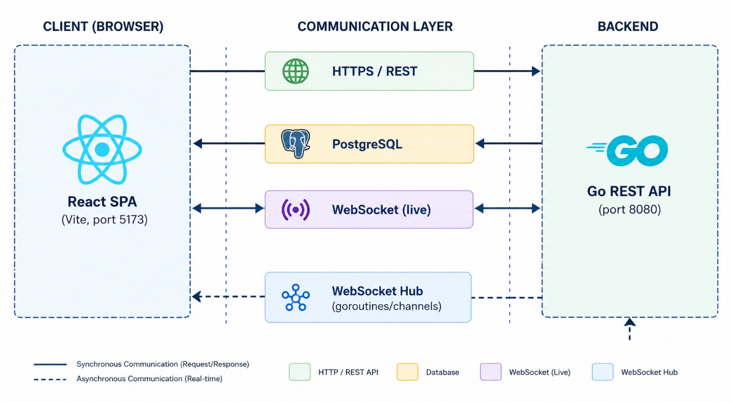

Backend Architecture (Go)
The backend is a single Go binary built with the gorilla/mux (Gorilla Web Toolkit - Mux Package, n.d.) (Gorilla WebSocket - Real-time Communication, n.d.) router (The Go Programming Language - Official Documentation, n.d.). It is organized by domain, one handler file per feature area, all sharing a single $*sql.DB$ connection pool:
- $main.go$ — builds the route table (SetupRouter) and starts the HTTP server.
- $middleware.go$ — JWT validation middleware, plus the WebSocket hub (the real-time notification engine).
- $auth.go$ — registration, login, profile, employee directory, HR-mediated password reset.
- $attendance.go$ — check-in/check-out, attendance history, HR’s all-employee attendance view.
- $leave.go$ — leave types, apply/approve/reject, leave balance.
- $payslip.go$ — payslip listing and detail retrieval with ownership checks.
- $holiday.go$ — public holiday listing.
- $notification.go$ — notification persistence, retrieval, mark-as-read, HR broadcast.
- $models.go$ — shared request/response/entity structs.
- $database.go$ — PostgreSQL connection setup and startup schema bootstrap.

The WebSocket Hub (Real-Time Layer)
Real-time notification delivery is implemented as a classic Go "actor": a single goroutine ($Hub.run$) owns the registry of connected clients and is the only code that ever reads or mutates it. Every other goroutine — one per connected client, plus every HTTP handler that wants to push a notification — communicates with it exclusively through channels (register, unregister, direct) rather than a shared, locked map:
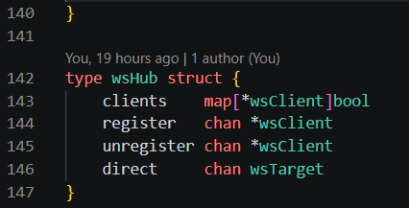
Because a browser’s native WebSocket API cannot set an Authorization header on the handshake, the JWT is instead passed as a $?token= query$ parameter and validated with the same logic as the HTTP middleware, on a route that is deliberately public (not behind the JWT-checking subrouter). (golang-jwt - JSON Web Tokens for Go, n.d.)

Frontend Architecture (React)
- $src/pages/$ — one component per screen (Login, Employee Dashboard, HR Dashboard, Apply Leave, My Leave Requests, View Payslip).
- $src/context/$ — AuthProvider and NotificationProvider (the latter owns the app-wide WebSocket connection).
- $src/hooks/$ — useAuth, useNotifications, useDateNavigator (shared date-picker/month-nav/day-tabs logic used by both dashboards’ attendance views).
- $src/components/$ — ProtectedRoute (role-aware route guard) and NotificationBell.
- $src/utils/$ — shared date/time formatting helpers.
- $src/services/api.js$ — the single Axios client and every REST call.
Auth and notification state are each split into a context-value module, a Provider component, and a custom hook, so Provider files export only a component (better React Fast Refresh behavior) while still exposing simple $useAuth()$ / $useNotifications()$ hooks to every page. (React - Official Documentation and Guide, n.d.) (Axios - Promise Based HTTP Client, n.d.)

Database Schema
PostgreSQL, 9 tables:
- Users
- Attendance
- break_time
- leave_types
- leave_balance
- leave_request
- public_holidays
- payslip
- notifications
Foreign keys cascade on delete (deleting a user cleans up their attendance, leave, payslip, and notification rows automatically). Full definitions are in $db/schema.sql$.
Table | Purpose
users | Employee and HR manager accounts, bcrypt-hashed passwords, role
attendance | Daily check-in/check-out records, one row per user per day
leave_types | The 5 seeded leave categories (Sick, Casual, Earned, Maternity, Paternity)
leave_balance | Remaining days per user, per leave type, per year
leave_request | Leave applications with an approval workflow (pending/approved/rejected)
payslip | Monthly salary breakdown per employee
public_holidays | Company/public holiday calendar
notifications | Persisted real-time notifications, with an is_read flag

Technology Stack

Backend
- $Go$ — REST API and WebSocket server.
- $gorilla/mux$ — HTTP routing.
- $gorilla/websocket$ — WebSocket upgrade and framing.
- $golang-jwt/jwt (v5)$ — JWT signing and verification.
- $golang.org/x/crypto/bcrypt$ — password hashing.
- $lib/pq$ — PostgreSQL driver.
- $joho/godotenv$ — .env loading for local development.

Frontend
- React 19 + React Router 7
- Vite — dev server and production bundler
- Axios — REST client
- Native browser WebSocket API — real-time updates (no client library needed)
- Plain CSS with a shared design-token system (CSS custom properties), no UI framework dependency

Infrastructure
- PostgreSQL 16
- Docker + Docker Compose — containerized deployment of all three services.
- nginx — serves the built frontend and handles client-side routing fallback.

Feature Walkthrough

Employee Dashboard
Shows today’s attendance status with a live $HH:MM:SS$ session timer while checked in, quick-action buttons (Check In, Check Out with a confirmation dialog, Apply Leave, My Requests, View Payslip), a day-by-day "My Attendance" browser, current leave balances across all 5 leave types, and profile information.
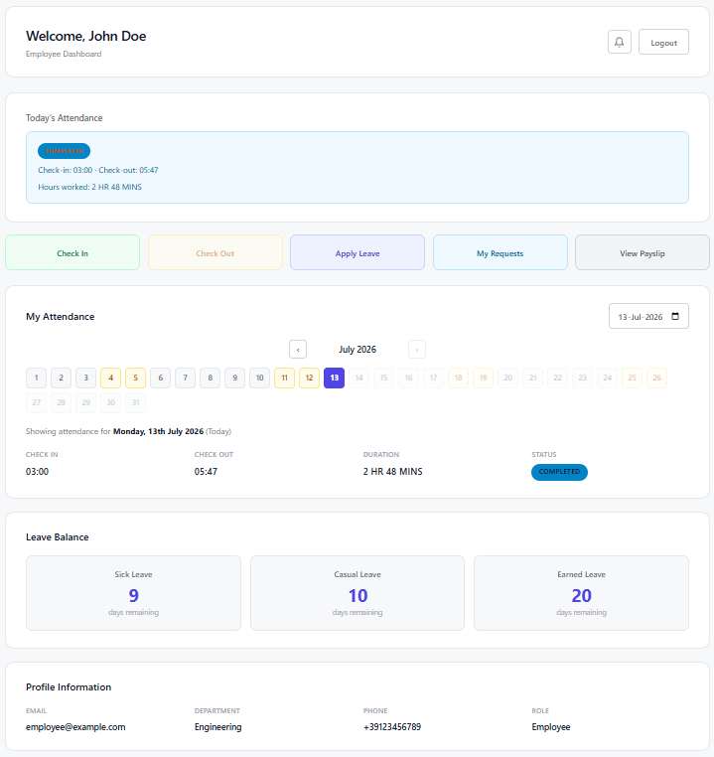

Apply Leave
A form where the employee picks a leave type (fetched live from the backend, not hardcoded), a start/end date, sees the number of days auto-calculated, and submits a reason.
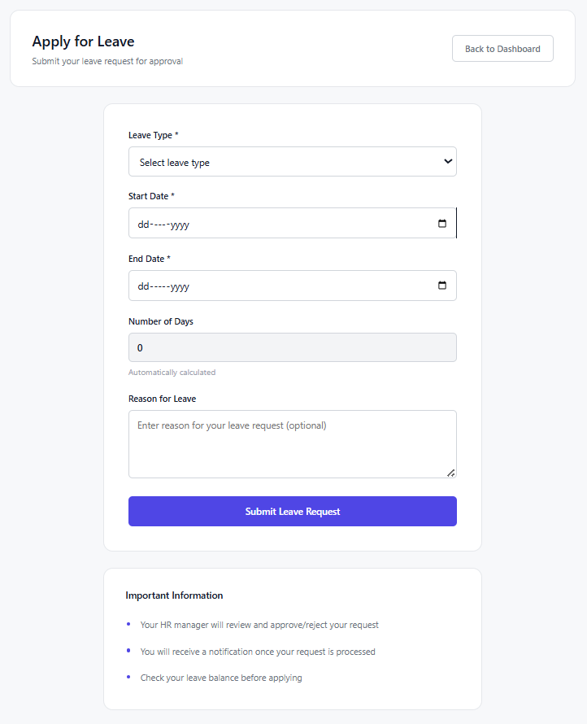

My Leave Requests
A filterable table (All/Pending/Approved/Rejected) of the employee’s own leave history, with HR’s approval/rejection notes visible once processed.
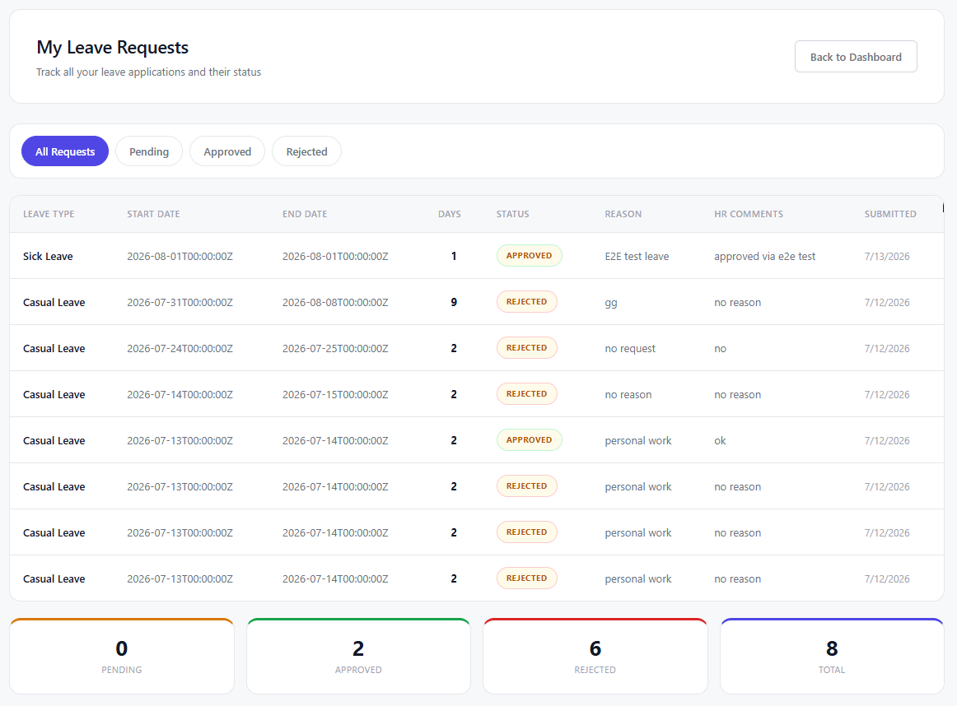

View Payslip
A grid of monthly payslip cards with net salary at a glance, expandable into a full document-style modal with earnings, deductions, attendance summary, and net salary.
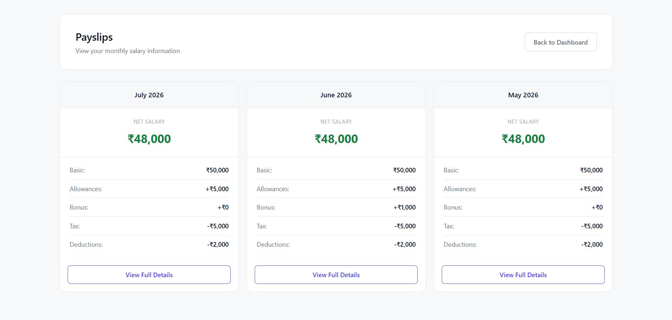
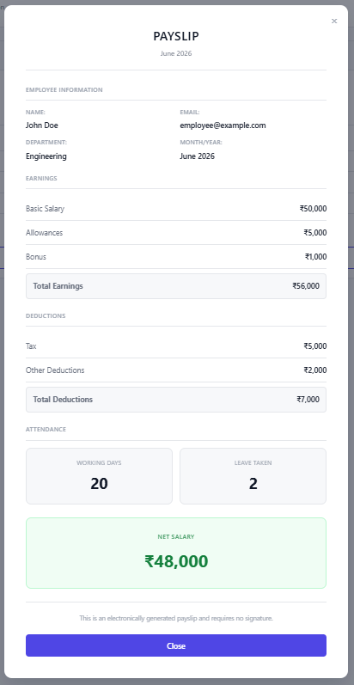

HR Dashboard — Leave Requests
HR sees every employee’s leave requests as cards, filterable by status, with the leave type, dates, reason, and an Approve/Reject modal that requires notes.
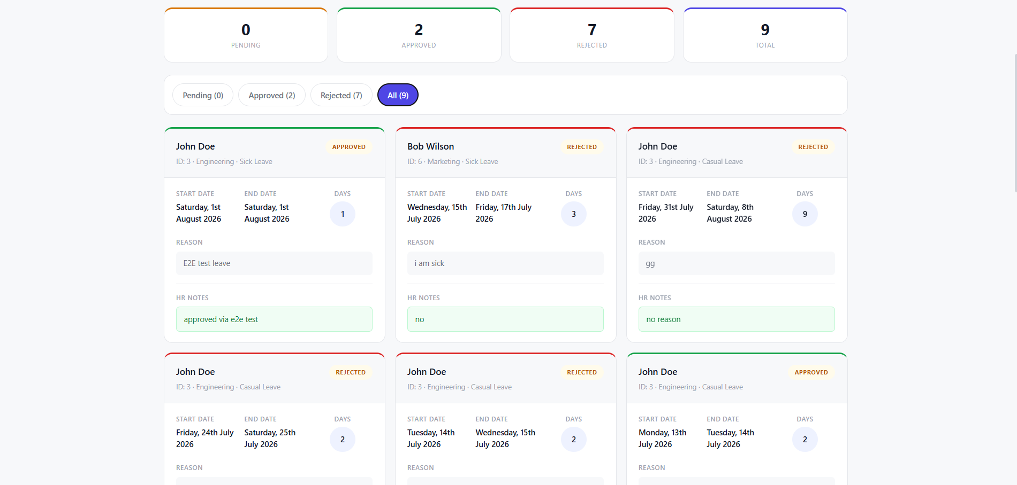
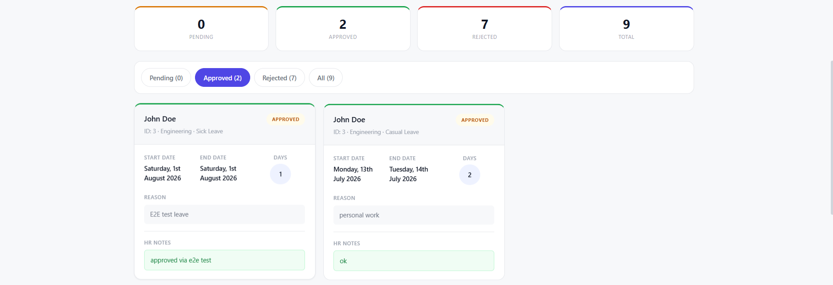

HR Dashboard — Attendance Report
A day-by-day attendance browser across all employees, with a date picker, month navigation, and day tabs (weekends highlighted, today outlined, future days disabled).
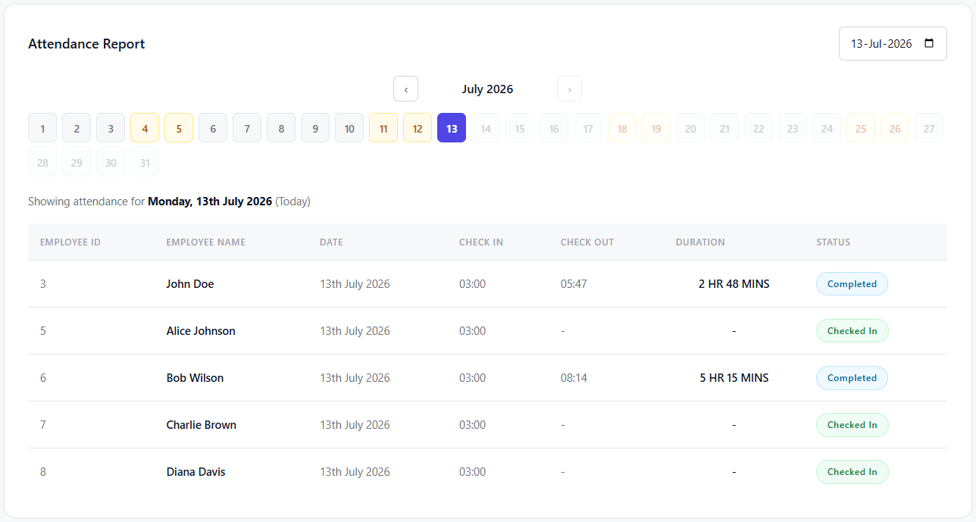

HR Dashboard — Employee Directory
A searchable table of every employee, with a "Reset Password" action per row that generates a new temporary password for HR to relay to the employee.
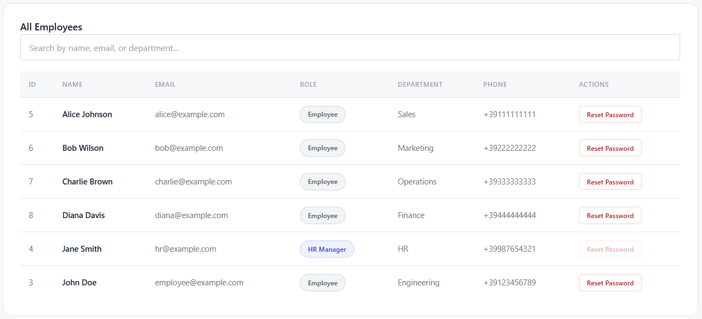
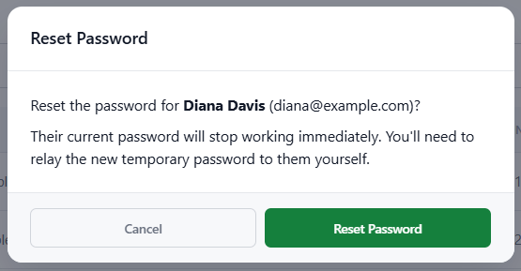

HR Dashboard — Send Notification
A compose form HR uses to broadcast an announcement to every employee instantly.
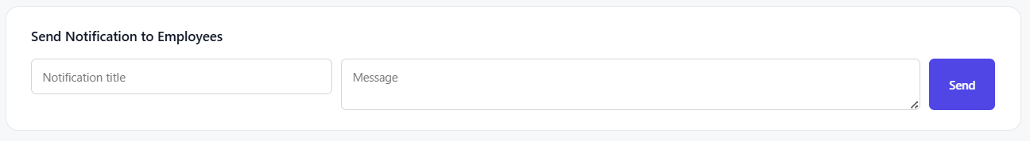

Real-Time Notification Bell
Present on both dashboards shows an unread-count badge and a dropdown of recent notifications, updated live over the WebSocket connection with no page refresh.
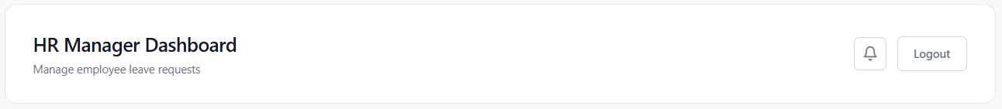
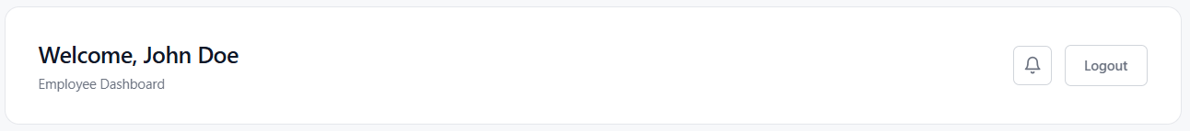

API Reference
All routes are prefixed with $/api$. Protected routes require an Authorization: Bearer <token> header. The WebSocket route is the one exception — it is public and authenticates via $a ?token= query$ parameter instead.

Authentication & Users
Method | Path | Access | Description
POST | /auth/login | Public | Log in, returns a JWT
POST | /auth/register | Public | Create an account
GET | /users/profile | Any | Get your own profile
PUT | /users/profile | Any | Update your own profile
GET | /users/employees | HR | List every employee
PUT | /users/{id}/reset-password | HR | Generate a new temporary password for an employee

Attendance
Method | Path | Access | Description
POST | /attendance/checkin | Any | Check in for today
POST | /attendance/checkout | Any | Check out for today
GET | /attendance/history | Any | Your own full attendance history
GET | /attendance/records?date= | HR | All employees’ attendance for one day (defaults to today)

Leave
Method | Path | Access | Description
GET | /leave/types | Any | List all leave types
POST | /leave/apply | Any | Apply for leave
GET | /leave/balance | Any | Your own leave balance
GET | /leave/requests | Any | Your own requests (employee) or everyone’s (HR)
PUT | /leave/approve/{id} | HR | Approve a pending request
PUT | /leave/reject/{id} | HR | Reject a pending request

Payslip, Holidays & Notifications
Method | Path | Access | Description
GET | /payslip/list | Any | Your own payslips (or all, for HR)
GET | /payslip/{id} | Owner or HR | One payslip’s full detail
GET | /holidays | Any | Public holiday calendar
GET | /notifications | Any | Your own notifications
PUT | /notifications/{id}/read | Any | Mark one notification as read
PUT | /notifications/read-all | Any | Mark all as read
POST | /notifications/broadcast | HR | Send a notification to every employee
GET | /ws/notifications?token= | Any (query-auth) | WebSocket upgrade for live push

Compile & Run Instructions
Two supported ways to run SyncHR: one command with Docker (recommended, no local Go/Node/Postgres setup needed) or running each piece natively for development. (PostgreSQL Official Documentation, n.d.)

Option A — Docker (Recommended)
Prerequisite: Docker and Docker Compose only.
docker compose up --build
This single command:
- Builds the Go backend into a small static binary in an Alpine image.
- Builds the React frontend and serves it via nginx, with the single-page-app fallback route configured so client-side routing works on refresh.
- Starts a PostgreSQL container and automatically applies $db/schema.sql$ on first boot (mounted as a Postgres $init$ script — no manual $psql$ step).
- Wires the three services together on a private Docker network, waiting for Postgres to report healthy before starting the backend.
Once it is up: Frontend on $http://localhost:5173$, Backend API on http://localhost:8080/api, Postgres on $localhost:5432$. Credentials/secrets can be overridden by copying $.env$.example to $.env$ at the repository root.
This flow was verified end-to-end during development: a completely fresh docker compose up --build (empty Postgres volume) correctly auto-applied the schema, and registration and login worked immediately through the containerized stack.

Option B — Manual Setup (Native Development)
Prerequisites:
- Go (see backend/go.mod for the toolchain version)
- Node.js 18+
- Reachable PostgreSQL instance.

Step 1 — Database
psql -U <your_user> -d <your_db> -f db/schema.sql

Step 2 — Backend
cd backend
cp .env.example .env # fill in real DB credentials and a JWT secret
go run .
The API starts on $http://localhost:8080$ (override with PORT in $.env$).

Step 3 — Frontend
cd frontend
npm install
npm run dev
The app starts on $http://localhost:5173$.

Creating Accounts
$db/schema.sql$ defines the tables only — it does not seed any user accounts. Register an account of each role via the API:
curl -X POST http://localhost:8080/api/auth/register \
-H "Content-Type: application/json" \
-d '{"email":"employee@example.com","password":"password123","first_name":"John","last_name":"Doe","role":"employee","department":"Engineering"}'
curl -X POST http://localhost:8080/api/auth/register \
-H "Content-Type: application/json" \
-d '{"email":"hr@example.com","password":"password123","first_name":"Jane","last_name":"Smith","role":"hr_manager","department":"HR"}'
role must be either $employee$ or $hr_manager$.

Deployment
The project ships with everything needed to run it as three containers behind Docker Compose:
- $backend/Dockerfile$ (multi-stage Go build into a minimal Alpine image)
- $frontend/Dockerfile$ (Vite build served by nginx, with an $nginx.conf$ that falls back to index.html for client-side routes)
- Root $docker-compose.yml$ orchestrating Postgres, the backend, and the frontend on a shared network.
For a real deployment beyond a single machine, the same three images can be pushed to any container registry and run on separate hosts, as long as:
- The frontend is built with $VITE_API_URL$ pointing at the backend’s real public URL (it is a build-time argument, not a runtime environment variable, since it gets baked into the static JS bundle).
- The backend’s DB_HOST/DB_PORT/DB_USER/DB_PASSWORD/DB_NAME and JWT_SECRET are set to real values, not the Docker Compose defaults.
- CORS and the WebSocket origin check (currently permissive, for development) are tightened for production use.
Note: The WebSocket hub’s connected-client registry lives in a single process’s memory. Running more than one backend instance behind a load balancer would require a shared pub/sub layer (e.g., Redis) to fan out notifications across instances — this is a known limitation of the current single-instance design, discussed further in the accompanying report. (MDN Web Docs - Cross-Origin Resource Sharing (CORS), n.d.)

Test Cases
27 automated Go tests cover authentication, RBAC, attendance, leave management, and the WebSocket notification hub, all passing, including under Go’s -race detector, which specifically exercises the hub’s concurrent goroutine/channel design under contention. Cases without an automated test are manual/UI checks, marked accordingly.

Authentication
ID | Scenario | Expected Result | Automated
AUTH-01/02 | Register then log in with the right credentials | 200 OK, valid JWT with the correct role | Yes
AUTH-03 | Log in with the wrong password | 401 Unauthorized, no token issued | Yes
AUTH-04 | Register with an email already in use | Registration rejected | Yes
AUTH-05 | Access a protected route with no token | 401 Unauthorized | Yes
AUTH-06 | Access with an expired token | 401 Unauthorized | Yes
AUTH-07 | Access with a wrong-secret token | 401 Unauthorized | Yes
AUTH-08 | Access with an "alg: none" token | 401 Unauthorized (signing method itself is validated) | Yes
AUTH-09 | HR resets an employee’s password | Old password stops working, new one logs in | Yes
AUTH-10 | Wrong credentials on the login form | Inline error shown, no page reload | Manual
AUTH-11 | Forgot password / new employee links | Opens a pre-filled mailto: to HR | Manual

Authorization (RBAC)
ID | Scenario | Expected Result | Automated
RBAC-01 | Employee calls an HR-only attendance endpoint | 403 Forbidden | Yes
RBAC-02 | Employee tries to approve leave | 403 Forbidden | Yes
RBAC-03 | Employee tries to broadcast a notification | 403 Forbidden | Yes
RBAC-04 | HR views the employee directory | 200 OK, full list | Manual
RBAC-05 | Employee navigates to the HR Dashboard URL | Redirected to their own dashboard | Manual
RBAC-06 | Employee tries to reset a password | 403 Forbidden | Yes
RBAC-07 | Two tabs, different accounts logged in | Stale tab syncs to the newest login | Manual

Attendance
ID | Scenario | Expected Result | Automated
ATT-01/03 | Full check-in → check-out cycle | 200 OK both times, status becomes checked_out | Yes
ATT-02 | Duplicate check-in same day | 400 Bad Request | Yes
ATT-04 | Check out without checking in | 400 Bad Request | Yes
ATT-05 | View own attendance history | 200 OK, only own records | Yes
ATT-06 | HR views a specific day, all employees | 200 OK, filtered to that date | Manual
ATT-07 | Live session timer while checked in | HH:MM:SS increments every second | Manual
ATT-08 | Check-out confirmation dialog | Dialog appears before submitting | Manual

Leave Management
ID | Scenario | Expected Result | Automated
LEAVE-00 | Fetch all leave types | All 5 seeded types returned | Yes
LEAVE-01 | Apply for leave within balance | 201 Created, status pending | Yes
LEAVE-02 | Apply for more days than balance allows | 400 Bad Request | Yes
LEAVE-03/04 | HR approves a request | 200 OK, balance decremented, employee notified | Yes
LEAVE-05/06 | HR rejects a request | 200 OK, status rejected, employee notified | Yes
LEAVE-07 | HR sees a new request live | Live WebSocket push, no refresh needed | Manual (verified via E2E script)
LEAVE-08 | HR filters by status | Only matching requests shown | Manual
LEAVE-09 | Leave type shown by name | Real name from a DB join, not a guessed ID | Yes

Real-Time Notifications (WebSocket)
ID | Scenario | Expected Result | Automated
NOTIF-01/02 | Connect with no/invalid token | 401, handshake refused | Yes
NOTIF-03 | Notification targeted at one user | Only that user’s socket receives it | Yes
NOTIF-04 | Notification targeted at a role | Only sockets with that role receive it | Yes
NOTIF-05 | One client disconnects | Other clients unaffected, hub keeps running | Yes
NOTIF-06 | 20 clients messaged concurrently | All 20 receive their message, no data race | Yes
NOTIF-07 | HR broadcasts an announcement | Persisted for every employee + live push | Manual (verified via E2E script)
NOTIF-08 | Reading a notification | is_read flips true, unread count drops | Manual + server logic covered
NOTIF-09 | Dropped connection reconnects | Automatic retry within a few seconds | Manual

Payslip
ID | Scenario | Expected Result | Automated
PAY-01/02 | View own payslip list and detail | 200 OK, only own data returned | Manual
PAY-03 | Try to view another employee’s payslip by ID | Access denied | Manual

Known Issues Surfaced By Testing
Writing this suite surfaced real, previously-undiscovered bugs, all now fixed and regression-covered:
- Login accepted no real passwords for API-registered accounts (a plaintext comparison instead of bcrypt.CompareHashAndPassword). Every account created through the register endpoint was permanently unable to log in.
- A timezone mismatch between Go’s local time and Postgres’s timezone-less TIMESTAMP column produced negative attendance durations (e.g. "-2.00 hours" for a near-instant check-in/check-out).
- The frontend hardcoded leave type names to IDs 1-3, silently making 2 of the 5 seeded leave types (Maternity, Paternity) impossible to select and mis-rendering their names anywhere they appeared.

Running the Automated Test Suite
Integration tests need a reachable Postgres database (configured via backend/.env). Each test registers its own throwaway account and deletes it afterward via $t.Cleanup$, so the suite is safe to run repeatedly without leaving data behind. If no database is reachable, DB-backed tests are skipped rather than failing the whole run.
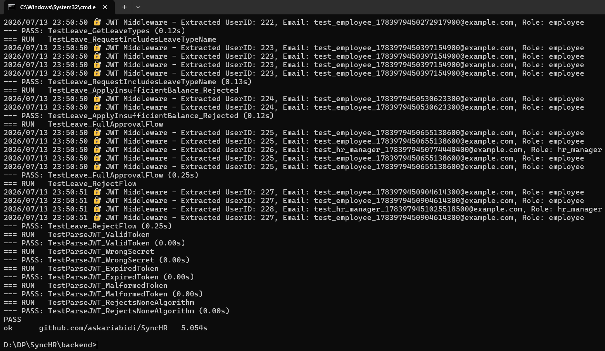

References
Axios - Promise Based HTTP Client. (n.d.). Retrieved from https://axios-http.com/
golang-jwt - JSON Web Tokens for Go. (n.d.). Retrieved from https://github.com/golang-jwt/jwt
Gorilla Web Toolkit - Mux Package. (n.d.). Retrieved from https://github.com/gorilla/mux
Gorilla WebSocket - Real-time Communication. (n.d.). Retrieved from https://github.com/gorilla/websocket
MDN Web Docs - Cross-Origin Resource Sharing (CORS). (n.d.). Retrieved from https://developer.mozilla.org/en-US/docs/Web/HTTP/CORS
PostgreSQL Official Documentation. (n.d.). Retrieved from https://www.postgresql.org/docs/
React - Official Documentation and Guide. (n.d.). Retrieved from https://react.dev/
RESTful API Design Best Practices and Guidelines. (n.d.). Retrieved from https://restfulapi.net/
The Go Programming Language - Official Documentation. (n.d.). Retrieved from https://go.dev/doc/

