Evalsy Cloud-Based Interview Platform Architecture

1. Overview
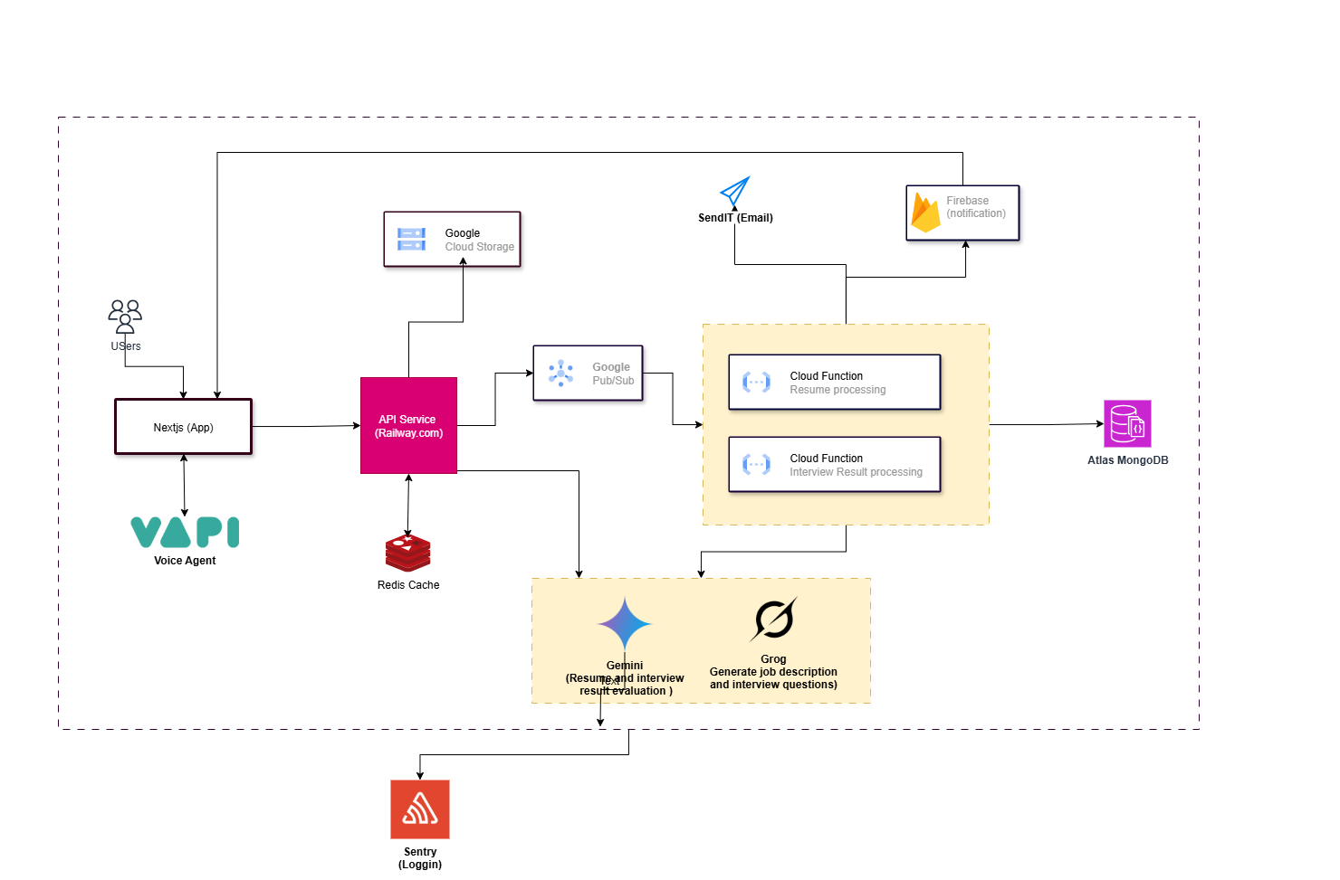
This document describes the system architecture of the Evalsy AI-powered interview platform. The architecture leverages a mix of frontend and backend technologies hosted on various cloud platforms. It is designed for scalability, fault-tolerance, and seamless AI integration.

2. Key Components
The major components of the architecture are as follows:
- • Next.js (App): Frontend client application used by candidates and recruiters.
- • VAPI (Voice Agent): Embedded voice agent for real-time interaction.
- • API Service (Railway.com): Backend services handling business logic and processing.
- • Redis Cache: Caching layer to reduce latency and improve performance.
- • Google Cloud Storage: Used to store candidate resumes and interview artifacts.
- • Google Pub/Sub: Messaging service to trigger background tasks asynchronously.
- • Google Cloud Functions: Serverless compute for background processing like resume parsing and interview result analysis.
- • Atlas MongoDB: Primary database to persist candidate and interview data.
- • Firebase: Real-time notifications engine.
- • SendIT (Email): External email service provider used for triggering email notifications.
- • Gemini & Grog: AI models responsible for evaluating candidate answers and generating results.
- • Sentry: Error logging and performance monitoring system.

3. Workflow Description
1. Users interact with the Next.js app, which connects to the VAPI Voice Agent for real-time interviews.
2. The frontend makes API requests to services hosted on Railway.com.
3. Files such as resumes are stored in Google Cloud Storage.
4. Background tasks are triggered via Google Pub/Sub to execute Google Cloud Functions:
- Resume processing
- Interview result evaluation (with help from Gemini/Grog)
5. Processed data is stored in Atlas MongoDB.
6. Notifications are pushed to users using Firebase and emails via SendIT.
7. Logs and errors are tracked using Sentry.

