INSERT INTO dbo.Customers (CustomerID, Name, Email, Phone, Address, JoinDate)

VALUES

(NEWID(), 'Grete', 'grete.lauren@gmail.com', '+3726262626', 'Grete sq 78', '2014-09-23'),

(NEWID(), 'Mari', 'mari.ann@gmail.com', '+3725959595', 'Mari road 34', '2020-03-29'),

(NEWID(), 'Markus', 'markus.jones@gmail.com', '+3725454545', 'Markus st 10', '2015-06-11'),

(NEWID(), 'Liina', 'liina.karl@gmail.com', '+3726060605', 'Liina dr 44', '2018-09-15'),

(NEWID(), 'Oliver', 'oliver.johnson@gmail.com', '+3726464646', 'Oliver rd 99', '2008-08-12'),

(NEWID(), 'Sven', 'sven.berg@gmail.com', '+3727474747', 'Sven ave 12', '2013-12-05'),

(NEWID(), 'Paul', 'paul.adams@gmail.com', '+3726363636', 'Paul ave 88', '2015-11-10'),

(NEWID(), 'Rauno', 'rauno.hansen@gmail.com', '+3726161616', 'Rauno park 56', '2022-01-21'),

(NEWID(), 'Kaisa', 'kaisa.miller@gmail.com', '+3726565656', 'Kaisa pl 10', '2023-01-24'),

(NEWID(), 'Helena', 'helena.smith@gmail.com', '+3726666666', 'Helena blvd 22', '2019-05-10');

'

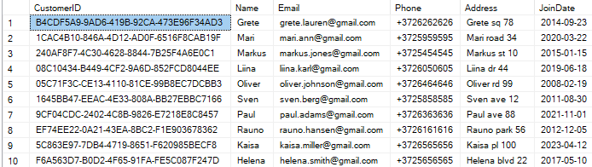

INSERT INTO dbo.Employees (EmployeeID, Name, Phone, Address, Email)

VALUES

(NEWID(), 'John Smith', '+3721111111', '123 Main St', 'john.smith@example.com'),

(NEWID(), 'Sarah Johnson', '+3722222222', '456 Elm St', 'sarah.johnson@example.com'),

(NEWID(), 'David Brown', '+3723333333', '789 Oak St', 'david.brown@example.com'),

(NEWID(), 'Emily Davis', '+3724444444', '321 Maple Ave', 'emily.davis@example.com'),

(NEWID(), 'Michael Miller', '+3725555555', '654 Pine Blvd', 'michael.miller@example.com'),

(NEWID(), 'Laura Wilson', '+3726666666', '987 Cedar Ct', 'laura.wilson@example.com'),

(NEWID(), 'Robert Moore', '+3727777777', '123 Birch Dr', 'robert.moore@example.com'),

(NEWID(), 'Anna Taylor', '+3728888888', '456 Willow Ln', 'anna.taylor@example.com'),

(NEWID(), 'James Anderson', '+3729999999', '789 Aspen Rd', 'james.anderson@example.com'),

(NEWID(), 'Linda Thomas', '+3721010101', '321 Poplar Pl', 'linda.thomas@example.com');

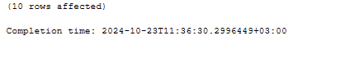

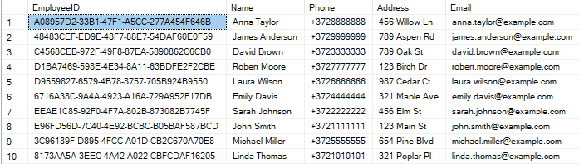

INSERT INTO dbo.Products (ProductID, Name, Description, Price)

VALUES

(NEWID(), 'Handmade Ceramic Mug', 'A beautifully crafted ceramic mug with unique designs.', 15.99),

(NEWID(), 'Natural Soy Candles', 'Eco-friendly soy candles with essential oils, available in various scents.', 24.99),

(NEWID(), 'Woven Basket', 'Handwoven basket perfect for storage or as a decorative piece.', 22.50),

(NEWID(), 'Wooden Cutting Board', 'Durable wooden cutting board, ideal for cooking and serving.', 35.00),

(NEWID(), 'Knitted Blanket', 'Soft, warm blanket handmade with high-quality yarn.', 49.99),

(NEWID(), 'Handcrafted Jewelry', 'Unique jewelry pieces made from natural materials and gemstones.', 39.99),

(NEWID(), 'Artisan Soap Set', 'Set of handcrafted soaps made with organic ingredients.', 19.99),

(NEWID(), 'Decorative Wall Hanging', 'Beautiful wall hanging made from natural fibers, adds warmth to any room.', 29.99),

(NEWID(), 'Leather Wallet', 'Handmade leather wallet with multiple card slots and a classic design.', 34.99),

(NEWID(), 'Painted Terracotta Planters', 'Colorful terracotta planters, perfect for indoor and outdoor plants.', 18.99);



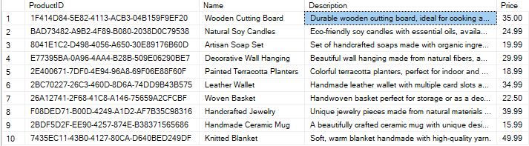

INSERT INTO dbo.Orders (OrderID, OrderDate, TotalAmount)

VALUES

(NEWID(), '2024-01-10', 150.00),

(NEWID(), '2024-01-15', 230.00),

(NEWID(), '2024-01-20', 320.00),

(NEWID(), '2024-02-01', 410.00),

(NEWID(), '2024-02-05', 180.00),

(NEWID(), '2024-02-12', 275.00),

(NEWID(), '2024-02-20', 360.00),

(NEWID(), '2024-03-01', 290.00),

(NEWID(), '2024-03-10', 450.00),

(NEWID(), '2024-03-15', 130.00);

select \* from dbo.Orders  
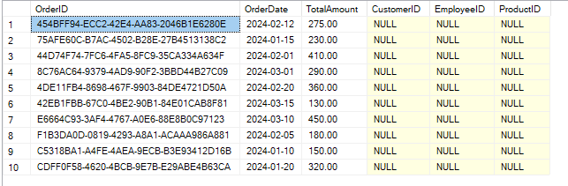

SELECT ProductID, Name AS ProductName, 'CategoryName' AS CategoryName

FROM dbo.Products;

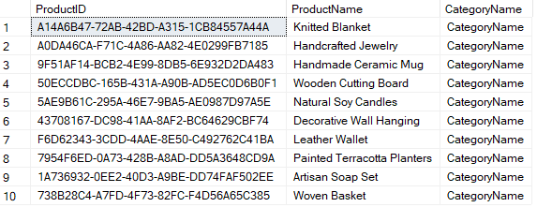

SELECT Customers.Name AS CustomerName, Orders.OrderID

FROM dbo.Customers

LEFT JOIN dbo.Orders ON Customers.CustomerID = Orders.OrderID

ORDER BY Customers.Name;

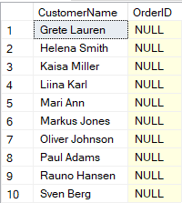

SELECT Orders.OrderID, Employees.Name AS EmployeeName

FROM dbo.Orders

RIGHT JOIN dbo.Employees ON Orders.OrderID = Employees.EmployeeID

ORDER BY Orders.OrderID;

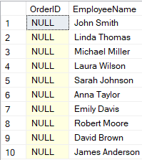

SELECT Customers.Name AS CustomerName, Employees.Name AS EmployeeName

FROM dbo.Customers

CROSS JOIN dbo.Employees

ORDER BY Customers.Name;

