DEPARTMENT OF PHYSICS
Centre of Advanced Study in Physics
PANJAB UNIVERSITY, CHANDIGARH-160 014 (INDIA)

Fax : +91 172 2541741, 2534492  Phone : +91 172 2534489  Email: physics@pu.ac.in | 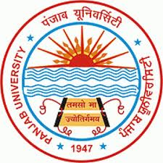 | Dated :  PHS: ................

Certificate from the Head of Department

This is to certify that Ankita Mehta D/o Sushil Kumar Mehta, is a bonafide Ph.D student of Department of Physics, Panjab University, Chandigarh. She is working under the supervision Prof. J.B. Singh and Prof. Vipin Bhatnagar, Department of Physics, Panjab University, Chandigarh, and Prof. Nick Van Remortel, Department of Physics, University of Antwerpen, Belgium, in the field of experimental high energy physics. She has been exempted from the Foreign Language for the submission of her Ph.D thesis.

Place: Chandigarh Signature of Head of Department

Date: (Prof. Navdeep Goyal, Chairman, Department of Physics)

