DEPARTMENT OF PHYSICS
Centre of Advanced Study in Physics
PANJAB UNIVERSITY, CHANDIGARH-160 014 (INDIA)

Fax : +91 172 2541741, 2534492  Phone : +91 172 2534489  Email: physics@pu.ac.in | 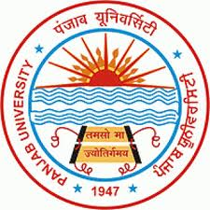 | Dated :  PHS: ................

Certificate from the Head of Department

This is to certify that research work entitled “STUDY OF DI-BOSON PROCESSES IN CMS EXPERIMENT AT LARGE HADRON COLLIDER” is carried out by Ankita Mehta, Ph.D student in the Department of Physics, Panjab University, Chandigarh, under the supervision of Prof. J.B. Singh and Prof. Vipin Bhatnagar, Department of Physics, Panjab University, Chandigarh, and Prof. Nick Van Remortel, Department of Physics, University of Antwerpen, Belgium. It is a piece of original work and no part of this work has been submitted for any other degree at this or any other University/institute. It is further certified that the thesis has also been thoroughly checked on anti-plagiarism software and nothing has been found which can be considered as plagiarism.

(Ankita Mehta)  Signature & Name  of the candidate | (Prof. J.B. Singh)  Signature & Name  of the supervisor | (Prof. Vipin Bhatnagar)  Signature & Name  of the supervisor | (Prof. Nick Van Remortel)  Signature & Name  of the supervisor

Place: Chandigarh Signature of Head of Department

Date: (Prof. Navdeep Goyal, Chairman, Department of Physics)

