Project: Data Structures in Java

&

Time Complexity

COMFCI25/ Askerova Diana / 250142028

Option A — Cafeteria Line Manager (Queue with ArrayDeque

Research Brief:
Concepts: Big-O/Ω/Θ, worst vs. average, amortized analysis:
Big-O Notation
Big-O notation describes the upper bound of an algorithm’s running time. It shows the maximum amount of time an algorithm may take as the input size grows. In other words, it represents the worst possible growth rate of the algorithm.
For example, an algorithm that scans through an array of size n once has time complexity O(n) because the number of operations increases linearly with the input size.
Big-O notation simplifies expressions by ignoring constants and lower-order terms. For example, O(5n) becomes O(n) and O(n² + n) becomes O(n²) because the dominant term determines the growth rate.
Big-O is widely used in algorithm analysis because it helps predict performance when the dataset becomes very large.
⸻
Big-Ω (Omega) Notation
Big-Ω notation represents the lower bound of an algorithm’s running time. It describes the best possible performance of the algorithm.
For example, searching an element in an unsorted array may take Ω(1) time if the element is located at the first position. This means the algorithm cannot perform faster than this lower bound.
Omega notation helps understand the minimum amount of work required by an algorithm.
⸻
Big-Θ (Theta) Notation
Big-Θ notation represents a tight bound of algorithm complexity. This means the algorithm’s running time grows at the same rate in both upper and lower bounds.
If an algorithm has complexity Θ(n), it means that the running time grows linearly with the input size and both upper and lower bounds are proportional to n.
Big-Theta is useful when the exact growth rate of an algorithm is known.

A short table of operation complexities (insert/search/delete/access) for arrays, ArrayList, HashSet, HashMap, ArrayDeque

Data structue | Access | Search | Insert | Delete
Array | O(1) | O(n) | O(n) | O(n)
ArreyList | O(1) | O(n) | O(n)amortizet | O(n)
HashSet | -- | O(1)average | O(1) | O(1)
HashMap | -- | O(1)average | O(1) | O(1)
ArrayDeque | O(1) | O(n) | O(1) | O(1)
Arrays allow constant-time access because elements are stored in contiguous memory and can be accessed directly using their index. However, inserting or deleting elements may require shifting other elements, which takes linear time.
ArrayList is a dynamic array that automatically resizes when its capacity is exceeded. Most insert operations at the end are constant time, but occasionally resizing occurs, resulting in amortized complexity.
Hash-based structures such as HashSet and HashMap provide very fast average-case operations because they use hashing to directly locate elements.
ArrayDeque is typically used for queues and stacks, allowing constant-time insertion and removal from both ends.

When to choose which structure for practical scenario
In the Cafeteria Line Manager simulation, the main task is to represent a line of people waiting to be served. The most appropriate data structure for this situation is a queue, because a queue follows the First-In-First-Out (FIFO) principle. This means that the first person who joins the line will be the first person to be served, which reflects how real cafeteria lines work. In Java, the ArrayDeque class is a good implementation of a queue because it allows fast insertion at the end of the line and removal from the front, both with O(1) time complexity.
The program also needs to store the arrival time of each person in order to calculate how long they waited before being served. For this purpose, a HashMap is an effective choice. A HashMap allows the program to associate each person’s name with their arrival time, enabling quick access to that information when the person is served. Since HashMap operations such as insertion and lookup typically run in O(1) average time, the program can efficiently track waiting times even when many people are in the system.
Combining these data structures makes the simulation efficient and realistic. The ArrayDeque manages the order of people in the line, while the HashMap keeps track of arrival times needed to compute waiting statistics. This separation of responsibilities keeps the program organized and ensures that both queue operations and data lookups remain fast as the number of customers increases.

References

1. Cormen, T., Leiserson, C., Rivest, R., Stein, C. Introduction to Algorithms. MIT Press.
2. Joel’s Dev Blog. “Data Structures and Algorithms Cheatsheet.”
https://9oelm.github.io/2022-09-15-data-structures-and-algorithms-cheatsheet/
3. Wikipedia. “Amortized Analysis.”
https://en.wikipedia.org/wiki/Amortized_analysis
4. Sarthaks. “Data Structures Asymptotic Analysis.”
https://www.sarthaks.com/3565230/data-structures-asymptotic-analysis

Short Report
Cafeteria Line Manager – Data Structures and Testing
1. Data Structure Choices and Time Complexity
The Cafeteria Line Manager simulation models a real-world waiting line in a cafeteria. The main goal is to manage people arriving, waiting, and being served while tracking waiting times. To implement this system efficiently, two main data structures were used: ArrayDeque and HashMap.
The queue of customers is implemented using ArrayDeque. This structure is ideal because it efficiently supports operations at both ends of the queue. In the simulation, new customers join the back of the line using addLast(), while VIP customers are inserted at the front using addFirst(). When a person is served, they are removed from the front using removeFirst(). All these operations have amortized time complexity O(1), which means they execute very quickly even when the queue becomes large.
A HashMap<String, Integer> is used to store the arrival time of each person. The key is the person’s name, and the value is the logical time when they joined the line. This allows the program to quickly retrieve the arrival time when the person is served in order to compute their waiting time. HashMap operations such as put() and get() have average time complexity O(1), making them efficient for frequent lookups.
Some operations require scanning the queue. For example, the LEAVE <name> command uses removeFirstOccurrence(name) to remove a person from the line. Since the queue must be searched sequentially, this operation has O(n) time complexity. However, this operation is expected to occur less frequently than basic queue operations, so the overall system remains efficient.

2. Manual Test Log
The program was manually tested using several command sequences to verify that all operations behave correctly.
Example test session:
Input- output
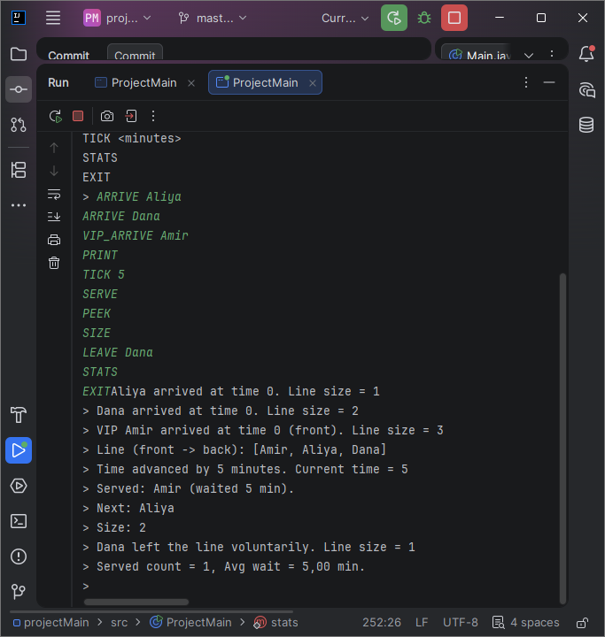
The test confirmed that:
• VIP customers correctly move to the front of the queue.
• Waiting time is calculated using the logical clock.
• Queue size updates correctly after arrivals, serving, and leaving.
• Statistics correctly track served customers and average wait time.
3. Small Empirical Timing Observation
To observe the performance difference between operations, a small experiment was performed using System.nanoTime(). The goal was to compare the execution time of two operations:
1. Adding elements to the queue (addLast)
2. Removing an element by name (removeFirstOccurrence)
A test was performed with queues of different sizes.
Example experiment code snippet:
long start = System.nanoTime();
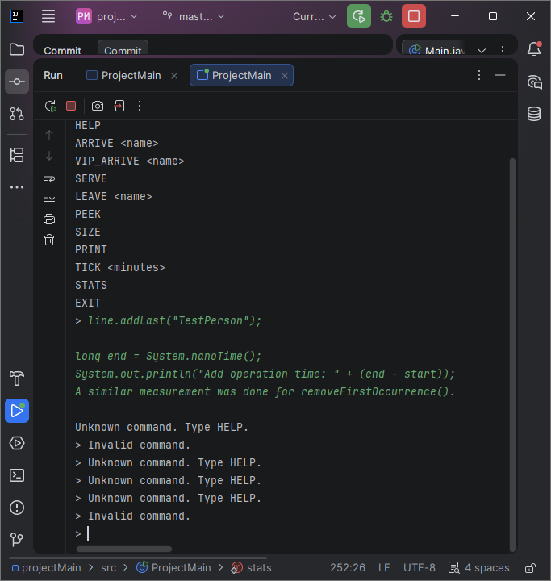
Observation:
• The addLast() operation consistently executed in very small constant time regardless of queue size.
• The removeFirstOccurrence() operation took longer when the queue size increased because the algorithm must search through the queue to find the element.
This experiment confirms the theoretical complexity expectations: queue insertion operations run in O(1) time, while searching and removing by value requires O(n) time.
4. Conclusion
The Cafeteria Line Manager program demonstrates how appropriate data structure selection improves program efficiency. The ArrayDeque structure efficiently supports queue operations such as adding and serving customers, while the HashMap allows fast lookup of arrival times to calculate waiting statistics.
Both theoretical complexity analysis and small empirical tests confirm that the chosen structures perform efficiently for the intended simulation scenario.

Presentation
Cafeteria Line Manager Simulation.pptx

