**Plan – my workflow**

**Get timestamps in milliseconds for the Pupil lab data**

**Merge raw data**

* A strategy will be to loop over each row in the manually annotated Boris data and for each timestamp find the nearest timestamp in the pupil lab data.
* A way to do this is by subtracting the annotated timestamp from all timestamp in the Pupil data and find the row with the lowest divergence; subtract all information from the other columns in this row.
* Loop over every single one.

**Visualizations and potential modelling**

**Questions for meeting 22/04**

* What columns are necessary?
* The time durations for each block are often longer than the time manually annotated with fixations. How come? Did the eyetracker keep recording?
* Is it correctly understood that I should just extract one row of from the pupil data per fixation annotated in the boris data? That is what I’ve currently done.

**Questions for Mihaela.**

* The function to convert from pupil to UNIX is giving me a hard time. I’ve based it exactly on the one from the documentation

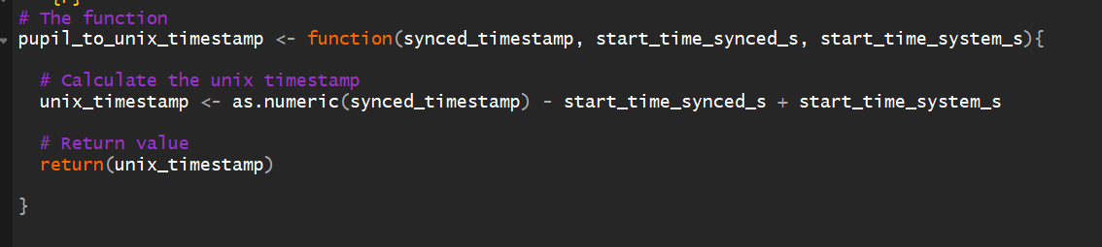

* It says one should add start_time_system_s which is a weird insanely high number from the json file. Then the output is as well a weird insanely high number. If we just don’t, it makes way more sense – and we will get something that seems like timestamps from approx. 0-185.21 (in this case)

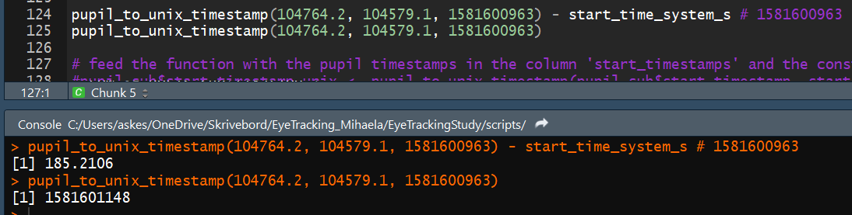

There are some rows in boris with identical timestamp but different information meaning that they will merge with the same row from pupil data

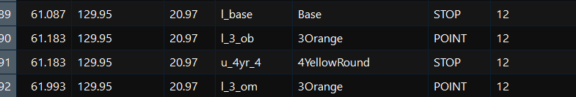

* I don’t understand how one can be looking at 3Orange and 4YellowRound at the same time? Is that on purpose?

There are also a few cases where the timestamp difference between to rows in boris is so small, that they will be assigned the same fixation from the pupil data. I don’t really know what to do about that.