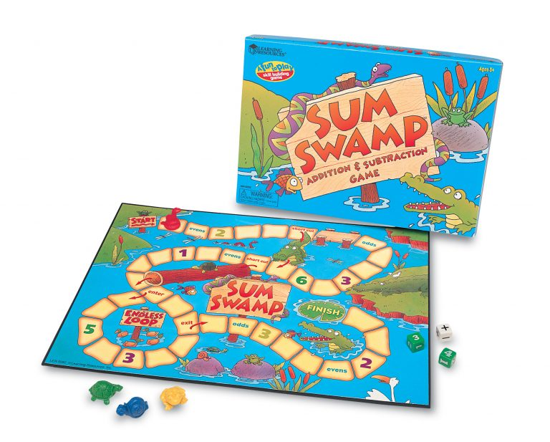

**Project 12**

Write a program that will simulate children’s board game named **Sum Swamp**®.

The object of the game is to the first critter to finish pad.

You will need separate classes for each object (Little Critter Game Pieces, Number Dice, Operation Die), as well as a separate game program (main method). To be clear, you will submit a total of four classes.

Contents of the Sum Swamp Game:

• Game Board

• 4 Little Critter Game Pieces

• 2 Number Dice

• 1 Operation Die

Directions for game play: Choose a game piece and place it on Start. The first player rolls all 3 dice and creates a number sentence by placing the highest number die first, the operation die second, and the smallest number die last. Then, add or subtract the numbers, and move ahead the sum or difference. For example, if you roll 3 + 2, move ahead 5 spaces. If you roll a combination that equals 0 (5 – 5 = 0), do not move. It is now the next player’s turn. The first player to reach the Finish pad is the winner! (Note: players do **not** need to roll the exact number to reach the Finish pad.)

Special spaces on the board:

“Evens” or “Odds”: If you land on one of these spaces, roll one number die. If you roll an “even” or “odd” number as indicated on the game board, move ahead that number of spaces. If you do not roll an even or odd number, as indicated on the game board, wait until your next turn and try again!

“Short Cut”: If you land on one of these spaces, follow the arrow as indicated on the board.

Number Space: If you land on a number space, roll the operation die. If you roll a +, move ahead the number indicated on the space. If you roll a –, move back that number.

Please have appropriate game information.

20 Bonus Points:

“Endless Loop”: All players enter the loop as the arrow on the board indicates. Players continue moving clockwise around the loop. If you land on the space marked “exit,” you can exit the loop on your next turn.

Don’t forget to include your name, the project number, the due date, the current date, and a short description of the program comments at the top of your program file. Also be sure to use good variable names. Please send your .class and .java files to the dropbox. Also turn in a printed copy of your program.