**COMSATS INSTITUTE OF INFORMATION TECHNOLOGY**

**ABBOTTABAD CAMPUS**

**Department of Computer Science**

**Food Ordering System in C**

**Project Report**

Submitted By:

Zafar Ullah Khan (FA20-BCS-113)

Farooq Khan (FA20-BCS-115)

Muhammad Awais Khan (FA20-BCS-120)

Submitted To: Dr. Nosheen Gul

**Table of Contents**

**Abstract** 3

**Introduction** 3

**Project details** 3

**Main features of project** 4

**Topics covered in project** 4

**Screen shots of project** 5

**Main code and Output explanation** 8

**Flow Diagram** 20

**Recommendation** 21

**Conclusion** 21

# **Abstract**

This project report covers the overall understanding and explanation of **Food Ordering System**. In this project, we chose to create a **Food Ordering System**. The purpose of the project was to provide users with the menu of the Cafe and sell food. By adapting this functionality, we have also provided users with a unique method to ask user for order. Using **C programming language**, we developed and implement most of the functionality required.

# **Introduction**

The idea of **Food Ordering System** is based on **ordering and serving food in a cafe**. This report aims to provide a detailed look at the **Data Structures, functions, and control structures** in the **C programming** along with **variables** and **(Go to) functions** etc. In this product, a user can order available food items, serve it, and check total records. Using this Food Ordering System, the user can easily order available foods.

In our **Food Manu** Each of the items have their own size. After ordering an item, the system displays the **total amount of bill** (in rupees) to the user. The user can also check total records of the cafe which displays the total number of orders taken and served.

**Food Ordering System** is developed using C Programming Language.

# **Project details**

In this project, we have made a **data Structure** and performed many tasks by using that structure. We also used different **variables, arrays, loops, conditions, and strings** for the development of it. **Firstly,** we have taken input from user to select a menu. Then we ask the user to input his/her name, numbers of these items. Then we have asked the user input code of the food. (Each item has unique code)

After this we thanked the user for ordering and displayed bill to him/her. We used **switch case** for the first menu and food items. We also used **goto statement** at many places that will be explained later in this report. For each menu we have made a function and called that function is called in the main function.

# **Main features of project**

**The main features of project are:**

* Order food
* Serve Food
* Total Orders
* About Cafe
* Exit and about us

# **Topics covered in project**

**In this project I have covered:**

* Variables
* Loops
* Structures
* Strings
* Basic input/outputs
* Switch statements
* If else statements
* Go to statement

# **Screen shots of project**

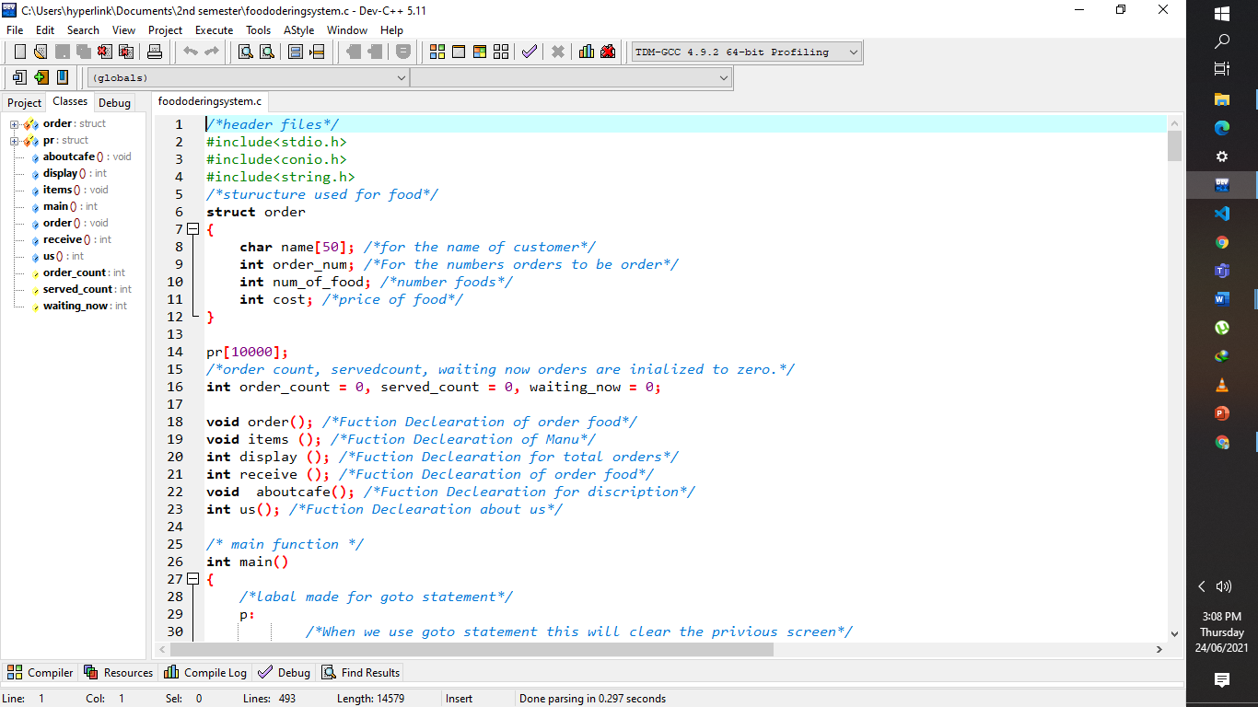**1:**

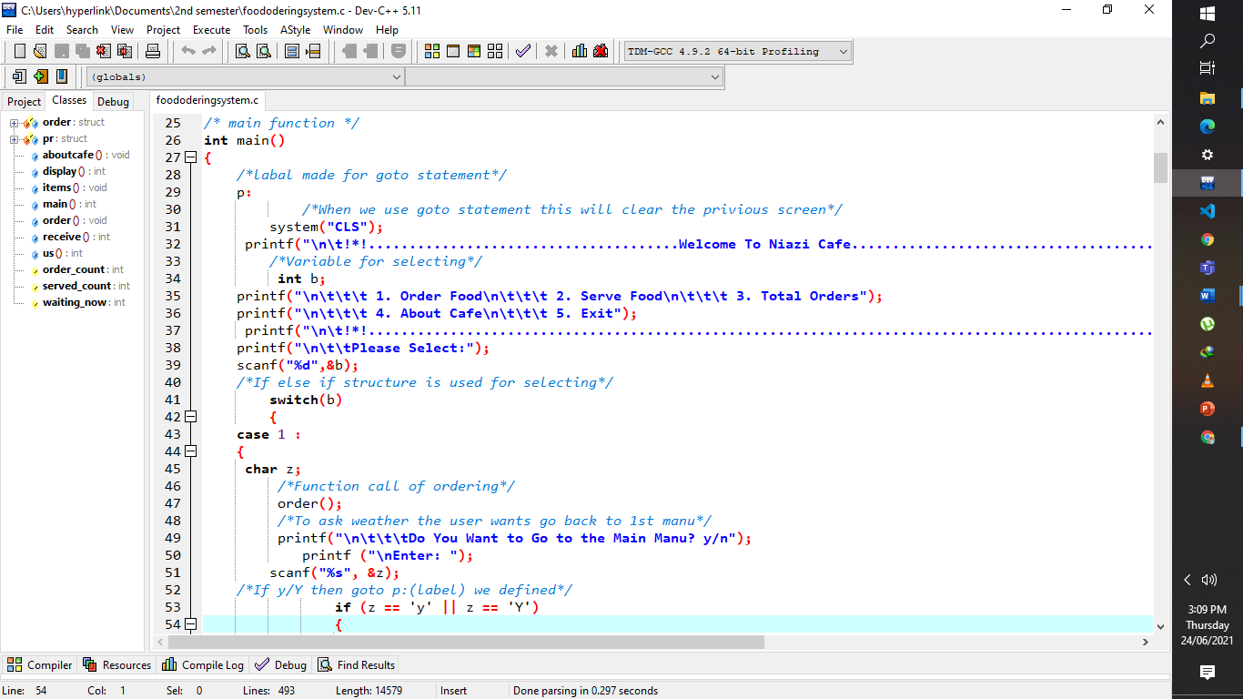**2:**

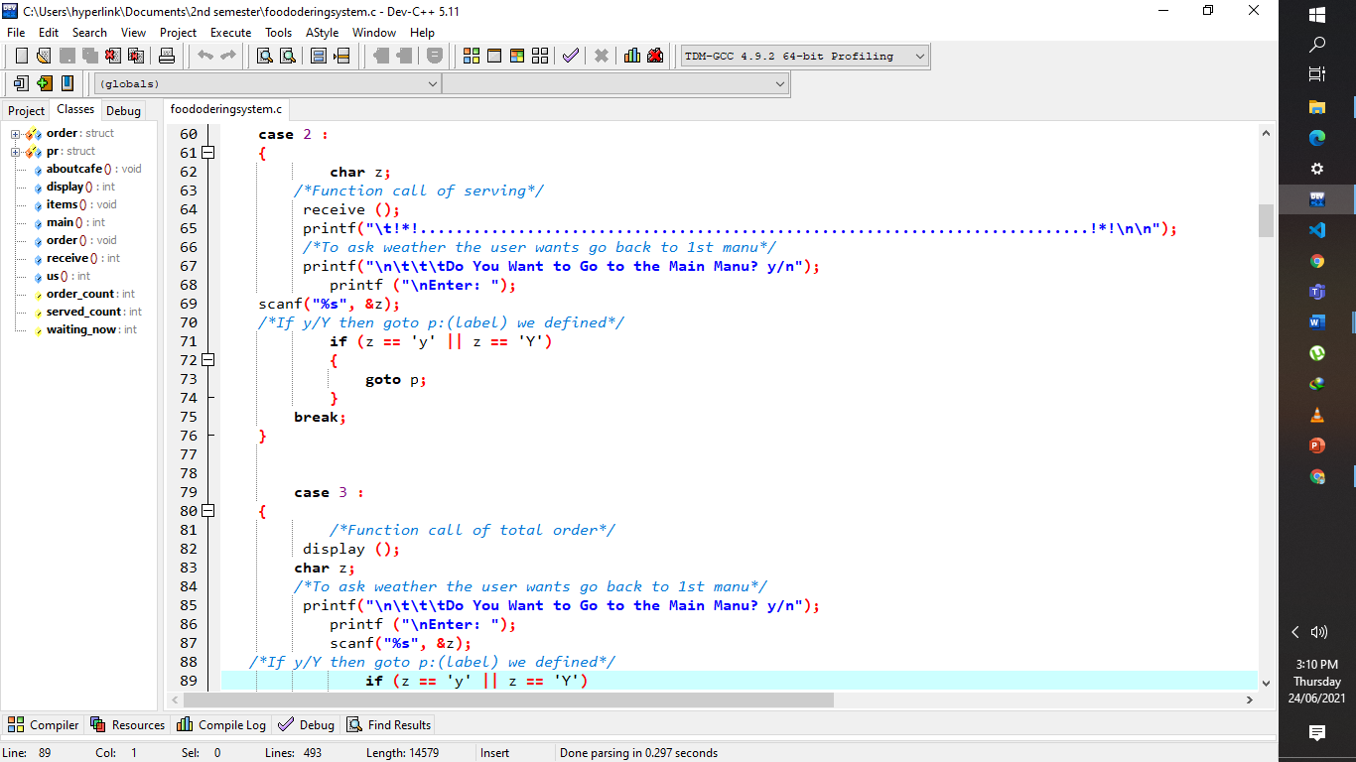**3:**

**4:**

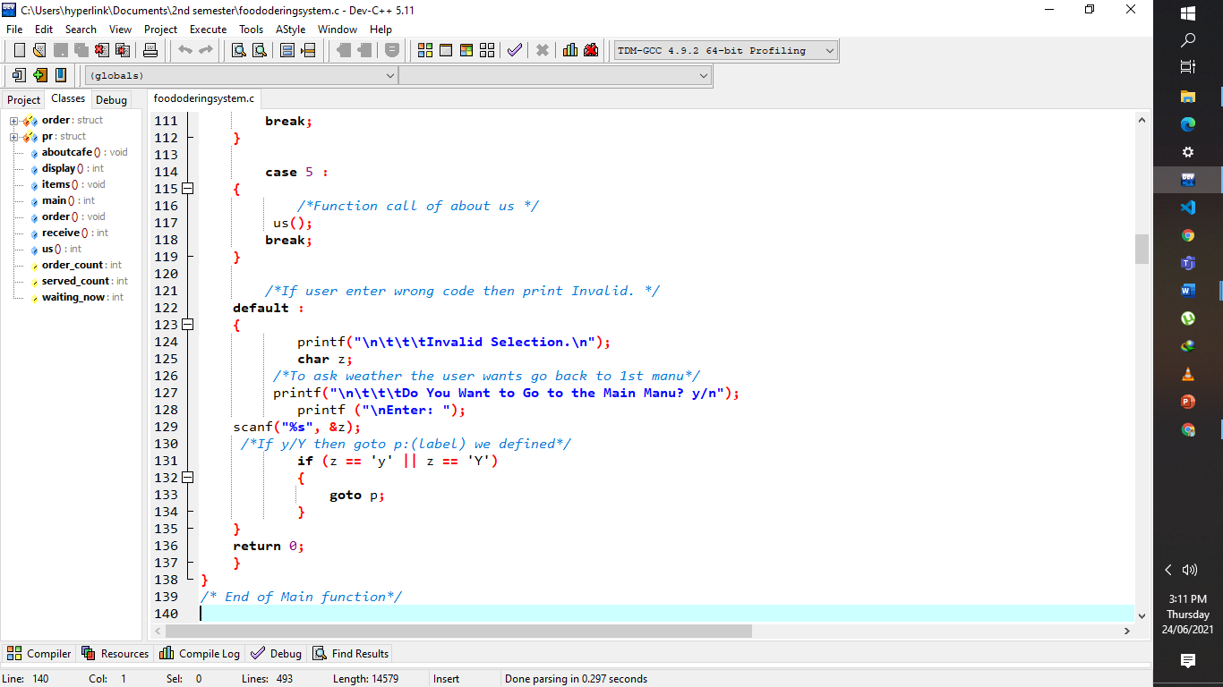

**5:**

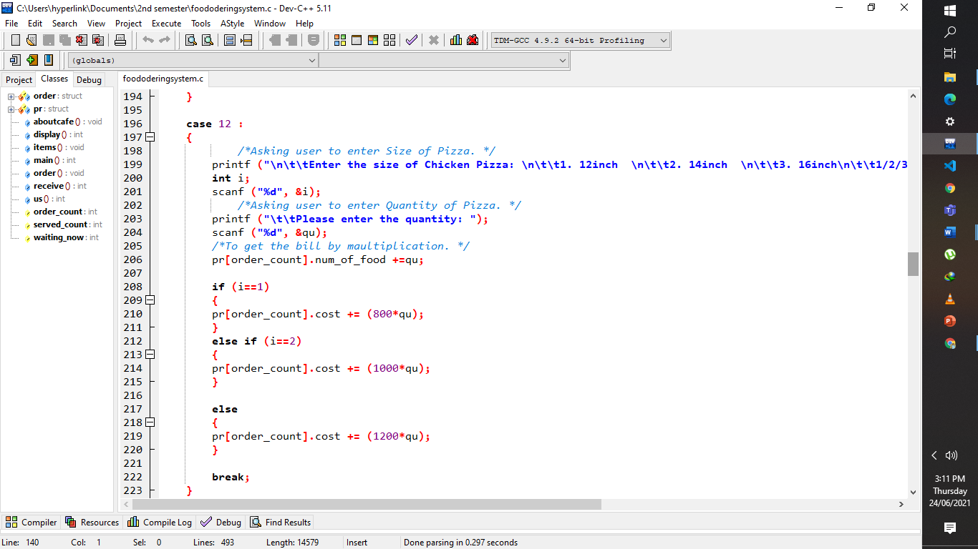

**6:**

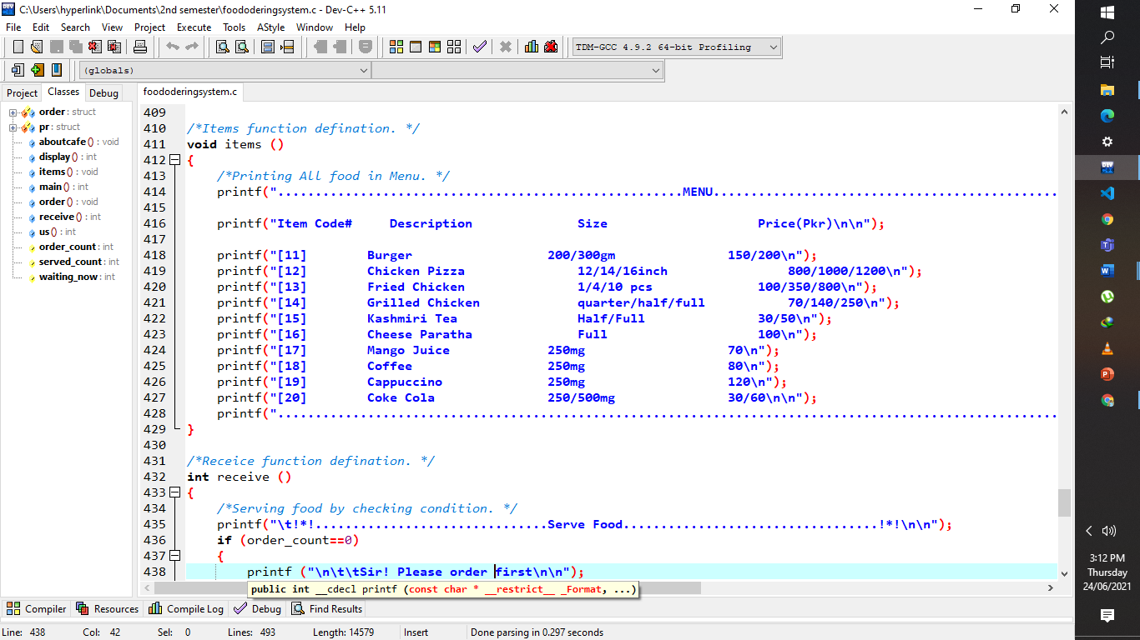

# **Main code and Output explanation**

In this Section we are explaining over all working of our project.

This is how our first output screen uprears after running our program.

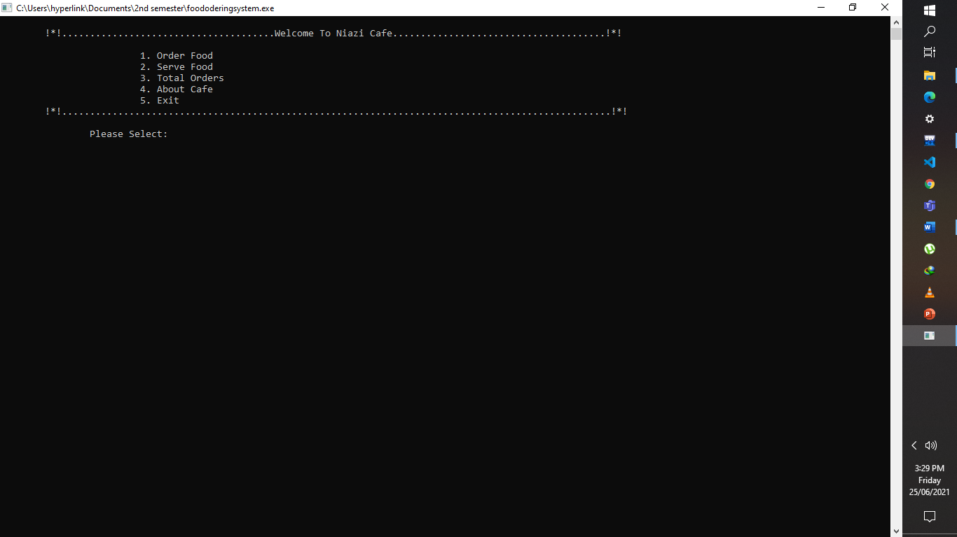

**Explanation:**

For all the 5 menu’s we have used switch case. For this we declared **variable b of integer type** and used **switch case** for different menus. We Ask user to select a menu by entering integer value b/w 1-5 if user enter integer except **1-5 then** we print you have **entered Invalid.**

We will be explaining each menu of above image.

When we **select (1)** then This output Screen is Shown on the screen.

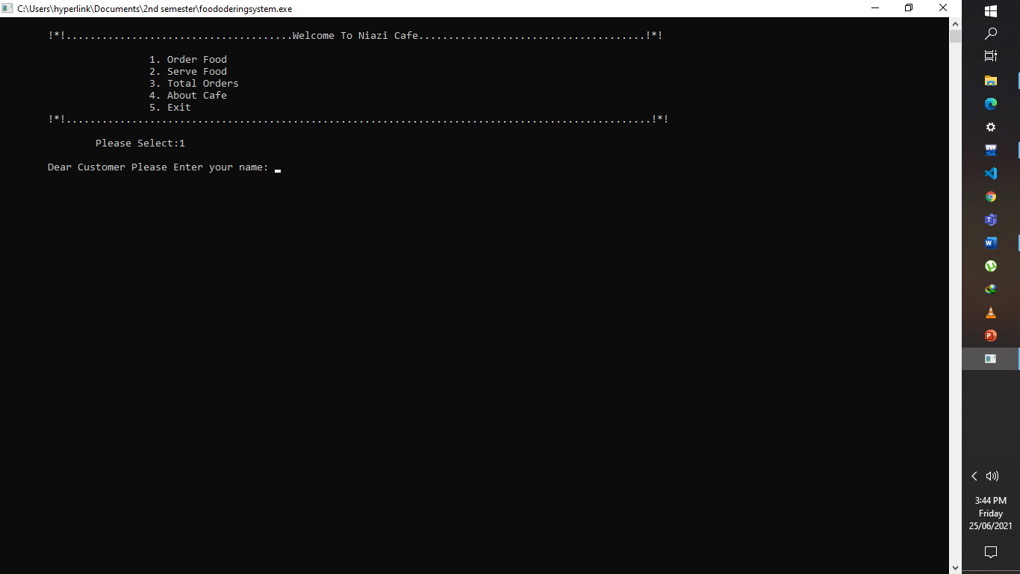

We ask user to Enter his name. We used structure variable (**pr[order_count].name)** for input customer name.

When we entered **customer name** this output screen is shown.

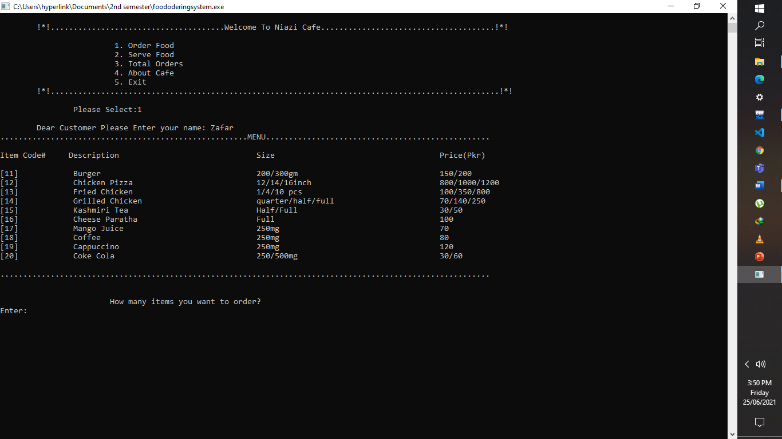

This is the menu of the **Cafe** that contains food. This menu is made by simple **printf ()** statements. And for this we used a function named **items ().**

Next, we ask user to enter numbers of items he/she wants. For this we used **variable n of integer data type**.

When we entered number of items then:

It asks us to Enter code of food item.

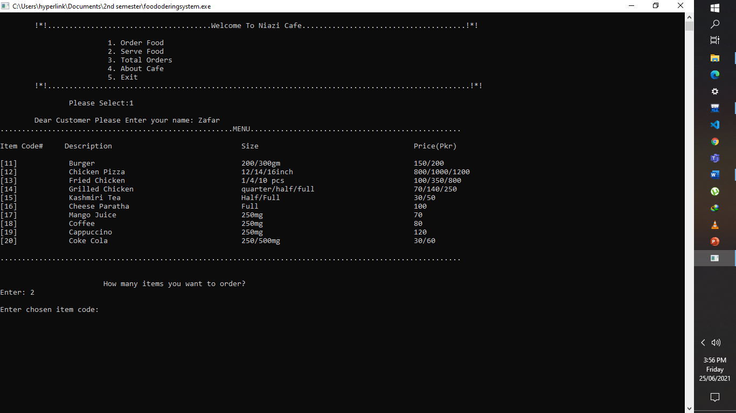

Each item is represented by specific code. By using this code, we can select item.

For this we used switch case. We used **in integer** for this. If user enter **b/w 11-20 it** selects a specific food and ask for size and quantity of item. Otherwise **invalid Input**.

Next, we entered correct item number so, program ask us to enter Size of That item.

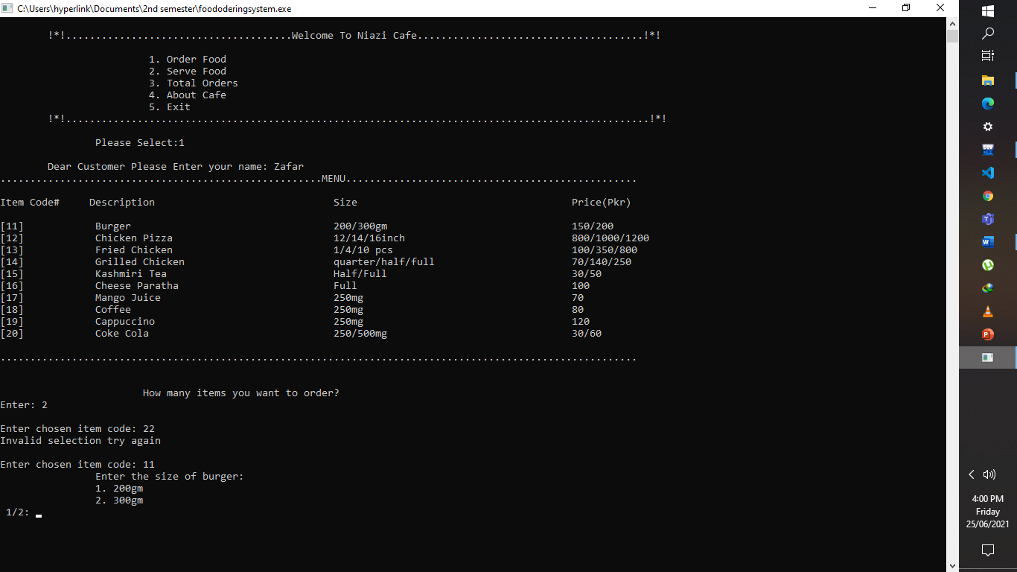

For this size of item **integer i** and **if else** are used for selection of size.

After Selection of size:

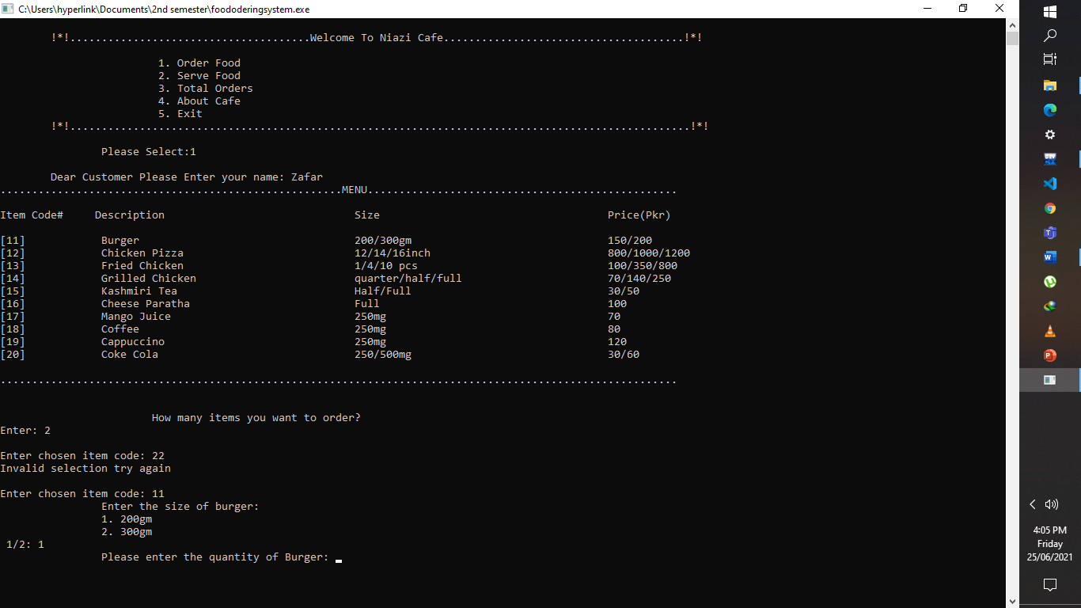

It asks us to enter quantity of that item.

For this we used **qu integer.**

After entering quantity of item, this:

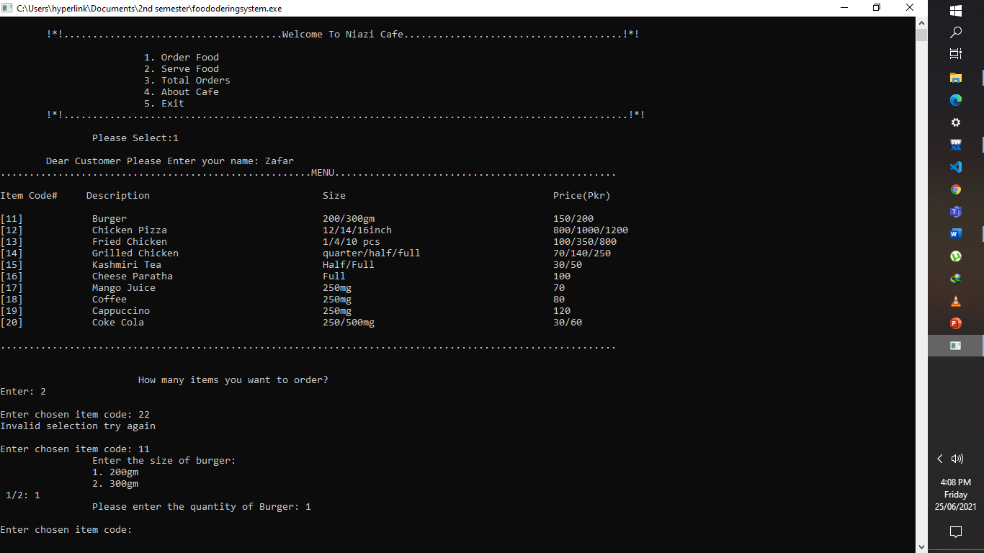

Returns to Code number if we given number of items **more than 1**. Else if it shows **Do u want anything more.**

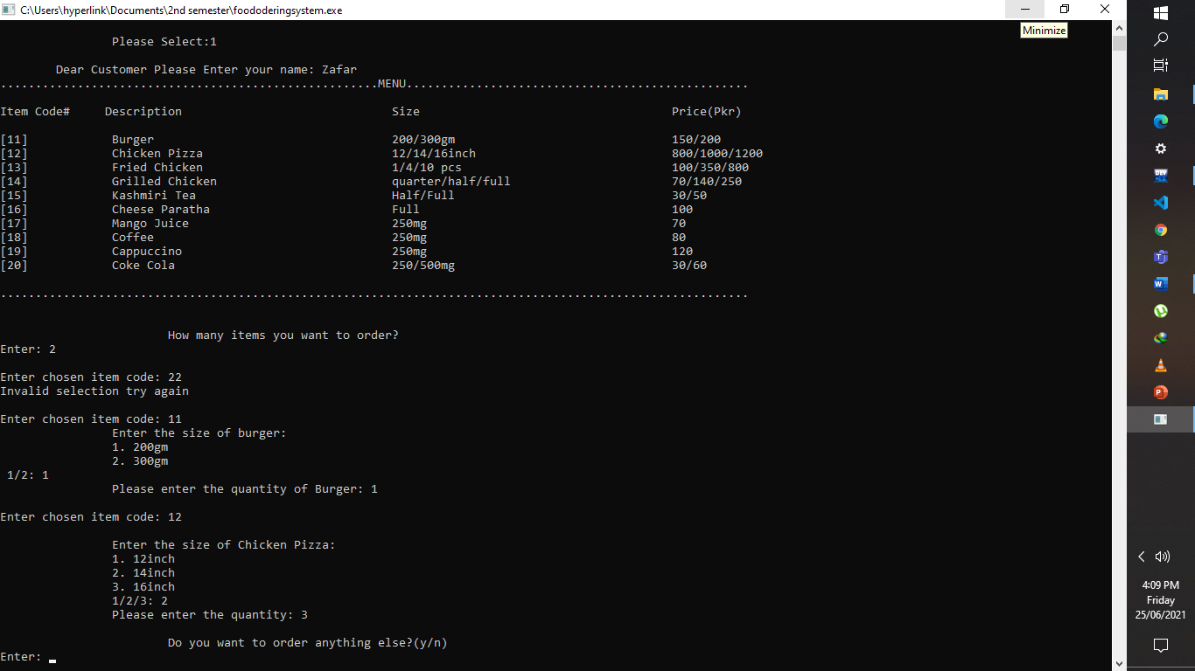

For this we used **char tem** and used if else and with in if statement **go to statement** is used.

If we press y that it goes to **number of items u want to order**. And if you enter n that it says

**thank you and shows bill.**

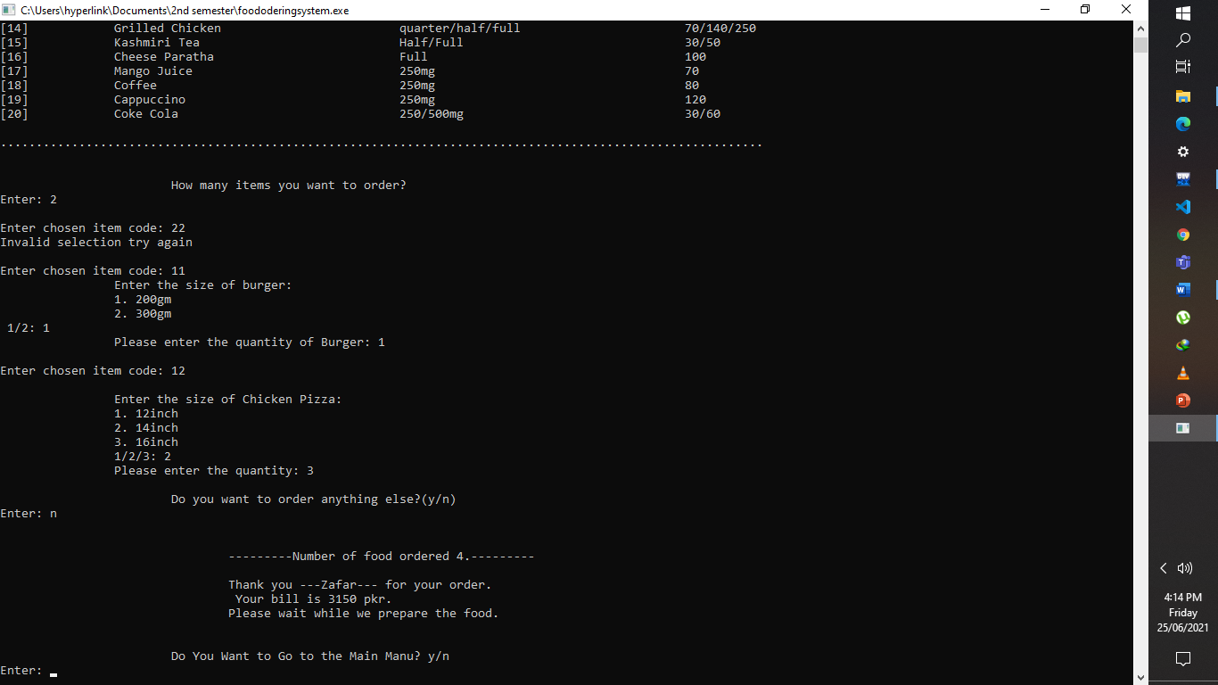

After showing Bill. It asks to enter character if y it returns to first menu and if n then program Terminates. For this we used goto.

By entering y:

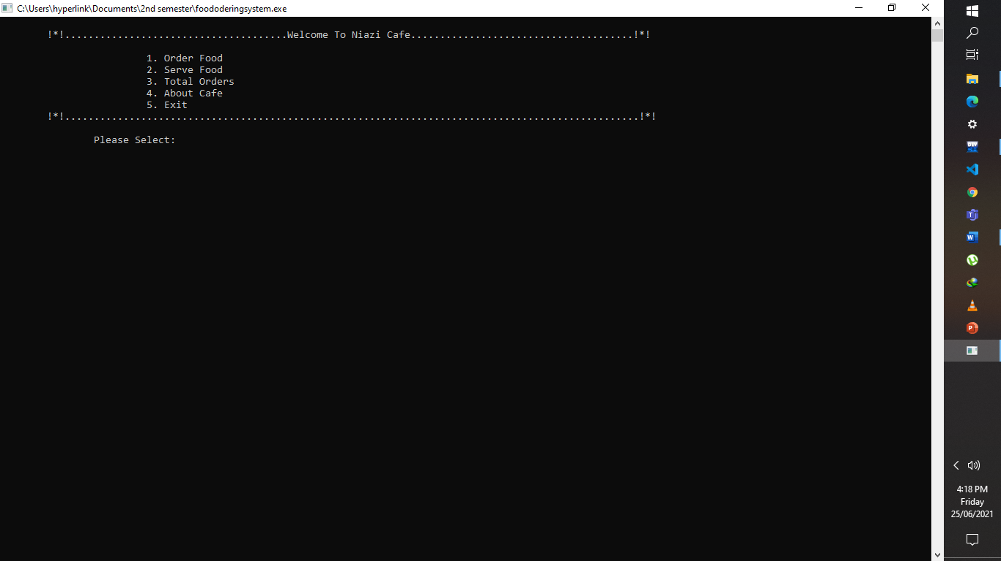

By entering n:

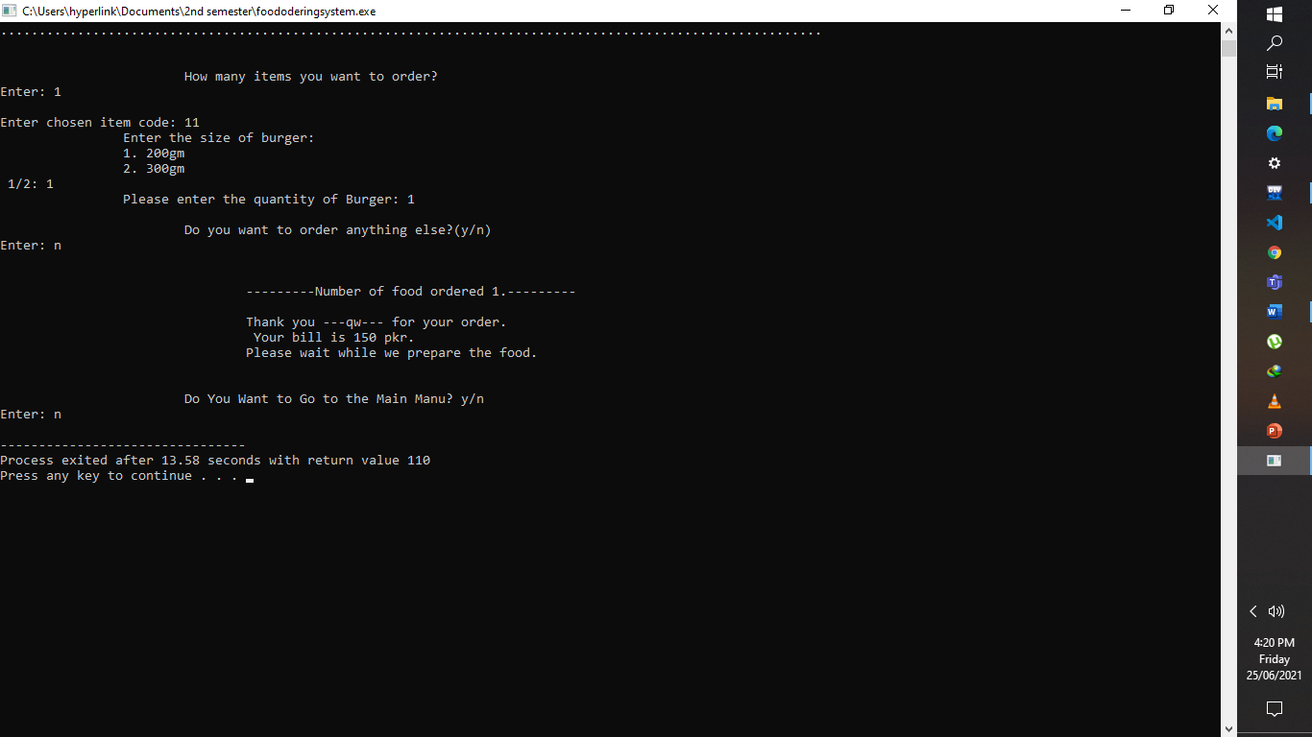

When we **select (2)** then This output Screen is Shown on the screen.

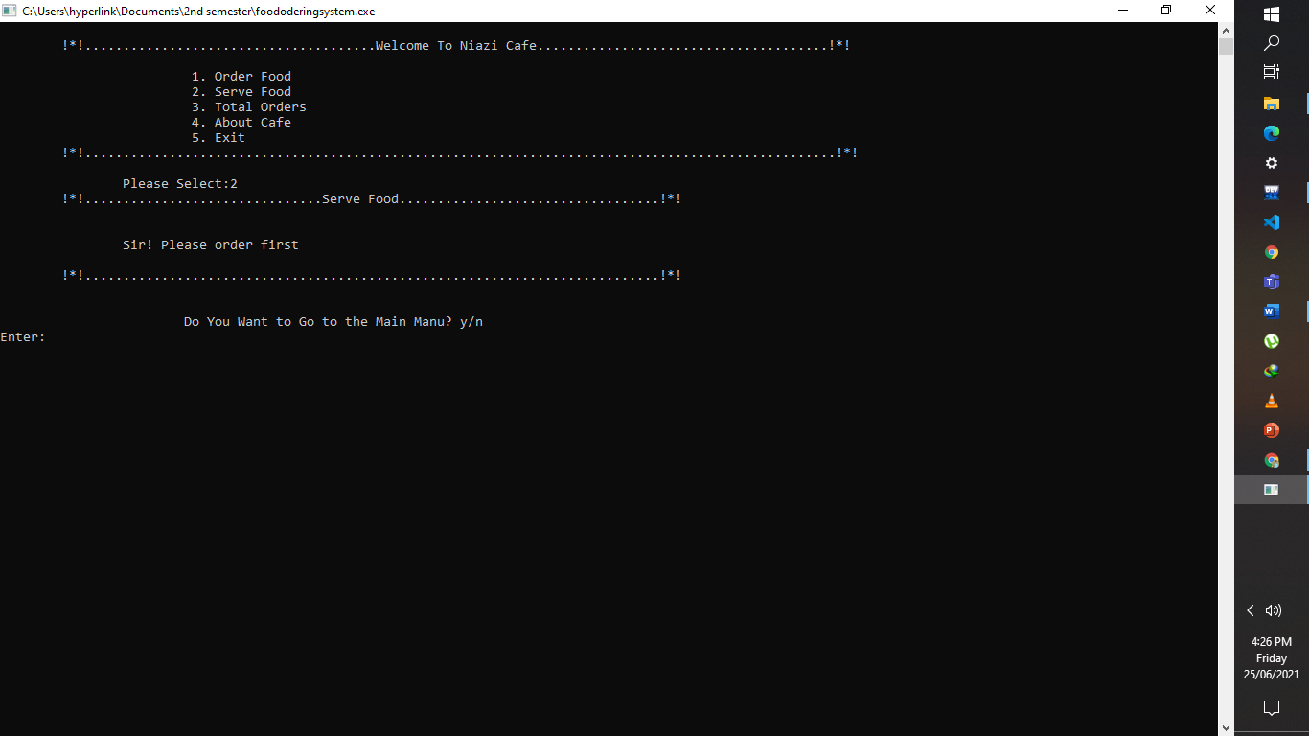

If we enter 2 with ordering it asks us to order first. As initially orders are zero. For this we used if else structure.

And it asks user, do you want to go to main menu by y if goes to main menu and by n program ends. For this we used goto.

If user enter 2 after ordering. Then:

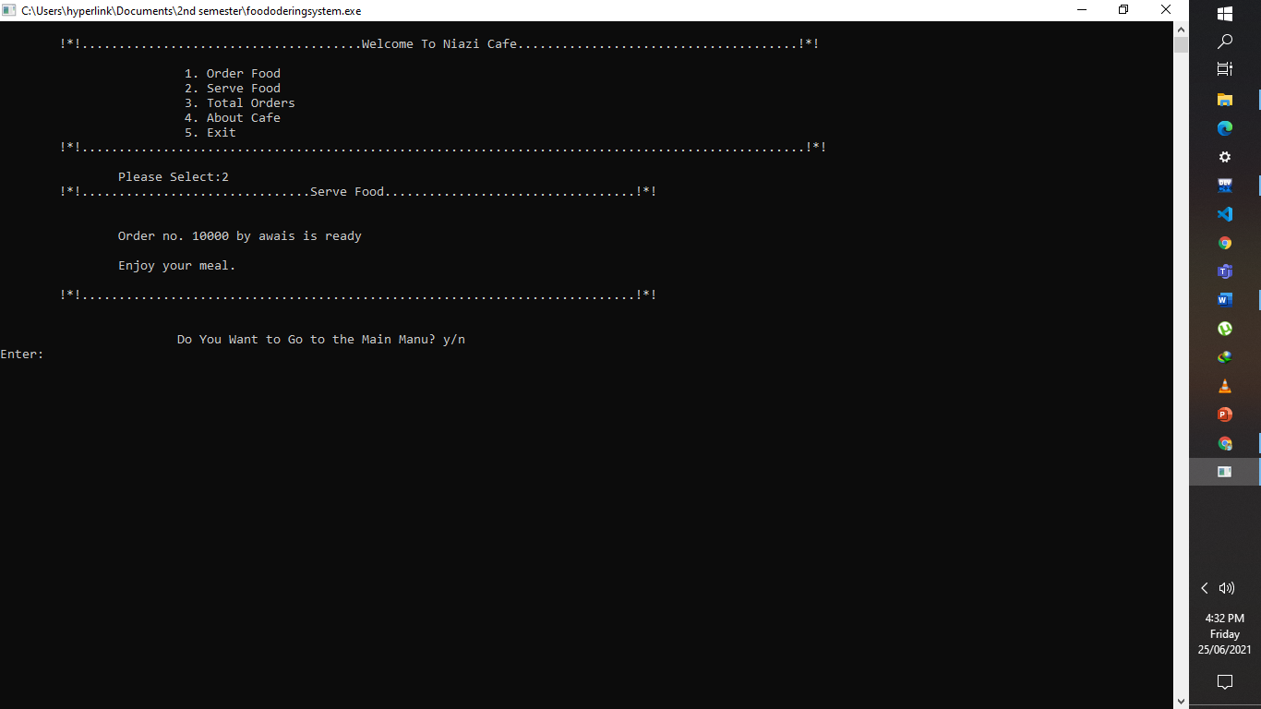

It shows order number and name of customer and print that food is served.

And it asks user, do you want to go to main menu by y if goes to main menu and by n program ends. For this we used goto.

When we **select (3)** then This output Screen is Shown on the screen.

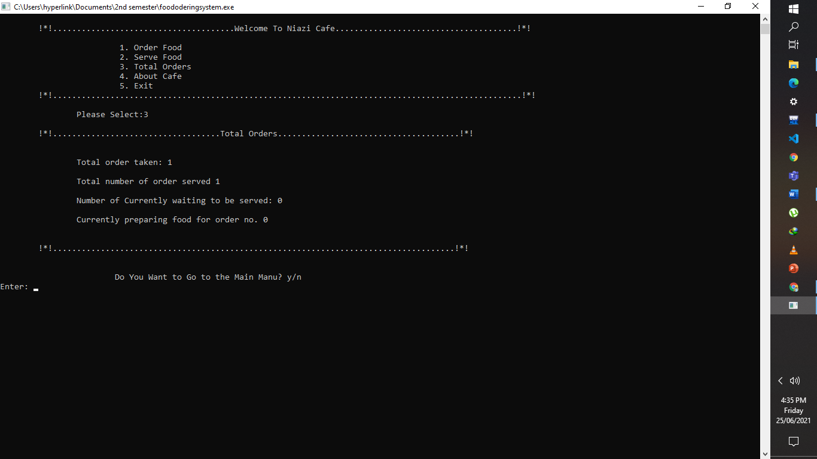

By selecting **3** it shows all numbers of orders, served orders, waiting, and preparing items

And it asks user, if you want to go back to main menu then enter y if you don’t then enter n for end the program. For this we used goto.

When we **select (4)** then This output Screen is Shown on the screen.

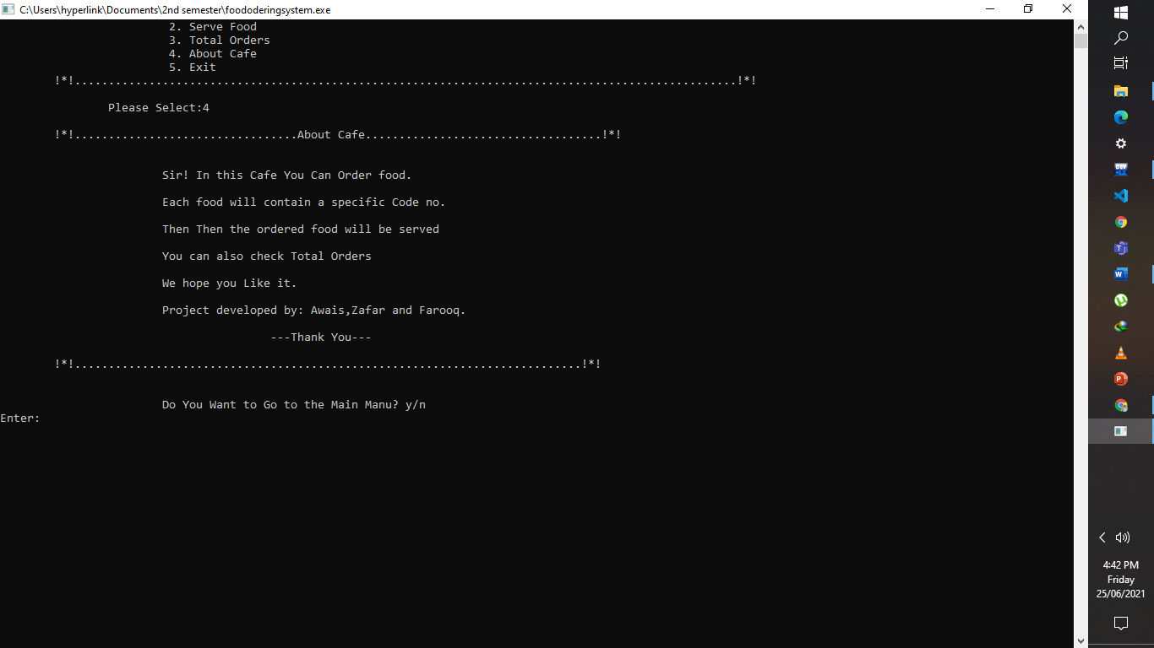

This is simply printed by printf statements.

And it asks user, do you want to go to main menu by y if goes to main menu and by n program ends. For this we used goto.

When we **select (5)** then This output Screen is Shown on the screen.

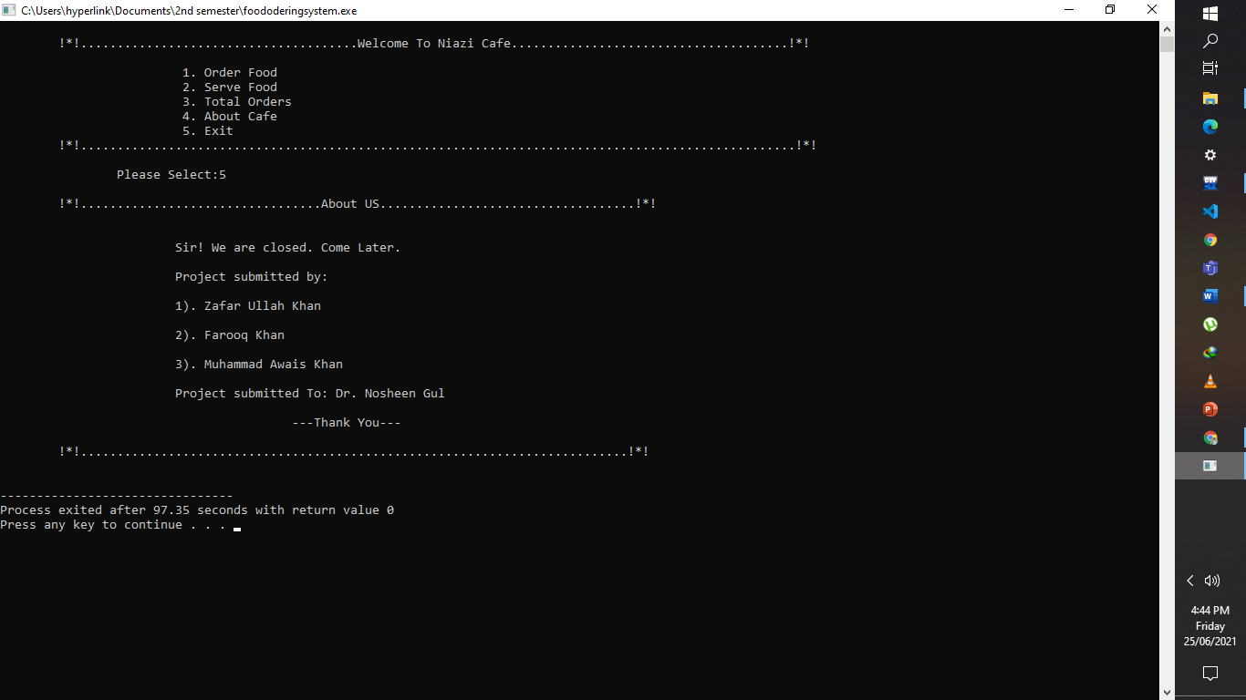

This is shown by **printf statements** and program exists.

# **Flow Diagram**

Start

C11

C13

C12

Welcome And other statements

Case1

**Yes**

Ask name and items no

Goto using if else

**No**

C14

**Yes**

Case2

Serve food using if else

C15

Goto using if else

**No**

C16

Case3

**Yes**

Show total Orders

C17

**No**

Goto using if else

Case4

**Yes**

C18

About Cafe

**No**

Goto using if else

C19

**Yes**

Case5

C20

Exit

Goto using if else

Invalid

Default

End

Goto using if else

# **Recommendation**

**Here are some recommendations for this project:**

* We can use file handling in this program so we can save data permanently.
* We can add time function in this program. As we know each food takes different time in preparation.
* We tried both above functionalities, but we could not manage to get them right due to short time because it takes more time for this functionality, **InshaAllah** we will complete it after exam for improvement.

# **Conclusion**

In this project we have learned about variables, structures, loops, strings, switch, if else, go to, and input output in the programming. This project really helped us in problem-solving ability and to analyze the problems. We were able to know about project management. We hope you like our work. Thanks!

The End!