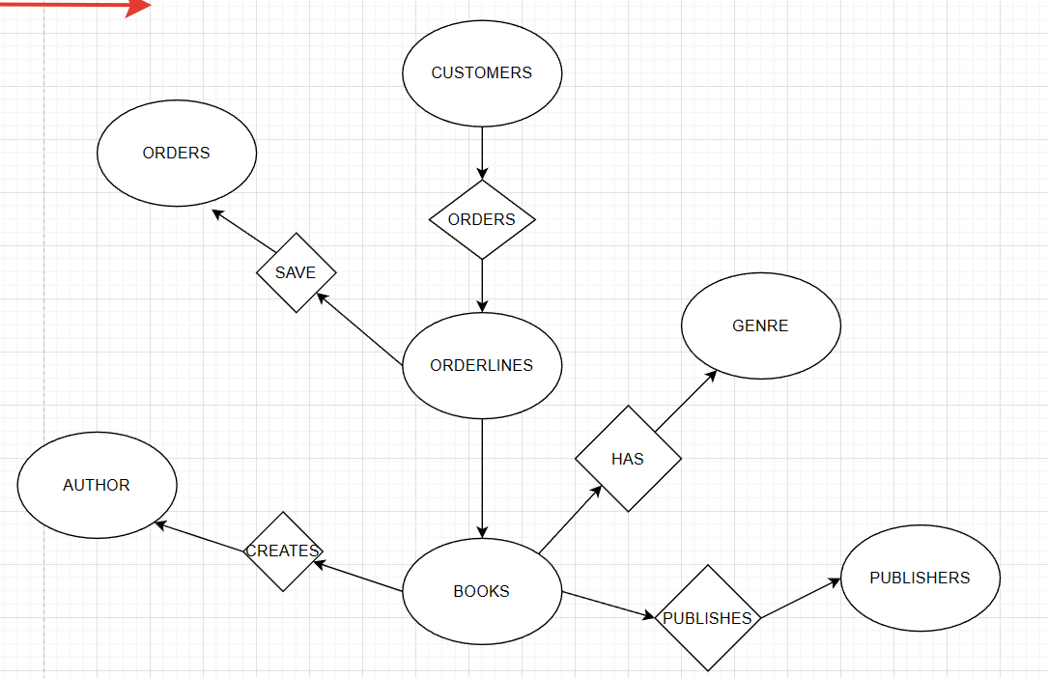

ER DIAGRAM

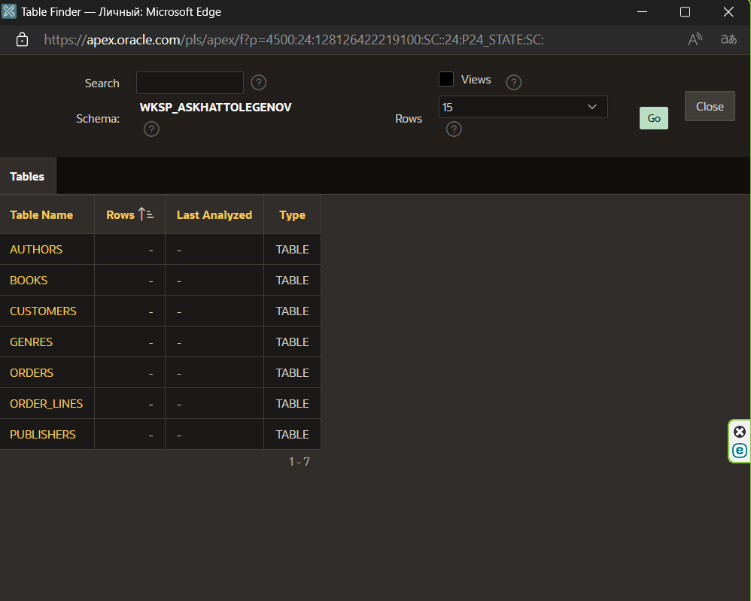

TABLES

PROCEDURE

CREATE OR REPLACE PROCEDURE GROUP_BY_BOOKS IS

AUTHOR_ID VARCHAR2(100);

BOOK_COUNT NUMBER;

AVG_PRICE NUMBER;

BEGIN

SELECT AUTHOR_ID, COUNT(*) AS BOOK_COUNT, AVG(PRICE) AS AVG_PRICE

INTO AUTHOR_ID, BOOK_COUNT, AVG_PRICE

FROM BOOKS

WHERE AUTHOR_ID = 1

GROUP BY AUTHOR_ID;

DBMS_OUTPUT.PUT_LINE('Author: ' || AUTHOR_ID || ', Book Count: ' || BOOK_COUNT || ', Avg Price: ' || AVG_PRICE);

END;

FUNCTION

CREATE OR REPLACE FUNCTION COUNT_ORDERS RETURN NUMBER

IS

OREDER_COUNT NUMBER;

BEGIN

SELECT COUNT(*) INTO OREDER_COUNT FROM ORDERS;

RETURN OREDER_COUNT;

END;

PROCEDURE

CREATE OR REPLACE PROCEDURE UPDATE_BOOKS(

NEW_ID IN NUMBER,

NEW_TITLE IN VARCHAR2,

NEW_AUTHOR_ID IN VARCHAR2

)

IS

BEGIN

UPDATE BOOKS

SET TITLE = NEW_TITLE,

AUTHOR_ID = NEW_AUTHOR_ID

WHERE BOOK_ID = NEW_ID;

DBMS_OUTPUT.PUT_LINE('Number of rows updated: ' || SQL%ROWCOUNT);

END;

PROCEDURE

CREATE OR REPLACE PROCEDURE EXEPTION_ADDBOOK(

NEW_TITLE IN VARCHAR2,

NEW_AUTHOR_ID IN VARCHAR2,

NEW_PUBLISHER_ID IN VARCHAR2

)

IS

-- Define user-defined exception

TITLE_ERROR EXCEPTION;

BEGIN

IF LENGTH(NEW_TITLE) < 5 THEN

RAISE TITLE_ERROR;

ELSE

INSERT INTO BOOKS(TITLE, AUTHOR_ID, PUBLISHER_ID)

VALUES (NEW_TITLE, NEW_AUTHOR_ID, NEW_PUBLISHER_ID);

DBMS_OUTPUT.PUT_LINE('New book added successfully!');

END IF;

EXCEPTION

WHEN TITLE_ERROR THEN

DBMS_OUTPUT.PUT_LINE('Book title must be at least 5 characters long!');

END;

TRIGGER

CREATE OR REPLACE TRIGGER TRIGGER_ROWCOUNT

BEFORE INSERT ON BOOKS

FOR EACH ROW

DECLARE

ROW_COUNT NUMBER;

BEGIN

SELECT COUNT(*) INTO ROW_COUNT FROM BOOKS;

DBMS_OUTPUT.PUT_LINE('Current row count: ' || ROW_COUNT);

END;