1. Select *one* UDP packet from your trace. From this packet, determine how many

fields there are in the UDP header.

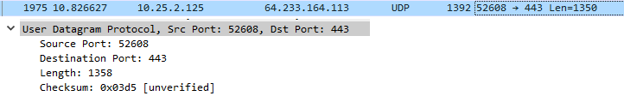

Answer: 4 fields: Source port, Destination Port, Length, Checksum

2. By consulting the displayed information in Wireshark’s packet content field for

this packet, determine the length (in bytes) of each of the UDP header fields.

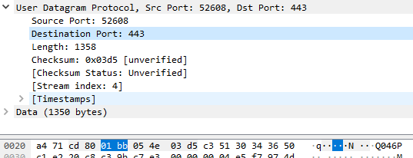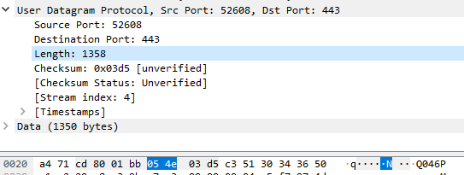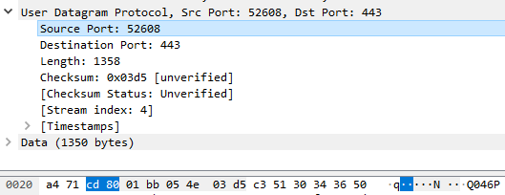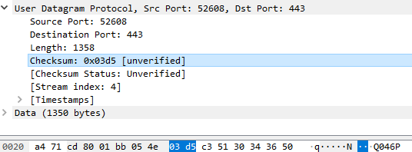

Answer: Each field/header is two bytes

3. The value in the Length field is the length of what? (You can consult the text for

this answer). Verify your claim with your captured UDP packet.

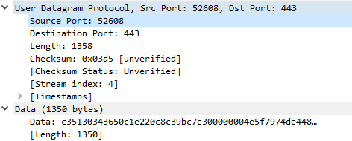

Answer: Value of Length field is length of UDP header with UDP data.

Length: 1358, Data: 1350, Header: 4\*2. (1358 = 1350 + 8)

4. What is the maximum number of bytes that can be included in a UDP payload?

Answer: 2^16 – 1 – 8 = 65527, thus max UDP payload is 65527 bytes

5. What is the largest possible source port number?

Answer: 2^16 -1 = 65535, thus max source port number is 65535

6. What is the protocol number for UDP? Give your answer in both hexadecimal and

decimal notation. To answer this question, you’ll need to look into the Protocol

field of the IP datagram containing this UDP segment

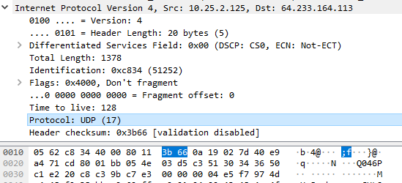

Answer: Decimal: 17, Hexadecimal: 0x11

7. Examine a pair of UDP packets in which your host sends the first UDP packet and

the second UDP packet is a reply to this first UDP packet. Describe the relationship between the

port numbers in the two packets.

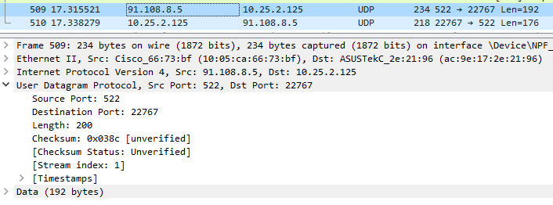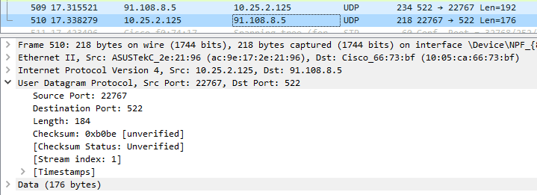

Answer: Ones ‘Source Port’ others ‘Destination Port’ as well as ones ‘Destination Port’ others ‘Source Port’