Student’s Full Name : Askhatov Amir
PRACTICAL 8 SUBMISSION
Answers are required only for the following 13 questions :
3,5,6,7,10,12,14,15,16,18,19,21,23
For each answer : Include SQL Statement in text form and Result-Grid SQL screenshot from your workbench)
SQL-3
SELECT COUNT(BOOK_NUM) AS "Available Books"
FROM BOOK
WHERE PAT_ID IS NULL;
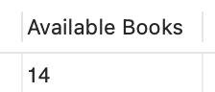

SQL-5
SELECT Min(BOOK_COST) AS "Least Expensive"
FROM BOOK;

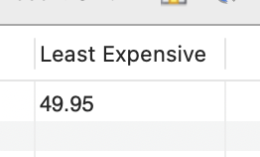

SQL-6
SELECT Sum(BOOK_COST) AS "Library Value"
FROM BOOK;
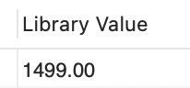

SQL-7
SELECT Count(DISTINCT PAT_ID) AS "Different Patrons"
FROM CHECKOUT;
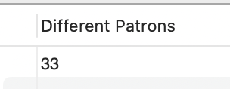

SQL-10
SELECT BOOK_NUM, Count(*) AS "Times Checked Out"
FROM CHECKOUT
GROUP BY BOOK_NUM
ORDER BY COUNT(*) DESC, BOOK_NUM DESC;
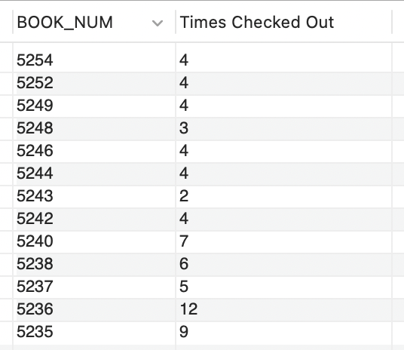

SQL-12
SELECT WRITES.AU_ID, BOOK.BOOK_NUM, BOOK.BOOK_TITLE, BOOK.BOOK_SUBJECT
FROM BOOK
JOIN WRITES ON BOOK.BOOK_NUM = WRITES.BOOK_NUM
JOIN AUTHOR ON AUTHOR.AU_ID = WRITES.AU_ID
ORDER BY BOOK.BOOK_NUM, WRITES.AU_ID;
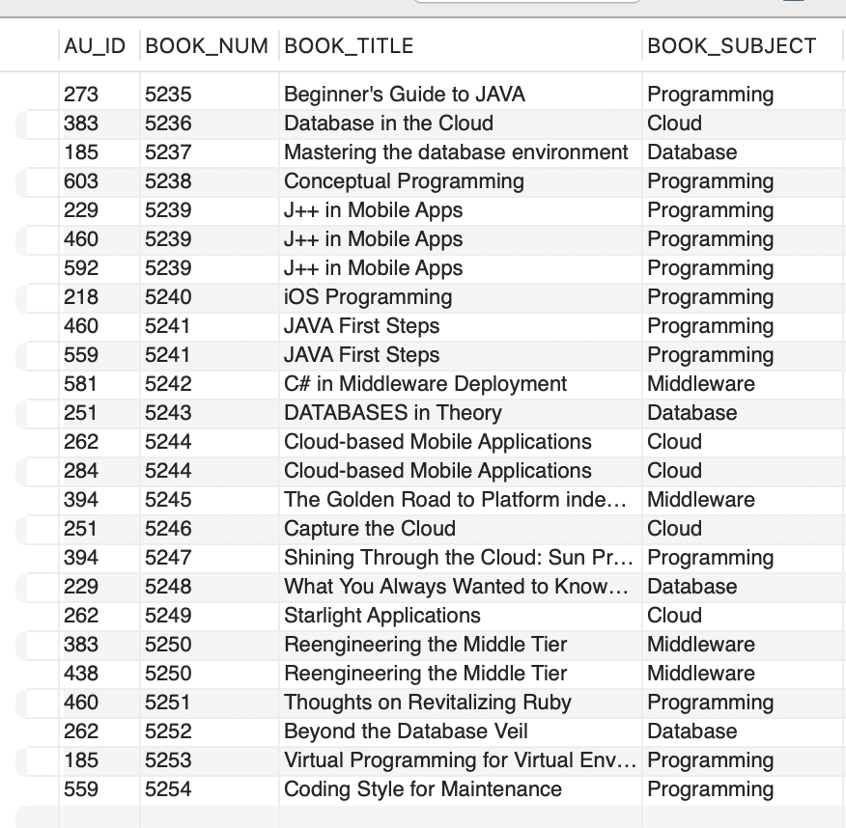

SQL-14
SELECT BOOK.PAT_ID, BOOK.BOOK_NUM, PATRON.PAT_FNAME, PATRON.PAT_LNAME, BOOK.BOOK_TITLE
FROM BOOK
JOIN PATRON ON BOOK.PAT_ID = PATRON.PAT_ID
WHERE BOOK.PAT_ID IS NOT NULL
ORDER BY PATRON.PAT_LNAME, BOOK.BOOK_TITLE;

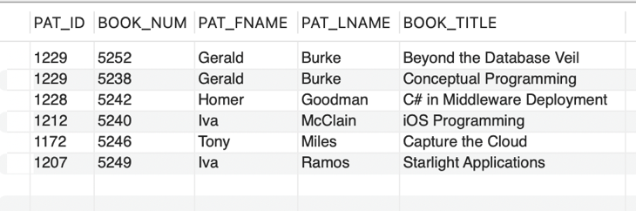

SQL-15
SELECT AUTHOR.AU_ID, AUTHOR.AU_FNAME, BOOK.BOOK_NUM, BOOK.BOOK_TITLE
FROM AUTHOR JOIN WRITES ON AUTHOR.AU_ID = WRITES.AU_ID
JOIN BOOK ON WRITES.BOOK_NUM = BOOK.BOOK_NUM
WHERE BOOK.BOOK_SUBJECT = 'Cloud'
ORDER BY BOOK.BOOK_TITLE, AUTHOR.AU_LNAME
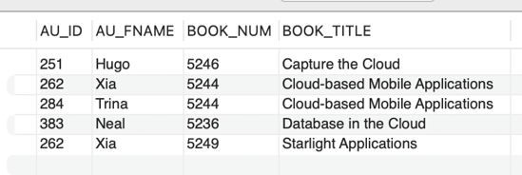

SQL-16
SELECT BOOK.BOOK_NUM, BOOK.BOOK_TITLE, AUTHOR.AU_LNAME, AUTHOR.AU_FNAME,PATRON.PAT_ID, PATRON.PAT_LNAME, PATRON.PAT_TYPE
FROM BOOK
JOIN WRITES ON BOOK.BOOK_NUM = WRITES.BOOK_NUM
JOIN AUTHOR ON WRITES.AU_ID = AUTHOR.AU_ID
JOIN PATRON ON BOOK.PAT_ID = PATRON.PAT_ID
WHERE BOOK.PAT_ID IS NOT NULL
ORDER BY BOOK.BOOK_TITLE;
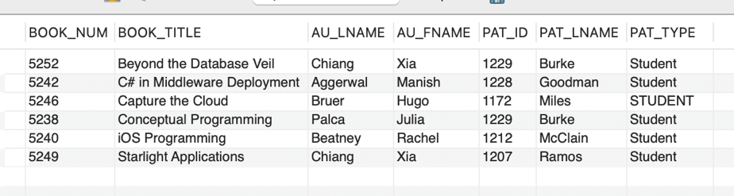

SQL-18
SELECT AUTHOR.AU_ID, AUTHOR.AU_LNAME, BOOK.BOOK_TITLE, CHECKOUT.CHECK_OUT_DATE, PATRON.PAT_LNAME
FROM AUTHOR
JOIN WRITES ON AUTHOR.AU_ID = WRITES.AU_ID
JOIN BOOK ON WRITES.BOOK_NUM = BOOK.BOOK_NUM
JOIN CHECKOUT ON BOOK.BOOK_NUM = CHECKOUT.BOOK_NUM
JOIN PATRON ON CHECKOUT.PAT_ID = PATRON.PAT_ID
WHERE AUTHOR.AU_LNAME = 'Bruer' AND PATRON.PAT_LNAME = 'Miles'
ORDER BY CHECKOUT.CHECK_OUT_DATE;

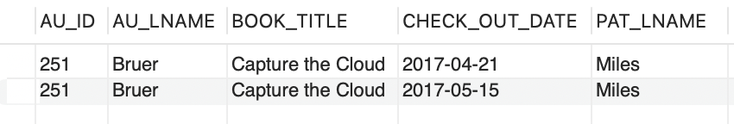

SQL-19
SELECT PAT_ID, PAT_FNAME, PAT_LNAME
FROM PATRON
WHERE PAT_ID NOT IN (SELECT PAT_ID FROM CHECKOUT)
ORDER BY PAT_LNAME, PAT_FNAME;

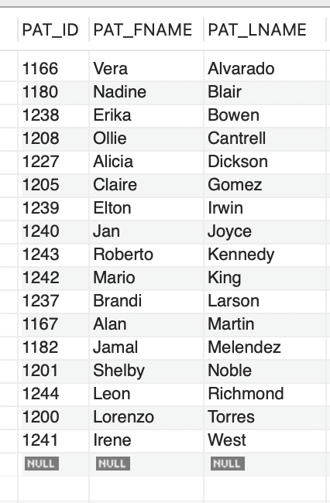

SQL-21
SELECT P.PAT_ID,P.PAT_LNAME,COUNT(C.BOOK_NUM) AS "Total Checkouts",COUNT(DISTINCT C.BOOK_NUM) AS "Different Books"
FROM PATRON P
JOIN CHECKOUT C ON P.PAT_ID=C.PAT_ID
GROUP BY P.PAT_ID,P.PAT_LNAME
HAVING COUNT(C.BOOK_NUM)>=3
ORDER BY COUNT(DISTINCT C.BOOK_NUM) DESC,COUNT(C.BOOK_NUM) DESC,P.PAT_ID ASC;

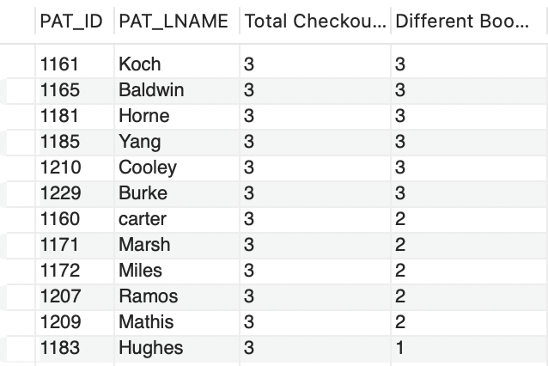

SQL-23
SELECT PAT_ID,ROUND(AVG(DATEDIFF(CHECK_IN_DATE,CHECK_OUT_DATE)),2) AS "Average Days Kept"
FROM CHECKOUT
GROUP BY PAT_ID
HAVING COUNT(*)>=3
ORDER BY ROUND(AVG(DATEDIFF(CHECK_IN_DATE,CHECK_OUT_DATE)),2) DESC;
