Student’s Name : Askhatov Amir
PRACTICAL 9 SUBMISSION
Answers are required only for the following 15 questions :
2,4,5,6,7,8,10,11,12,14,15,16,17,19,20.
Questions 21-24 are optional, as they are complex.
Include SQL Statement and screenshot the first few (about 5-10) rows of the RESULT GRID from your workbench, NOT the whole window.
SQL-2
SELECT AU_ID, AU_FNAME, AU_LNAME
FROM AUTHOR
WHERE AU_ID NOT IN (SELECT AU_ID FROM WRITES w JOIN BOOK b ON w.BOOK_NUM = b.BOOK_NUM WHERE b.BOOK_SUBJECT = 'Programming' )
ORDER BY AU_LNAME;

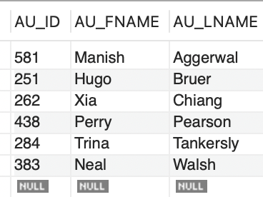

SQL-4
SELECT b.BOOK_NUM, b.BOOK_TITLE, b.BOOK_SUBJECT, a.AU_LNAME, COUNT(w2.BOOK_NUM) AS NUM_BOOKS
FROM BOOK b
JOIN WRITES w ON b.BOOK_NUM = w.BOOK_NUM
JOIN AUTHOR a ON w.AU_ID = a.AU_ID
JOIN WRITES w2 ON a.AU_ID = w2.AU_ID
WHERE b.BOOK_SUBJECT = 'Cloud'
GROUP BY b.BOOK_NUM, b.BOOK_TITLE, b.BOOK_SUBJECT, a.AU_LNAME
ORDER BY b.BOOK_TITLE, a.AU_LNAME;
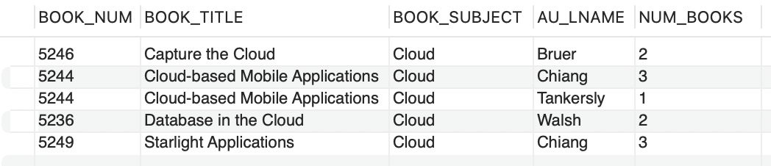

SQL-5
SELECT MIN(avg_cost) AS 'Lowest Average Cost', MAX(avg_cost) AS 'Highest Average Cost'
FROM (SELECT AVG(BOOK_COST) AS avg_cost FROM BOOK GROUP BY BOOK_SUBJECT) sub;
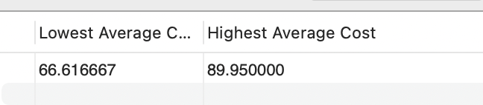

SQL-6
SELECT EMP_FNAME, EMP_LNAME, EMP_EMAIL
FROM LGEMPLOYEE
WHERE EMP_HIREDATE BETWEEN '2005-01-01' AND '2014-12-31'
ORDER BY EMP_LNAME, EMP_FNAME;

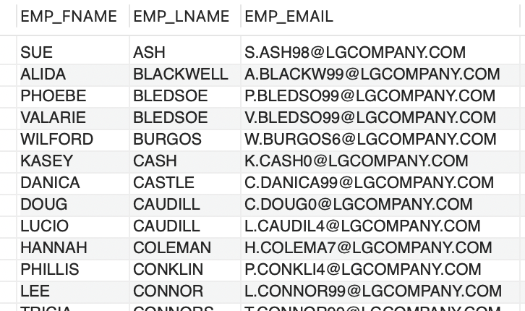

SQL-7
SELECT EMP_FNAME, EMP_LNAME, EMP_PHONE, EMP_TITLE, DEPT_NUM
FROM LGEMOPLOYEE
WHERE DEPT_NUM = 300
OR EMP_TITLE = 'CLERK I'
ORDER BY EMP_LNAME, EMP_FNAME;

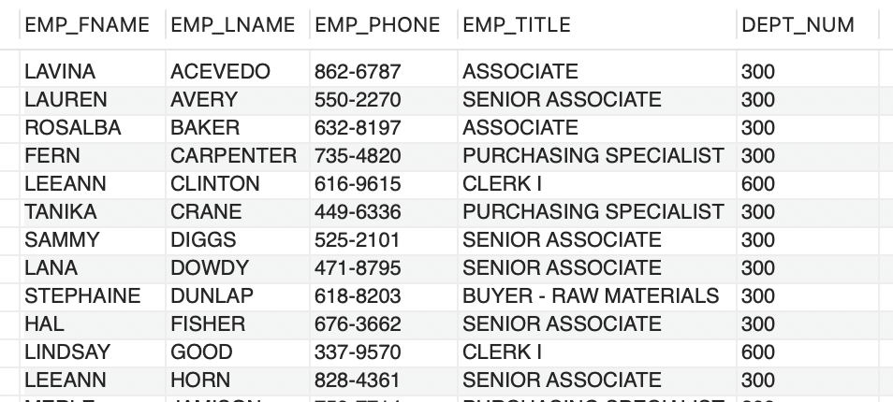

SQL-8
SELECT e.EMP_NUM,
e.EMP_LNAME,
e.EMP_FNAME,
CONCAT(MONTH(s.SAL_FROM), '/', DAY(s.SAL_FROM), '/', YEAR(s.SAL_FROM)) AS SAL_FROM,
CONCAT(MONTH(s.SAL_END), '/', DAY(s.SAL_END), '/', YEAR(s.SAL_END)) AS SAL_END,
s.SAL_AMOUNT
FROM LGEMPLOYEE e
JOIN LGSALARY_HISTORY s ON e.EMP_NUM = s.EMP_NUM
WHERE e.EMP_NUM IN (83731, 83745, 84039)
ORDER BY e.EMP_NUM, s.SAL_FROM;
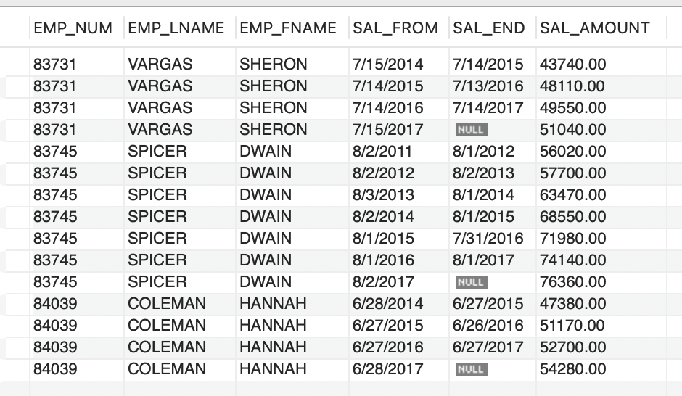

SQL-10
SELECT e.EMP_NUM,
e.EMP_LNAME,
e.EMP_EMAIL,
e.EMP_TITLE,
d.DEPT_NAME
FROM LGEMPLOYEE e
JOIN LGDEPARTMENT d ON e.DEPT_NUM = d.DEPT_NUM
WHERE e.EMP_TITLE LIKE '%ASSOCIATE'
ORDER BY d.DEPT_NAME, e.EMP_TITLE, e.EMP_NUM;
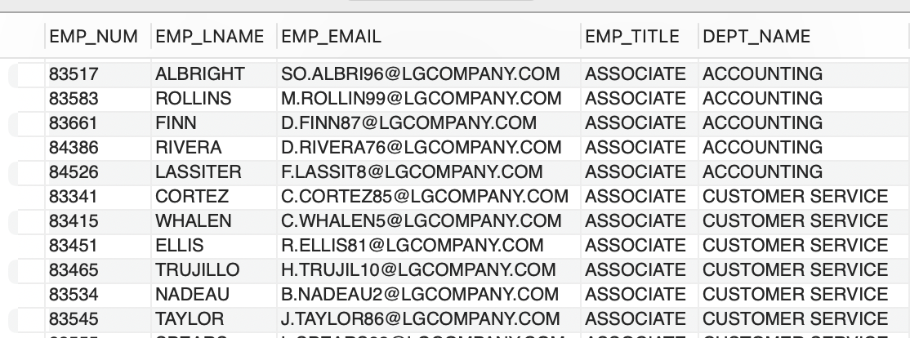

SQL-11
SELECT b.BRAND_NAME,
COUNT(p.PROD_SKU) AS NUMPRODUCTS
FROM LGBRAND b
JOIN LGPRODUCT p ON b.BRAND_ID = p.BRAND_ID
GROUP BY b.BRAND_NAME
ORDER BY b.BRAND_NAME;
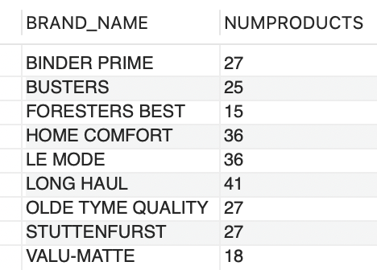
SQL-12
SELECT BRAND_ID,
SUM(PROD_QOH) AS TOTAL_INVENTORY
FROM LGPRODUCT
GROUP BY BRAND_ID
ORDER BY BRAND_ID DESC;

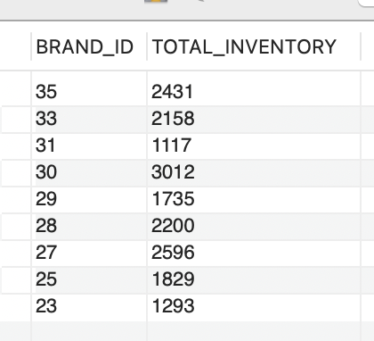
SQL-14
SELECT e.EMP_NUM,
e.EMP_FNAME,
e.EMP_LNAME,
MAX(s.SAL_AMOUNT) AS MAX_SALARY
FROM LGEMPLOYEE e
JOIN LGSALARY_HISTORY s ON e.EMP_NUM = s.EMP_NUM
WHERE e.DEPT_NUM = 200
GROUP BY e.EMP_NUM, e.EMP_FNAME, e.EMP_LNAME
ORDER BY MAX_SALARY DESC;
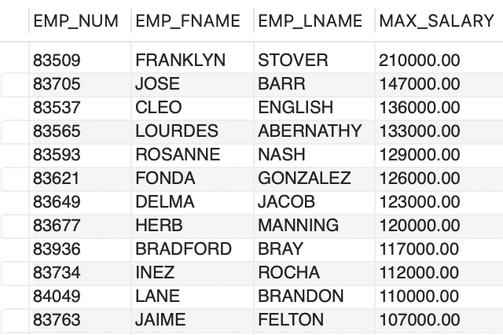

SQL-15
SELECT d.DEPT_NUM,
d.DEPT_NAME,
d.DEPT_PHONE,
e.EMP_NUM,
e.EMP_LNAME
FROM LGDEPARTMENT d
JOIN LGEMPLOYEE e ON d.EMP_NUM = e.EMP_NUM
ORDER BY d.DEPT_NAME;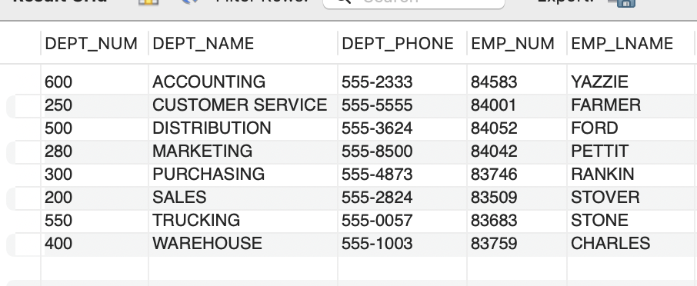

SQL-16
SELECT v.VEND_ID,
v.VEND_NAME,
b.BRAND_NAME,
COUNT(p.PROD_SKU) AS NUM_PRODUCTS
FROM LGVENDOR v
JOIN LGSUPPLIES s ON v.VEND_ID = s.VEND_ID
JOIN LGPRODUCT p ON s.PROD_SKU = p.PROD_SKU
JOIN LGBRAND b ON p.BRAND_ID = b.BRAND_ID
GROUP BY v.VEND_ID, v.VEND_NAME, b.BRAND_NAME
ORDER BY v.VEND_NAME, b.BRAND_NAME;

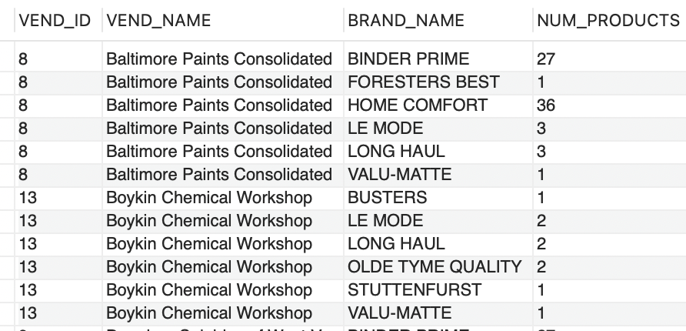
SQL-17
SELECT MAX(AVG_PRICE) AS LARGEST_AVG_PRICE
FROM (
SELECT AVG(PROD_PRICE) AS AVG_PRICE
FROM LGPRODUCT
GROUP BY BRAND_ID
) sub;
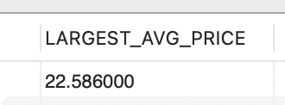

SQL-19
SELECT e.EMP_NUM,
e.EMP_LNAME,
e.EMP_FNAME,
s.SAL_AMOUNT
FROM LGEMPLOYEE e
JOIN LGSALARY_HISTORY s ON e.EMP_NUM = s.EMP_NUM
WHERE e.DEPT_NUM = 300
AND s.SAL_END IS NULL
ORDER BY s.SAL_AMOUNT DESC;
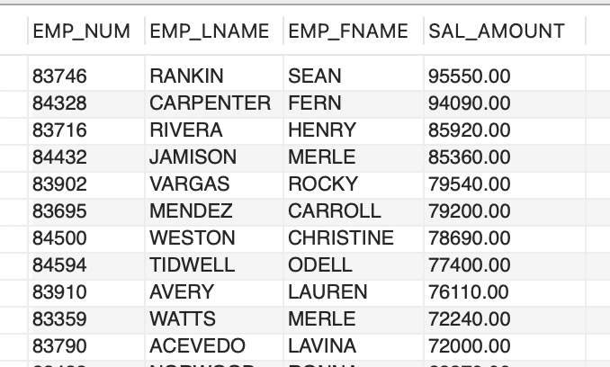

SQL-20
SELECT e.EMP_NUM,
e.EMP_LNAME,
e.EMP_FNAME,
s.SAL_AMOUNT
FROM LGEMPLOYEE e
JOIN LGSALARY_HISTORY s ON e.EMP_NUM = s.EMP_NUM
WHERE s.SAL_FROM = (
SELECT MIN(s2.SAL_FROM)
FROM LGSALARY_HISTORY s2
WHERE s2.EMP_NUM = e.EMP_NUM
)
ORDER BY e.EMP_NUM;
