Student’s Full Name : Askhatov Amir
PRACTICAL 7 SUBMISSION
Answers are required only for the following 14 questions :
2,4,6,8,10,12,14,16,17,19,20,21,24,25
SQL-2 ( Include SQL Statement and result SQL screenshot from your workbench)
SELECT CHECK_NUM, CHECK_OUT_DATE, CHECK_DUE_DATE
FROM CHECKOUT
ORDER BY CHECK_NUM;

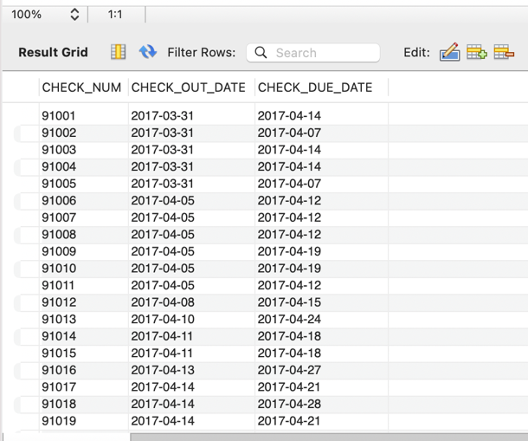

SQL-4
SELECT BOOK_NUM, BOOK_TITLE AS TITLE, BOOK_COST AS 'Replacement Cost'
FROM BOOK
ORDER BY BOOK_NUM;

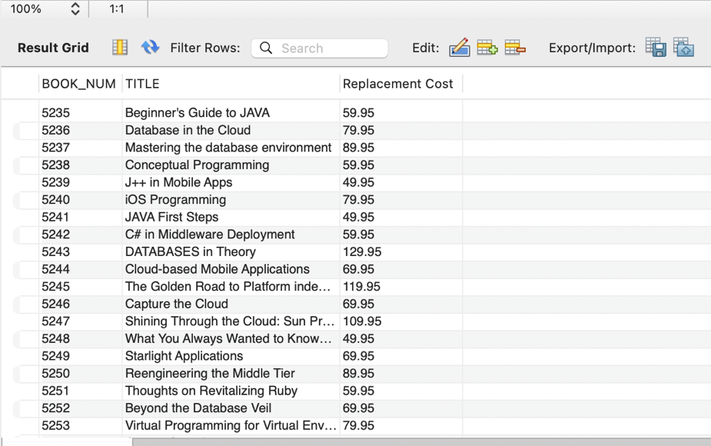
SQL-6
SELECT DISTINCT BOOK_SUBJECT
FROM BOOK
ORDER BY BOOK_SUBJECT;
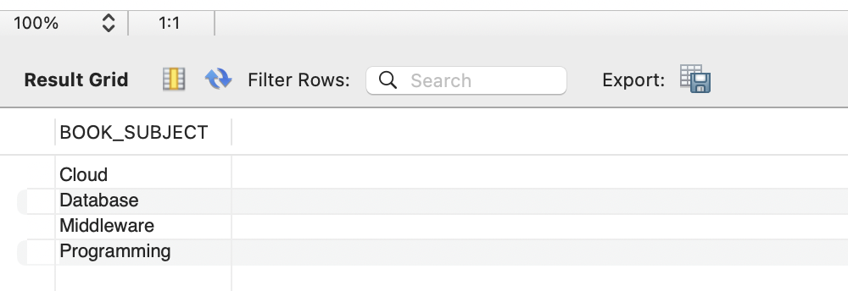

SQL-8
SELECT BOOK_TITLE, BOOK_YEAR, BOOK_SUBJECT
FROM BOOK
ORDER BY BOOK_SUBJECT ASC, BOOK_YEAR DESC, BOOK_TITLE ASC;
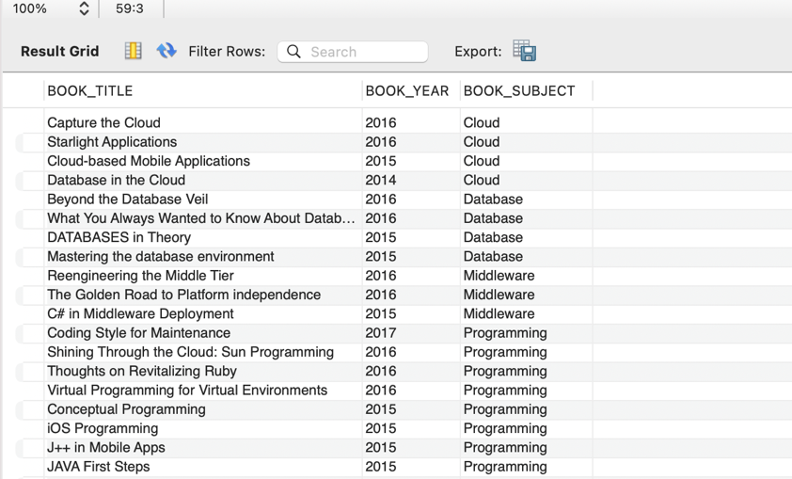

SQL-10
SELECT BOOK_NUM, BOOK_TITLE, BOOK_COST
FROM BOOK
WHERE BOOK_SUBJECT = 'Database'
ORDER BY BOOK_NUM;
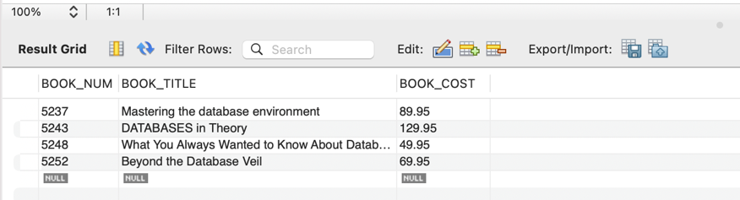
SQL-12
SELECT BOOK_NUM, BOOK_TITLE, BOOK_YEAR
FROM BOOK
WHERE BOOK_YEAR > 2015
AND BOOK_SUBJECT = 'Programming'
ORDER BY BOOK_NUM;
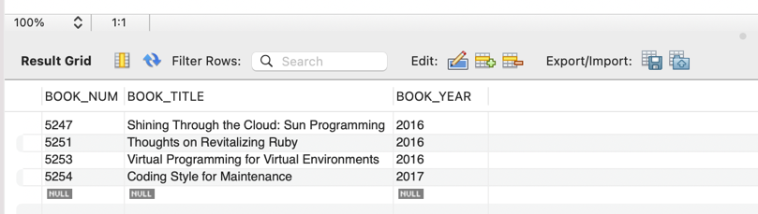

SQL-14
SELECT AU_ID, AU_FNAME, AU_LNAME, AU_BIRTHYEAR
FROM AUTHOR
WHERE AU_BIRTHYEAR BETWEEN 1980 AND 1989
ORDER BY AU_ID;

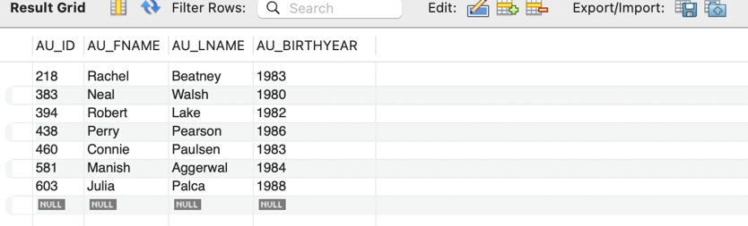

SQL-16
SELECT PAT_ID, PAT_FNAME, PAT_LNAME
FROM PATRON
WHERE PAT_TYPE = 'Student'
ORDER BY PAT_ID;

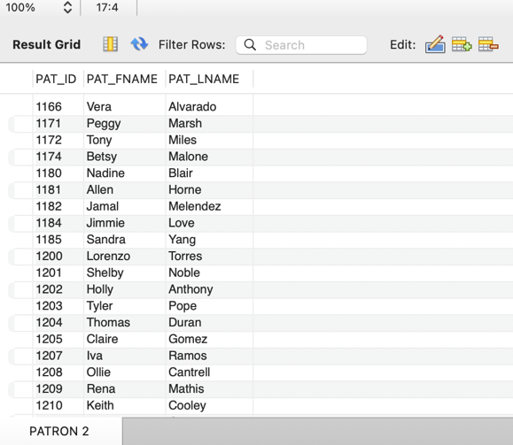

SQL-17
SELECT PAT_ID, PAT_FNAME, PAT_LNAME, PAT_TYPE
FROM PATRON
WHERE PAT_LNAME LIKE 'C%'
ORDER BY PAT_ID;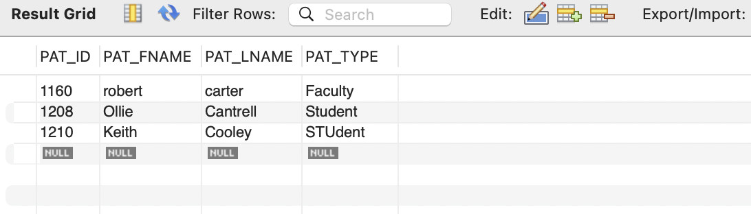

SQL-19
SELECT AU_ID, AU_FNAME, AU_LNAME
FROM AUTHOR
WHERE AU_BIRTHYEAR IS NULL
ORDER BY AU_ID;

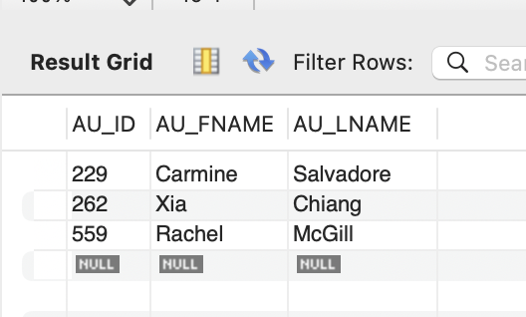

SQL-20
SELECT CHECK_NUM, BOOK_NUM, PAT_ID, CHECK_OUT_DATE, CHECK_DUE_DATE
FROM CHECKOUT
WHERE CHECK_IN_DATE IS NULL
ORDER BY BOOK_NUM;
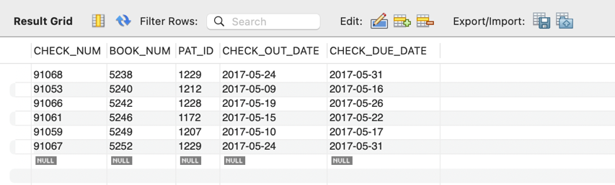

SQL-21
SELECT AU_ID, AU_FNAME, AU_LNAME, AU_BIRTHYEAR
FROM AUTHOR
ORDER BY AU_BIRTHYEAR DESC, AU_LNAME ASC;

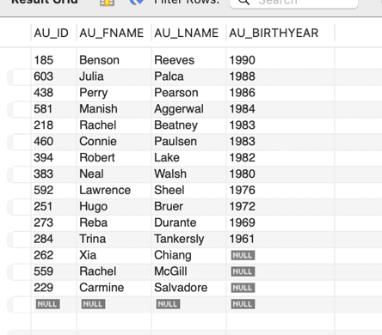

SQL-24
SELECT BOOK_NUM,
CONCAT(BOOK_TITLE, ' (', BOOK_YEAR, ')') AS `Title and Year`,
BOOK_SUBJECT
FROM BOOK
ORDER BY BOOK_NUM;

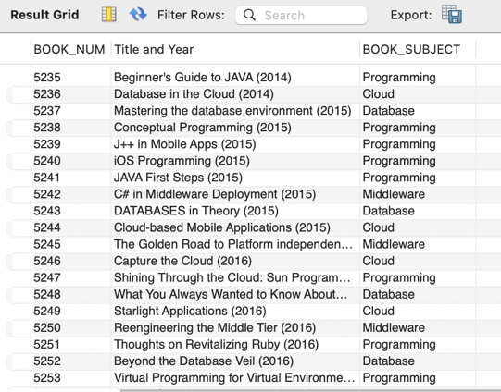

SQL-25
SELECT PAT_ID,
CONCAT(PAT_FNAME, ' ', PAT_LNAME) AS `Full Name`,
PAT_TYPE
FROM PATRON
ORDER BY PAT_TYPE,
UPPER(PAT_LNAME),
UPPER(PAT_FNAME);

