Project Proposal: Comp 1536 Set 1B Wednesday, 15, 2014

**Group Members**

* John Janzen
* Lukasz Pacyk (Group Leader)
* Stuart Budd
* Byunghak Kim (Andrew)
* Leon Ho

1. **Topic**
2. To provide BCIT members with an inconvenient transit route the option of carpooling with a fellow student. Additionally, it provides current BCIT students who already commute with a car to BCIT (or a sky train station) a chance at reducing commute expenses by 80% which includes parking and gas.
3. The goal of the site is to connect students to their institution of knowledge and each other. By giving the community to carpooling options, the opportunity to socialize is provided. . Reasons for creating this website are to provide a useful service, connect the community, and potentially introduce carpooling to a larger community.
4. The target of the website are explicitly faculty and students. The demographic we want to target is car owners and transit users. This essentially encompasses anyone that travels to BCIT. We want to attract people that have inconvenient access to transit or have a lengthy transit. Students on a budget will have the opportunity of saving money and acquiring new connections.
5. We hope to accomplish a variety of elements on our websites. We want to list maps with routes that will help navigate the service. We hope that we can provide a forum for others to connect with each other. Environmentally we hope to reduce traffic and emissions.
6. Contents included are split amongst categories.
   * Text: List of postings, forum, FAQ’s
   * Matching System: hotspots, meeting places
   * Graphics: Map, route picture, images
   * Media: Picture slide show, videos, graphics, Facebook, BCIT and twitter link.
7. There are many factors that will affect how well we do. A basic demand for the website is a base requirement. First, interest in the product must be sparked by marketing the service. The service relies on people using it. Secondly, a positive response from the community must be achieved. The website itself must be easy to access and navigate for repeated use from users.
8. We analyzed two websites that are similar to our idea.

Ridejoy.com

Every users needs to register with their private information (address, name, and so on).

Can find easily carpooling people who want to save money and time when they register it. It divides users into two groups offer drivers and request riders.

Carpool.com

Offers carpooling services to the community. It support user registration. It also works with other schools and businesses to offer carpool options in your city. However, the website is fairly cluttered and finding the information you need is difficult. Navigation is confusing and it is not immediately clear what carpool routes are available. The website is national and has no specific community it focuses on. Not a high enough concentration of people use it in an area to become effective.

**2. Functional requirements**

1. We propose a form input that will require user sign in first. User registration will be restricted to users with my.bcit.ca or bcit.ca email. This will authenticate that a user is from BCIT. Afterwards we hope to implement data input for passengers and drivers that will allow us to categorize and display their entries. We want to make the matching process as streamlines as possible so that it can be quick and easy for users.
2. We want to list passenger and driver requests in the form of postings similar to how craigslist displays theirs. However, we want to set up a standard uniform submission and display style that will allow users to quickly browse through listings.
   * Address
   * Departure and return times
   * Preferences
   * Interests
   * Gender

**3. Work plan**

Our team is well structured towards creating this website. We all have some sort of experience that will contribute towards the development of this website. Experience includes html, PHP, Photoshop, and navigation. We hope to all contribute equally and bring our strengths and creativity towards completing this website. Immediately, we have designated a 2 hour meeting time every Wednesday where we will discuss our progress and set new tasks and goals. During our meetings we plan to gather our completed work and present it in order to assess quality as a group. Moral is high amongst our group and we are all ambitious. If deadlines are difficult for an individual to meet we will as a group try to help each other move forward as a team.

**Mile Stone 2: Wire Frame**

We have decided to design a simple and clean page design with a Jell-O layout. The website layout will mimic BCIT's website theme so that the target audience is comfortable with the website flow. Site header and logo will be consistent on every page to allow easy accessibility and use.

Our intro page includes site name and our copyright, last update and contact email. We have chosen a color scheme that has good contrast and is easily viewable to people suffering from color blindness. This synergizes to provide proper contrast between text, background, text, graphics, and white space. Our header and logo take up no more than one-quarter to one-third of the browser window at 1024x768 resolutions. Initially the content will be fitted within the window without scrolling. As the user delves deeper into the website and his attention is ensured, more content will be displayed in detail.

One thing to note is that our intro page will be dynamic. The page will not refresh as a whole. Instead, the content body of the page will be loaded from a separate page and inserted into the intro page body without breaking the websites flow. This way we can keep the user interested by having a fluid design.

Website Directory

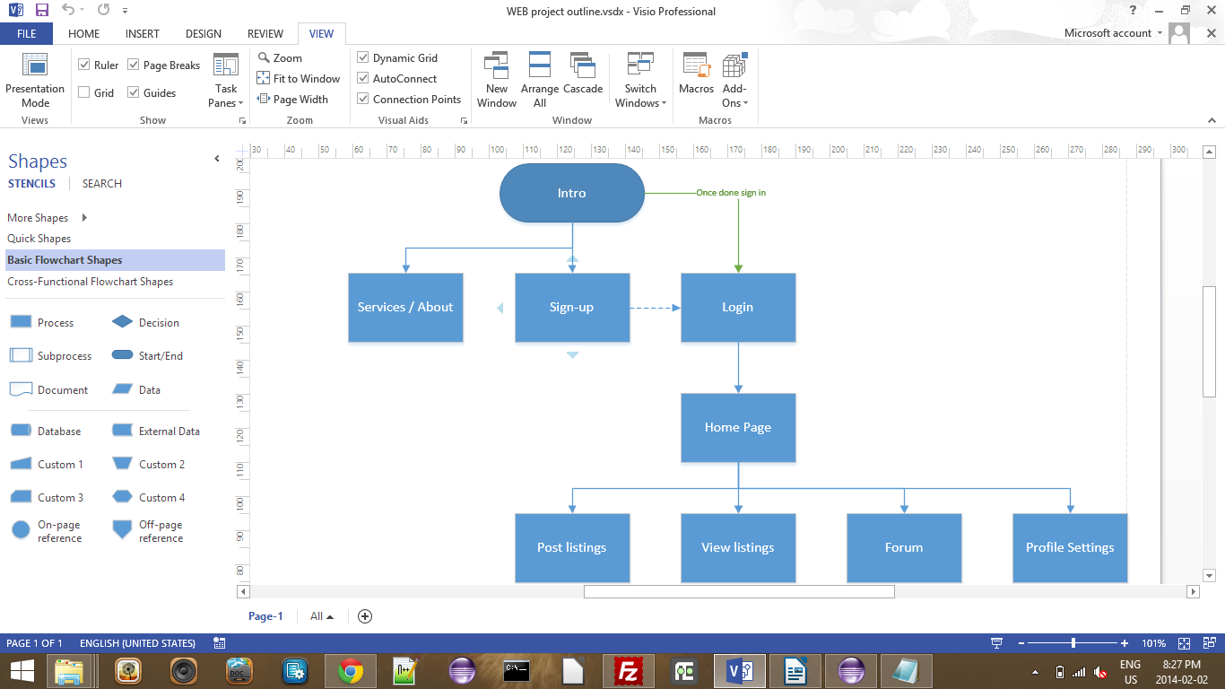

Intro Page

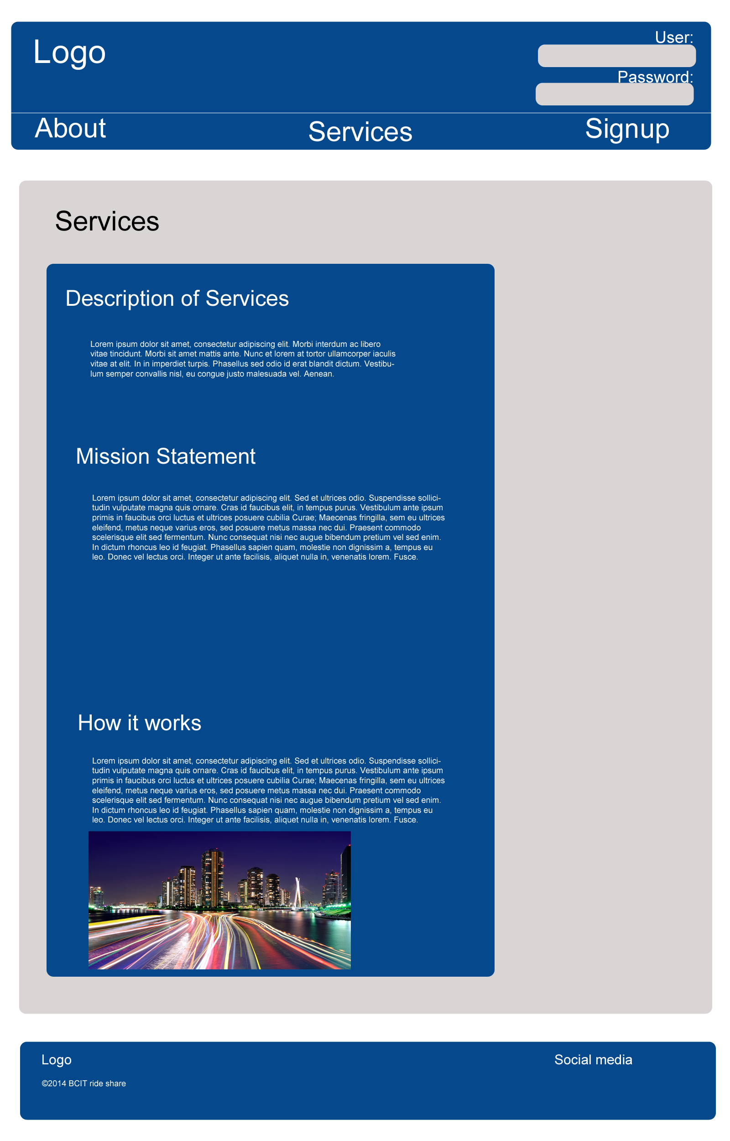

About

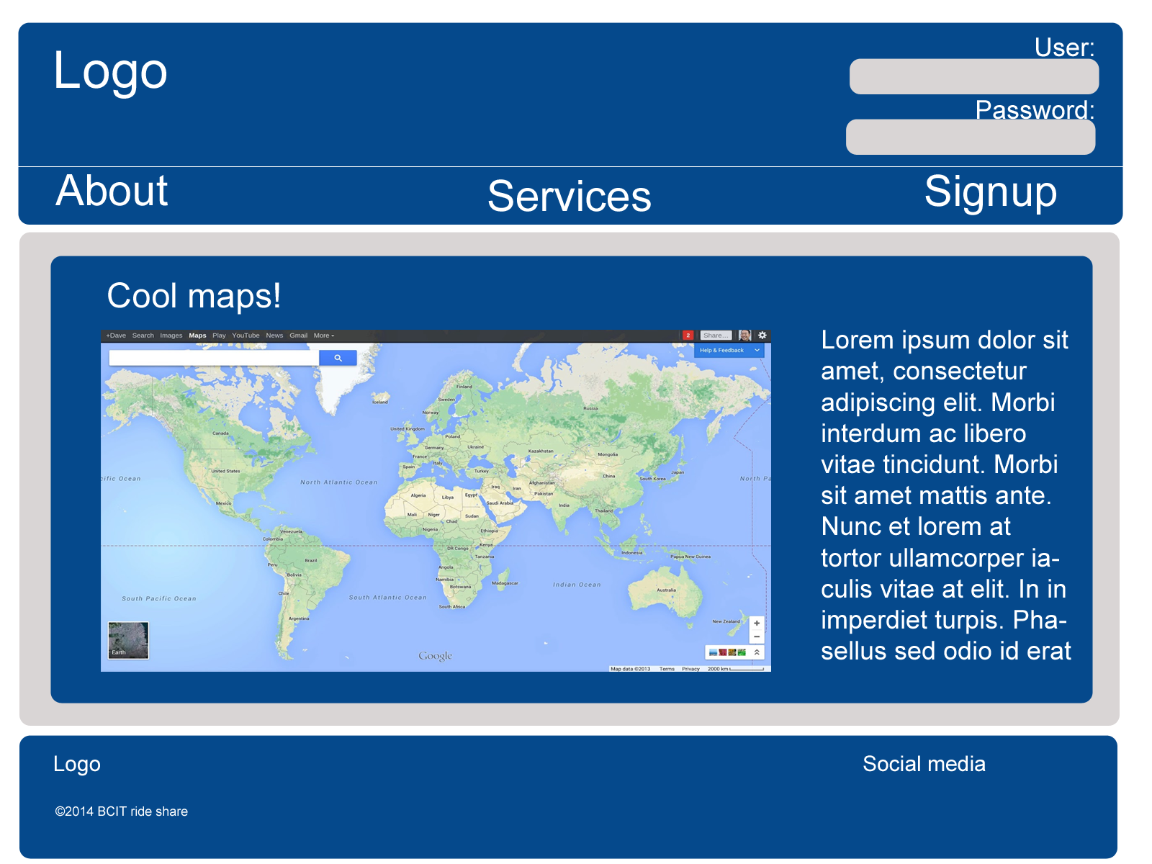

Sign Up

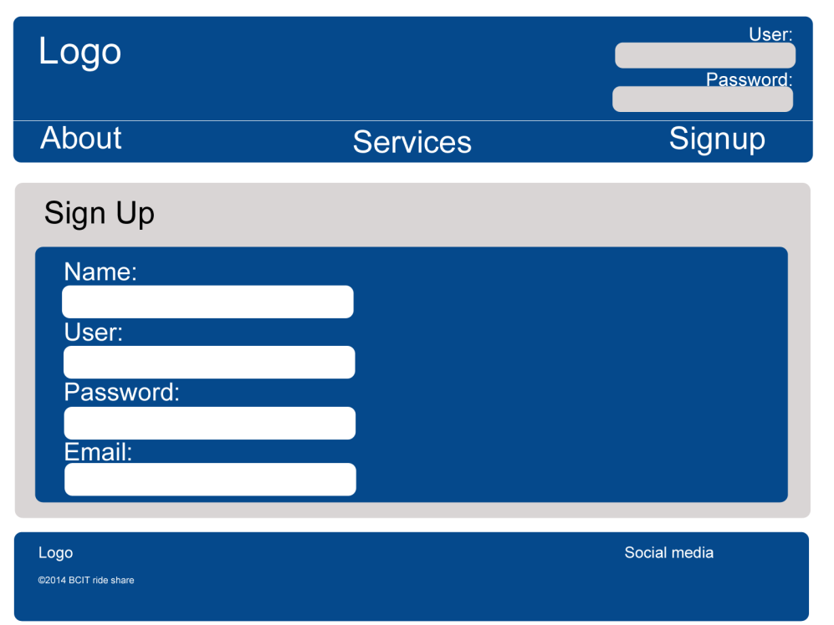

List Posting

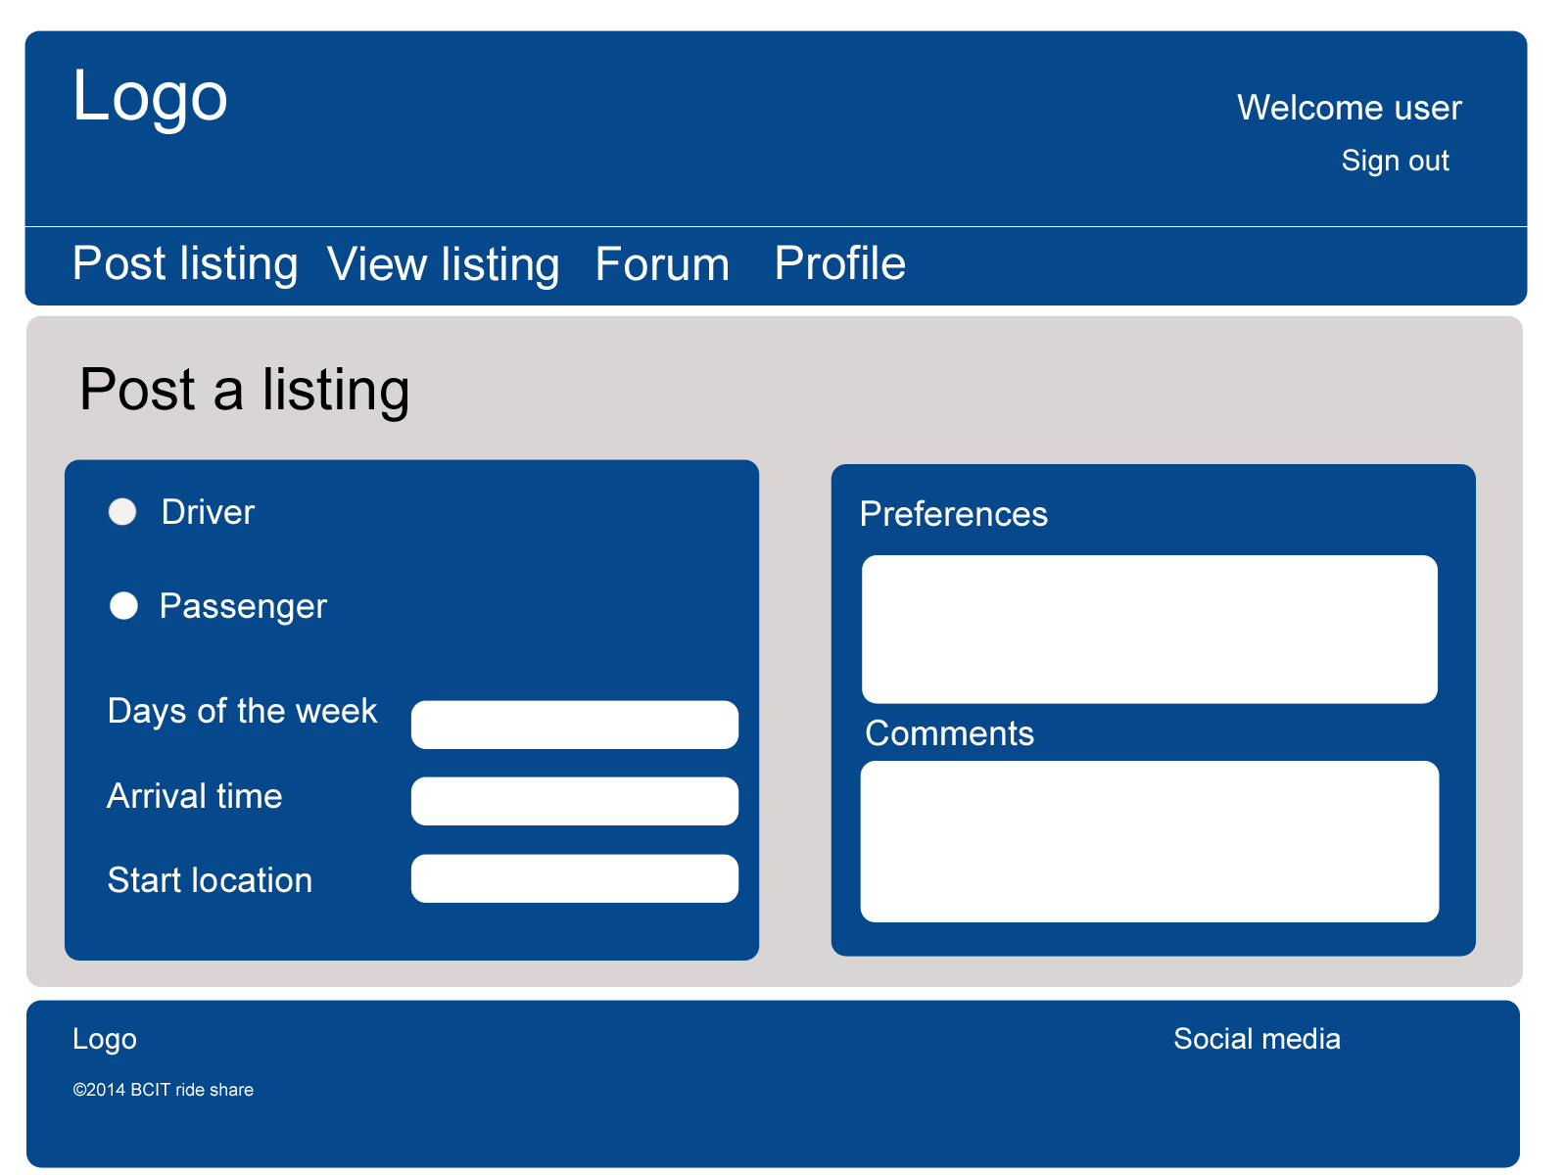

Forum

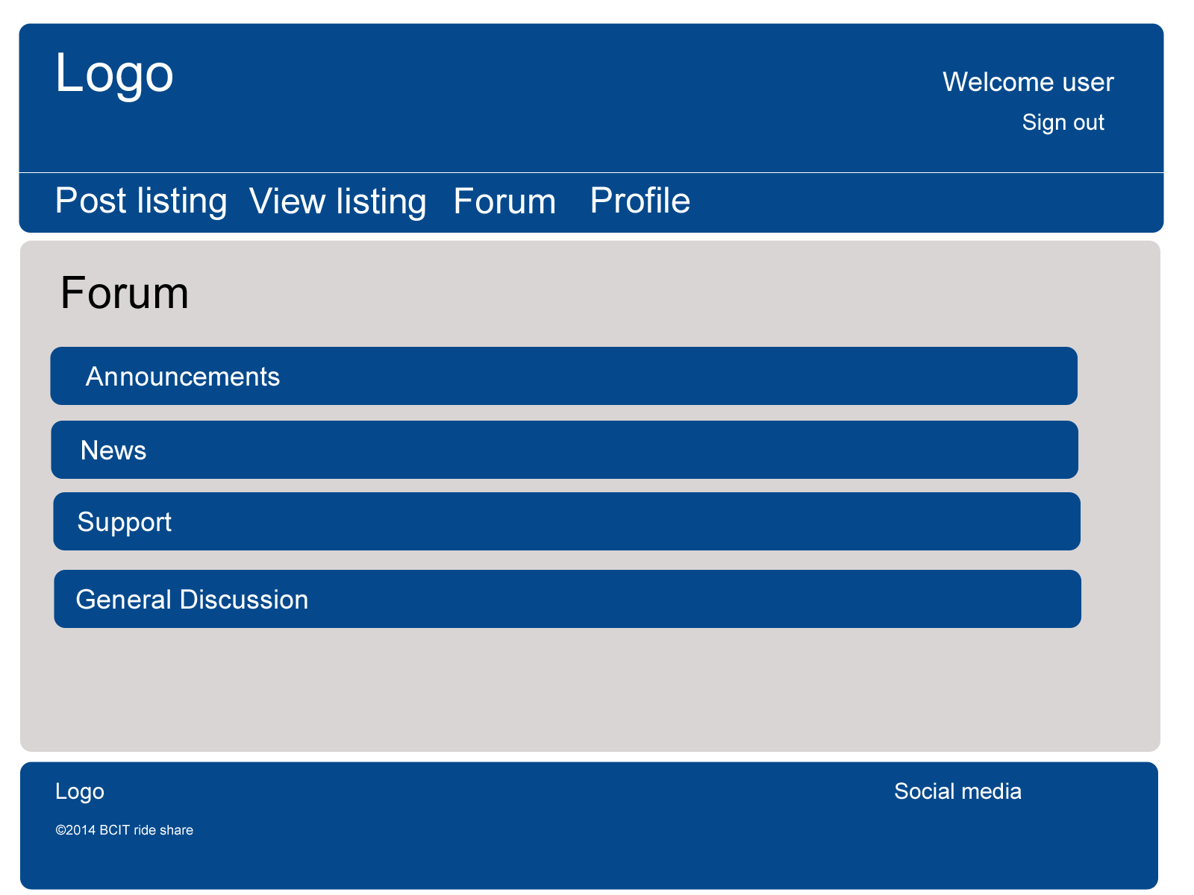

List View

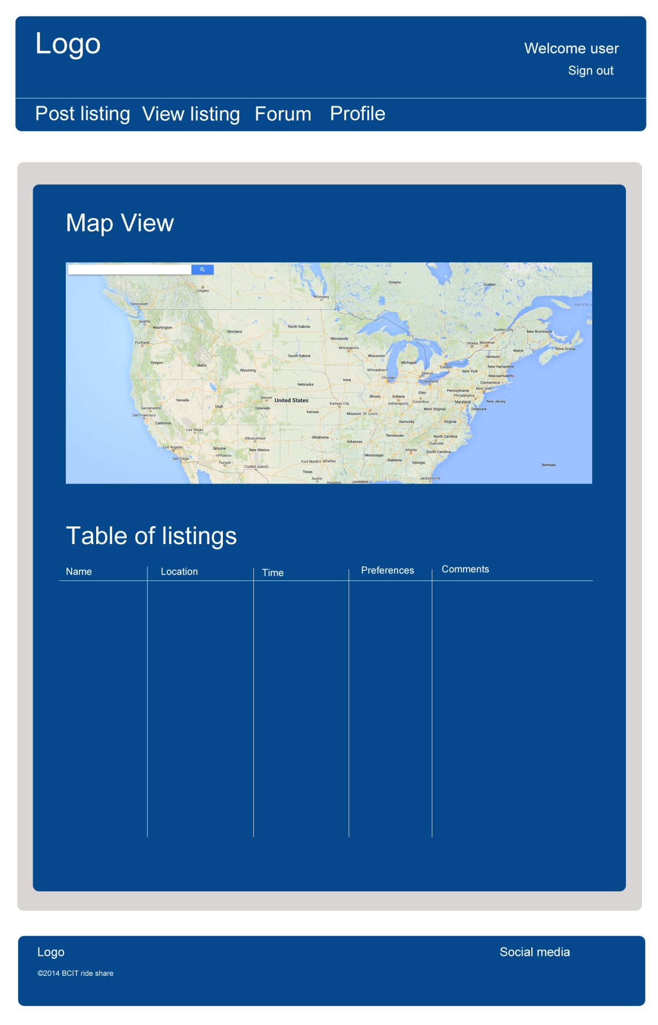

**5. New Additions**

Milestone 4

* Added AJAX for pages for all pages, minus the logged in pages.
* Added validation to all for fields, look at *Milestone4FieldDocumentation.docx* for more information
* Added ability to be able check if current address is located correctly on Google maps
* Warnings are now inline using a span tag.
* Now able to submit pages even with Javascript disabled.
* Email validation now uses official RFC 5322 standard
* Removed header and footer for all pages to be loaded by AJAX.

Success and problems faced with this milestone:

Problems:

A problem that came up was that we were not able to load in Google maps via AJAX. This problem still persists because Google does not support loading it in this way. We also had a tough time validating all of our code because when different parts were loaded in via AJAX we could not put it into the validator.

Success:

One success story from this milestone is that we got Google maps to calculate the coordinate of your address, and redraw it out onto a map. This way we can verify that the user entered in a correct address, and save this coordinate into an SQL database where it can be reshown to other users. Some other success that we had was that using REGEX we can validate if someone is using a valid 604 or 778 phone number. The biggest success that we had was implementing AJAX into the beginning part of our website even though Google maps did not support it.

Milestone 5

- Added ability to login, and log out

- Added ability to change profile, and delete account

- Added ability to post listing with a map to reflect these postings

- Added ability to search through listings according to time, day of week, and type of passenger.

- Removed table view

- Added ability to set individual times for each day when posting a listing.