NAME Set

COMP 4560 | DUE: Week of September 21, start of lab

Laboratory Assignment #1

When two regions of identical color/brightness are viewed against backgrounds of different colors/brightnesses, most people perceive them to have different colors/brightnesses – when the background is dark, the region looks brighter than when the background is light. It probably occurs to you that this is not surprising – anything should look brighter against a dark background than a light background because of the increased contrast.
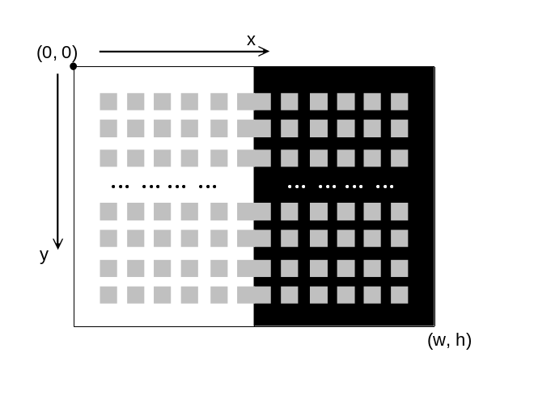

But the human perceptual system is not nearly that simple or predictable. For this second exercise, you will set up a simple example where exactly the opposite occurs (as well as at least one other well-known visual illusion makes an appearance)! Sometimes the main effect to be produced here is called “brightness assimilation” (with a cameo appearance of the so-called Hermann’s grid illusion). The setup is shown to the right in a rough schematic form:

The details are:
- the drawing area is divided vertically into two halves, one having a very light background color such as white, and the other having a very dark background color, such as black.
- superimposed on this background is a grid of squares of a uniform lightish color such as a light gray, each measuring s pixels by s pixels, separated vertically and horizontally by channels of width g pixels. The grid is set up so that the squares along the vertical midline abut each other (there is no vertical gap between the two center columns).
- the grid of small squares is set up so that there is a bordering gap around the top, bottom, left and right hand sides of the background which is at least as wide as 2s + g.

Note that although the sketch above shows 8 rows of 12 small squares, the actual number of rows and columns of small squares will depend on the relative sizes of s, g, w, and h.

Your task in this assignment is to set up some fairly specific pseudocode to produce the above grid of small squares, assuming the identifiers s, g, w, and h have already been given defined integer values. You may assume you have access to a function

rectangle(ulx, uly, brx, bry)

which will produce the image of a rectangle of some predefined color with upper-left corner at (ulx, uly) and bottom-right corner at (brx, bry). Your pseudocode may not make any assumptions about the relative values of s, g, w, and h – it must produce a new image conforming to the three rules above if one or more of these four parameters are changed.
Hints:
- the pattern must be symmetric about the vertical dividing line down the center of the drawing region. You will probably find it easiest to do the “drawing” with reference to that location rather than with reference to the left side of the drawing region. There is no need to center the pattern vertically on the drawing region.
- obviously you will be producing a sequence of rows, each of which consist of a sequence of elements. This means that you will be designing nested loop(s) at least two levels deep. You cannot accomplish this diagram with a reasonable amount of complexity using just a single level loop.
- there are several different types of loop control one might contemplate. In this case, drawing needs to stop when the next row or column would violate the border rule given above. This means that a control structure using the keyword “while” might be easier to implement than one using the keyword “for.”
- Note that the function “rectangle(ulx, uly, brx, bry)” produces the entire rectangle of the indicated dimensions. You do not have to draw that rectangle pixel by pixel.

Write down your pseudocode here. Please include “comments” to help me understand the intention of the elements of your algorithm. Do not include pseudocode for operations not described in the box above.

