Antonio Skilton

September 20, 2016

Advertising Spending Strategy Memo

This dataset makes clear that the product sells best in urban and suburban markets[1], that sales are higher in markets with high television spending[2], and that newspaper advertising is the weakest of the three advertising options in all markets[3].

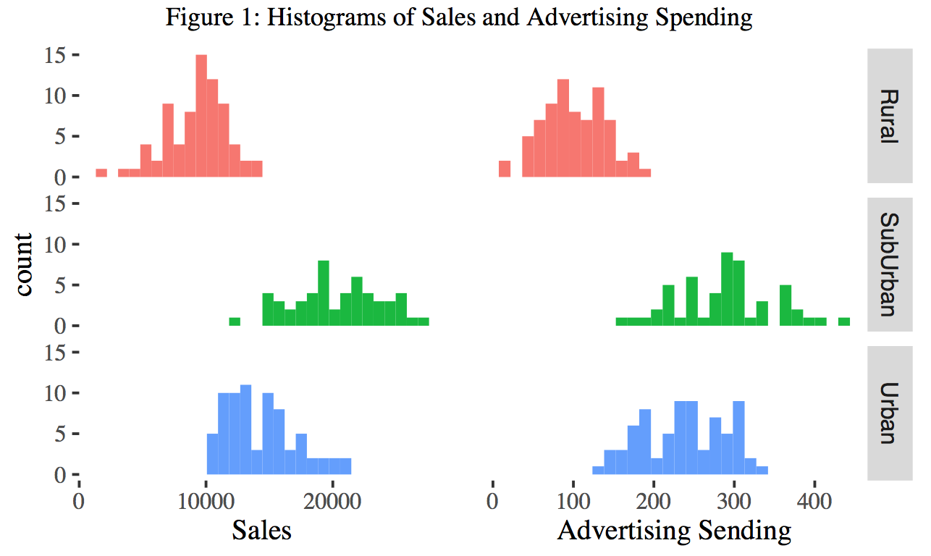The histograms below show the revenue from sales as well as total advertising spending (both in thousands of dollars), grouped by both advertising medium and market type. Advertising spending is higher in markets which relatively higher sales. As stated above, those are suburban and urban markets (in that order) While we can’t whether advertising spending actually causes sales in these markets, it is likely that allocating spending in this way is a safe bet.

The plots in Figure 2 show that not all advertising spending are tied to higher spending in all markets.[4] In particular, newspaper advertising spending across the newspaper advertising is shown to be ineffective in all markets. According to this data, the most effective way to increase sales revenue is to increase spending in radio advertising in suburban and urban markets.[5]

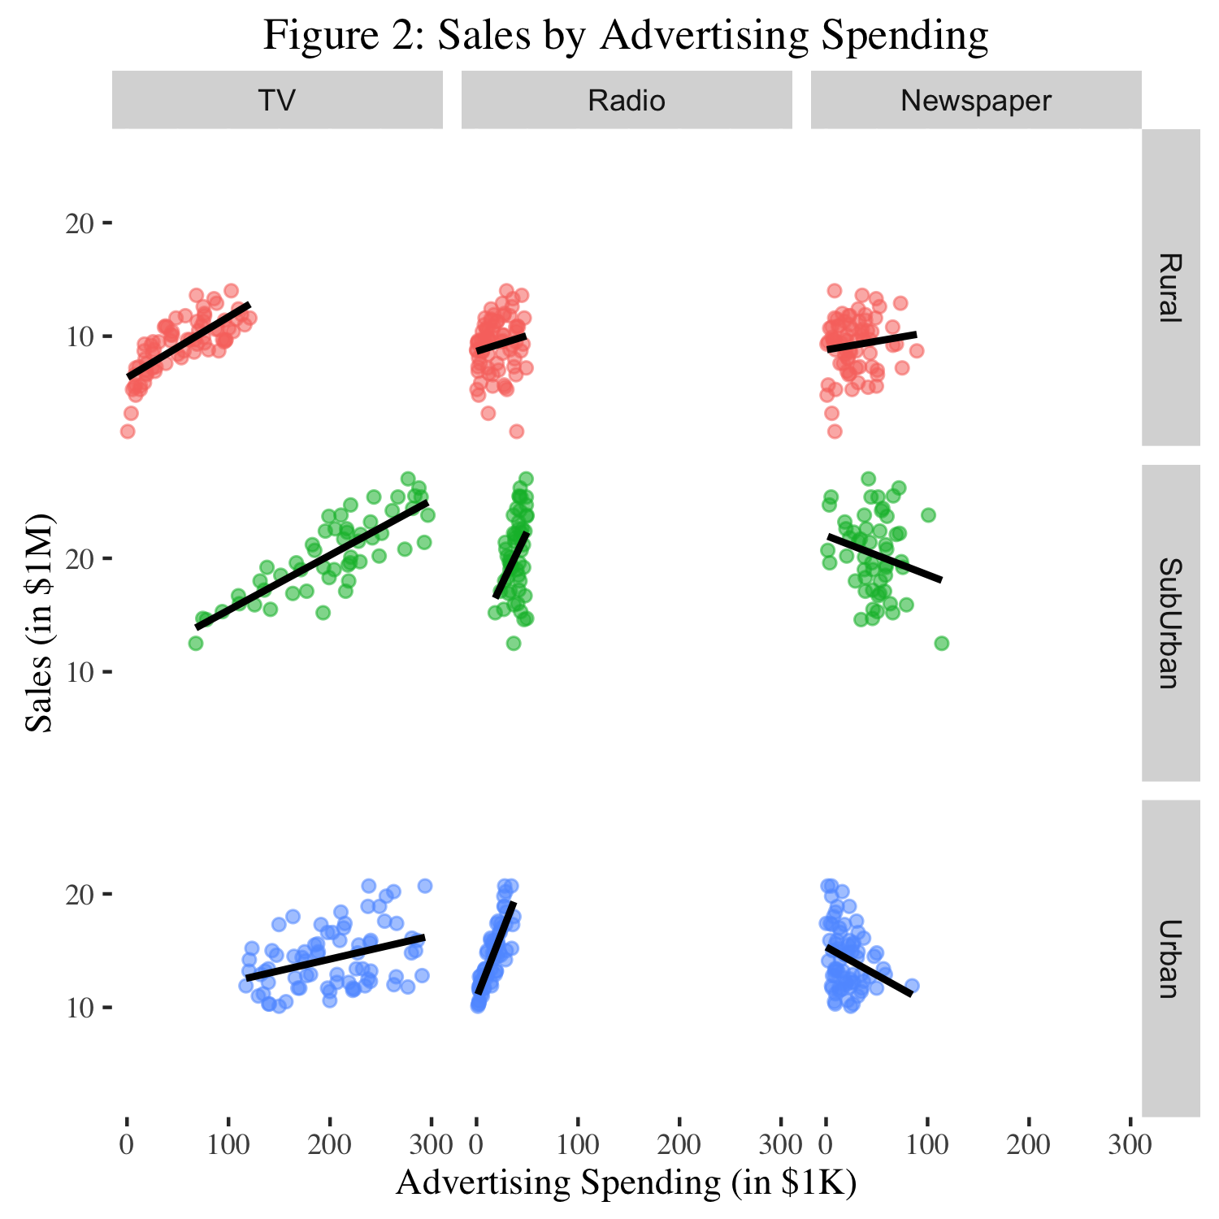

However, as is evident in Figure 2 above and Table 2 below, the amount of spending in radio and newspaper advertising markets is well below what is spent in television advertising. We do not have any way to guess how efficient radio advertising spending might be if we spent an amount in the range typical for television advertising spending. This is an important caveat that must guide future marketing strategy.

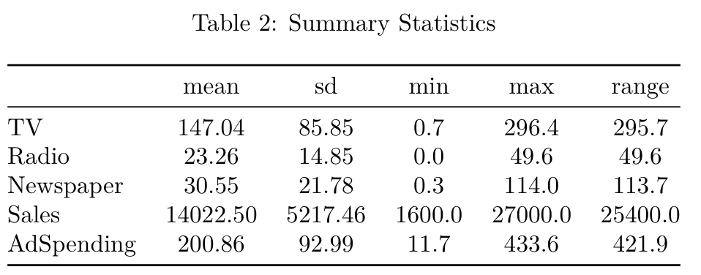

1. First column of Figure 2, Figure 3 in appendix.
2. First column of Figure 4 in appendix.
3. Table 3 in appendix.
4. The plots depicting television advertising in rural and suburban markets both show that markets in which advertising spending is higher are also likely to experience higher sales.
5. Table 4 of the appendix