# HBC Infrastructure Cost and Scaling Plan

## Overview

This document summarizes the projected infrastructure costs for the Hindu Business Community (HBC) platform over a 12-month timeline, including stacked cost estimates for hosting, backend services, and scaling considerations.

## Monthly Infra Cost Breakdown

Month 1–2 (100–1000 users): Vercel: ₹0, Supabase: ₹0 — Free tier

Month 3–4 (1000–3000 users): Vercel: ₹1700, Supabase: ₹1700 — Pro plans start

Month 5–8 (3000–9000 users): Vercel: ₹3400, Supabase: ₹5100 — Storage and edge functions scaling

Month 9–12 (10,000–15,000 users): Vercel: ₹6800, Supabase: ₹8500 — High concurrency and autoscale

## Stacked Cost Chart

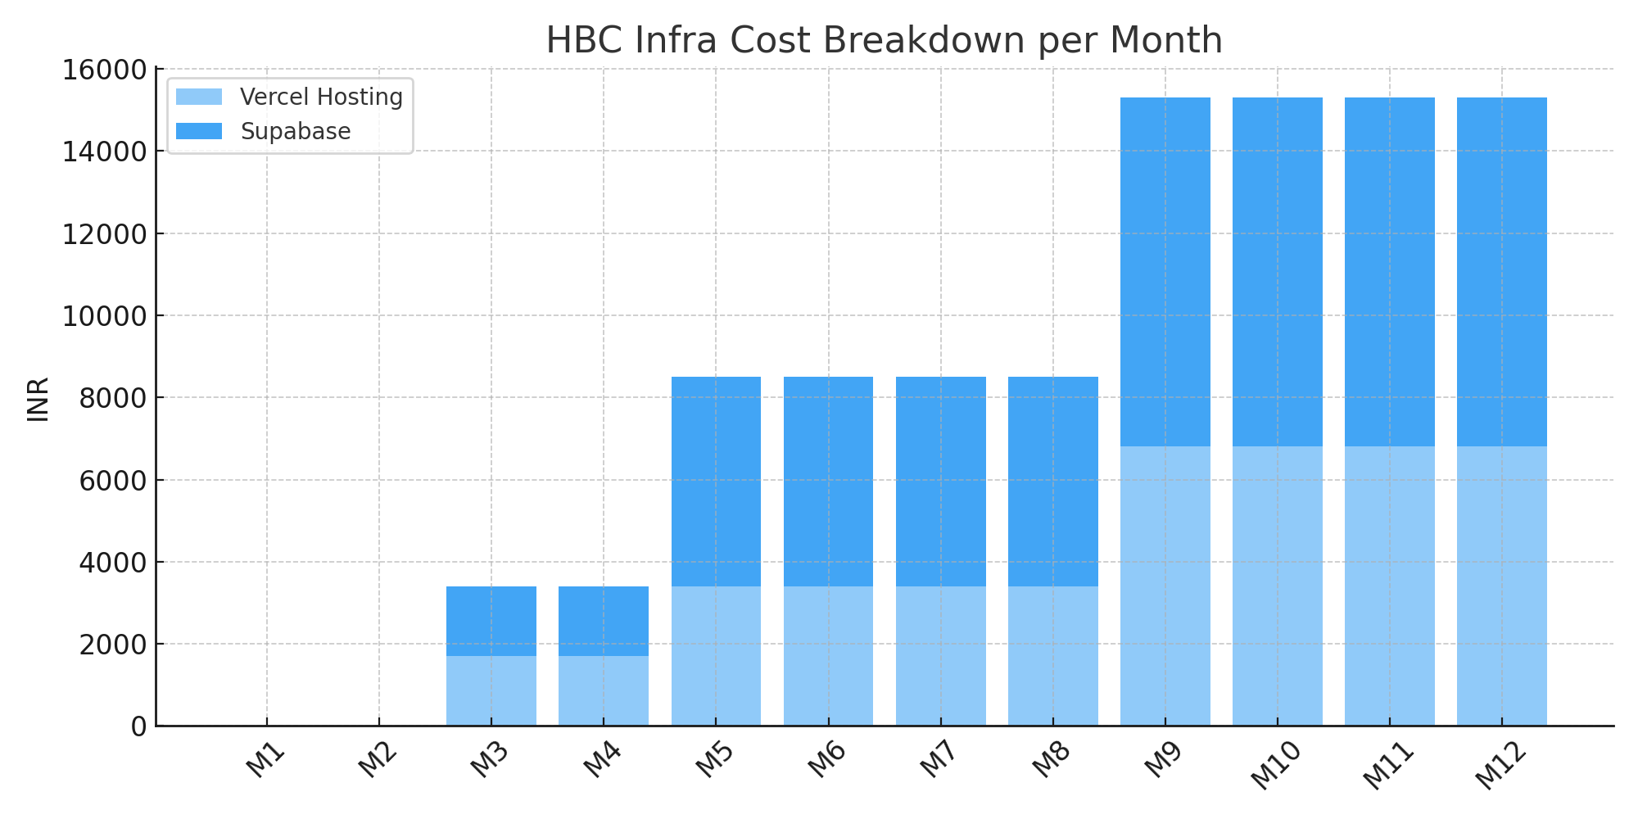

## Scaling Plan Highlights

- Use Vercel for frontend deployment (SSR + CDN autoscaling)

- Use Supabase for backend (PostgreSQL, Auth, Storage, Realtime)

- Enable RLS and backup from Day 1

- Introduce Edge Functions, Invoices, Campaign Features gradually

- Use Resend/SMTP for email delivery

- Plan upgrade milestones: Month 3, 5, 9