1. Create a Storage Account in Azure for Terraform State

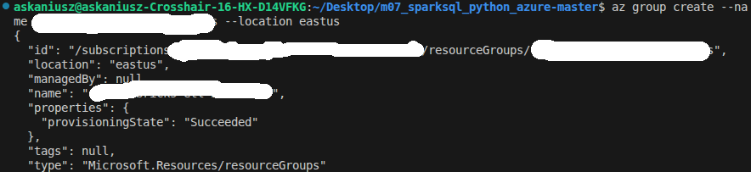
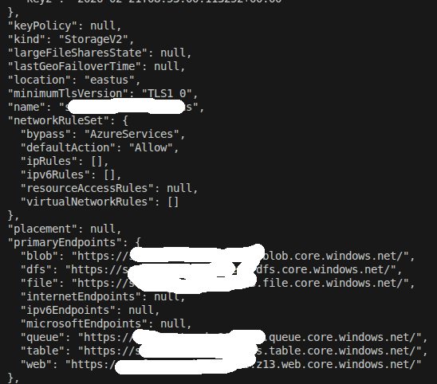

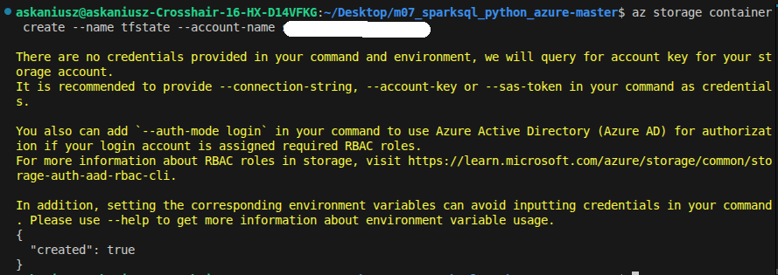

3. Update Terraform Configuration

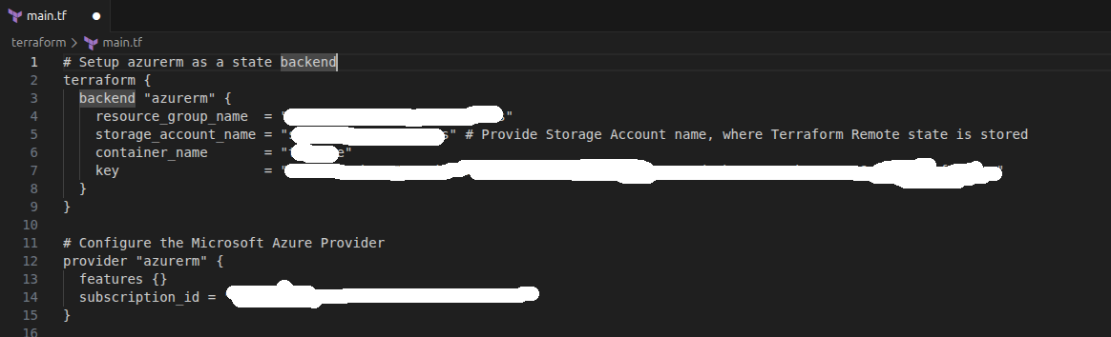

4. Deploy Infrastructure with Terraform

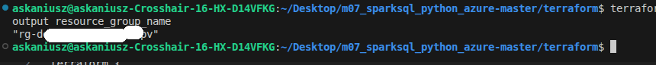
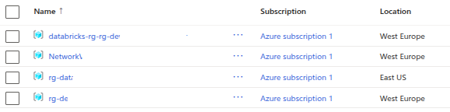
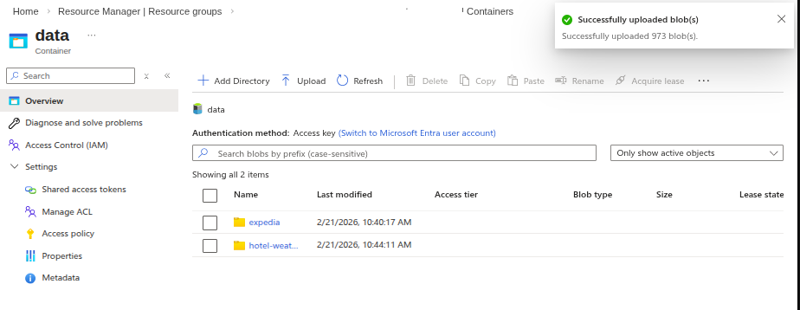

6. Launch notebooks on Databricks cluster

Create cluster

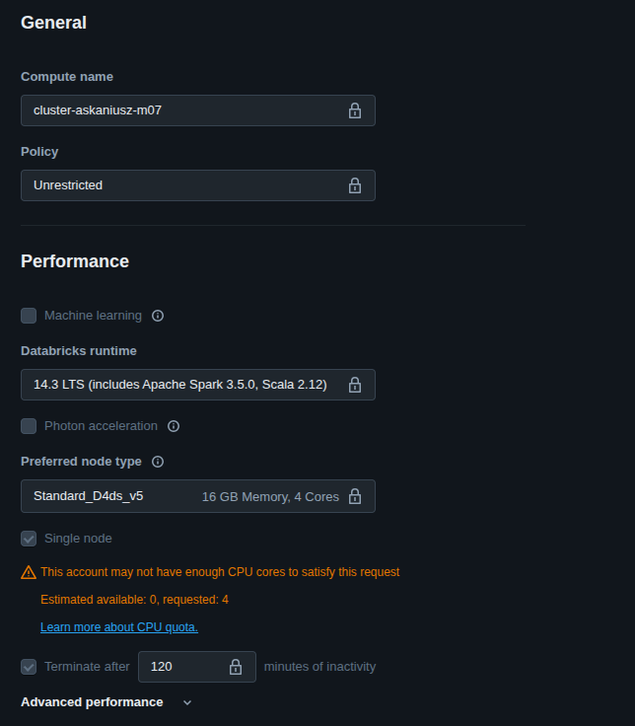

Create Databricks Notebook → 01_create_metadata
Create three schemas: bronze, silver and gold.

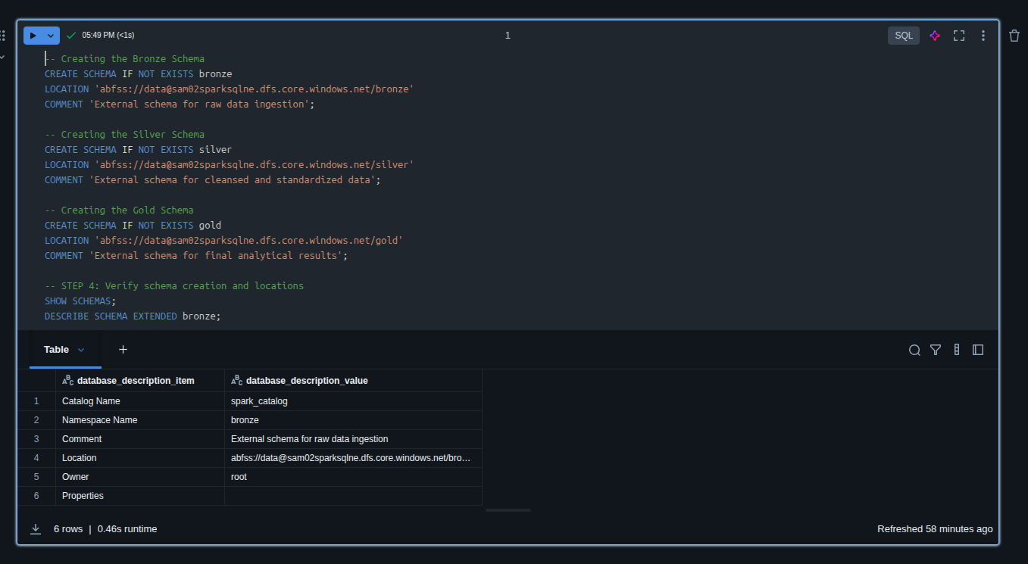

Encrypt Personally Identifiable Information (PII) fields to protect sensitive data.

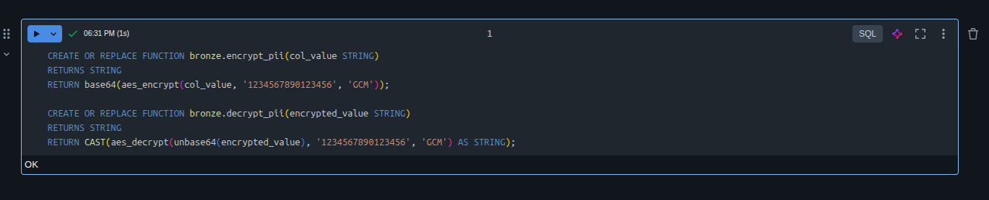

Load bronze data

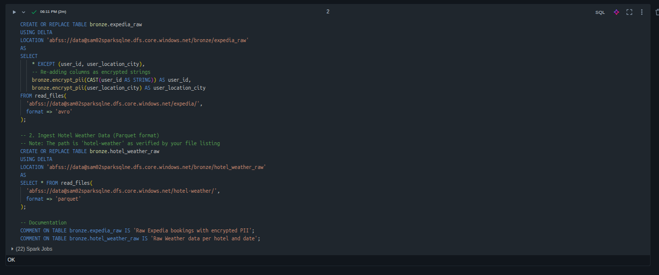

Bronze to Silver

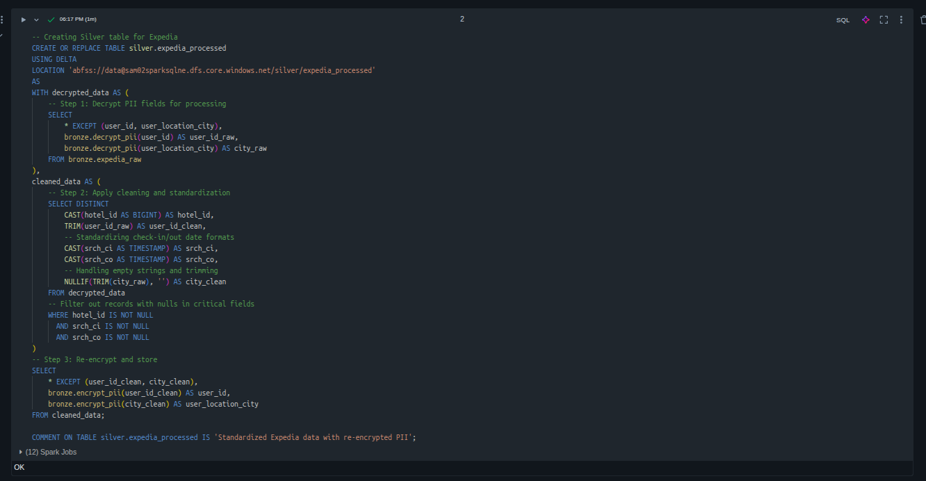
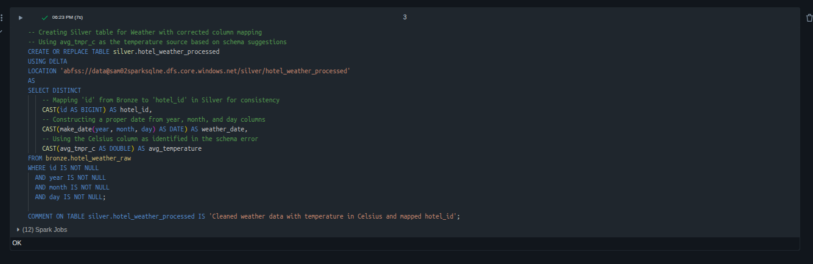

Silver to Gold

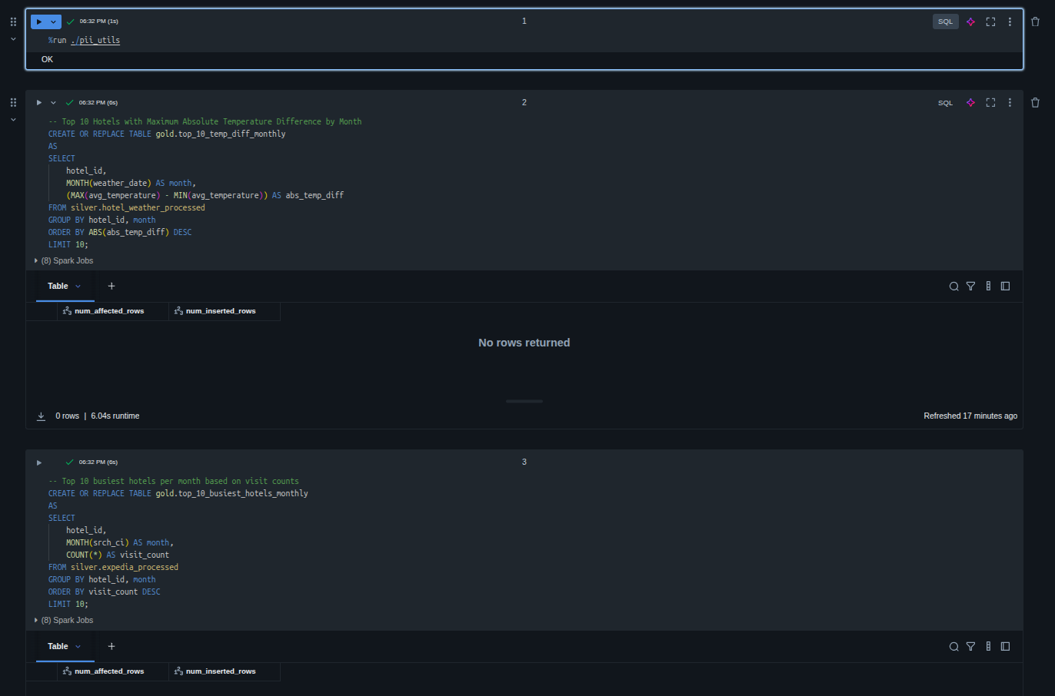
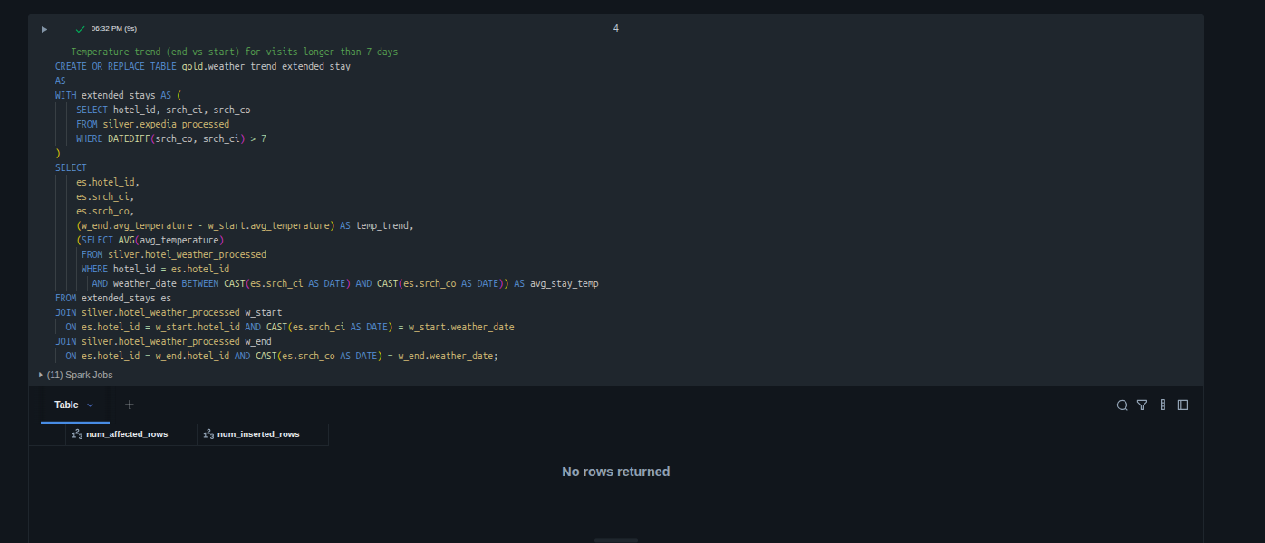

Orchestrate the Jobs via Databricks Workflow

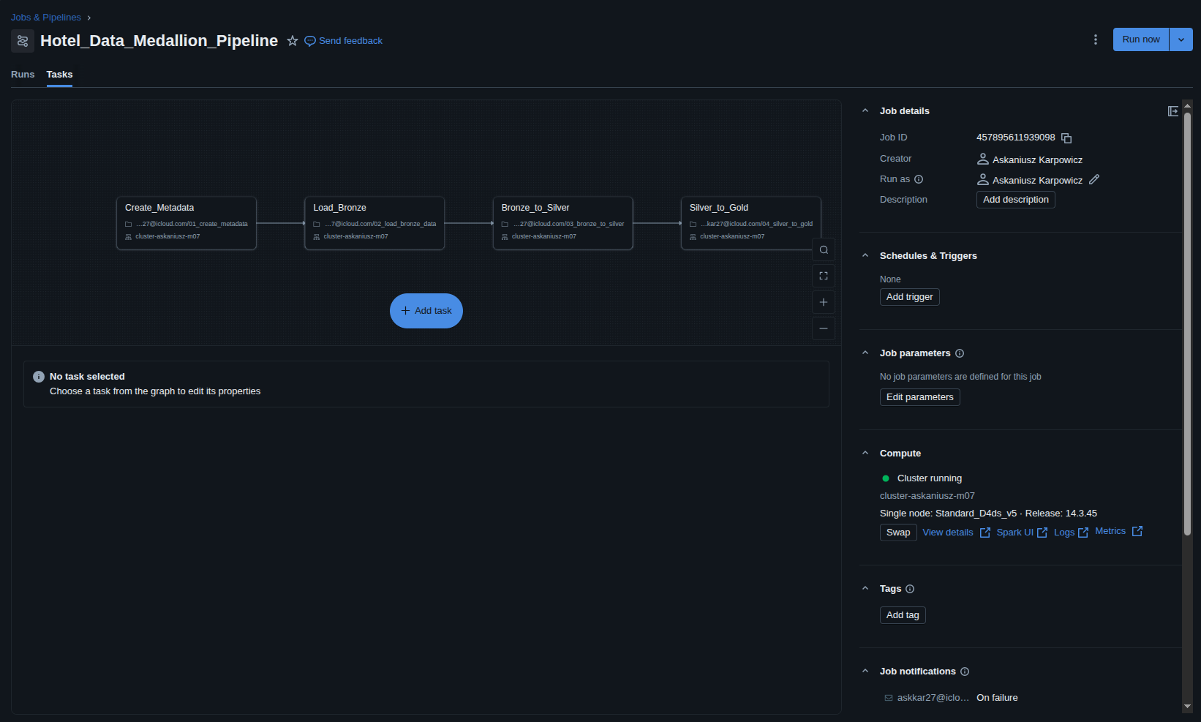
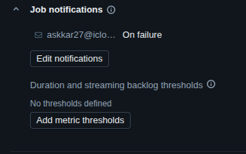

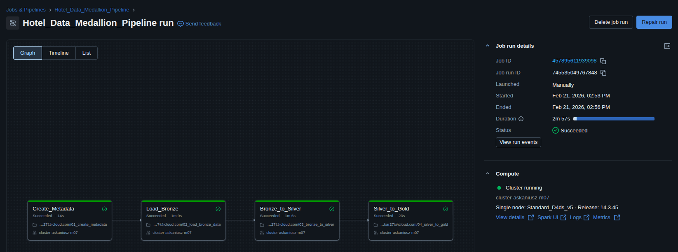

Check data after Workflow
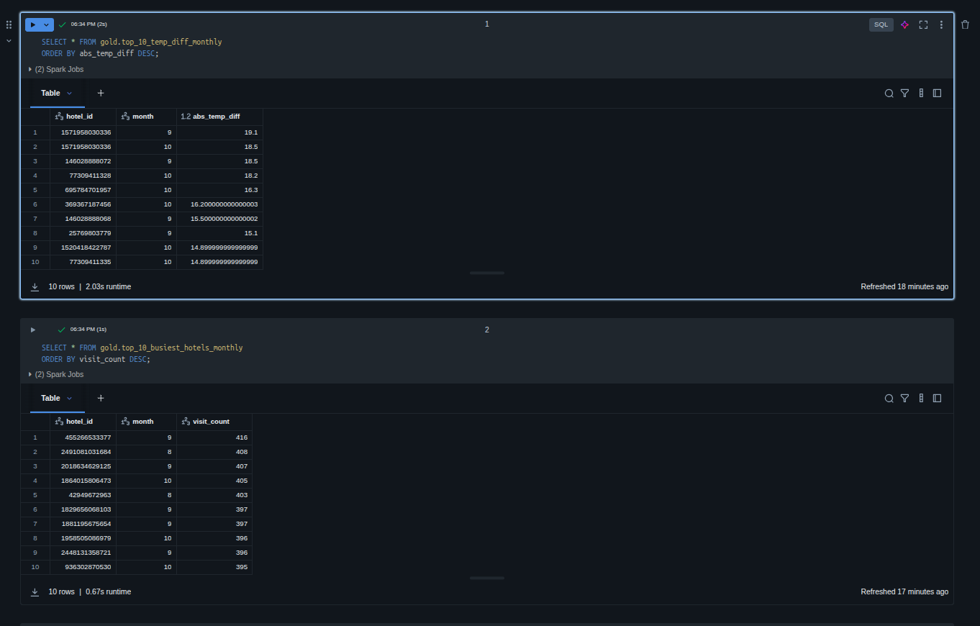

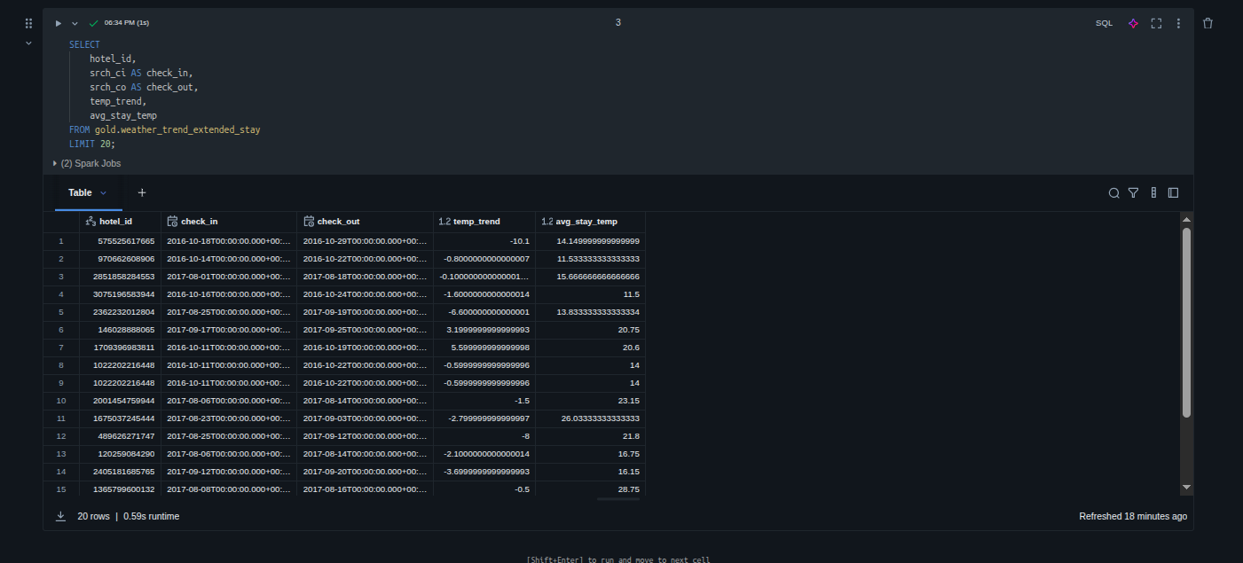

7. Destroy Infrastructure

