**Ashesh Kumar**

**501254**

**I.T. – 6**

**Q. To implement CORBA.**

**Hello.idl**

module HelloApp

{

interface Hello

{

string sayHello();

oneway void shutdown();

};

};

**HelloClient.java**

import HelloApp.*;

import org.omg.CosNaming.*;

import org.omg.CosNaming.NamingContextPackage.*;

import org.omg.CORBA.*;

public class HelloClient

{

static Hello helloImpl;

public static void main(String args[])

{

try{

// create and initialize the ORB

ORB orb = ORB.init(args, null);

// get the root naming context

org.omg.CORBA.Object objRef =

orb.resolve_initial_references("NameService");

// Use NamingContextExt instead of NamingContext. This is

// part of the Interoperable naming Service.

NamingContextExt ncRef = NamingContextExtHelper.narrow(objRef);

// resolve the Object Reference in Naming

String name = "Hello";

helloImpl = HelloHelper.narrow(ncRef.resolve_str(name));

System.out.println("Obtained a handle on server object: " + helloImpl);

System.out.println(helloImpl.sayHello());

helloImpl.shutdown();

} catch (Exception e) {

System.out.println("ERROR : " + e) ;

e.printStackTrace(System.out);

}

}

}

**HelloServer.java**

import HelloApp.*;

import org.omg.CosNaming.*;

import org.omg.CosNaming.NamingContextPackage.*;

import org.omg.CORBA.*;

import org.omg.PortableServer.*;

import org.omg.PortableServer.POA;

import java.util.Properties;

class HelloImpl extends HelloPOA {

private ORB orb;

public void setORB(ORB orb_val) {

orb = orb_val;

}

// implement sayHello() method

public String sayHello() {

return "\nHello world !!\n";

}

// implement shutdown() method

public void shutdown() {

orb.shutdown(false);

}

}

public class HelloServer {

public static void main(String args[]) {

try{

// create and initialize the ORB

ORB orb = ORB.init(args, null);

// get reference to rootpoa & activate the POAManager

POA rootpoa = POAHelper.narrow(orb.resolve_initial_references("RootPOA"));

rootpoa.the_POAManager().activate();

// create servant and register it with the ORB

HelloImpl helloImpl = new HelloImpl();

helloImpl.setORB(orb);

// get object reference from the servant

org.omg.CORBA.Object ref = rootpoa.servant_to_reference(helloImpl);

Hello href = HelloHelper.narrow(ref);

// get the root naming context

// NameService invokes the name service

org.omg.CORBA.Object objRef =

orb.resolve_initial_references("NameService");

// Use NamingContextExt which is part of the Interoperable

// Naming Service (INS) specification.

NamingContextExt ncRef = NamingContextExtHelper.narrow(objRef);

// bind the Object Reference in Naming

String name = "Hello";

NameComponent path[] = ncRef.to_name( name );

ncRef.rebind(path, href);

System.out.println("HelloServer ready and waiting ...");

// wait for invocations from clients

orb.run();

}

catch (Exception e) {

System.err.println("ERROR: " + e);

e.printStackTrace(System.out);

}

System.out.println("HelloServer Exiting ...");

}

}

**Server Side**

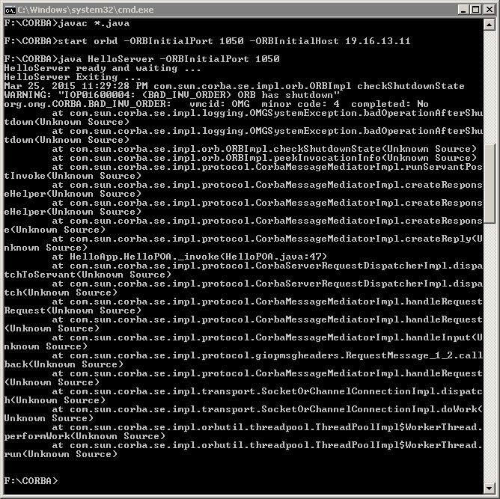

**Client Side**

