**Q. To implement .Net Remoting**

**TicketServer.cs**

using System;

using System.Runtime.Remoting;

using System.Runtime.Remoting.Channels;

using System.Runtime.Remoting.Channels.Tcp;

class Program {

static void Main(string[] args) {

TicketServer();

}

static void TicketServer() {

Console.WriteLine("Ticket Server started...");

TcpChannel tcpChannel = new TcpChannel(9998);

ChannelServices.RegisterChannel(tcpChannel);

Type commonInterfaceType = Type.GetType("MovieTicket");

RemotingConfiguration.RegisterWellKnownServiceType(commonInterfaceType, "MovieTicketBooking", WellKnownObjectMode.SingleCall);

System.Console.WriteLine("Press ENTER to quitnn");

System.Console.ReadLine();

}

}

public interface MovieTicketInterface {

string GetTicketStatus(string stringToPrint);

}

public class MovieTicket: MarshalByRefObject,

MovieTicketInterface {

public string GetTicketStatus(string stringToPrint) {

string returnStatus = "Ticket Confirmed";

Console.WriteLine("Enquiry for {0}", stringToPrint);

Console.WriteLine("Sending back status: {0}", returnStatus);

return returnStatus;

}

**Client.cs**

using System;

using System.Runtime.Remoting;

using System.Runtime.Remoting.Channels;

using System.Runtime.Remoting.Channels.Tcp;

class MyClient {

public static void Main() {

TcpChannel tcpChannel = new TcpChannel();

ChannelServices.RegisterChannel(tcpChannel);

Type requiredType = typeof(MovieTicketInterface);

MovieTicketInterface remoteObject = (MovieTicketInterface) Activator.GetObject(requiredType, "tcp://localhost:9998/MovieTicketBooking");

Console.WriteLine(remoteObject.GetTicketStatus("Ticket No: 3344"));

}

}

**Steps :**

**Step 1 ) Create 2 new C# console application projects**

1. **TicketServer**

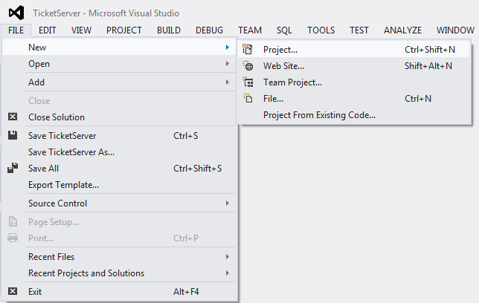

1. **Client**

Repeat same procedure for client and save it as “Client.cs”

**Step 2 : Now for using Remoting Packages perform the following step.**

**On the right side in the solution explorer.**

Click on the References and under Assemblies search for **“System.Runtime.Remoting”**

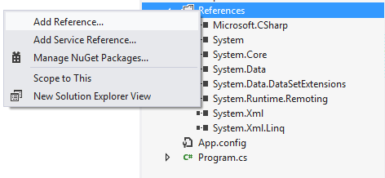

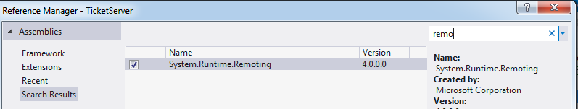

Repeat the same procedure for adding the Remoting Reference in Client project also.

**Step 3: Copy the server code in TicketServer.cs project and client code in Client.cs project**

**Step 4: Build both the projects and now the “.exe” file will be created in the project folder**

**Step 5: Now here we have to link the server interface with the client and pass the object reference**

For linking the server’s TicketServer.exe file in the Client

Open the client project and in the solution explorer under the References Tab browse for **“TickerServer.exe”**

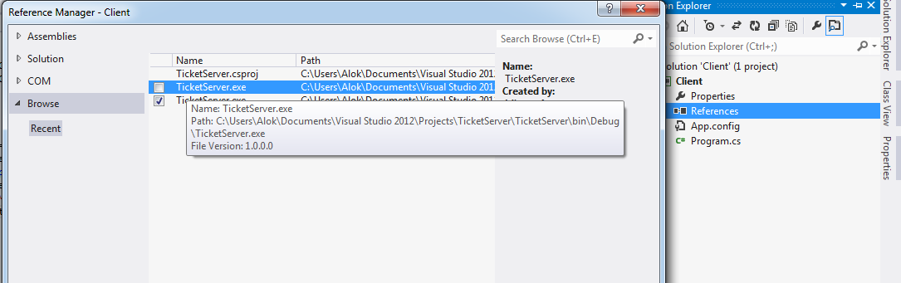

**Step 6: Rebuild both projects just to ensure that the References are linked and compiled properly.**

**Step 7: Now Debug both the projects. For debugging**

**For Server**

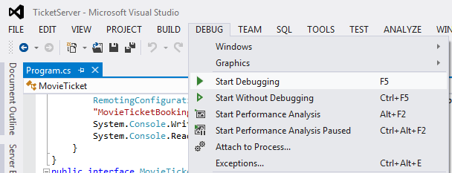

**And repeat the same for client also.**

**Output:**

**(when initially the server is running)**

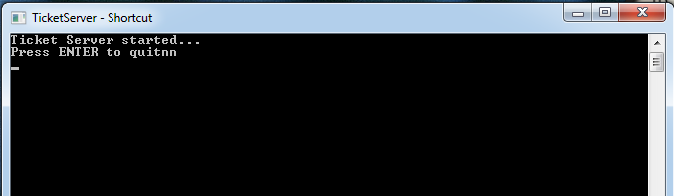

**(when the client in running)**

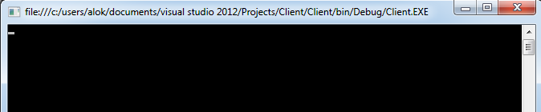

**(server window after client run)**

