**Ashesh Kumar**

**501254**

**I.T. – 6**

**Q. To implemnet Socket Programming.**

**GreetingServer.java**

import java.net.*;

import java.io.*;

public class GreetingServer extends Thread {

private ServerSocket serverSocket;

public GreetingServer(int port) throws IOException {

serverSocket = new ServerSocket(port);

//amount of time the server waits for any connection

serverSocket.setSoTimeout(10000);

}

public void run() {

while (true) {

try {

System.out.println("Waiting for client on port "

+ serverSocket.getLocalPort() + "...");

Socket server = serverSocket.accept();

System.out.println("Just connected to "

+ server.getRemoteSocketAddress());

//read in a string from the client

DataInputStream in

= new DataInputStream(server.getInputStream());

System.out.println(in.readUTF());

//write out a string to the client

DataOutputStream out

= new DataOutputStream(server.getOutputStream());

out.writeUTF("Thank you for connecting to "

+ server.getLocalSocketAddress() + "\nGoodbye!");

server.close();

} catch (SocketTimeoutException s) {

System.out.println("Socket timed out!");

break;

} catch (IOException e) {

e.printStackTrace();

break;

}

}

}

public static void main(String[] args) {

//assign command line arguments to port variables,

//should be a valid port number and be available

int port = Integer.parseInt(args[0]);

try {

Thread t = new GreetingServer(port);

t.start();

} catch (IOException e) {

e.printStackTrace();

}

}

}

**GreetingClient.java**

import java.net.*;

import java.io.*;

public class GreetingClient {

public static void main(String[] args) {

//assign command line arguments to variables

String serverName = args[0];

int port = Integer.parseInt(args[1]);

try {

System.out.println("Connecting to " + serverName

+ " on port " + port);

Socket client = new Socket(serverName, port);

System.out.println("Just connected to "

+ client.getRemoteSocketAddress());

//write out a string to the server

OutputStream outToServer = client.getOutputStream();

DataOutputStream out

= new DataOutputStream(outToServer);

out.writeUTF("Hello from "

+ client.getLocalSocketAddress());

//read in a string from the server

InputStream inFromServer = client.getInputStream();

DataInputStream in

= new DataInputStream(inFromServer);

System.out.println("Server says " + in.readUTF());

//closes the socket,

//which makes this Socket object no longer capable of connecting

client.close();

} catch (IOException e) {

e.printStackTrace();

}

}

}

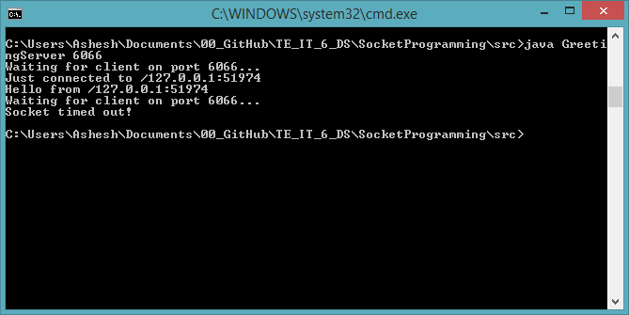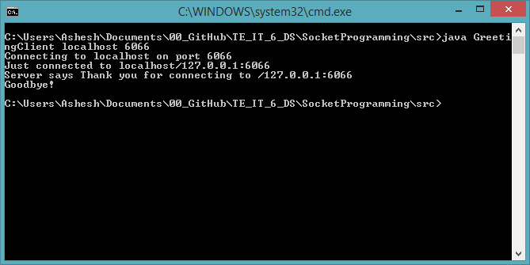**Server Side  
  
  
  
  
  
  
  
  
  
  
  
  
  
  
  
  
  
  
  
  
  
  
Client Side**