A game can be thought of as a tree of possible future game states. For example, in Tic-Tac-Toe the game state is the arrangement of the board, plus information about whose move it is. The current state of the game is the root of the tree (drawn at the top). In general this node has several children, representing all of the possible moves that we could make. Each of those nodes has children representing the game state after each of the opponent's moves. These nodes have children corresponding to the possible second moves of the current player, and so on. The leaves of the tree are final states of the game: states where no further move can be made because one player has won, or perhaps the game is a tie. Actually, in general the tree is a graph, because there may be more than one way to get to a particular state. In some games (e.g., checkers) it is even possible to revisit a prior game state.

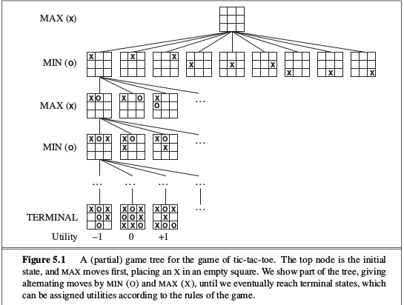
A game can be formally defined as a kind of search problem with the
following elements:
- S0: The initial state, which specifies how the game is set up at the start.
- PLAYER (s): Defines which player has the move in a state.
- ACTIONS (s): Returns the set of legal moves in a state.
- RESULT (s, a): The transition model, which defines the result of a move.
- TERMINAL-TEST (s): A terminal test, which is true when the game is over and false otherwise. States where the game has ended are called terminal states.
- UTILITY (s, p): A utility function (also called an objective function or payoff function), defines the final numeric value for a game that ends in terminal state s for a player p. In chess, the outcome is a win, loss, or draw, with values +1, 0, or 1/2 .

Minimax search
If we can traverse the entire game tree, we can figure out whether the game is a win for the current player assuming perfect play: we assign a value to the current game state by we recursively walking the tree. At leaf nodes we return the appropriate values. At nodes where we get to move, we take the max of the child values because we want to pick the best move; at nodes where the opponent moves we take the min of child values. This gives us the following pseudo-code procedure for minimax evaluation of a game tree.

fun minimax(n: node): int =
if leaf(n) then return evaluate(n)
if n is a max node
v := L
for each child of n
v' := minimax (child)
if v' > v, v:= v'
return v
if n is a min node
v := W
for each child of n
v' := minimax (child)
if v' < v, v:= v'
return v

Alpha-Beta Pruning
The problem with minimax search is that the number of game states it has to examine is exponential in the depth of the tree. Unfortunately, we can’t eliminate the exponent, but it turns out we can effectively cut it in half. The trick is that it is possible to compute the correct minimax decision without looking at every node in the game tree. That is, we can borrow the idea of pruning from Chapter 3 to eliminate large parts of the tree from consideration. The particular technique we examine is called alpha–beta pruning. When applied to a standard minimax tree, it returns the same move as minimax would, but prunes away branches that cannot possibly influence the final decision.

fun alphabeta(n: node, d: int, min: int, max: int): int =
if leaf(n) or depth=0 return evaluate(n)
if n is a max node
v := min
for each child of n
v' := alphabeta (child,d-1,v,max)
if v' > v, v:= v'
if v > max return max
return v
if n is a min node
v := max
for each child of n
v' := alphabeta (child,d-1,min,v)
if v' < v, v:= v'
if v < min return min
return v

