Week 1 Report: Exploratory Data Analysis of EEG Seizure Dataset

1. Objective
The objective of Week 1 was to understand the EEG seizure dataset, verify its structure and integrity, explore label distributions and subject-wise imbalance, and perform initial exploratory data analysis (EDA) in the time domain and frequency domain. This step establishes a foundation for subsequent seizure detection and prediction modeling.

2. Dataset Description
The EEG dataset used in this study consists of segmented electroencephalogram (EEG) time-series recordings from ten epilepsy patients, collected at the Neurology & Sleep Centre, Hauz Khas, New Delhi, in collaboration with the Neurocomputing Laboratory, Indian Institute of Technology (IIT) Delhi.
EEG signals were acquired using the Grass Telefactor Comet AS40 Amplification System at a sampling frequency of 200 Hz. During acquisition, gold-plated scalp electrodes were positioned according to the standard international 10–20 electrode placement system, ensuring consistent and clinically accepted spatial coverage of brain activity.
To reduce noise and physiological artifacts, the recorded EEG signals were band-pass filtered between 0.5 Hz and 70 Hz. The continuous EEG recordings were subsequently segmented into three clinically relevant seizure stages:
- Interictal (non-seizure baseline),
- Pre-ictal (period preceding seizure onset), and
- Ictal (seizure activity).
Each dataset folder corresponds to a specific seizure stage and contains fifty MATLAB (.mat) files, with each file representing one EEG time-series segment. Each EEG segment consists of 1,024 samples, corresponding to a duration of 5.12 seconds.
This dataset is part of an ongoing research effort, and the complete EEG recordings are available upon request following publication. Users of this dataset are requested to cite the dataset source and associated manuscripts when publishing results derived from these signals.
The dataset consists of EEG clips stored in MATLAB (.mat) format, organized by subject. Subjects include both canine models (Dog_1–Dog_4) and human patients (Patient_1–Patient_8).
Each EEG clip contains:
- data: multichannel EEG signal
- freq: sampling frequency
- channels: channel metadata
- latency: seizure-related timing information (when available)

Key dataset statistics:
- Total clips: 58,837
- Sampling frequency: 5,000 Hz
- Clip duration: ~1 second (5,000 samples)
- Channels per clip: 16–55 (subject dependent)

3. Label Distribution and Dataset Imbalance

Overall class distribution
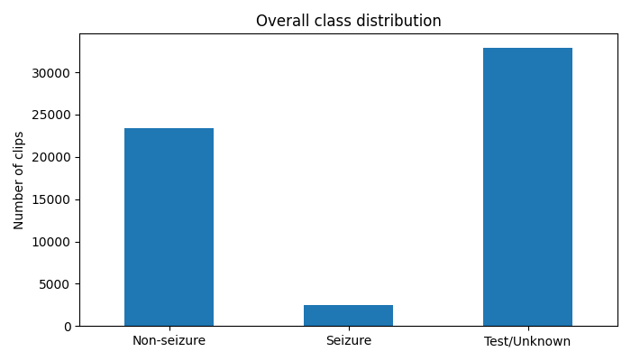

Figure 1: Overall Class Distribution
Figure 1. Overall distribution of EEG clips across non-seizure (interictal), seizure (ictal), and test/unknown classes. The dataset exhibits severe class imbalance, with seizure clips forming a small minority.
From metadata extraction:
Class | Count
Non-seizure (interictal) | 23,445
Seizure (ictal) | 2,477
Test / Unknown | 32,915
Observation:
The dataset is severely imbalanced, with seizure clips comprising ~4.2% of all data. A large portion of the dataset is unlabeled (test/unknown), which limits direct supervised learning without careful filtering.

4. Subject-wise Distribution Analysis

4.1 Labeled clips per subject (stacked bar plot)
- Every subject shows a dominant non-seizure class
- Seizure clips are consistently fewer than non-seizure clips
- Some subjects (e.g., Dog_3, Patient_6, Patient_7) contribute significantly more data than others
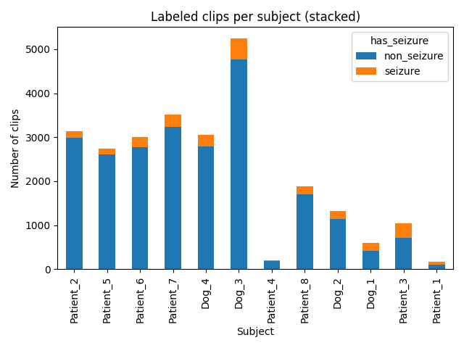

Figure 2: Labeled Clips per Subject
Figure 2. Subject-wise distribution of labeled EEG clips, showing non-seizure and seizure segments. All subjects exhibit strong class imbalance, with significantly fewer seizure clips.

4.2 Test/Unknown clips per subject
- The number of test/unknown clips varies widely across subjects
- Subjects such as Dog_3 and Patient_2 contain thousands of unlabeled clips
- This reinforces the need for careful dataset partitioning during modeling
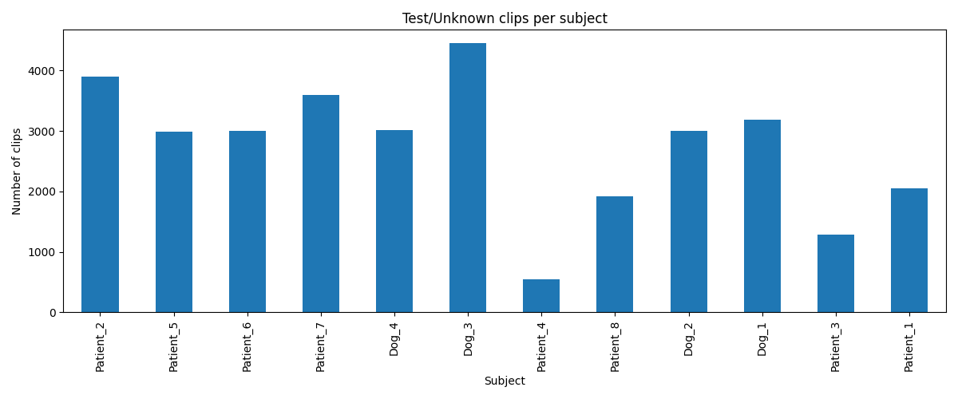

Figure 3: Test/Unknown Clips per Subject
Figure 3. Distribution of test/unknown EEG clips across subjects. A large proportion of the dataset remains unlabeled, motivating careful data filtering for supervised learning.

4.3 Seizure rate per subject
- Seizure rates among labeled clips range from ~5% to ~40%
- Subjects such as Patient_1 and Patient_3 exhibit higher seizure prevalence
Key Insight:
EEG seizure patterns are highly subject-dependent, indicating that subject-wise splits or cross-subject generalization analysis will be important in later stages.
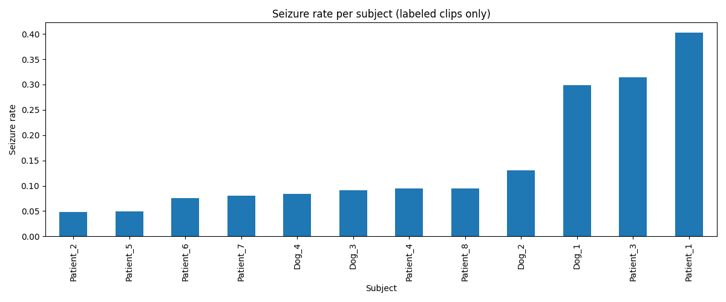

Figure 4: Seizure Rate per Subject
Figure 4. Seizure rate per subject computed using labeled clips only. The seizure prevalence varies substantially across subjects, indicating subject-specific seizure characteristics.

5. Time-Domain EEG Analysis

Raw EEG signals
Raw EEG plots for interictal, ictal, and test clips reveal:
- Clear oscillatory behavior across channels
- Interictal signals appear more regular and stable
- Ictal signals show increased amplitude, synchronization, and abrupt waveform changes
- Channel-to-channel variability is visible, reflecting spatial diversity of brain activity
Interpretation:
Seizures manifest as highly synchronized neural activity, observable even before frequency-domain analysis.
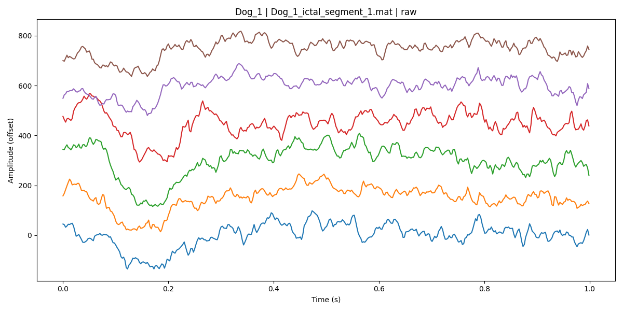

Figure 5: Ictal Raw EEG
Figure 5. Example ictal EEG clip showing increased amplitude, synchronization, and abrupt waveform changes across channels, characteristic of seizure activity.

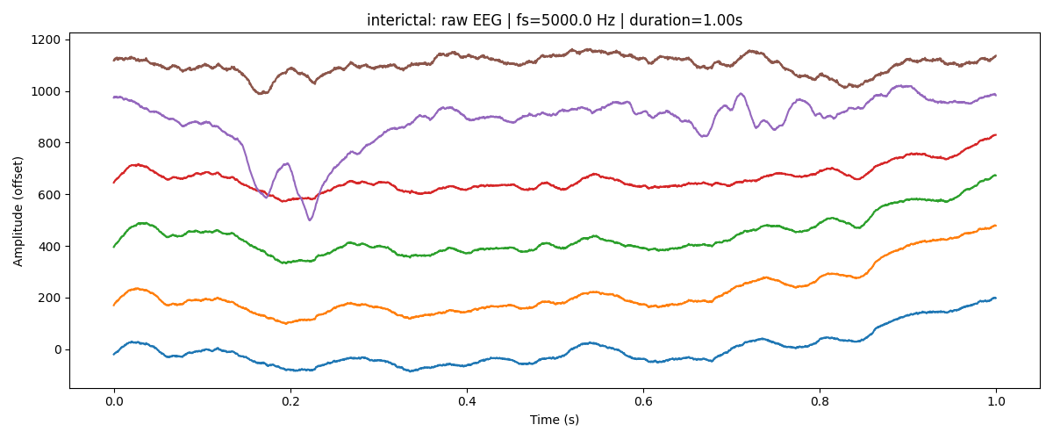

Figure 6: Interictal Raw EEG
Figure 6. Example interictal EEG clip showing raw multichannel signals (first six channels). Signals exhibit relatively stable and regular oscillatory patterns.

6. Frequency-Domain Analysis

6.1 Power Spectral Density (PSD)
Welch PSD plots demonstrate:
- Dominant energy in low-frequency bands
- Gradual power decay with increasing frequency
- Ictal clips exhibit higher overall power, especially at lower frequencies, compared to interictal clips
Interpretation:
This aligns with known seizure physiology, where abnormal rhythmic discharges amplify low-frequency EEG components.
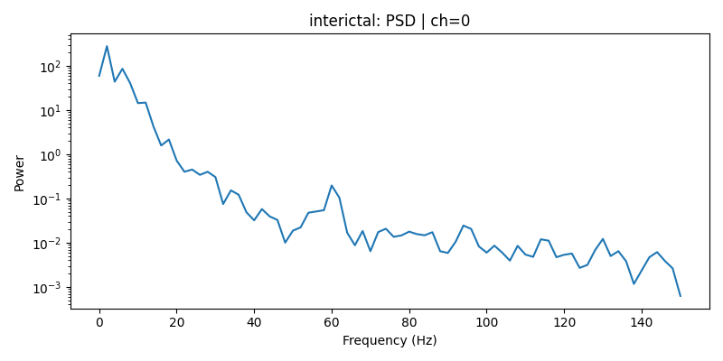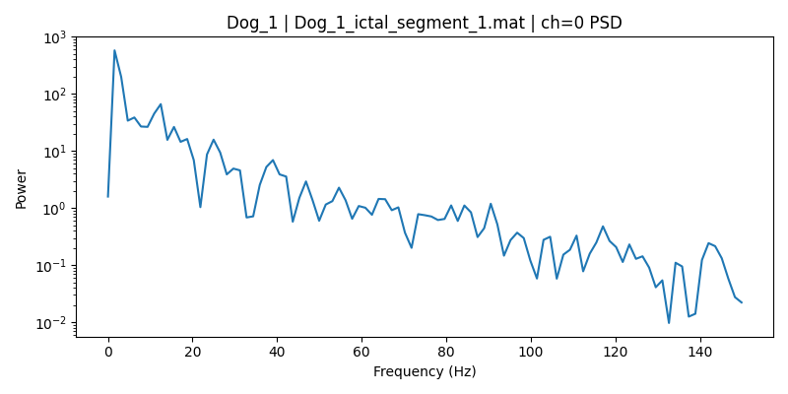

Figure 7: Power Spectral Density (PSD)
Figure 7. Power spectral density (Welch method) of an EEG channel comparing ictal and interictal clips. Seizure segments exhibit higher power, particularly in lower frequency bands

7. Time–Frequency Analysis (Spectrograms)

Spectrogram observations (0–150 Hz and 0–35 Hz views):
- Interictal clips show relatively stable power distribution over time
- Ictal clips show bursts of power and time-varying frequency activity
- Test clips often resemble interictal patterns but vary by subject
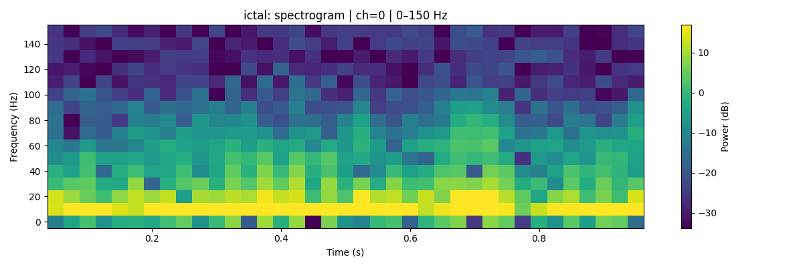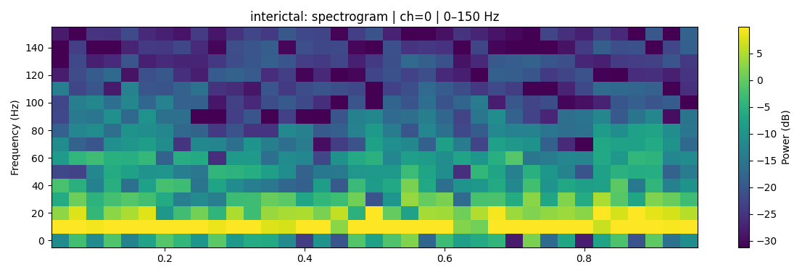
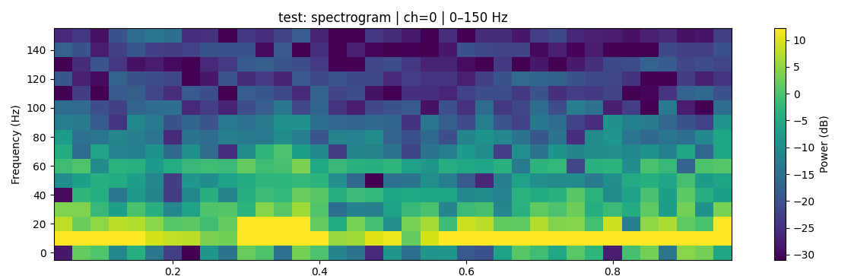
Low-frequency–focused spectrograms (0–35 Hz) clearly highlight:
- Delta (1–4 Hz) and theta (4–8 Hz) dominance
- Increased temporal structure during seizures
Interpretation:
Spectrograms effectively capture seizure dynamics and will be valuable inputs for deep learning models.

8. Band Power Analysis
Normalized band power plots (delta → gamma) show:
- Delta and theta bands dominate EEG energy
- Ictal clips often show relatively increased alpha and sigma power
- Gamma power remains low across all conditions
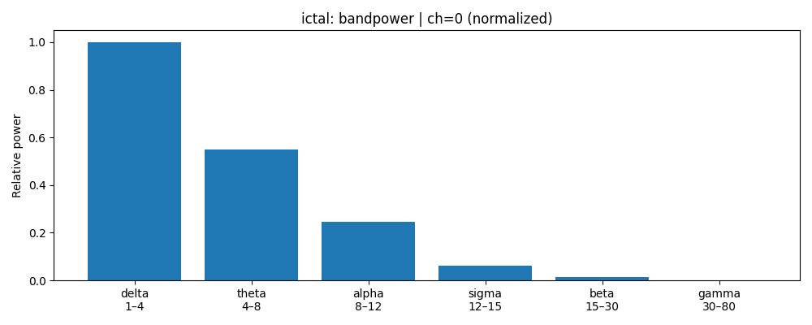
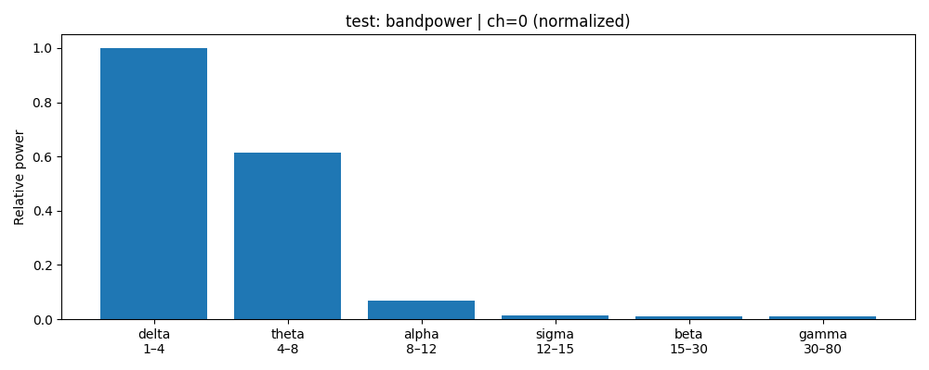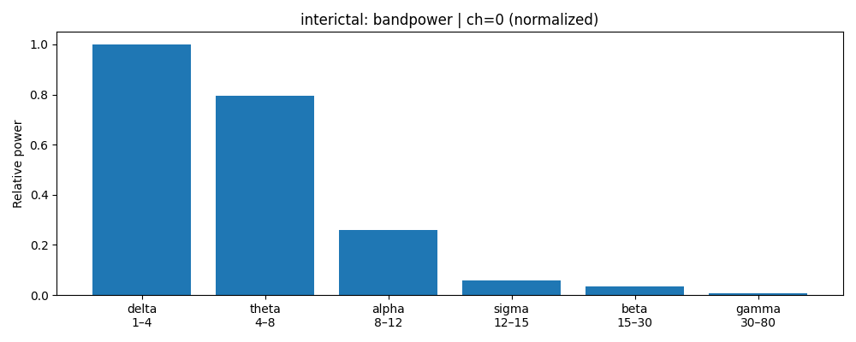
Key Insight:
Band power features provide compact, interpretable representations of seizure-related activity and are suitable for classical ML baselines.

9. Windowing Validation
Sliding-window segmentation was tested:
- Example output shape: (7, channels, window_samples)
- Confirms feasibility of converting clips into fixed-size windows
- Enables preparation for CNN, RNN, or Transformer-based architectures

10. Key Challenges Identified
- Severe class imbalance
- Large proportion of unlabeled data
- Subject-specific seizure characteristics
- High sampling rate → large data volume

11. Conclusions (Week 1)
Week 1 successfully:
- Validated dataset structure and integrity
- Identified strong class imbalance and subject dependence
- Demonstrated clear seizure signatures in time, frequency, and time–frequency domains
- Established a robust EDA and visualization pipeline
- Confirmed feasibility of feature extraction and windowing

