**Objective:**

Use CM tools such as Puppet, Ansible, or Chef to automate the installation of basic Drupal or WordPress. Setup a sample site. Automate the solution using Cloudformation template.

**Deliverable:**

A CloudFormation template that accepts user inputs as parameters where applicable ( for example, Admin password). This template should setup VPC, create subnets, launch a CM instance, pull the necessary code (modules, classes, recipes etc) from a GIT repo (or S3), and configure the web instance for basic Drupal or Wordpress setup.

**Description**:

The final template is WordPressCloudFormationTemplate, and when deploy, it will create

1. **Stack Sample**

1 VPC with CIDR Block [20.0.0.0/16]

3 Subnets (2 Private [(20.0.0.0/24 and 20.0.0.3.0/24) and 1 Public (20.0.0.0/24)]

2 Route Tables (1 for PublicSubnet, 1 for PrivateSubnet)

1 InternetGateway for Public Access of our WordPress Application

2 Security Groups (One for WebServer, One for DB Instance)

* DBSecGroup: Allows traffic only on DB port (3306)
* WebServerSecGroup: Allows traffic on SSH (22) and HTTP (80) ports

1 EC2 Instance for WebServer (Public Subnet)

1 RDS Instance for Wordpress Database (Private Subnet)

1 Route Table and 1 Route for the internet attached to the Public Subnet

1 keypair to ssh into ec2 instances

**Stack description**

AWS CloudFormation Template CloudFormation WordPress: This template creates a VPC, a public and private subnet, routetables, IGW, an Ansible Managed EC2 Instance, and a WordPress Installation and an AWS RDS instance.

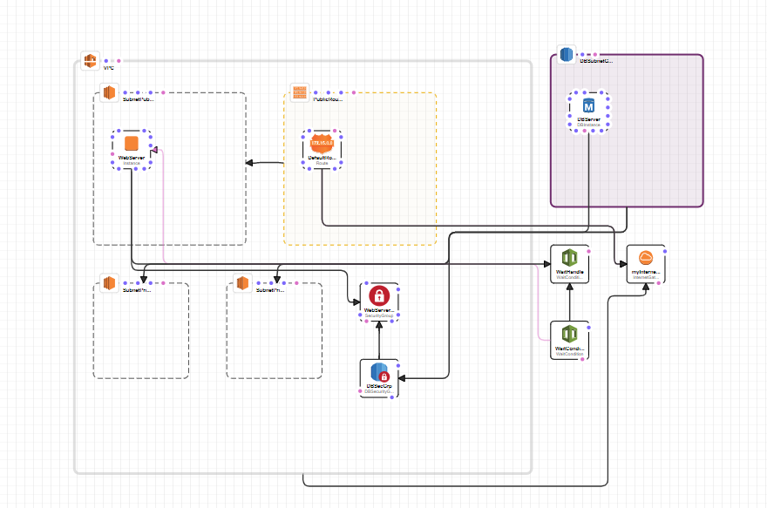

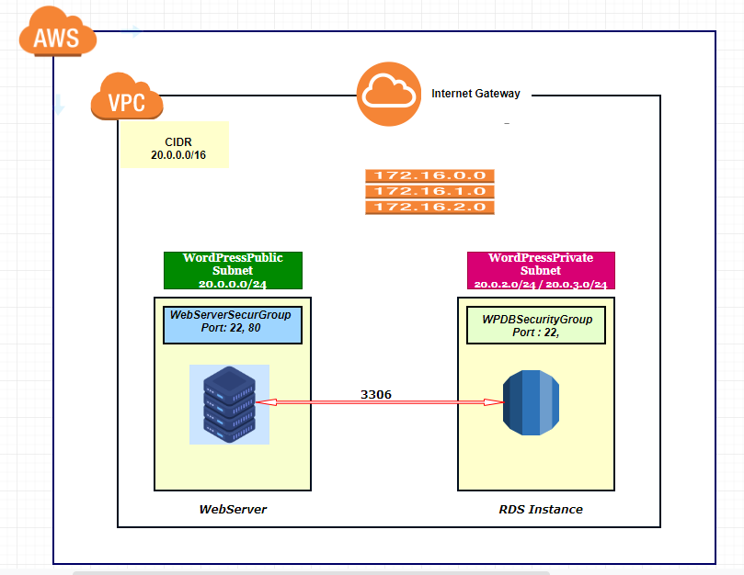

1. **Pre-required Tools**

(From the GithuB repos)

1. **Credetials needed to provision resources Sttings.**

##Create .aws in your home directory, using the following command

mkdir ~/. aws/

##Create credentials file in ~/.aws/

touch credentials

##ADD both aws_access_key and aws_secret_access_key to the credentials file by running

aws configure

##Download WordPress repos from GitHub

git clone https://github.com/askossivi/CloudFormation_deployed.git

##vi and Add the following to file /etc/ansible/hosts

[local]

localhost

Then,

cd CloudFormation_depoyed

and run

ansible-playbook -i /etc/ansible/hosts deploy-wp.json –verbose

Wait for the stack completion then go to the below URL by replacing the WebServerPublicIp with the Public webbserver Ip

http://WebServerPublicIp/wordpress/wp-admin/install.php