Stats 212

Wassim Askoul

July 13, 2017

## Final Project

### Wassim Askoul

This report is going to address a statistic in the field of Neuroscience and Cognitive Science. The data was aqcuired through an experiement done by Wassim Askoul at the department of psychology, St. Olaf College under the supervision of Professor Jeremy Loebach. Even though the participants were not randomly selected, the observations from every person are random. For the purposes of this report, we are going to consider that the data provided satisfies the randomness needed to perform statistical procedures like t-distribution and ANOVA for example.

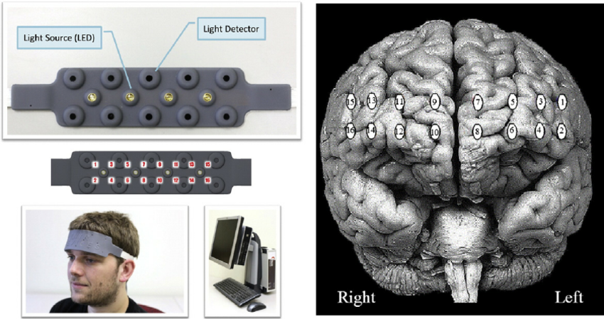

Figure 1: An image of fNIR where it shows the positions referred to below in the background and later in the data

#### Background

Cognitive Neuroscience and Artificial Intelligence has a very interesting intersection as developing fields and AI was one major breakthrough in the cognitive revolution. A huge problem in the field of AI is understanding the reasons of the evaluation and motivation controls that humans have and use, in order for it to be implemented in an AI system; meaning we cannot replicate human cognition or turn it as a variable. This issue generates a question such as: "What is the most functional allocation of control in the brain that determines values such as cognitive effort, motivation and reward-based decision making?" This question has couple of assumptions based on philosophical and neuroscientific theories. Firstly, the most functional allocation of X in the brain does not mean the one and only allocation in the brain, where X is processed and executed. However, it is the most important area that focussing on its activity would give the most relevant data to understand X. Secondly, X - specifically cost-benefit decision making - is taken to be as the function of that allocation, based on the philosophical theory of mind, functionalism. This research attempts to experiment and validate whether the Dorsal Anterior Cingulate Cortex (dACC) is a possible candidate to hold decision making as its function.

This problem is an ongoing debate in the neuroscientific community. The lack of enough evidence of how decisions are executed in the brain is of a great issue until this day. More research is needed to be exhibited on the different candidate areas that would play a role in decision making. This way a more scientifically-based conclusions could be drawn upon this area of the brain. The contribution of this research would be fruitful whether the results would support or deny the hypothesis of the paper. A positive results would yield a more concentrated research on dACC; however, a negative results would allow the neuroscientific community to focus research on different areas to allocate the function of decision making.

The idea of the research started by reading an article from Google's deepmind publications. The research presented a theory of control called Expected Value of Control (EVC). This theory replaces a previously used theory of control, which is Foraging Value Theory (FVT). EVC is an integrative theory that proposes dACC as being the optimal allocation of control by determining the overall value of control. (Shenhav, Cohen, Botvinick, 2016, p. 1) The notion of "optimal" is interesting. An optimal system is not needed as much as a functional system. The human brain seems to be not optimal for many tasks even while it has afforded us the world we see today. However, this research still offers an outlined hypothesis accounting for dACC's sensitivity to a wide array of experimental variables, and their relationship to subsequent control adjustments. Such variables are like: speed-accuracy trade off, choice or strategy change, learning rate, response bias, etc. A lot of contradictory research has been present between different studies on the dACC with human subjects.

However, studies were done on monkey subjects to draw on homologies between the brains of human and non-human primates. The failed attempt of this research created an outlined directions to distinguish illusory cross-species differences from the true evolutionary differences that make humans unique. The study draws attention on the results that the differences between humans and primates, when it comes to decision making, has to be based on anatomical difference. Based on this research, area 32 is the most interesting one where researchers found that it is one main anatomical difference between the two. (Cole, Yeung, Freiwald, Botvinick, 2009; Procyk, Wilson, Stoll, Faraut, Petrides, Amiez, 2014) This specifies the area of interest, area 32, to further test and validify throughout this research to help better understand the human decision making abilities.

To further support the claims on the importance of area 32 as the main area of focus to understand the relevance of dACC, a research fixates a study on the anterior and posterior mid-cingulate cortex (MCC) as a constitution of the ACC. Through evaluating six human cingulate gyri with Nissl staining and immunoreactive for neuron-specific nuclear binding protein and intermediate neurofilament proteins (NFP), area 24 was considered to be a more relevant range to execute a selective vulnerability to chronic pain and stress syndrome. (Vogt, Berger, Derbyshire, 2003) While the role of this research was based on a more psychosocial analysis and conclusion, the emphasis on area 24 as an execution range of the brain was noted. This is important since area 24 is considered to be cytoarchitecturally and externally bounded by area 32. This extends the basis of this research to further investigate area 32 as an origin for such findings as those associated with area 24 for an emotional related activations.

Furthermore, correlation between area 32 and both area 9 and 46 was hypothesised and validated through an EEG-informed fMRI study. The study speculated, based on accepted theories, a functional connection between the areas mentioned before; meaning activity in area 32 can predict activity in both area 9 and 46. (Philiastides, Sajda, 2007, p. 3) This information could be a great connection to further expand the validity of the localization of area 32 for this research's purposes. Moreover, the same study accounted for an unmodulated regressor activations of area 10, which is positioned in front of the wanted area (area 32). (Philiastides, Sajda, 2007, p. 5) However, this account of the area is connected to feedback loop of limb usage. This further aids the purposes of the proposed research by accounting for controlling movement of limbs to acquire a less noisy, more relevant data for the acquired area.

After successfully laying out the importance of the area investigated, localize it to the best our knowledge can aid us, connect different methods to further expand the research, it is time to account for data analysis needed for a wrapped up usage of the activations of area 32. Reinforcement Learning (RL) is the area of cognitive neuroscience and AI meet to better place the knowledge learned from areas like area 32 in the brain. RL suggests a way to analyze data received from reward-based decision making areas of the brain, area 32 in this research, by using Efficient Coding (EC) from information theory as a mathematical backup. This analytical method uses Markov Decision Processes (MDP) as a way to show how decision making in humans is internally represented. MDP provide a mathematical framework for modeling decision making in situations where outcomes are partly random and partly under the control of a decision maker. (Botvinick, Weinstein, Solway, Barto, 2015) This framework would serve as the analysis of the data that would be collected through this research to build a mathematically sound basis to further use and share the data from the dACC.

The role of the Dorsal Anterior Cingulate Cortex has not yet been thoroughly defined neither in the field of Cognitive Neuroscience nor in the field of Artificial Intelligence. A major problem in the field of AI is the categorical understanding of the reasons for the motivation that pushes human beings to make decisions. This paper aims to explore the most functional allocation of control in the brain; on the contrary of the most optimal allocation, that determines values such as cognitive effort, motivation and reward-based decision making. After thorough literature reviews on the subject, I proposed to study this by answering the question: "Does the dorsal anterior cingulate cortex (dACC), brain area (BA) 32 specifically, play the main role in the reward-based decision making process?" The hypothesis is that dACC (BA 32) plays an important role due to its location and interconnection with BA 9, BA 46. The experimentation was done using two methods: functional near-infrared spectroscopy (fNIR) and electroencephalogram (EEG), and three tasks designed specifically to activate various parts of the brain in order to localize and measure the activation of BA 32. Preliminary results showed high level of similarities between results obtained from the pool of participants, principally in the third task where the difference between the oxygenation and deoxygenation levels in the fNIR results were highest. This report is supposed to act as a statistical approval of the findings through identifying research questions like: "Is the dACC, represented by opiodes 7 through 10, correlated to the memory test evaluation? Does the Oxygenation and Deoxygenation of the diffirent positions of the dACC related? Does the coordination between Brain Area 9 and 46 has any significant influence on any of the other variables like coordination between brain area 9 and brain area 46 in the three tasks and gender?"

#### Methods

##### Subjects

Forty-four healthy young adults from St. Olaf College community participated in the study (22 female, 22 male). The age of the subjects ranged between 18 and 23, with a mean age of 22.43 years. Subjects were given credit in their Introductory Psychology course for their participation (n=14). Of these 44 subjects, two were excluded from the final data analysis resulting in 22 female participents and 20 male.

##### Stimuli

Stimulus materials came from three different tasks that were programmed using C++ and the open source psychology interface PEBL.

###### Task 1, Pursuit Rotor

The pursuit rotor task is a task used in common use in the mid 20th century which involved a participant trying to follow (pursue) a small disc on a rotating turntable. The task was altered to offer a better localization of brodmann area 10; anterior prefrontal cortex or BA 10. This area is responsible for multi-task coordination. The alteration was an addition of a random circle popping on the screen every 5 seconds with an instruction to the participants to hold the spacebar whenever both the rotating circle and the random one are on the same side of the screen (west or east). The task consisted of four trials of 15 seconds each. The stimulus was based on the duration of each trial.

###### Task 2, Corsi Blocks

A traditional spatial working memory task. Blocks on the screen are lit up, and the subject must reproduce the order they are lit in. The task was targeting both BA 9 and BA 46; medial prefrontal cortex and dorsolateral prefrontal cortex. The task consisted of two trials of each level; a level is based on the number of blocks lit in a sequence (levels are between two blocks up to eight blocks with an average of six blocks across the participants of this experiment).

###### Task 3, PEBL Gambling task

The Iowa gambling task (IGT) is a psychological task thought to simulate real-life reward-based decision making. It was introduced by Antoine Bechara, Antonio Damasio, Hanna Damásio and Steven Anderson, then researchers at the University of Iowa. The task was modified by the addition of a percentage of possible win on each deck in order to push participants to follow a determined deck. This task was considered the main goal of the experiment as it was targeting dorsal anterior cingulate cortex (BA 32). The task consisted of 100 trials of one second on average across 42 participants.

##### Sorting and Compiling

Functional Near-Infrared Spectroscopy (fNIR Systems) and Electroencephalography (EEG Biopac MP36) were the materials used to collect the data. fNIR uses near-infrared light measures the hemodynamic response associated with neuron activity. fNIR was used to study BA10 and BA32. EEG Biopac MP36 uses electrodes on the scalp measure the synchronized postsynaptic currents due to neuronal firing and it was used to study BA9 and BA46. EEG data was analyzed as event-related potentials (ERP) across different trials of the three tasks. Stimuli were processed using Excel and R. Stimulus processing involved two phases, a sorting phase, which sorted data of every person between data from the fNIR system and the ERP across the three tasks, and a compiling phase, which averaged different opioids from the fNIR system (7,8,9, and 10); ignoring (1-6 and 11-16), and the ERP data. Analysis used band-pass filters across the ERP data to collect the stimuli between 13 and 30 Hz (Beta frequency).

#### Layout of Analysis

In the beginning, four multiple regression models are going to fit our data using the difference between oxygenation and deoxygenation of the four areas (7-10) of the third task with respect to the difference between oxygenation and deoxygenation of the four areas (7-10) of the first and second tasks and memory level (5 to 9) and gender. The hypothesis of these four multiple regression is that gender and memory level are not relevant to the difference between oxygenation and deoxygenation of the four areas (7-10) of the third task; however, the difference between oxygenation and deoxygenation of the four areas (7-10) of the first and second tasks are significant. This would lead us to do a chi-square test of independence between the difference between oxygenation and deoxygenation of the four areas (7-10) of every task and its corresponding coordination data between brain areas 9 and 46. The hypothesis in these three chi-square test of independence is that the difference between the observations of the different areas (7-10) with respect to the coordination observation are independent. If there we reject the null hypothesis in any of these three test than this would be a motivation for us to initiate a t-test on the different pairs of data to find the dependent variables.

#### Analysis

##### Perliminary Results

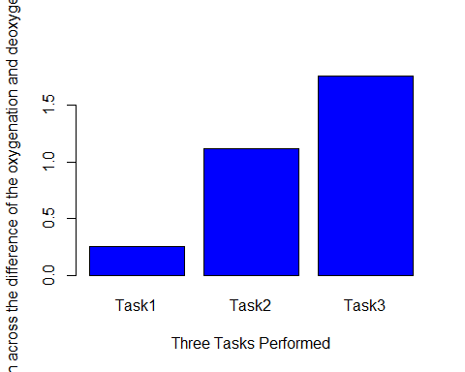

The above graph is just a start to understand the general behaviour of the data with respect to the different tasks. As we can see that the activation of the area of interest under some generalization in Task 3 is noticably higher than that of Task 1 and Task 2. However, we cannot be sure whether this difference is from a single area or from the addition of the small increments of difference between the areas across the tasks. In order to understand what is the relation of every area to the tasks, I suggest to perform multiple regression in four different times of the difference between oxygenation and deoxygenation of the different areas seperatly, where the response in each model is considered the area of interest of the third task and the predictive variables are the area of interest of the first and second task, memory test as a categorical variable that goes from 5 to 9 and gender.

##### Multiple Regression

In order to understand whether task three, which is the main task that is assumed to activate the dACC (brain are 32), is indeed related to activation the brain area 32 represented by areas 7,8,9,10 as the center of reward-based decision making in the brain.

The data is interesting, we can see that the only significant predictor for all four response variables in all four models is the difference of oxygenation and deoxygenation of areas 7,8,9,10 from the second task (p=3.06e-7,2.66e-7,1.48e-6,3.89e-8 respectively). This would translate into multiple results: first, it could mean that the first task was not good enough to activate the areas of the brain to a significant level; second, task two and task three are related in activating the areas of the brain with similarity under the assumption of isolation of the areas; third, it is a good start to move on and perform a three two-way ANOVA seperated by task. The average of the areas (7,8,9,10), respresenting the activation in the dACC since all four areas would be considered as part of dACC, as the dependent variable. And the independent variables are the coordination between brain area 9 and brain area 46 and gender.

##### Two-way ANOVA

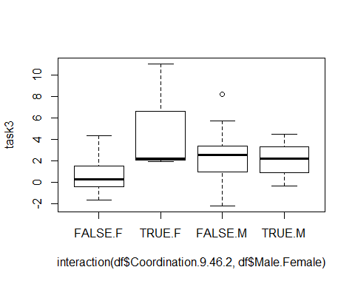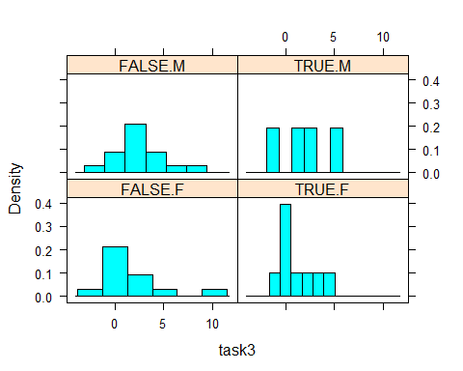

As we can see from the above boxplot and histograms that this set of data: Average of the areas 7,8,9,10 of the third task, coordination between BA9 and BA46, and gender, the following conditions are met:

Independence: Independence is met within and between groups; where every observation represents data from a person.

Normality: The histograms shows that the different combination of groups show a nearly normal behavior. It is good note that in the case of true coordination and male it is not a clearcut of nearly normal model; however, based on the other other three cases, I believe that with more observations of the same case would have showna a closer normal model.

Equal Variance: Other than an outliers in the false male group, the variance of the different groups is in the same range concentrated below 6 and above -2.

Through these results (p = 0.46) we can see that two-way ANOVA revealed that the interaction between the coordination between BA 9 and BA 46 along with gender shows that the variances are not equal and therofore, aproves of the data of the multiple regression as in isolation is not a factor in the way the regression model were calculated.The same thing cannot be said about task one and task two since the two-way ANOVA test resulted in showing that the variances are equal where p=0.82 and 0.0655 respectively.

##### T-test

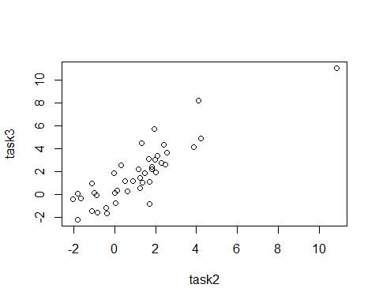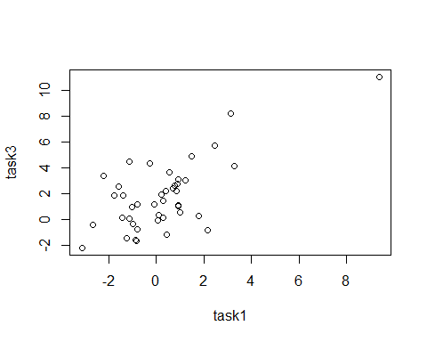

This portion of the analysis is to check whether the average difference between the task 2 and 3, and task 1 and 3 is significantly different. As found in the previous results, we find that the difference between the averages of task 2 and task 3 is insignificant (p = 0.2323). However, the difference between task 1 and task 3 is extremely significant (p = 0.004576).

#### Conclusion

In conclusion, the first task was not good enough to activate the areas of the brain to a significant level. Task two and task three are related in activating the areas of the brain with similarity under the assumption of isolation of the areas;however, the two-way ANOVA revealed that the interaction between the coordination between BA 9 and BA 46 along with gender shows that the variances are not equal and therofore, aproves of the data of the multiple regression as in isolation is not a factor in the way the regression model were calculated. Moereover, two t-tests showed that the difference between the averages of task 2 and task 3 is insignificant but that between task 1 and task 3 is extremely significant.

#### References (APA Style)

1. Shenhav, A., Cohen, J. D., & Botvinick, M. M. (2016). Dorsal anterior cingulate cortex and the value of control. Nature Neuroscience, 19(10), 1286-1291.
2. Cole, M. W., Yeung, N., Freiwald, W. A., & Botvinick, M. (2009). Cingulate cortex: Diverging data from humans and monkeys. Trends in Neurosciences, 32(11).
3. Procyk, E., Wilson, C. R., Stoll, F. M., Faraut, M. C., Petrides, M., & Amiez, C. (2014). Midcingulate Motor Map and Feedback Detection: Converging Data from Humans and Monkeys.
4. Vogt, B. A., Berger, G. R., & Derbyshire, S. W. (2003). Structural and functional dichotomy of human midcingulate cortex. European Journal of Neuroscience, 18(11), 3134-3144.
5. Philiastides, M. G., & Sajda, P. (2007). EEG-Informed fMRI Reveals Spatiotemporal Characteristics of Perceptual Decision Making. Journal of Neuroscience, 27(48), 13082-13091.
6. Botvinick, M., Weinstein, A., Solway, A., & Barto, A. (2015). Reinforcement learning, efficient coding, and the statistics of natural tasks. Current Opinion in Behavioral Sciences, 5, 71-77.
7. Solway, A., & Botvinick, M. M. (2015). Evidence integration in model-based tree search. Proceedings of the National Academy of Sciences, 112(37), 11708-11713.