THE UNIVERSITY OF BURDWAN



PROSPECTUS OF ONLINE POST GRADUATE ADMISSIONS

2015

THE UNIVERSITY OF BURDWAN

7/24/2015

From Vice Chancellor's Desk

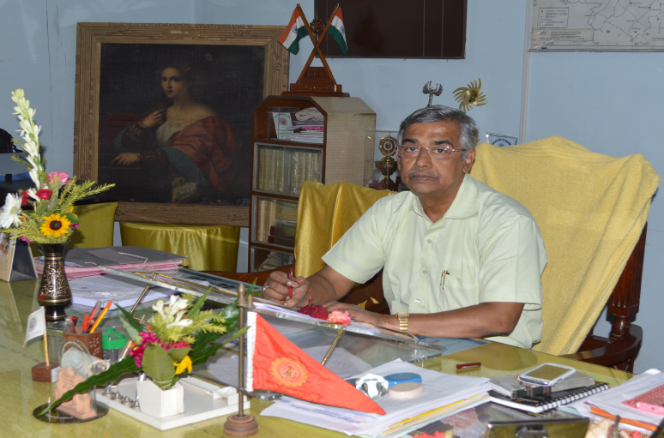

##### साविद्यायाविमुक्तये

I am happy to launch the programme of on-line admission to Post-Graduate Courses to the University of Burdwan for the session 2015-17. By clicking the mouse of your computer, students would now be able to meet all queries with regard to post graduate studies. This would enable them to submit the application, monitor their position on the merit list and make the payment of fees.

Our intention is to make the system absolutely transparent and a zero tolerant exercise with regard to discrimination and suppression of fact.

I welcome you, our prospective students, their guardians and all other stakeholders of the university to make the best use of the system. I would also seek your cooperation to bear with us in the event of encountering a technical snag or two, sometimes beyond our control.

Let's log on to the new era of technology

**Prof. SmritikumarSarkar**

**Burdwan, 24thJuly, 2015**

# Post Graduate Subject Offering:

Below are the listed subject offering for post graduate admission. All the post graduate subjects categorized in 3 type of courses, they are M.A. / M. Sc./ M. Com.

|  |  |  |  |
| --- | --- | --- | --- |
| **Sl. No** | **Subject Code** | **Post Graduate Subject** | **Course** |
| 1 | COMM | COMMERCE | M. Com |
| 2 | BIOT | BIOTECHNOLOGY | M. Sc. |
| 3 | BOTA | BOTANY | M. Sc. |
| 4 | CHEM | CHEMISTRY | M. Sc. |
| 5 | ENVS | ENVIRONMENTAL SCIENCE | M. Sc. |
| 6 | GEOG | GEOGRAPHY | M. Sc./M.A. |
| 7 | MATH | MATHEMATICS | M. Sc./M.A |
| 8 | MICR | MICROBIOLOGY | M. Sc. |
| 9 | PHYG | PHYSIOLOGY | M. Sc. |
| 10 | PHYS | PHYSICS | M. Sc. |
| 11 | STAT | STATISTICS | M. Sc. |
| 12 | ZOOL | ZOOLOGY | M. Sc. |
| 13 | CMPS | COMPUTER SCIENCE AND APPLICATIONS | M. Sc. |
| 14 | BENG | BENGALI | M.A. |
| 15 | ENGL | ENGLISH | M.A. |
| 16 | ECON | ECONOMICS | M.A./M.Sc |
| 17 | EDUC | EDUCATION | M.A. |
| 18 | HIST | HISTORY | M.A. |
| 19 | HIND | HINDI | M.A. |
| 20 | LIBR | LIBRARY SCIENCE & INFORMATIONS | M.A. |
| 21 | M.A.SS | MASS COMMUNICATION | M.A. |
| 22 | POLS | POLITICAL SCIENCE | M.A. |
| 23 | PHIL | PHILOSOPHY | M.A. |
| 24 | SANS | SANSKRIT | M.A. |
| 25 | SOCI | SOCIOLOGY | M.A. |
| 26 | SANT | SANTALI | M.A. |
| 27 | URDU | URDU | M.A. |
| 28 | WOMS | WOMENS STUDIES | M.A. |
| 29 | MPED | M.P. Ed. | M.A. |
| 30 | MEDX | M. Ed. (FRESHERS) | M.A. |
| 31 | MUSH | M.A. IN HINDUSTHANI CLASSICAL VOCAL | M.A. |
| 32 | MUSR | M.A. IN RABINDRA SANGEET | M.A. |

# Center offering courses& intake:

|  |  |  |  |
| --- | --- | --- | --- |
| **Sl. No** | **Center Name** | **Post Graduate Subject** | **Intake** |
| 1 | BURDWAN UNIVERSITY CAMPUS | BENGALI | 203 |
| 2 | BURDWAN UNIVERSITY CAMPUS | COMMERCE | 115 |
| 3 | BURDWAN UNIVERSITY CAMPUS | ENGLISH | 176 |
| 4 | BURDWAN UNIVERSITY CAMPUS | ECONOMICS | 95 |
| 5 | BURDWAN UNIVERSITY CAMPUS | EDUCATION | 44 |
| 6 | BURDWAN UNIVERSITY CAMPUS | HISTORY | 166 |
| 7 | BURDWAN UNIVERSITY CAMPUS | HINDI | 93 |
| 8 | BURDWAN UNIVERSITY CAMPUS | LIBRARY SCIENCE & INFORMATIONS | 27 |
| 9 | BURDWAN UNIVERSITY CAMPUS | MASS COMMUNICATION | 56 |
| 10 | BURDWAN UNIVERSITY CAMPUS | POLITICAL SCIENCE | 112 |
| 11 | BURDWAN UNIVERSITY CAMPUS | PHILOSOPHY | 93 |
| 12 | BURDWAN UNIVERSITY CAMPUS | SANSKRIT | 110 |
| 13 | BURDWAN UNIVERSITY CAMPUS | SOCIOLOGY | 56 |
| 14 | BURDWAN UNIVERSITY CAMPUS | SANTALI | 34 |
| 15 | BURDWAN UNIVERSITY CAMPUS | WOMENS STUDIES | 34 |
| 16 | BURDWAN UNIVERSITY CAMPUS | M.P. ED. | 40 |
| 17 | BURDWAN UNIVERSITY CAMPUS | M. ED. | 22 |
| 18 | BURDWAN UNIVERSITY CAMPUS | BIOTECHNOLOGY | 14 |
| 19 | BURDWAN UNIVERSITY CAMPUS | BOTANY | 60 |
| 20 | BURDWAN UNIVERSITY CAMPUS | CHEMISTRY | 79 |
| 21 | BURDWAN UNIVERSITY CAMPUS | ENVIRONMENTAL SCIENCE | 27 |
| 22 | BURDWAN UNIVERSITY CAMPUS | MATHEMATICS | 117 |
| 23 | BURDWAN UNIVERSITY CAMPUS | MICROBIOLOGY | 18 |
| 24 | BURDWAN UNIVERSITY CAMPUS | PHYSICS | 89 |
| 25 | BURDWAN UNIVERSITY CAMPUS | STATISTICS | 33 |
| 26 | BURDWAN UNIVERSITY CAMPUS | ZOOLOGY | 86 |
| 27 | BURDWAN UNIVERSITY CAMPUS | GEOGRAPHY | 64 |
| 28 | BURDWAN UNIVERSITY CAMPUS | COMPUTER SCIENCE AND APPLICATIONS | 30 |
| 29 | BANKURA CHRISTIAN COLLEGE | BENGALI | 34 |
| 30 | BANKURA CHRISTIAN COLLEGE | ENGLISH | 44 |
| 31 | BURDWAN RAJ COLLEGE | BENGALI | 34 |
| 32 | CHANDERNAGAR GOVT. COLLEGE | BENGALI | 34 |
| 33 | CHANDERNAGAR GOVT. COLLEGE | GEOGRAPHY | 22 |
| 34 | HOOGLY MOHSIN COLLEGE | BOTANY | 18 |
| 35 | HOOGLY MOHSIN COLLEGE | COMMERCE | 56 |
| 36 | HOOGLY MOHSIN COLLEGE | ENGLISH | 34 |
| 37 | HOOGLY MOHSIN COLLEGE | PHYSIOLOGY | 17 |
| 38 | HOOGLY MOHSIN COLLEGE | POLITICAL SCIENCE | 44 |
| 39 | HOOGLY MOHSIN COLLEGE | URDU |  |
| 40 | M.U.C. WOMENS' COLLEGE | ENGLISH | 34 |
| 41 | NETAJI MAHAVIDYALAYA | BENGALI | 34 |
| 42 | PADMJA NAIDU MUSIC COLLEGE | RABINDRA SANGEET | 22 |
| 43 | PADMJA NAIDU MUSIC COLLEGE | HINDUSTANI CLASSICAL VOCAL MUSIC | 22 |
| 44 | P.R.M.S. MAHAVIDYALAYA | SANTALI | 22 |
| 45 | RAMPURHAT COLLEGE | BENGALI | 34 |
| 46 | RAMANANDA COLLEGE | BOTANY | 18 |
| 47 | SURI VIDYASAGAR COLLEGE | ZOOLOGY | 18 |
| 48 | VIVEKANANDA MAHAVIDYALAYA | CHEMISTRY | 18 |

# Eligibility Criteria

Only the candidates obtaining graduation degree from regular honors courses are eligible for applying Burdwan University Post Graduate Courses.

Candidate obtaining graduation degree from open/distance courses is not eligible.

**Details eligibility marks criteria given in below table**

|  |  |  |  |
| --- | --- | --- | --- |
| **Sl.** | **Post Graduate Subject** | **General/ OBC-A/OBC-B**  **(Regular Honours)** | **SC/ ST**  **( Regular Honours)** |
| 1 | COMMERCE | 50% in graduation | 45% in graduation |
| 2 | BIOTECHNOLOGY | 55% in graduation | 50% in graduation |
| 3 | BOTANY | 50% in graduation | 45% in graduation |
| 4 | CHEMISTRY | 50% in graduation | 45% in graduation |
| 5 | ENVIRONMENTAL SCIENCE | 50% in graduation | 45% in graduation |
| 6 | GEOGRAPHY | 50% in graduation | 45% in graduation |
| 7 | MATHEMATICS | 50% in graduation | 45% in graduation |
| 8 | MICROBIOLOGY | 50% in graduation | 45% in graduation |
| 9 | PHYSIOLOGY | 50% in graduation | 45% in graduation |
| 10 | PHYSICS | 50% in graduation | 45% in graduation |
| 11 | STATISTICS | 50% in graduation | 45% in graduation |
| 12 | ZOOLOGY | 50% in graduation | 45% in graduation |
| 13 | COMPUTER SCIENCE AND APPLICATIONS | 50% in graduation | 45% in graduation |
| 14 | BENGALI | 50% in graduation | 45% in graduation |
| 15 | ENGLISH | 50% in graduation | 45% in graduation |
| 16 | ECONOMICS | 50% in graduation | 45% in graduation |
| 17 | EDUCATION | 50% in graduation | 45% in graduation |
| 18 | HISTORY | 50% in graduation | 45% in graduation |
| 19 | HINDI | 50% in graduation | 45% in graduation |
| 20 | LIBRARY SCIENCE & INFORMATIONS | 50% in graduation | 45% in graduation |
| 21 | MASS COMMUNICATION | 50% in graduation | 45% in graduation |
| 22 | POLITICAL SCIENCE | 50% in graduation | 45% in graduation |
| 23 | PHILOSOPHY | 50% in graduation | 45% in graduation |
| 24 | SANSKRIT | 50% in graduation | 45% in graduation |
| 25 | SOCIOLOGY | 50% in graduation | 45% in graduation |
| 26 | SANTALI | 50% in graduation | 45% in graduation |
| 27 | URDU | 50% in graduation | 45% in graduation |
| 28 | WOMENS STUDIES | 50% in graduation | 45% in graduation |
| 29 | M.P. ED. | 50% in B.P.Ed or B.P.E. Age of the applicant shall not be more than of 35 years as on 01.07.2015 | 45% in B.P.ED or B.P.E. Age of the applicant shall not be more than of 35 years as on 01.07.2015 |
| 30 | M. ED. (FRESHERS) | 55% in B.Ed | 50% in B. Ed. |
| 31 | M.A. IN HINDUSTHANI CLASSICAL VOCAL MUSIC | 50% in graduation | 45% in graduation |
| 32 | M.A. IN RABINDRA SANGEET | 50% in graduation | 45% in graduation |

**Details subject criteria given in below table**

|  |  |  |
| --- | --- | --- |
| **Sl.** | **Post Graduate Subject** | **Graduation Degree** |
| 1 | COMMERCE | COMMERCE |
| 2 | BIOTECHNOLOGY | * SCIENCE GRADUATE IN BIO-TECHNOLOGY * ENGINEERING GRADUATE IN BIO TECHNOLOGY * CHEMISTRY HONOURS WITH BIO SCIENCE AS COMBINATION SUBJECT * ANY BRANCH OF BIOSCIENCE IN HONOURS WITH CHEMISTRY AS COMBINATION SUBJECT * AGRICULTURAL SCIENCE. |
| 3 | BOTANY | BOTANY |
| 4 | CHEMISTRY | CHEMISTRY |
| 5 | ENVIRONMENTAL SCIENCE | ENVIRONMENTAL SCIENCE, MICRROBIOLOGY, BOTANY, CHEMISTRY, ZOOLOGY, PHYSICS, GEOGRAPHY, GEOLOGY, PHYSIOLOGY, BIO-TECHNOLOGY, BIO-CHEMISTRY, BSC. AGRICULTURAL HONOURS(10+2+4) |
| 6 | GEOGRAPHY | GEOGRAPHY |
| 7 | MATHEMATICS | MATHEMATICS |
| 8 | MICROBIOLOGY | MICROBIOLOGY |
| 9 | PHYSIOLOGY | PHYSIOLOGY |
| 10 | PHYSICS | PHYSICS |
| 11 | STATISTICS | STATISTICS, MATHEMATICS |
| 12 | ZOOLOGY | ZOOLOGY |
| 13 | COMPUTER SCIENCE AND APPLICATIONS | B.Sc (H) IN COMPUTER SCIENCE/ BCA(H) OR BE/ B.TECH IN COPM SC./ COMPUTER SCIENCE & TECH/ INFORMATION TECHNOLOGY |
| 14 | BENGALI | BENGALI |
| 15 | ENGLISH | ENGLISH |
| 16 | ECONOMICS | ECONOMICS |
| 17 | EDUCATION | EDUCATION |
| 18 | HISTORY | HISTORY |
| 19 | HINDI | HINDI |
| 20 | LIBRARY SCIENCE & INFORMATIONS | ALL SUBJECTS |
| 21 | MASS COMMUNICATION | ALL SUBJECTS |
| 22 | POLITICAL SCIENCE | POLITICAL SCIENCE |
| 23 | PHILOSOPHY | PHILOSOPHY |
| 24 | SANSKRIT | SANSKRIT |
| 25 | SOCIOLOGY | SOCIOLOGY |
| 26 | SANTALI | SANTALI |
| 27 | URDU | URDU |
| 28 | WOMENS STUDIES | ECONOMICS, HISTORY, POLITICAL SCIENCE, SOCIOLOGY, PHILOSOPHY, ENGLISH, BENGALI, HINDI, SANSKRIT, SANTALI, URDU |
| 29 | M.P. ED. | B.P. ED., B.P.E |
| 30 | M. ED. (FRESHERS) | B. ED. |
| 31 | M.A. IN HINDUSTAN CLASSICAL VOCAL | MUSIC |
| 32 | M.A. IN RABINDRA SANGEET | MUSIC |

# Online form fill up instructions

* Post graduate online application system is available in **http://128.199.77.108/bupgadm**
* Kindly go through the information sheet before filling up the online application form.
* After filling the second part of application form click on SUBMIT button, which will navigate to the profile page of candidate where candidate can view his/her information. Please note Application Code for future reference.
* Once submit the application form candidate will receive the application code through SMS.
* After submitting the application form, candidate has to upload his/her photo by clicking on the Upload Photo link in the profile page. Uploading the photo is mandatory otherwise the application will be treated as cancelled.
* After submitting the application form candidate has to pay the application fees of Rs 200/- (Rupees two hundred only) through online or offline by clicking CONFIRM BANK PAYMENT link. Before making the payment, go through the payment steps and instructions available in CONFIRM BANK PAYMENT link. Keep printed copy of payment confirmation for future reference (if needed).
* Candidate can view his/her profile page at any time through login (clicking on the LOGIN TO STUDENT PROFILE button in the home page). Enter application code as user name and password.
* Download the ADMIT CARD for admission test which will be available only before 72 hours of admission test.
* Once rank list is published candidate should download the Rank Card from his profile page. Printed copy of Rank card, application form and other testimonials are mandatory documents for admission.
* A separate list will be published for selected candidates. Only the selected candidates are advised to contact with the respective department for detailed information of admission.

# Payments:

Candidates are requested to pay the application fees (INR 200) after filling up the application from through online.The link for online payments is available in online portal. In case candidate not able to triggered the link from portal they can use [**https://www.onlinesbi.com/prelogin/icollecthome.htm**](https://www.onlinesbi.com/prelogin/icollecthome.htm) for online payment. The online facility support for

* Net banking facility with all nationalized and large and popular private sector bank.
* Any kind of ‘VISA’ , ‘MASTER’ and ‘RUPEY’ debit card.
* Any Credit card
* Offline challan

Those who are not having online payment options they can fill the challan form from the link and pay the application fees along with the printed copy of challan to any SBI branch.

Detailed instruction for online payment is available in ‘Confirm Bank Payment’ link in the online application portal.

# Procedure of selection:

**Based on Marks of Under Graduate**

60% of the total intake of seats will be reserved exclusively for the pass-out candidates from the Under- Graduate Colleges affiliated to the University of Burdwan. Admission to these seats will be offered strictly on the basis of marks secured in the concerned Honours subject. In case of the uniform score in the concerned Honours Degree, the percentage of marks obtained by the candidate in Higher SecondaryExamination will be considered and calculated for determining the higher position in the merit list. And if the percentage of Higher Secondary marks is also be the same, percentage of Secondary Examination will be considered for ranking.

**Based on Admission Test Marks**

40% of the total seats will be filled up through Open Admission Test. The test will be held on the basis of MCQ with negative marking. Candidates from other Universities within and outside West Bengal will have to appear in the said admission test. Candidates from the colleges under the University of Burdwan can also appear in the said admission test to vie for a better option regarding choice of centre of study. For M.Ed., M.P.Ed., Library and Information Science, Mass Communication, Biotechnology, Environmental Sciences, Computer Science and Applications, 100% of the seats would be filled up through Open Admission Test. Please look into the Appendix-I for selection criteria of M.P.Ed.

The University also reserves all right to drop or include any name of the candidate, if any suppression of facts on the part of the students or any mistake in calculation is detected at any stage before or after the admission.

**admissions procedure:**

Only the selected candidate for various kind of merit category will be called for admissions. The selected candidate list will be called for admission based on their rank. The selected candidate will be appearing for admission in **GOLAPBAG CAMPUS** of **THE UNIVERSITY OF BURDWAN**. The selected candidate list will be available in RESULT button in Home page of the portal.

Candidate need to carry the below documents and testimonials at the time of admissions

* Original and photocopy of mark-sheets of all public examinations passed
* Original and photo copy of birth certificate/ admit card of Madhyamik or equivalent examinations.
* Original Schedule Caste / Schedule Tribes / OBC-A/ OBC-B/ Differently Abled/ Sports certificate issued in favour of the candidates.
* Rank card, which is available in the online admission portal
* Printed copy of Application form, which is available in the online admission portal

Below are the details of issued authority whose certificate will be acceptable for different kind of reservations.

**Schedule Caste& Schedule Tribes:**

Relevant Certificate must conform to West Bengal Govt. Memo No. 1813-BCW/MR-94/11 dated 20th June, 2011.Candidates claiming reservation against SC/ST and OBC-A/OBC-B(relevant certificate is required) quota of seats must submit relevant caste certificates issued in their favour by one of the authorities listed below:

* Deputy Collector of Land Revenue,
* Kolkata Collector of Stamp Revenue,
* Kolkata Metropolitan Magistrate, Kolkata,
* Addl. Chief Metropolitan Magistrate, Kolkata,
* Chief Metropolitan Magistrate, Kolkata,
* 1st Class Stipendiary Magistrate,
* Executive Magistrate,
* Sub-Divisional Magistrate,
* Sub-Divisional Officer,
* Deputy Collector,
* Addl. District Magistrate,
* Collector and District Magistrate within their respective jurisdictions in case of candidates claiming to be Schedule Caste or Schedule Tribe and ordinarily residing within such jurisdictions.

**OBC-A & OBC-B:**

The West Bengal Higher Educational Institutions (The Reservation in Admissions) Act, 2013 enacted by Govt of West Bengal has opened the opportunity for the students belonging to OBC-A and OBC-B (as determined and notified by Backward Classes Welfare Department, Govt. of West Bengal) for reservation of seats in higher education in the state. The communities listed by the Department of Backward Classes Welfare, Govt. of West Bengal as OBC-A and OBC-B would get the benefit of reservation.

**Differently Abled**

The Certificate must be live and issued by an appropriate authority not below the rank of Superintendent of Sub-Divisional Hospital. In the certificate, the extent of Physical Disability must not be less than 40%. In addition, candidates who claim reservation against such quota, must also personally appear before the Medical Board constituted by the University on 11th August, 2015 at 12 noon in the Office Chamber of the Secretary, Faculty Council (Arts etc.), with all relevant reports and certificate in original for verification of their eligibility under this quota. If the candidate claiming reservation under D.A. quota, fails to appear before the medical board on the stipulated date and time, he /she will be treated as a general candidate.

**Sports**

Candidates seeking admission against Sports (SP) quota of seats must have to submit certificates for their participation in Inter-State or Inter-University Sports and Athletic competitions (not earlier than Madhyamik level) and physically fit for representing the University team in AIU Games as per AIU norms.Candidates who claim reservation against Sports quota, must also personally appear before the Board on 12th August at 12 noon in the Office of the Sports Board, BU with all relevant certificates of performance in original for verification of their eligibility under this quota. If the candidate claiming reservation under Sports category fails to appear before the board on the stipulated date and time, he /she will be treated as a general candidate.

# Support & Assistance:

For any further clarification related to the rules, regulations, eligibility or timeline,

* M.Sc. candidate will contact to the Secretary of Faculty Council of Science ([secretary_sc@buruniv.ac.in](mailto:secretary_sc@buruniv.ac.in)).
* M.A. and M.Com candidate will contact with The Secretary of Faculty Council of Arts, Commerce, etc. ([secretary_atrs@buruniv.ac.in](mailto:secretary_atrs@buruniv.ac.in)).
* Any Technical difficulties candidate can directly contact with technical support team available in **pgadmission.complaint@buruniv.ac.in**

Note: For any kind of communication candidate always carry or submit the evidence of candidature

# Admission Program:

* Issuance of on-line application form:**25.07.2015 - 08.08.2015**
* Interview of Differently Abled applicants at the chamber of secretary, Faculty Arts, etc on **11.08.2015 at 12 noon**
* Interview of candidates for Sports at the office of Sports Board on**12.08.2015 at 12 noon**
* Admission Test (40% of total intake) :
  + All M.A. and M. Com Subjects except Library & Information Science : **18.08.2015**
  + All M. Sc. Subjects and Library & Information Science on**19.08.2015**
* Publication of Results of Admission Test (40% of total Intake) and Merit Category (60% of total Intake) on **27.08.2015**
* Verification of testimonials &admission at respective department:**28.08.2015 to 03.09.2015**

**Commencement of Classes: 4th september, 2015**

* Final List publication for all categories:  **22.09.2015**
* Final round of Admission (All Subjects) for all categories : **23.09.2015** (On completion of 15 days of regular classes)

# Funding Agency:

|  |  |  |
| --- | --- | --- |
| FUNDING AGENCY | TYPE OF SCHOLARSHIPS | AMOUNT |
| UGC Funding | Indira Gandhi Single Girl Child Scholarship | Rs. 2,000/-p.m For 20 months |
| State Government  Funding | Merit-cum-Means Scholarship | Rs.16,800/- p.a. for Science Students  Rs.14,400/- p.a. for Arts Students |
| Minority Scholarship | Rs.3000/- + Rs. 2200/(Course Fee) Total Rs.5,200/- p.a. ( optional Rs. 2,700/- for Hostel) |
| Minority Merit-cum-Means Scholarship | Rs.4,500/- + Course Fee Rs.18675/- p.a. for MBA Students  Rs.7,000/- + Course Fee p.a.  Rs.16,775/- p.a.  Rs.10,000/-,+ Course Fee Rs.18655/- p.a. For MBA students |
| S.C. S.T. Scholarship | Rs. 9,000/- plus Hostel Expenses |
| Labour Welfare Scholarship | Rs.3,000/- to the Wards of Biri Workers |
| Physically Handicapped Scholarship | Rs. 2880/- for Boarders in Hostels & Rs.2040/- who are not Boarders in hostel |
| Endowments | Rastriya Sanskrit Sansthan Scholarship | Rs. 5,000/- p.a. |
| National Board of Higher Mathematics Scholarship | Rs.72,000/- paid to 1(one) students who stood 1st in Hons. Exam |
| National Handicapped Finance Dev. Corp. | Rs. 10,000/- to 1(one) or 2(two) students |
| MHRD-CSS Scholarship | Rs. 10,000/- p.a. for Graduation Level &Rs. 20,000/- p.a. for Master Degree Level |
| Corporate Funding | Sitaram Jindal Scholarship | Rs.6200/-, 4200/-, 1800/- |
| O.N.G.C. Scholarship | Rs. 60,000/- p.a. paid to the students who stood 1st in M.Sc. Physics & Chemistry |

# Facilities provided to the students:

## Hostels

**Boys Hostel:**

* Aurovinda Chatrabas
* Chittaranjan Chatrabas
* Rabindra Chatrabas
* Netaji Chatrabas
* Vivekannada Chatrabas

**Girls’ Hostel:**

* Nivedita Chatrinivas
* Sarojini Chatrinivas
* Mirabai Chatrinivas
* Pritilata Chatrinivas
* Gargi Chatrinivas

## Green campus

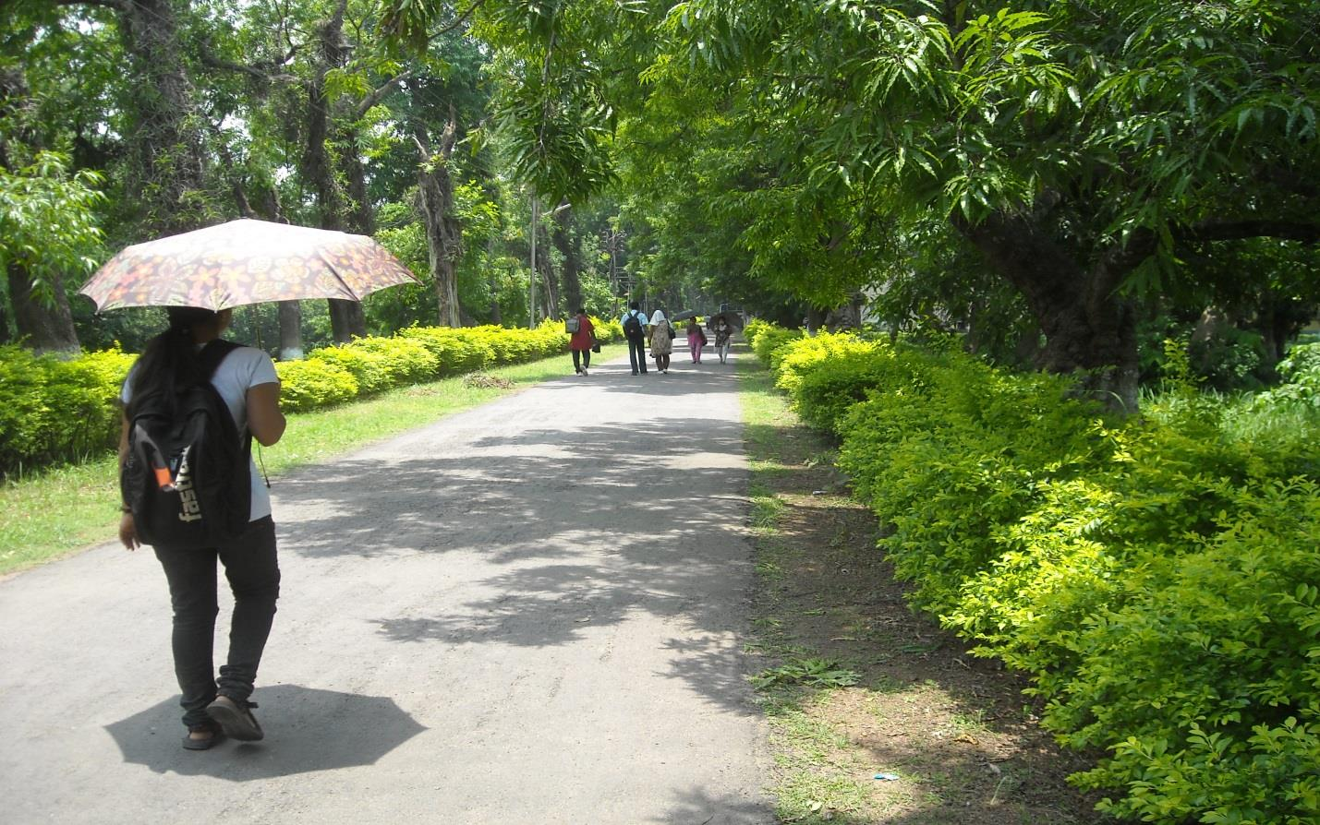

## Health Centre

Burdwan University Health Centre was started in 1965 with a view to providing health services to the students, teachers and employees of the university. The Health Centre is located on the south (Chandnighat) of Krishnasayer Eco-Garden.

The health center is a recognized urban training center for Burdwan Medical College & Hospital

Services offered by Health Centre

* Outdoor Services

Outdoor services along with Emergency management are available on all weekdays both in the morning and in the afternoon. The Health Centre also provides medicines to the outdoor patients. At present these facilities are available to the following:

All regular students of the university

* + Full-time Research Scholars of the university
  + Teachers and employees (including family members) of the university
  + Hostel workers and their family members
* Mothers and Child Health Care

Additionally, mothers and child health care including immunization, etc. are available to population surrounding the Health Centre once in a week.(This service is open to all).

* Training Programs

Training to Interns of Burdwan Medical College & Hospital is also provided by the Health Centre.

* Facilities Available
  + ECG
  + X-RAY
  + USG
  + PATHOLOGICAL TEST
  + LUNG FUNCTION TEST
  + FOETAL DOPPLER
  + IMMUNISATION (OPEN TO ALL)
  + FAMILY PLANING
  + PHYSIOTHERAPY

## Placement & Students Welfare Cell

## Gymnasium

**Appendix-I**

## **For Physical Education (M.P.Ed)**

* Each candidate is required to appear in a written test followed by a physical fitness test. There shall be 5 (five) field tests: 50m dash, standing broad jump, 4×10m shuttle run, 600m run and shot throw.
* Candidate has to submit a health /fitness certificate approved by registered medical officer, stating clearly that the candidate is fit to undergo vigorous physical exercise. This certificate is to be submitted before appearing in the physical fitness test. No candidate will be allowed to appear in the test if any surgical operations is made within 24 months and in case of female candidate if pregnancy occurred within last 18
* Date of Field Trial: 19.08.15 & 20.08.15
* Reserved Date for field trial if necessary: 21.08.15.
* Reporting Time and Venue: 19th August, 2015 at 8.00 A.M, Mohanbagan Ground, Tarabag, Near Krishnashyar park (West), Burdwan.
* Candidates appearing in the field trial should bring 2 colored recent passport sizes
* photographs and with proper sports uniform.