THE UNIVERSITY OF BURDWAN

HOW TO MAKE ONLINE PAYMENT?

# STEP 1:

Click into the check box and then click to **Proceed** button.

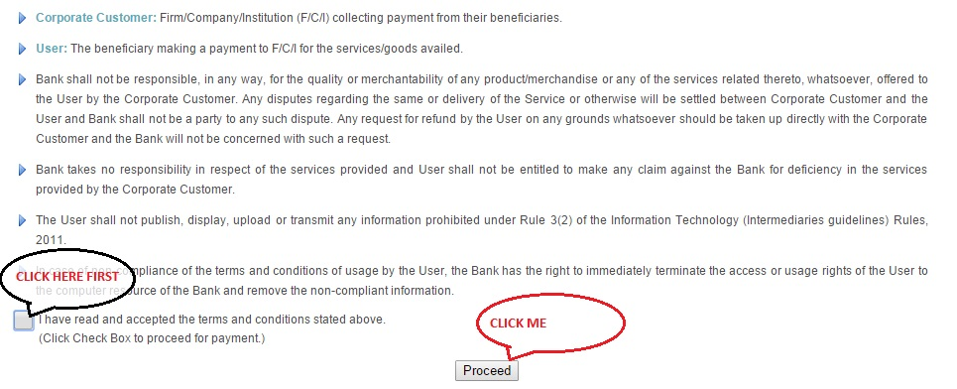

# STEP 2:

* Select WEST BENGAL from **State of Corporate/ Institution**
* Select EDUCATIONAL INSTITUTE from **‘Type of Corporate/ Institution’**
* Click on GO button

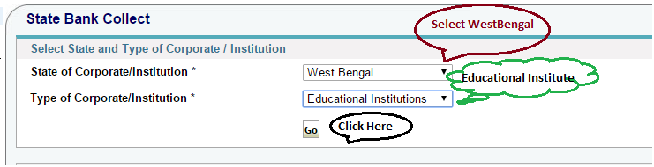

# STEP 3:

* Select THE UNIVERSITY OF BURDWAN from **Educational Institution Name**
* Click on SUBMIT button

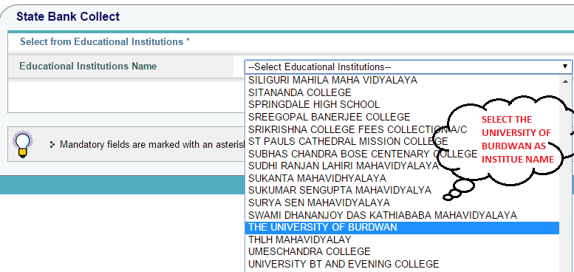

# STEP 3:

* Select **Application Fees for Geospatial Science** from **Select Payment Category**
* On selection of item from drop down one form will be open

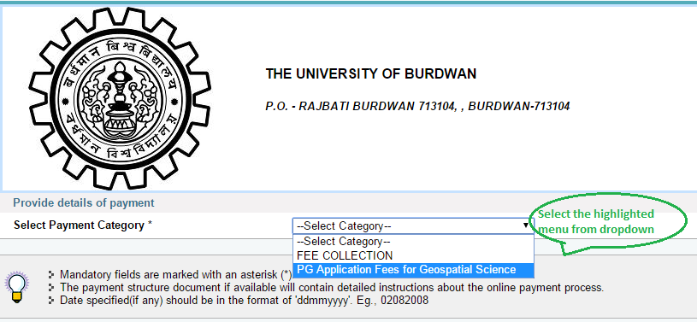

* Fill up the form carefully.
* Write correct **“Application Number”, “Name of the Applicant”, “Date of Birth”, “Mobile Number”, Course Applied For”** Which are mandatory for online payment. The form will be look like the below screen shots.
* After fill up the information click on “SUBMIT” button.

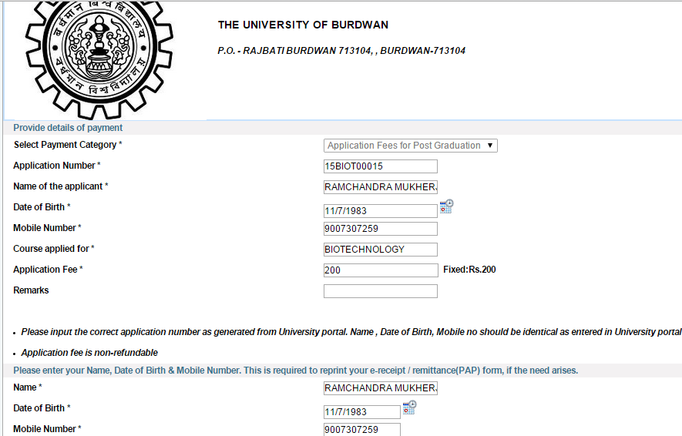

# STEP 5:

* Candidate will receive a below screen
* Click on **Confirm** Button to confirm the payment.

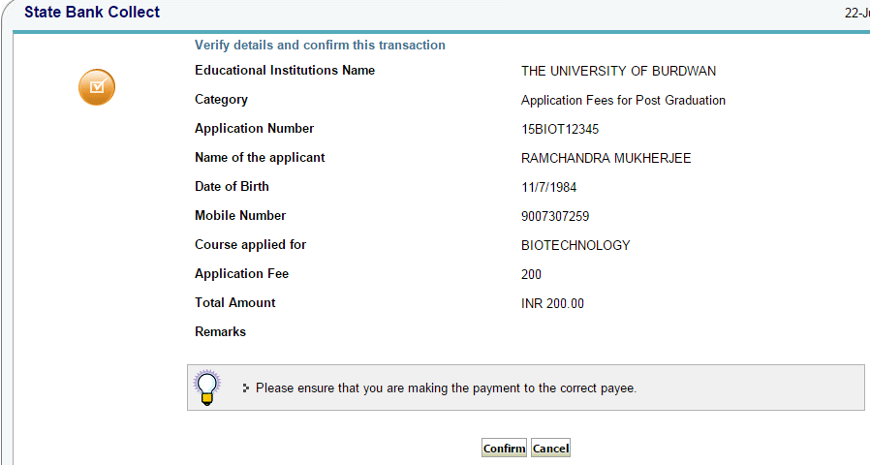

# STEP 6:

* If you wish for Net banking transfer of any of **State Bank group** then select particular bank.
* If you wish to pay through other bank account then click on **Other Bank Internet banking in** the below portion of the page
* If anybody wish to do the payment through any state bank debit card then select **‘State Bank ATM-Cum-Debit-Card’** if want to do the payment any other Debit card then click on ‘OTHER BANK DEBIT CARD
* If anybody wish to payment through credit card then select **CREDIT CARD** option from the below link
* Those who are not having any of the net banking / debit card/ credit card facility then applicant can use Manual challan by clicking on the CHALLAN OPTION in below of the page. Once challan filled up then applicant will go to nearest any of SBI branch and do the payment.

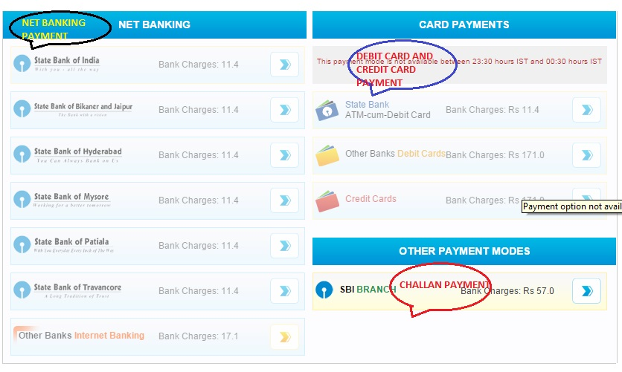

# STEP 7:

If user wants to pay through challan then download the challan from **“**[**Click here to save the Pre-Acknowledgement Form in PDF**](javascript:paymentTransferPrint1('DU25748424'))**”.** Print the challan and pay any of your nearest SBI branch.

END