**Loraine Joy DM. Manayao**

280 Banaban II, Angat, Bulacan

Cell #: 09357566561

[ljdmanayao@neu.edu.ph](mailto:ljdmanayao@neu.edu.ph)

**PERSONAL DATA**

Date of Birth : November 5, 1999

Age : 18 yrs. old

Place of Birth : Sto.Nino Hospital, Bulacan

Height : 5’2”

Religion : Iglesia Ni Cristo

Sex : Female

Civil Status : Single

**EDUCATIONAL BACKGROUND**

**TERTIARY :** New Era University

Bachelor of Science in Computer Science

Quezon City

3rd yr Student at present

**SECONDARY :** Lourdes College of Bulacan

Veteransville, Tugatog, Angat, Bulacan

Batch 2011-2015

**ELEMENTARY :** Lourdes College of Bulacan

Veteransville, Tugatog, Angat, Bulacan

Batch 2005-2011

**SKILLS**

Computer literate (Basic Programming)

Good in oral and written communication

**ACHIEVEMENTS**

Made an E-Loading System

Made a game entitled “Rock-Paper-Scissors”

Made a Compiler (LKR)

Made a CCS Event Registration

Made a Vivify Spa Website



**Cris D. Luzano**

191-Q Townhouse Tandang Sora, QC

Cell #: 09359815470

[cdlluzano@neu.edu.ph](mailto:cdlluzano@neu.edu.ph)

**PERSONAL DATA**

Date of Birth : August 17, 1999

Age : 18 yrs. old

Place of Birth : Cabanatuan City

Height : 5’5”

Religion : Iglesia Ni Cristo

Sex : Male

Civil Status : Single

**EDUCATIONAL BACKGROUND**

**TERTIARY :** New Era University

Bachelor of Science in Computer Science

Quezon City

3rd yr Student at present

**SECONDARY :** New Era University

Quezon City

Batch 2012-2015

Pres. Diosdado P. Macapagal Memorial High School

Angat, Bulacan

Batch 2011-2012

**ELEMENTARY :** Dr. Antonio C. Villarama Memorial School

Marungko, Angat, Bulacan

Batch 2006-2011

**SKILLS**

Computer literate (Basic Programming)

Good in oral and written communication

**ACHIEVEMENTS**

Made an Text-Twist using java

Made a Bus Reservation System using java

Made a Compiler (VCRY) using java

Made a CCS Event Registration using java and DB2

Have knowledge in IBM DB2

Made a Vivify Spa Website

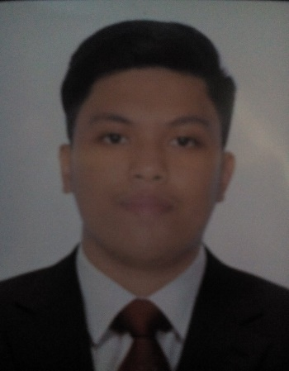

**Joren Niall G. Echavez**

443 Manzanas St.

Brgy.415, Zone 42, Sampaloc, Manila

Cell #: 09366832570

jorenniall23@gmail.com

**PERSONAL DATA**

Date of Birth : December 23, 1998

Age : 19 yrs. old

Place of Birth : San Jose Delmonte, Bulacan

Height : 5’5”

Religion : Iglesia Ni Cristo

Sex : Male

Civil Status : Single

**EDUCATIONAL BACKGROUND**

**TERTIARY :** New Era University

Bachelor of Science in Computer Science

Quezon City

3rd yr Student at present

**SECONDARY :** New Era University

Quezon City

Batch 2012-2015

**ELEMENTARY :** New Era University

Quezon City

Batch 2005-2011

**SKILLS**

Computer literate (Basic Programming)

Good in oral and written communication

**ACHIEVEMENTS**

Designed a Reservation of cinema system (case study in CS 121L) using Java;

Designed Java Like compiler(Case study in CS211L) through java;

Knowledgeable using IBM DB2 express-C;

Designed an algorithm game (Rock, Paper, Scissors) through java;

Adept in using MS product(MS word, MS PowerPoint and MS Excel);