**Use Case Diagram of AskSenpai**

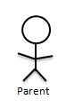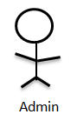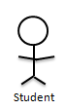

**Activity Diagram for AskSenpai**

Invalid Answer

Login

Input query

Corresponding answer

NO

YES

Logout

Invalid answer will send to admin