1. Open pgAdmin and select the required DB. Then right click on the DB and select Backup



2. Provide valid filename and location.Under the format select the option **“Plain”**



3. Ensure that Pre Data , Data & Post Data options are selected under Dump Options #1.



4. Under Queries all options need to be selected under Dump Options #2.



1. Under Objects all the objects should be selected. Then Clcik on the Backup Button



1. Once the Backup is completed successfully it should return status 0



Repeat the same steps again to take backup of a different DB by selecting that DB.

Database Restore:

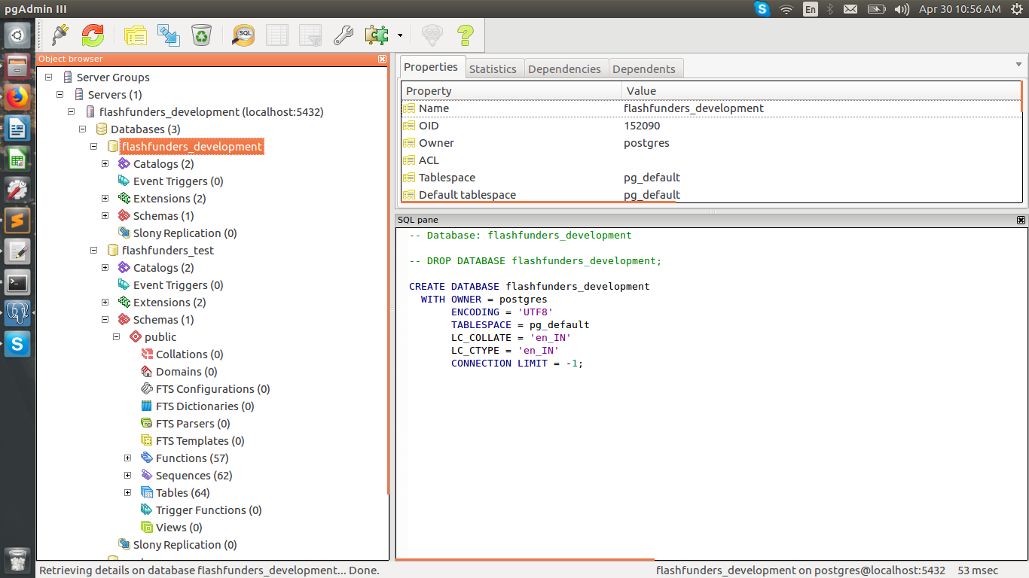

right click on the database and click on Restore.

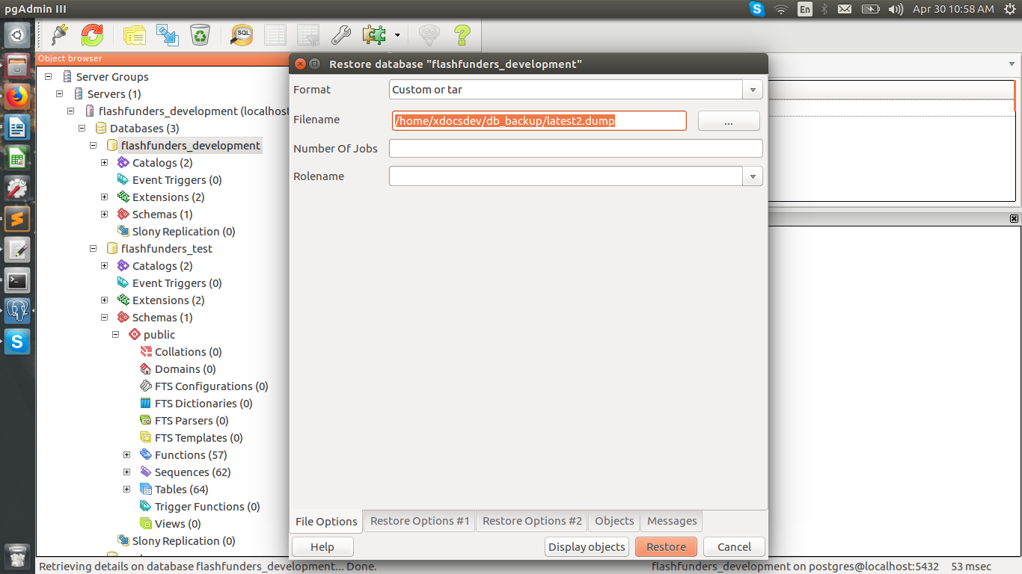

Select the dump file and click on Restore Options #1 tab

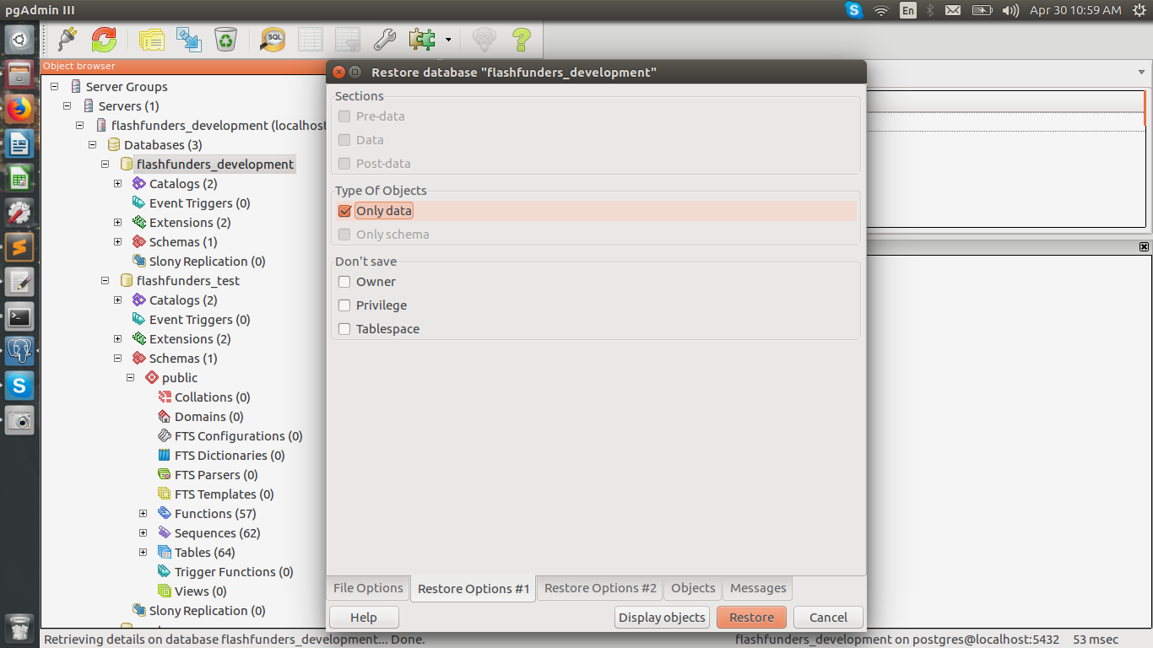

click on Only data check box and click on Restore button.

**Db restoration using postgres command line:**



* Enter below commands in the same terminal.

1)Open terminal

2)sudo su postgres

3)createdb sample_db;

4)Enter postgres password

5)psql -U postgres sample_db < sample_db_dump;