1. Open pgAdmin and select the required DB. Then right click on the DB and select Backup

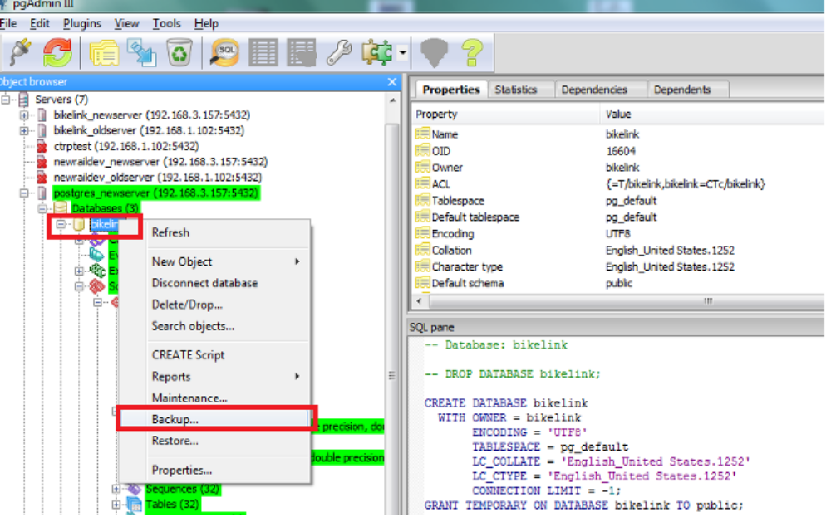
2. Provide valid filename and location.Under the format select the option “Plain”

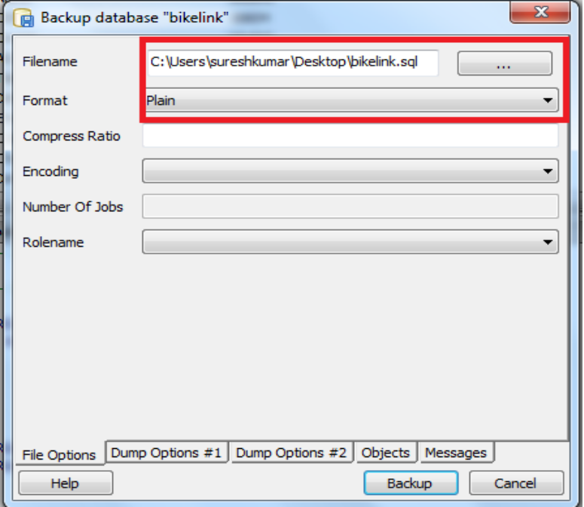

3. Ensure that Pre Data , Data & Post Data options are selected under Dump Options #1.

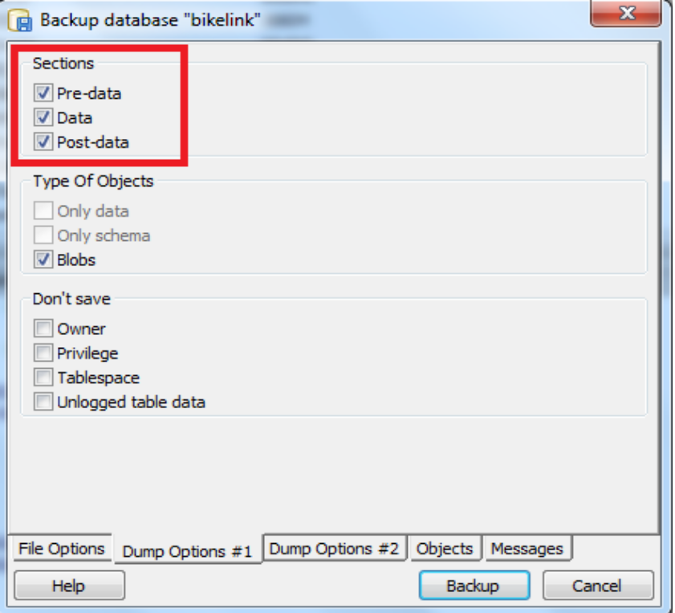
4. Under Queries all options need to be selected under Dump Options #2.

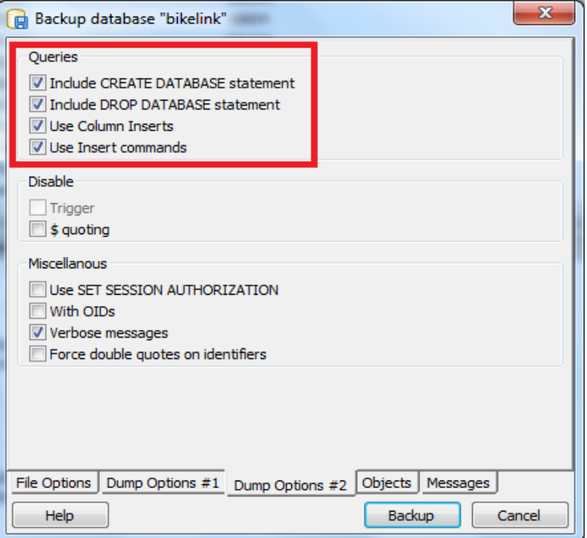

- Under Objects all the objects should be selected. Then Clcik on the Backup Button
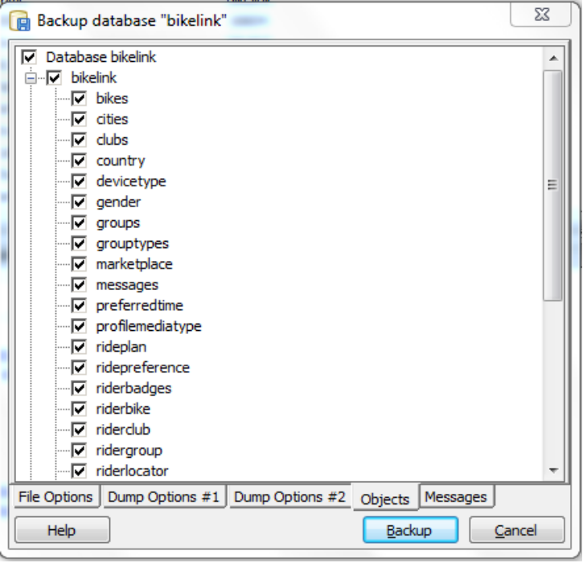

- Once the Backup is completed successfully it should return status 0

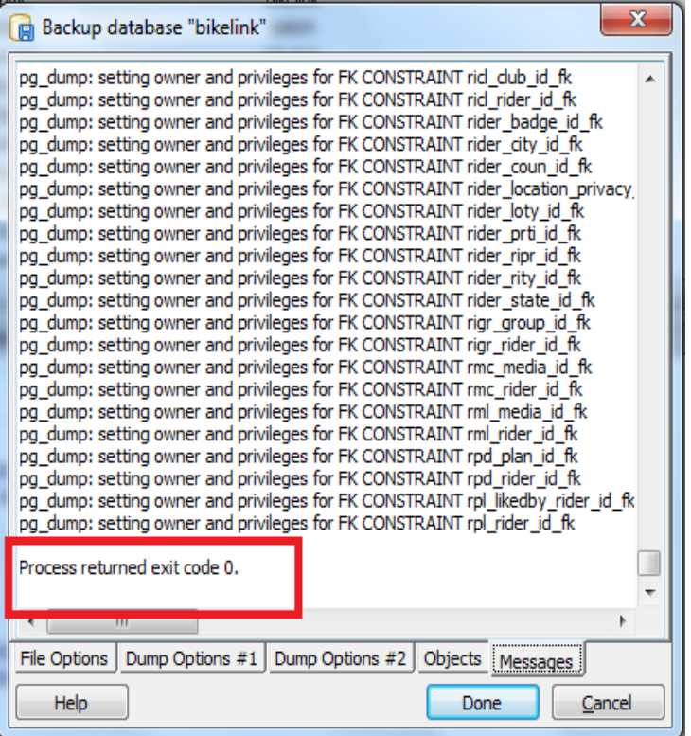

Repeat the same steps again to take backup of a different DB by selecting that DB.

Database Restore:
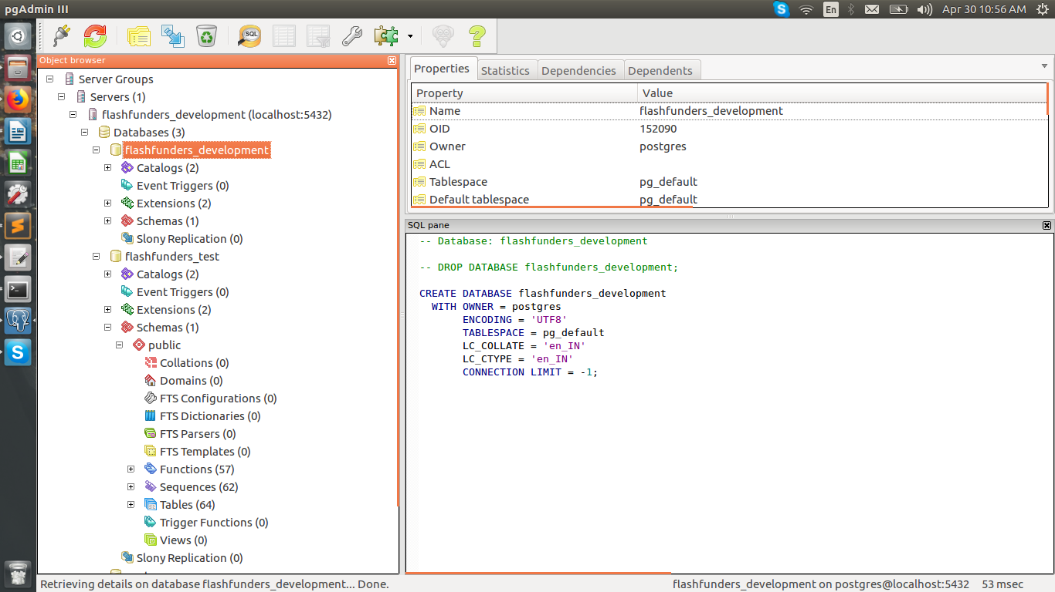

right click on the database and click on Restore.
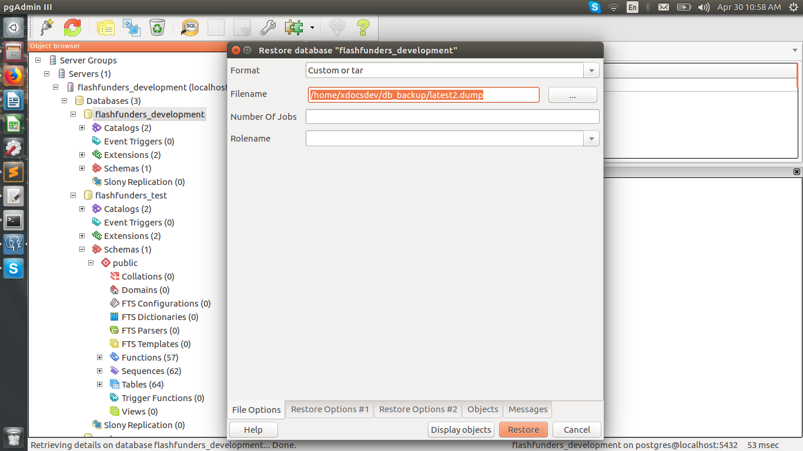

Select the dump file and click on Restore Options #1 tab
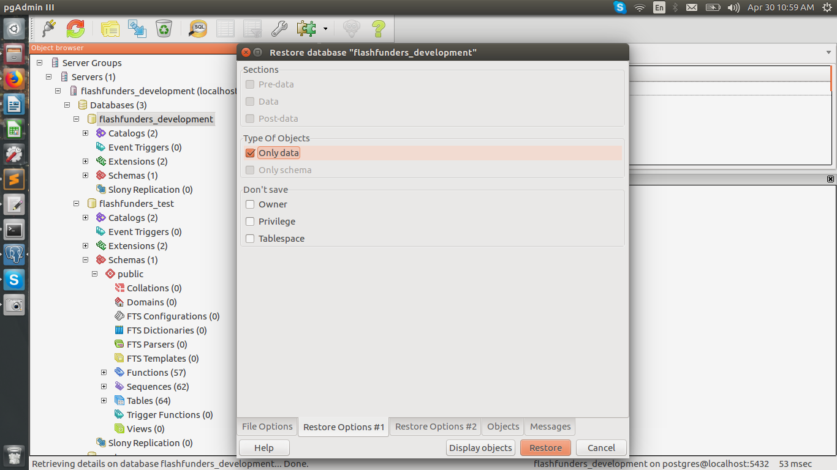
click on Only data check box and click on Restore button.

Db restoration using postgres command line:

* Enter below commands in the same terminal.

1)Open terminal
2)sudo su postgres
3)createdb sample_db;
4)Enter postgres password
5)psql -U postgres sample_db < sample_db_dump;

