Assignment 3

Data Management (INFO125)
Deadline: Friday, 18.10.2024 at 13:00

Aslak Vandvik, Mads Ask, Selma Børtveit

Question 1
Consider the following relations for a database that keeps track of booking flats and choose the primary keys:
FLAT (Flat#, Type, Address, Price_perUnit)
OPTION (Flat#, Option_name, Extra_price)
BOOKING (Agent#, Flat#, Date, Booking_price)
AGENT (Agent_id, Name, Phone)

FLAT
Flat# | Type | Address | Price_perUnit
A105 | 3BHK | Waltham Abbey | 200
A308 | 5BHK | Charlotte Street | 220
B216 | 3BHK | Old Gloucester Street | 290
B201 | 3BHK | Old Gloucester Street | 290

OPTION
Flat# | Option_name | Extra_price
A105 | Balcony East Facing | 1100
A308 | Window | 600
B216 | Mezzanine Floor | 1000

BOOKING

Agent# | Flat# | Date | Booking_price
A1 | A105 | 12-01-2016 | 1100
A2 | B216 | 02-02-2016 | 2100

AGENT

Agent_id | Name | Phone
A1 | Will Smith | 44 20 7520 1490
A2 | Ashley Rawdon | 44 20 8650 2999
A3 | John Stuart | 44 20 7419 5000

Now answer the following questions:
- What can be the foreign keys for this schema, stating any assumptions you make.
  - Flat# in OPTION references Flat# in FLAT. The OPTION table lists options for flats, and each option is associated with a spesific flat.
  - Agent# in BOOKING references Agent_id in AGENT. Each booking is made by an agent.
  - Flat# in BOOKING references Flat# in FLAT. Each booking is for a spesific flat. Flat# in BOOKING should match a flat listed in the FLAT table.
- Which of the following operations violate the referential integrity constraints and which one does not.
- INSERT <’A1’, ‘A308’, ’03-03-2016’, 2100> INTO BOOKING
  - Agent# = ‘A1’ exists in the AGENT table.
  - Flat# = ‘A308’ exists in the FLAT table.
  - No violation.
- INSERT <’A1’, ‘C205’, ’03-03-2016’, 2100> INTO BOOKING
  - Agent# = ‘A1’ exists in the AGENT table.
  - Flat# = ‘C205’ does not exist in the Flat table.
  - This is a violation because the required flat doesn´t exist in the Flat table.
- INSERT <’A4’, ‘Arilia Sengupta’, ‘44 20 7836 5454’> INTO AGENT
  - No violation because it doesn´t reference any other table.

Question 2
Consider the following Hotel, Room, Booking and Guest schemas in a DBMS.
- Hotel(hotelNo,hotelName, hotelType, hotelAddress, hotelCity, numRoom)
- Room(roomNo, hotelNo, roomPrice)
- Booking(bookingNo, hotelNo, guestNo, checkIn, checkOut, totalGuest, roomNo)
- Guest(guestNo, firstName, lastName, guestAddress)
The hotelNo is the primary key for Hotel table and roomNo is the primary key for the Room relation. Booking stores the details of room reservations and bookingNo is the primary key. Guest stores the guests details and guestNo is the primary key.
- Write SQL script to list details of hotels in New York in descending order by number of rooms
- Write SQL script to list the details of all guests whose first name is ‘Sara’ in ascending order by address.
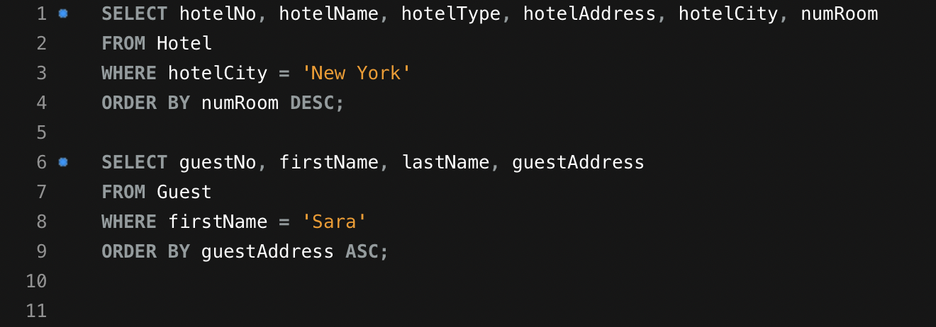

Question 3
The following figure represents a database schema called Art_Gallery. Write SQL statements that would create a Art_Gallery database with the given tables (relations) and columns (attributes). Specify the primary keys and foreign keys according to the figure. You can make your own decisions on the data types for the columns and their domains. You can also decide whether or not certain columns can have NULL values. Note: Different Solutions are possible.
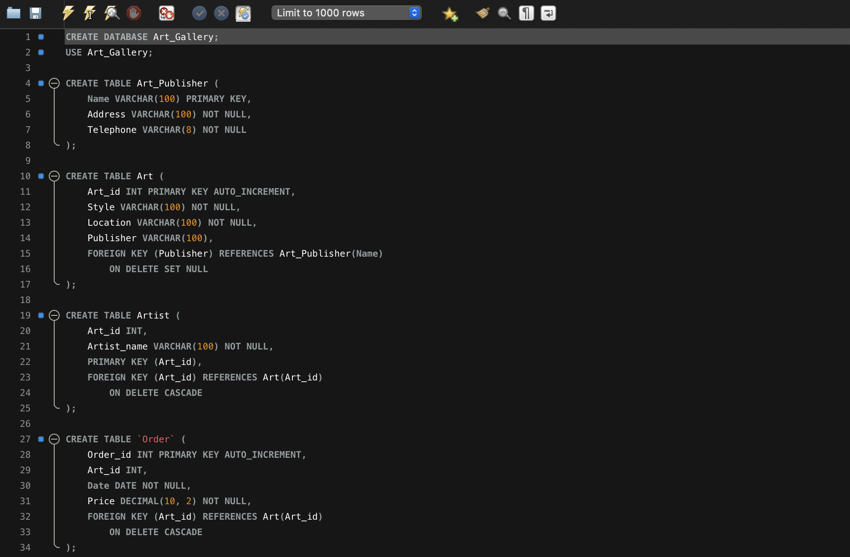
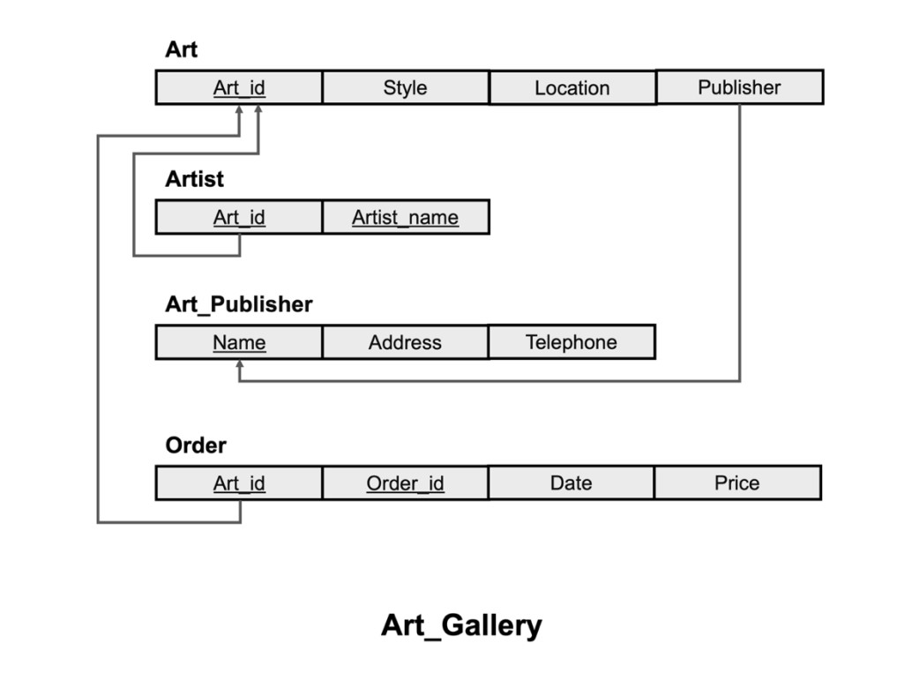

Question 4
Consider the following EER diagram and map it to the relational model as well as indicating the foreign keys.
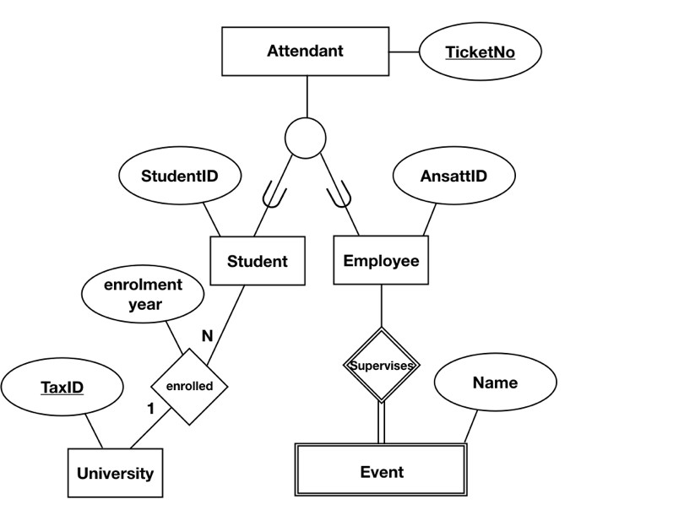
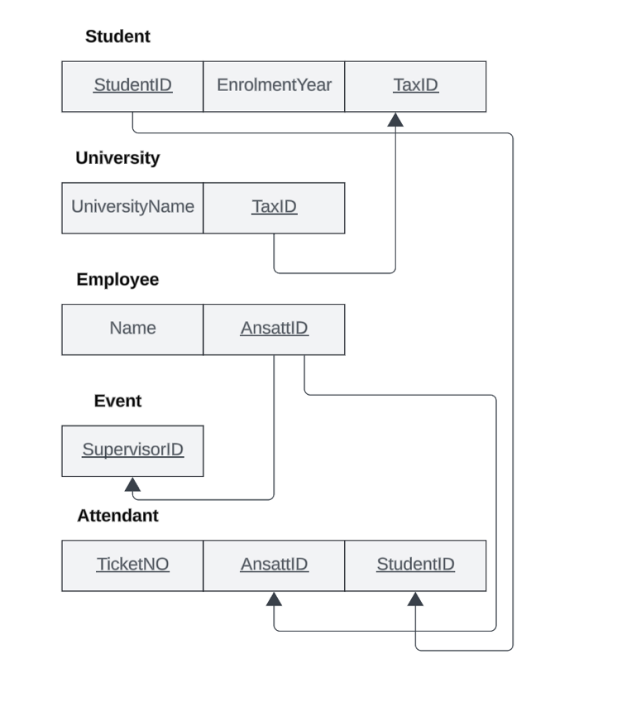
Note: Different Solutions are possible

