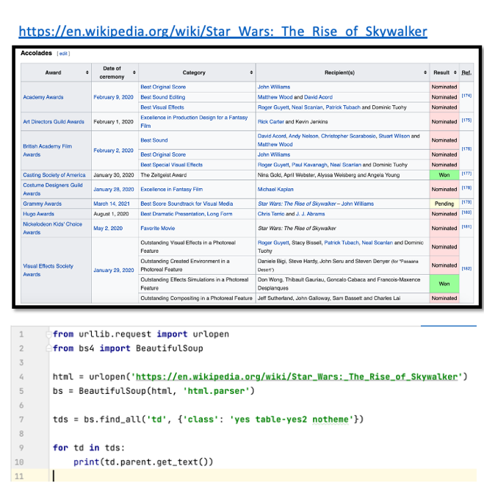
Task 2.a)
The Python code doesn't print the Award and Date of Ceremony columns consistently due to the way the table is structured. The code is requesting the parent element of the columns that have the "Won" value. However, only the <td> tags at the top of the table, which contain the "Won" value, have the Award and Date of Ceremony as their parent elements. This explains why the columns are not printed every time.

