TASK NO: 2

TASK NAME: **AI, ML, DL Relationship Diagram**

|  |
| --- |
| **DATA SCIENCE** |

|  |
| --- |
| **ARTIFICAL INTELLIGENCE** |

|  |
| --- |
| **MACHINE LEARNING** |

|  |
| --- |
| **DEEP LEARNING** |

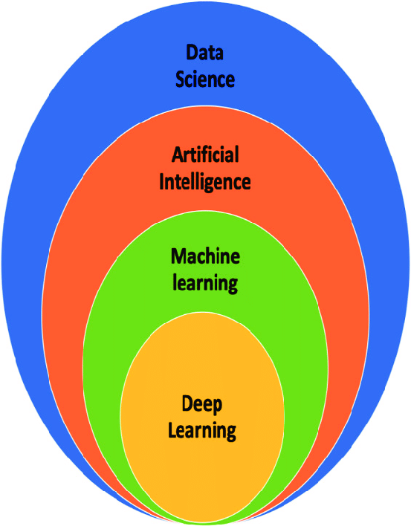

**EXPLANATION:**

**Data Science**: The broadest field, using AI, ML, and statistical techniques to analyze and extract insights from data.

**Artificial Intelligence (AI)**: Artificial intelligence (AI) is a technology that uses machines to mimic human intelligence. AI systems can learn from data, make decisions, and perform tasks.

**Machine Learning (ML)**: A subset of AI that enables machines to learn from data without explicit programming.

**Deep Learning (DL)**: A subset of ML that uses deep neural networks to process complex data like images and speech.