030,032,035,ramen.R

**Kode Penuh :**

|  |
| --- |
| ramen_ratings <- readr::read_csv("https://raw.githubusercontent.com/aslam200/030-032-035_datamining_polibatam/master/ramen-ratings.csv") |
| library(tidyverse) |
| view(ramen_ratings) |
|  |
| ramen_ratings %>% |
| summarise(NAs = sum(is.na(stars))) |
|  |
| clean_ramen_ratings <- ramen_ratings %>% |
| filter(!is.na(stars)) |
|  |
| #Ulasan cepat - Peringkat yang dimaksud menurut negara: |
| clean_ramen_ratings %>% |
| group_by(country) %>% |
| summarise(Mean = mean(stars)) %>% |
| ggplot(clean_ramen_ratings, mapping = aes(reorder(country, Mean), Mean)) + |
| geom_col() + |
| coord_flip() |
|  |
| #Membuat variabel dengan data yang digunakan sebelumnya: |
| StarsMeanByCountry <- mutate(summarise(group_by(clean_ramen_ratings,country), |
| stars_mean = mean(stars)) |
| ) |
|  |
| StarsMeanByCountry <- arrange(StarsMeanByCountry, desc(stars_mean)) |
| TopTenCountries <- StarsMeanByCountry[1:10,] #Top 10 countries |
|  |
| #Memainkan dengan ggplot |
| ggplot(TopTenCountries, mapping = aes(reorder(country, stars_mean), stars_mean)) + |
| geom_col(colour = "black", size =1, fill = "white", width = .75) + coord_flip() + |
| geom_text(aes(label=stars_mean), vjust=.1, hjust= 1.05, color="blue", size=4) |
|  |
|  |
| #Top 10 negara dengan peringkat terbaik |
| PlotA <- ggplot(TopTenCountries, mapping = aes(reorder(country, stars_mean), stars_mean, fill =country)) + |
| geom_bar(stat="identity", colour ="black") + coord_flip() + |
| theme(legend.position="none") + |
| scale_fill_brewer(palette="Set3") + |
| geom_text(aes(label=stars_mean), vjust=.1, hjust= 1, color="black", size=4,fontface = "bold") + |
| labs(title="Top 10 Countries",x="Countries", y="Stars Mean") |
|  |
|  |
|  |
| #Styles, Countries, jumlah baris per masing-masing dan Stars |
| StylesOfCountries <- mutate(summarise(group_by(clean_ramen_ratings,style, country), |
| count = n(), |
| stars_mean = mean(stars)) |
| ) |
|  |
| #Hapus NA's |
| StylesOfCountries <- StylesOfCountries %>% |
| filter(!is.na(style)) |
|  |
| view(StylesOfCountries) |
|  |
| PlotB <- StylesOfCountries %>% |
| filter(count >=50) %>% |
| ggplot(StylesOfCountries, mapping = aes(count, style)) + |
| geom_point() + |
| geom_text(aes(label=country),angle =45, check_overlap = T) + |
| geom_text(aes(label=stars_mean), vjust=2, hjust=-.1,angle=45, color="red",check_overlap = T) + |
| labs(title="Styles of Countries and their Stars Mean",x="Number of records", y="Types of styles") |

**Dataset :**

**Ramen-ratings.cvs**

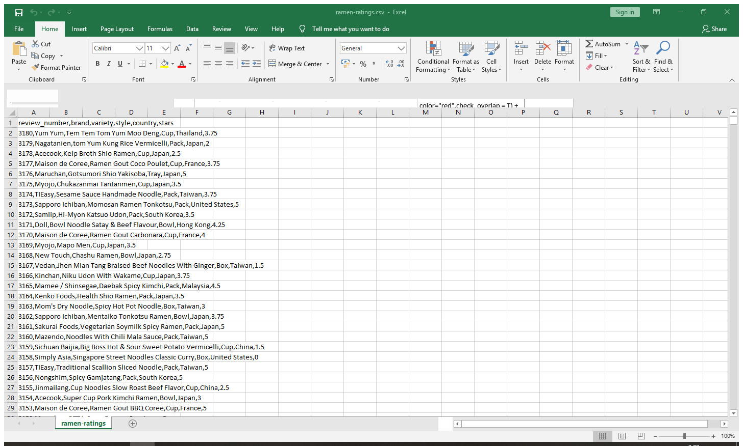

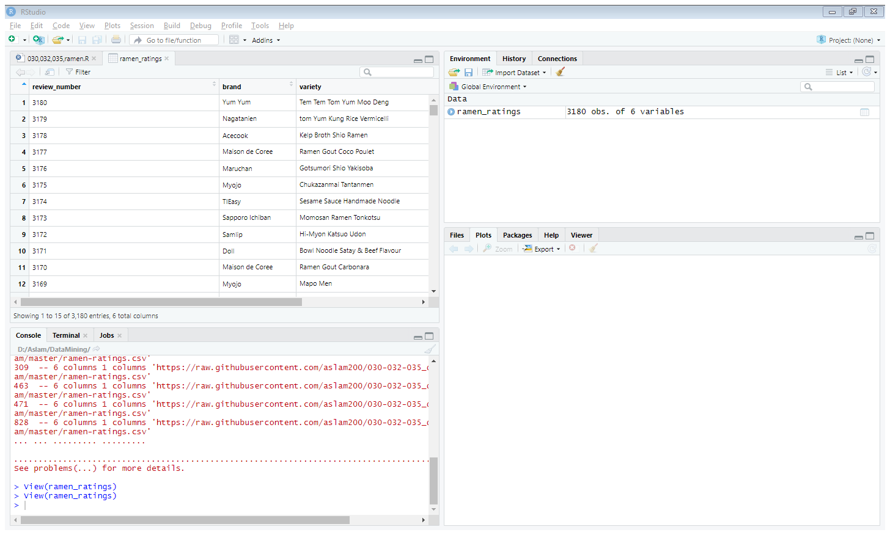

Menampilkan dataset ramen-ratings.csv melalui github yang sudah di raw

ramen_ratings <- readr::read_csv("https://raw.githubusercontent.com/aslam200/030-032-035_datamining_polibatam/master/ramen-ratings.csv")

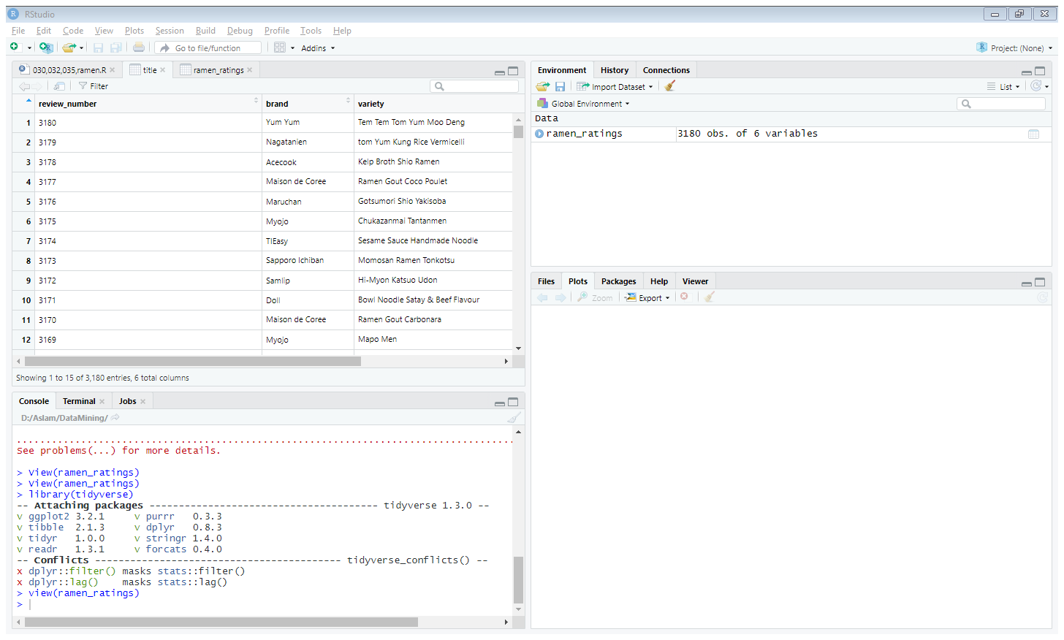

Dan disini menampilkan isi dataset ramen-ratings.csv

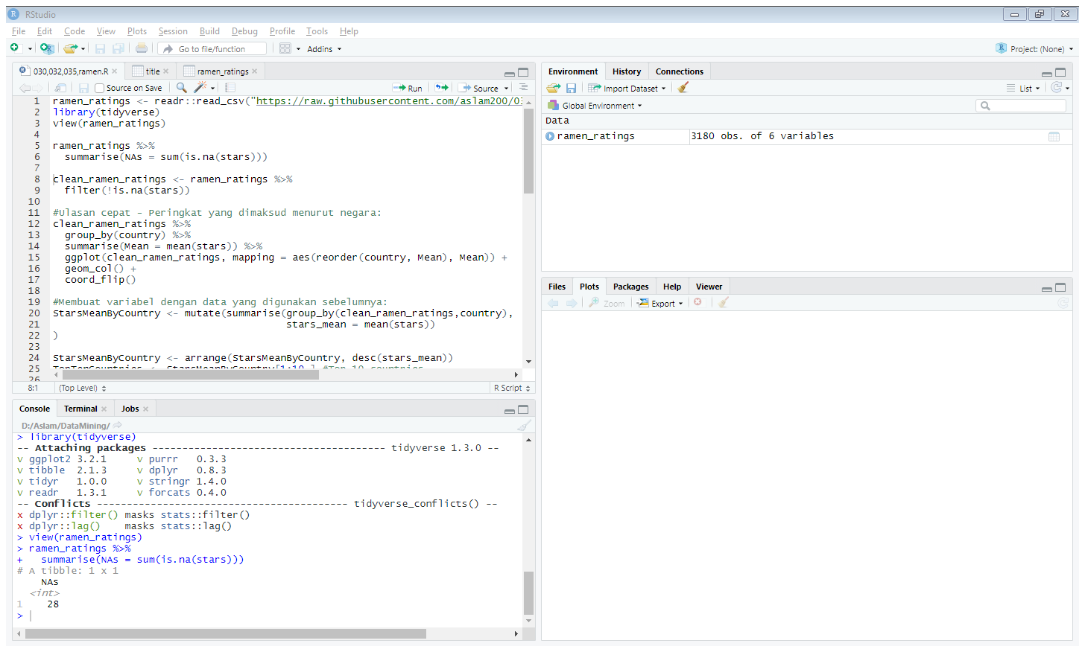

ramen_ratings %>%

summarise(NAs = sum(is.na(stars)))

kode ini untuk menjumlah kan table stars yang tidak memiliki rating

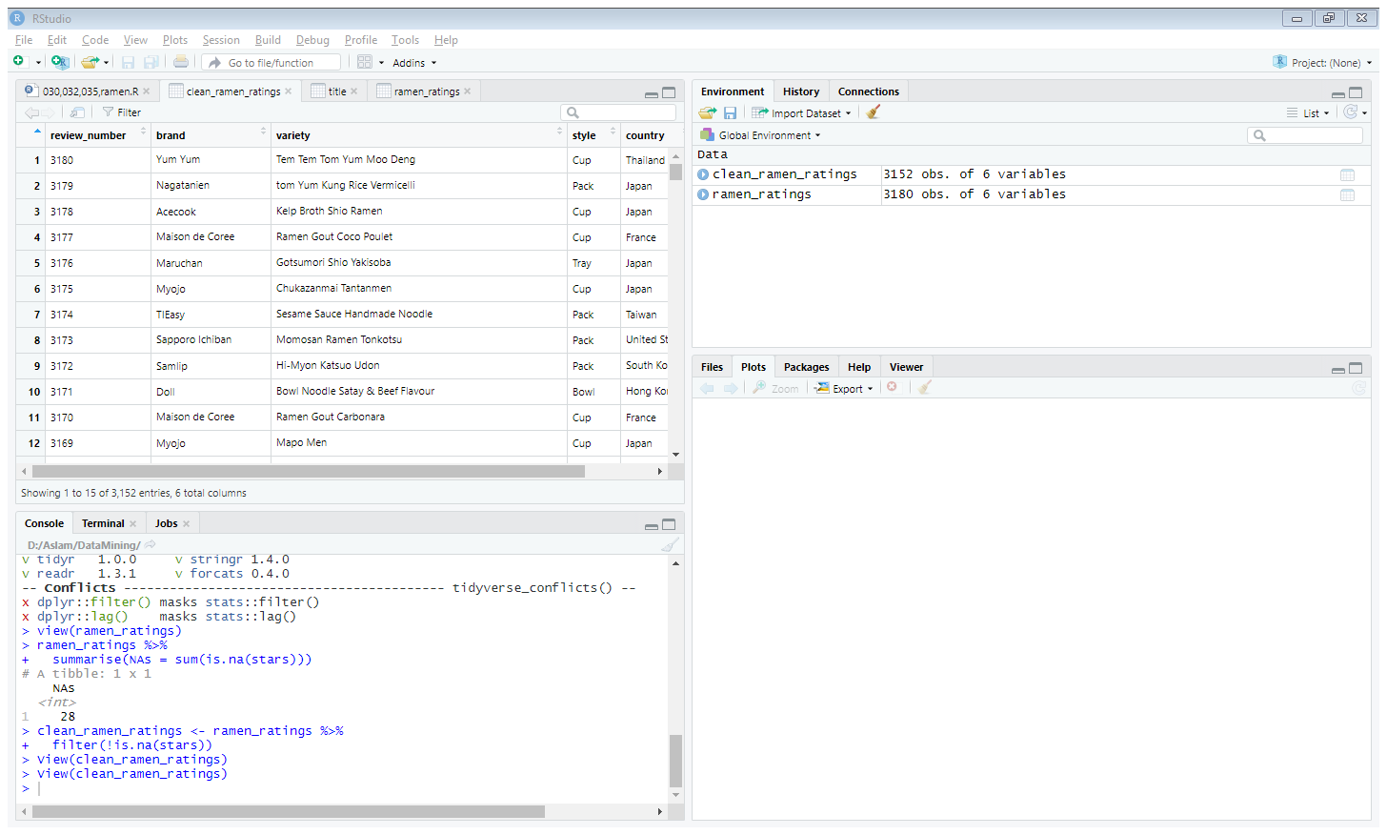

clean_ramen_ratings <- ramen_ratings %>%

filter(!is.na(stars))

kode ini untuk menghapus data yang tidak ada rating seperti ditandai NA

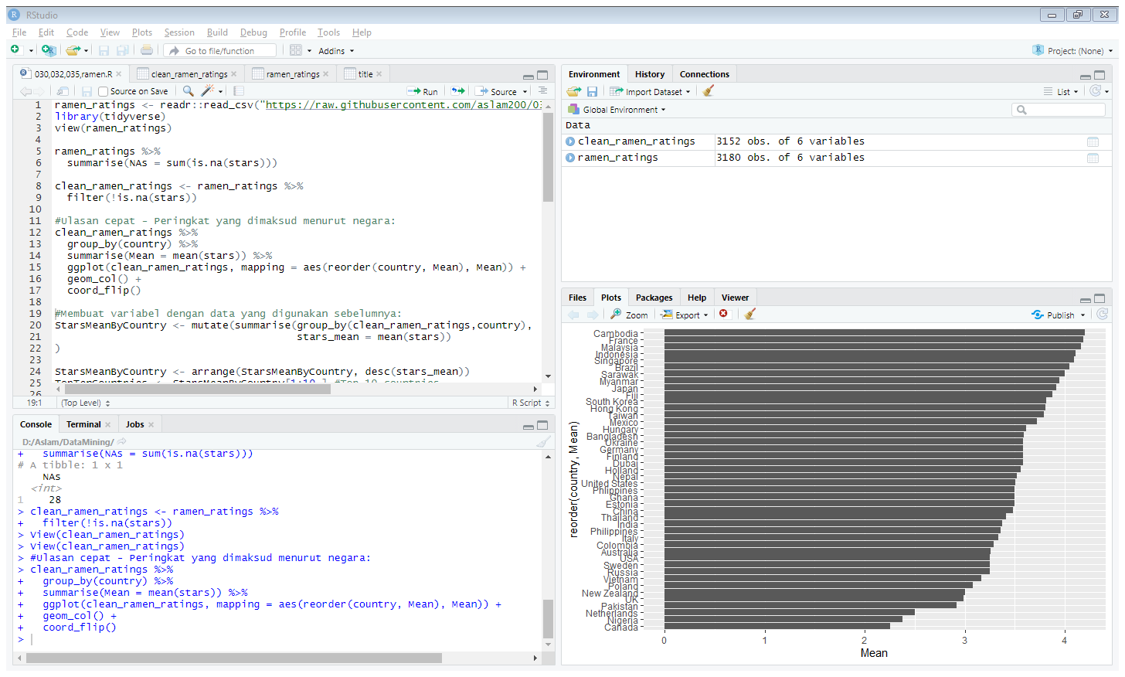

clean_ramen_ratings %>%

group_by(country) %>%

summarise(Mean = mean(stars)) %>%

ggplot(clean_ramen_ratings, mapping = aes(reorder(country, Mean), Mean)) +

geom_col() +

coord_flip()

dimana kode ini akan membuat grapik dengan ggplot, dan menampilkan rata rata tiap bintang yg sudah digrup negara dan grafik hitam menunjukkan ratingnya

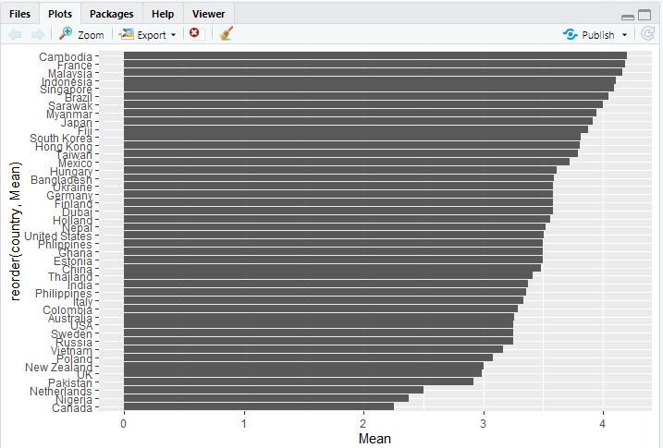

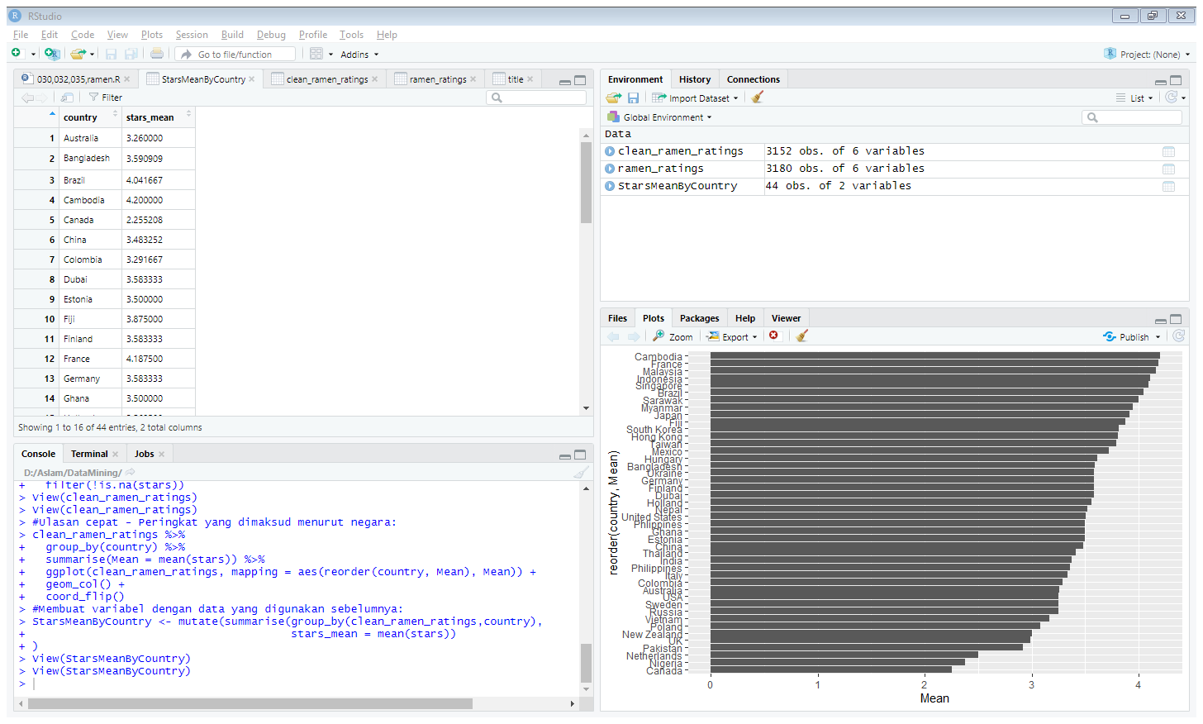

StarsMeanByCountry <- mutate(summarise(group_by(clean_ramen_ratings,country),

stars_mean = mean(stars))

)

StarsMeanByCountry <- arrange(StarsMeanByCountry, desc(stars_mean))

Dan disini menampilkan country dan stars_mean , dan banyak country ada 40 country dan ratarata bintang tiap negara

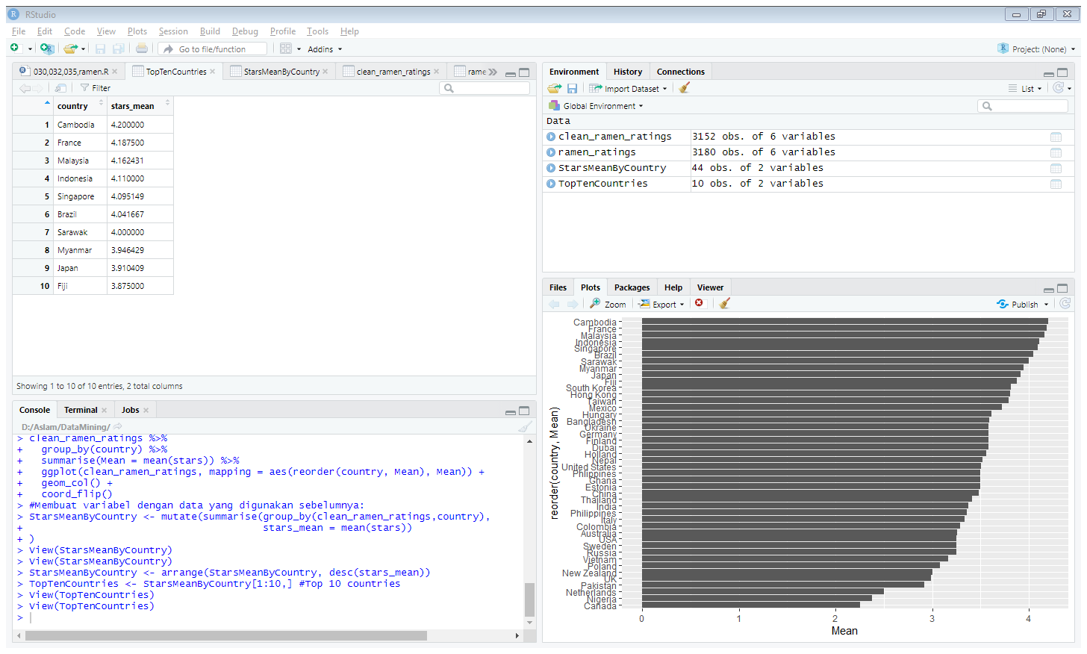

TopTenCountries <- StarsMeanByCountry[1:10,]

Meringkas dari starsmeanbycountry menjadi 1- 10 negara saja yang ditampilkan

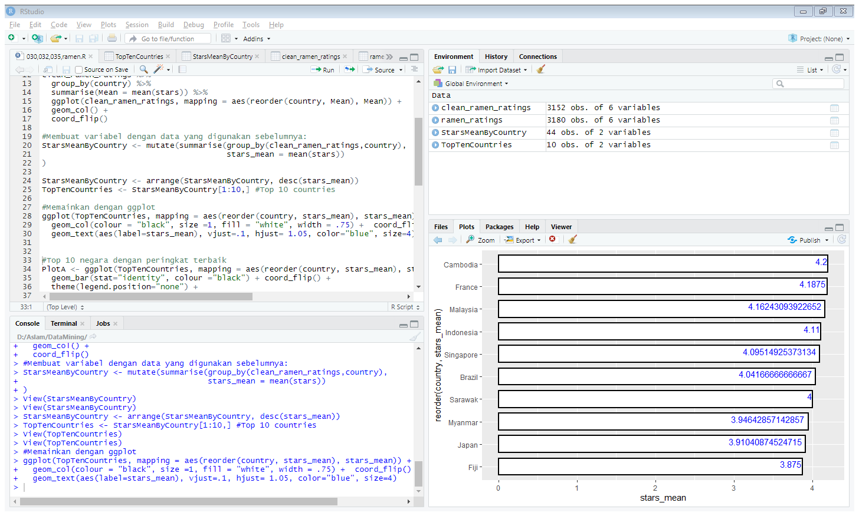

ggplot(TopTenCountries, mapping = aes(reorder(country, stars_mean), stars_mean)) +

geom_col(colour = "black", size =1, fill = "white", width = .75) + coord_flip() +

geom_text(aes(label=stars_mean), vjust=.1, hjust= 1.05, color="blue", size=4)

dengan grafik seperti itu hanya 10 negara saja yg ditampilkan

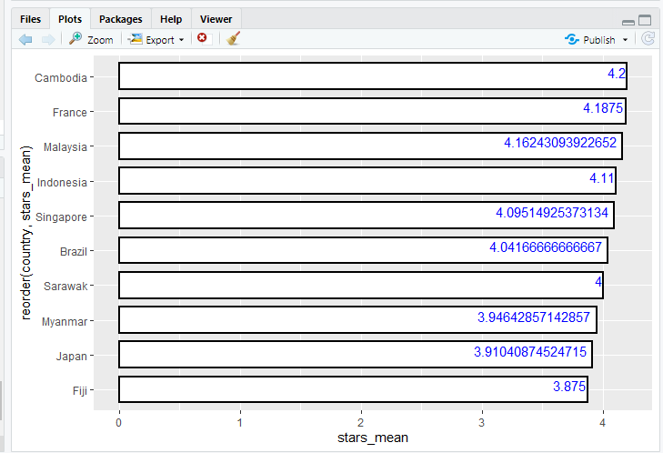

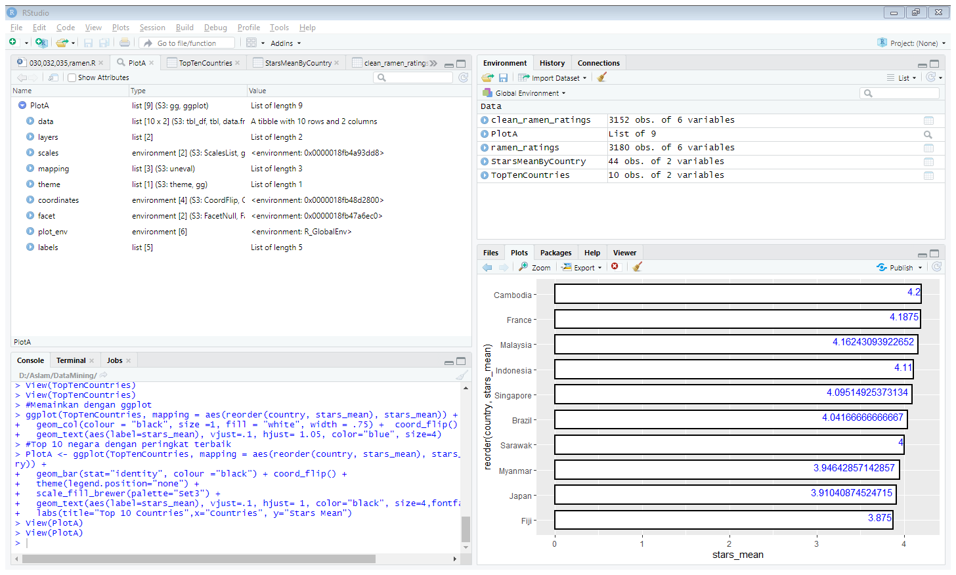

Plot A <- ggplot(TopTenCountries, mapping = aes(reorder(country, stars_mean), stars_mean, fill =country)) +

geom_bar(stat="identity", colour ="black") + coord_flip() +

theme(legend.position="none") +

scale_fill_brewer(palette="Set3") +

geom_text(aes(label=stars_mean), vjust=.1, hjust= 1, color="black", size=4,fontface = "bold") +

labs(title="Top 10 Countries",x="Countries", y="Stars Mean")

hasil grafik 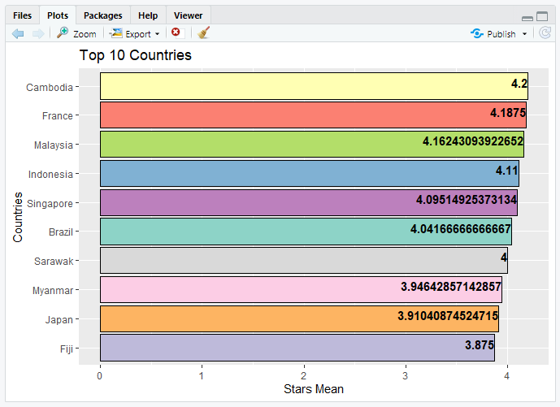

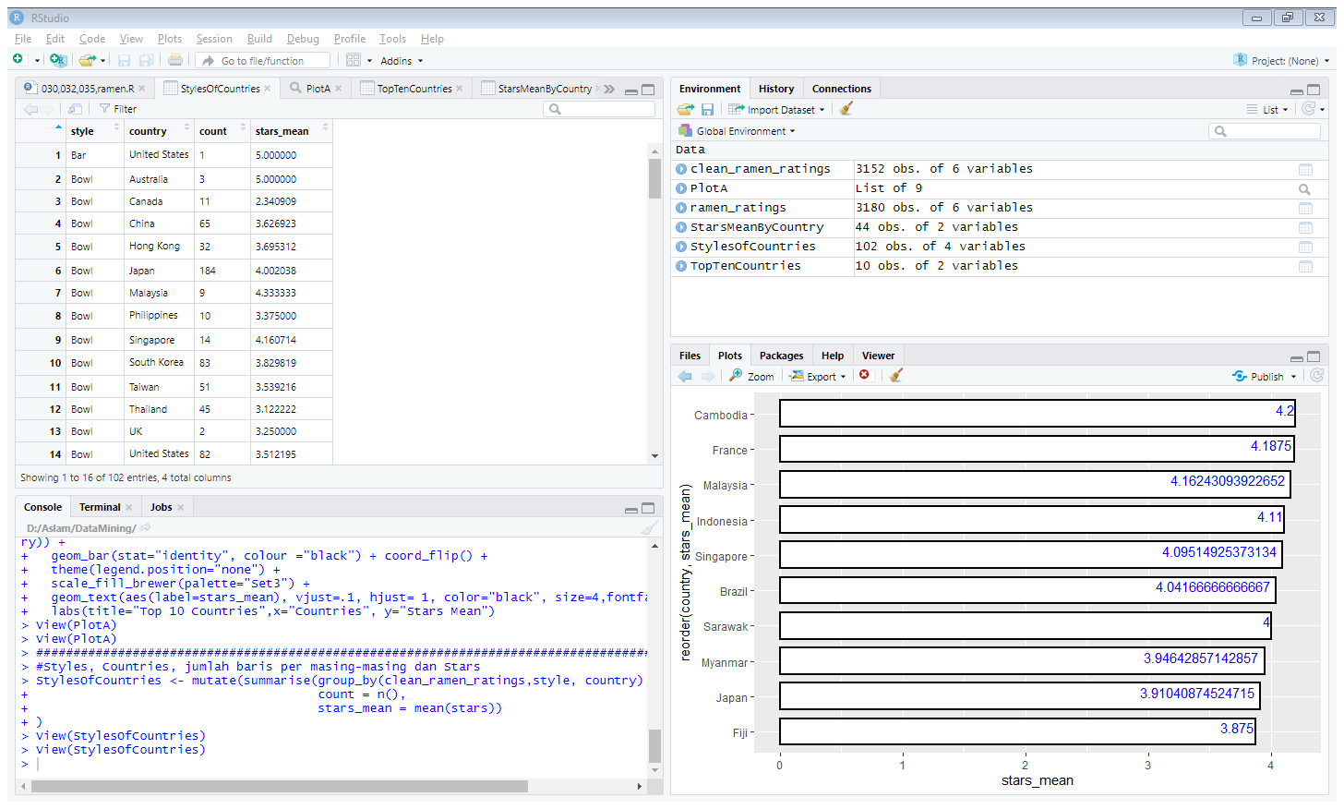

StylesOfCountries <- mutate(summarise(group_by(clean_ramen_ratings,style, country),

count = n(),

stars_mean = mean(stars))

)

Yaitu cara makan ramen tiap negara , ada yang bar , bowl dan lain lain

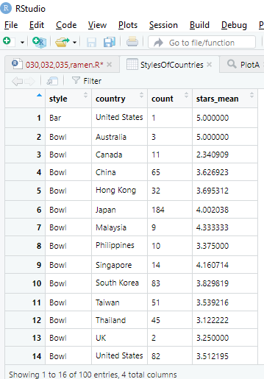

StylesOfCountries <- StylesOfCountries %>%

filter(!is.na(style))

untuk menghapus yang berada kolom style yang tidak ada cara makan atau NA

lalu dihapus menjadi 100 entries dari 102 entries.

Referensi dari   
  
#https://stackoverflow.com/questions/25664007/reorder-bars-in-geom-bar-ggplot2 #Discovering reorder

#https://ggplot2.tidyverse.org/reference/geom_text.html #Discovering geom_text

#https://rpubs.com/woobe/ggplot2_ref_part02 #Discovering some new colors for ggplot

#http://www.sthda.com/english/wiki/ggplot2-barplots-quick-start-guide-r-software-and-data-visualization #A little help