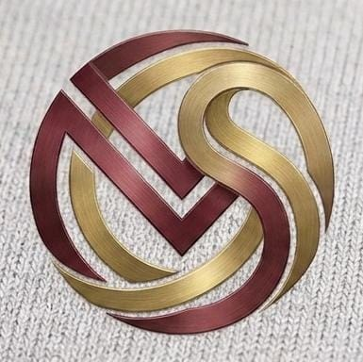  M.S FASHION  THE ART OF BESPOKE ETHNIC MENSWEAR  Royal Sherwanis • Jodhpuri Bandhgalas • Bespoke Suits | ATELIER & WORKSHOP OFFICE  Ground Floor, 10/A, Sanaullah Compound,  Near Sauda Bakery, Dharavi Main Road,  Mahim (East), Mumbai – 400017, MH, India  Phone / WhatsApp: +91 89993 86222  Email: msfashionbespoke@gmail.com  Web: www.msfashionbespoke.com  Reg. Id / Udyam MSME: MH-19-UDYAM-2026

Ref. No: MSF/PROJ/2026-27/05 | Date: 27th October 2026
PROJECT COMPLETION & INDUSTRIAL SPONSORSHIP CERTIFICATE
TO WHOMSOEVER IT MAY CONCERN
This is to certify that Mr. Aslam Ansari (Roll No: 05, Seat No: _______________), a bonafide student of Bachelor of Science in Computer Science (B.Sc. CS) from Rizvi College of Arts, Science and Commerce (Affiliated to the University of Mumbai), has successfully completed his live client project titled:
“M.S FASHION: BESPOKE ETHNIC MENSWEAR PLATFORM”
at our atelier premises and technical environment during the Academic Year 2026–2027. The project was executed under the industrial guidance of our Master Tailoring Staff and Management.
During this assignment, Mr. Aslam Ansari designed, engineered, and deployed a robust full-stack bespoke e-commerce platform using React.js, Node.js/Express, and MongoDB. The system successfully digitizes our physical bespoke tailoring operations by implementing: (1) High-resolution editorial cataloging for Sherwanis, Jodhpuris, Indo-Western garments, and Tuxedos; (2) An interactive CSS Visual Zoom Calibrator allowing clients to inspect intricate zardozi and dabka hand-embroidery up close; (3) A luxury appointment scheduling module fortified with Gmail SMTP OTP email verification to eliminate spam inquiries; (4) Direct WhatsApp atelier consultation with auto-generated garment image links and bespoke quotation estimates; and (5) An administrative portal featuring sequential reference tracking and 4-border phone gallery image crop calibration.
The software has undergone thorough functional testing and has been validated against our commercial workshop requirements. Mr. Aslam Ansari exhibited exemplary dedication, intellectual curiosity, technical competence, and high professional ethics throughout this tenure. We express our sincere satisfaction with his deliverable and wish him grand success in his academic examinations and future career.
 | For M.S FASHION  _____________________________________  AUTHORIZED SIGNATORY / PROPRIETOR  M.S Fashion Bespoke Atelier  Mahim (East), Mumbai – 400017  Contact: +91 89993 86222
  [ OFFICIAL ATELIER SEAL / RUBBER STAMP ]

M.S FASHION ATELIER • BESPOKE MADE-TO-MEASURE MENSWEAR • CONTRACT BULK MANUFACTURING
Atelier: Dharavi Main Road, Mahim (East), Mumbai – 400017 | Tel: +91 89993 86222 | Email: msfashionbespoke@gmail.com

