M.S FASHION: BESPOKE ETHNIC MENSWEAR
PLATFORM
A Project Report
Submitted in Partial fulfilment of the
Requirements for the award of the Degree of
BACHELOR OF SCIENCE (COMPUTER SCIENCE)
SEM V
By Aslam Ansari
Seat No:
Under the esteemed guidance of
Prof. Javed Pathan
Assistant Professor

DEPARTMENT OF COMPUTER SCIENCE

RIZVI COLLEGE OF ARTS, SCIENCE AND COMMERCE

(Affiliated to University of Mumbai)

MUMBAI-400050

MAHARASHTRA

2026-2027

RIZVI COLLEGE OF ARTS, SCIENCE AND COMMERCE
(Affiliated to University of Mumbai)
MUMBAI-MAHARASHTRA-400050
DEPARTMENT OF COMPUTER SCIENCE
CERTIFICATE
This is to certify that the project entitled, “M.S Fashion: Bespoke Ethnic Menswear Platform”, is bonafide work of Aslam Ansari bearing Seat No: Roll No: 05 submitted in Partial fulfilment of the requirements for the award of degree of BACHELOR OF SCIENCE in COMPUTER SCIENCE SEM V from University of Mumbai.

Project Guide | HOD
External Examiner
Date: __________ | College Seal

ACKNOWLEDGEMENT
I would like to extend my sincere appreciation to the Department of Computer Science at Rizvi College of Arts, Science, and Commerce for providing me with the opportunity to undertake and complete this project dissertation.
I am deeply grateful to our Principal, Dr. Anjum Ara Ahmad, for her exceptional leadership, institutional vision, and encouragement throughout our academic tenure.
I would also like to express my sincere gratitude to the Head of the Department, Professor Arif Patel, for his support in terms of providing essential departmental facilities, computing laboratories, and academic guidance throughout the course, which has been instrumental in the completion of this project.
I would like to convey my profound thanks to my esteemed project guide, Professor Javed Pathan. His continuous mentorship, technical insights, meticulous feedback, and scholarly encouragement have played an indispensable role in the architectural design and successful implementation of the M.S Fashion bespoke platform.
Lastly, I am deeply thankful to my dear parents and family members for their unwavering support, moral encouragement, and blessings that sustained my efforts throughout the development of this dissertation.
Aslam Ansari
Roll No: 05

PLAGIARISM REPORT
The plagiarism scan report for the M.S Fashion: Bespoke Ethnic Menswear Platform project documentation shows 0% plagiarism, indicating that no copied content was detected during the scan. The report records 0% Exact Match and 0% Partial Match, meaning that no significant text was found to directly or partially match the sources checked by the plagiarism detection system.
The report also shows 100% Unique Content, demonstrating that the submitted documentation is identified as original. Overall, the result indicates that the project report maintains a high level of originality and does not contain detectable plagiarized content according to the scan.
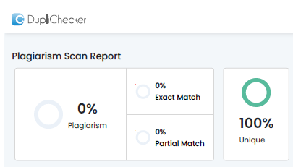
Figure: Plagiarism Scan Report Certificate (0% Plagiarism / 100% Unique)

DECLARATION
I hereby declare that the project entitled, “M.S Fashion: Bespoke Ethnic Menswear Platform”, has not been in any case duplicated to submit to any other university for the award of any degree. To the best of our knowledge other than us, no one has submitted to any other university. The project is done in partial fulfilment of the requirements for the award of degree of BACHELOR OF SCIENCE (COMPUTER SCIENCE) to be submitted as semester V project as part of our curriculum.
Aslam Ansari

ABSTRACT
M.S Fashion: Bespoke Ethnic Menswear Platform is a technology-driven web application designed to simplify, modernize, and elevate the bespoke tailoring consultation experience for high-end Indian ethnic menswear. Clients seeking wedding and celebration attire—such as royal Sherwanis, aristocratic Jodhpuri Bandhgalas, Indo-Western fusion ensembles, and bespoke Tuxedos—often face challenges with traditional off-the-rack sizing, lack of pre-trial visual inspection, unorganized communication, and fragmented record keeping. The proposed system provides a centralized digital atelier platform where users can explore curated collections, inspect intricate hand-embroidery with interactive zoom calibration, configure royal accessories, calculate itemized price estimations, and book verified private fittings.
The system incorporates an interactive hardware-accelerated CSS Transform-Origin Visual Zoom Calibrator (2.2x zoom) that allows clients to examine fine Zardozi wirework, brocade textures, and accessory details. To solve high-ticket bridal wear communication challenges, the application integrates an intelligent Royal Atelier AI Stylist Chatbot providing contextual styling advice for wedding events, explaining the 15+ body measurement process, and routing inquiries directly to the Master Craftsman on WhatsApp (+91 89993 86222) with automated garment photo links. A two-step royal Email OTP verification protocol powered by Gmail SMTP safeguards the boutique from appointment spam while enabling a client-defined Expected Budget (Self Budget) entry.
By integrating modern web technology (React, Node.js, Express, MongoDB), an AI conversational assistant, and centralized master administrative controls (with sequential Ref IDs and a 4-border phone gallery image crop studio), the proposed system makes bespoke ethnic menswear tailoring more organized, accessible, transparent, and proactive, improving the overall couture experience for clients and master tailors alike.

TABLE OF CONTENTS
CHAPTER 1. INTRODUCTION 01
1.1 Introduction 01
1.2 Problem Definition 02
1.3 Aim 04
1.4 Objectives 05
1.5 Goal 05
1.6 Need of the System 06
CHAPTER 2. REQUIREMENT SPECIFICATION 07
2.1 Introduction 07
2.2 System Environment 07
2.3 Software Requirements 08
2.4 Hardware Requirements 10
2.5 Methodology 10
2.6 Spiral Model 11
CHAPTER 3. SYSTEM ANALYSIS 15
3.1 System Analysis 15
3.2 Analysis of Existing System 16
3.3 Analysis of the Proposed System 17
CHAPTER 4. SURVEY OF TECHNOLOGY 20
4.1 React.js 20
4.2 Tailwind CSS 21
4.3 Node.js 22
4.4 Express.js 23
4.5 MongoDB 23
4.6 Vite 24
4.7 Nodemailer 24
4.8 Royal Atelier AI Stylist 25
4.9 Postman 25
CHAPTER 5. SYSTEM DESIGN 26
5.1 Introduction 26
5.2 System Architecture Diagram 26
5.3 Data Flow Diagram 28
5.3.1 Level 0 DFD 28
5.3.2 Level 1 DFD 29
5.4 Activity Diagram 31
5.5 E-R Diagram 32
5.6 Use-Case Diagram 33
CHAPTER 6. SYSTEM IMPLEMENTATION 35
6.1 Introduction 35
6.2 Flowchart 35
6.3 Coding 37
6.3.1 Frontend 38
6.3.2 Backend 68
6.4 Testing Approaches 85
6.4.1 Unit Testing 85
6.4.2 Usability Testing 85
6.4.3 Security Testing 85
6.4.4 Test Cases 86
CHAPTER 7. RESULTS 88
7.1 Introduction 88
7.2 Results 89
7.2.1 Home & Navigation 89
7.2.2 Category Catalog 90
7.2.3 Product Detail & Accessories 91
7.2.4 CSS Zoom Viewer 92
7.2.5 Price Breakdown & WhatsApp 93
7.2.6 Appointment Booking 94
7.2.7 Email OTP Verification 95
7.2.8 Royal AI Stylist Chatbot 96
7.2.9 Master Admin Dashboard 97
7.3 Overall Result 98
CHAPTER 8. CONCLUSION AND FUTURE SCOPE 99
8.1 Conclusion 99
8.2 Future Scope and Enhancement 99
CHAPTER 9. REFERENCE 102

CHAPTER 1. INTRODUCTION
1.1 Introduction
In the modern era, traditional ethnic menswear occupies an important and celebrated position in Indian culture and global couture. Garments such as the Sherwani, Jodhpuri Bandhgala, Indo-Western achkan, and bespoke evening Tuxedos are widely revered as symbols of heritage, regal prestige, and artisanal craftsmanship. For wedding celebrations, festive gatherings, and formal galas, grooms and family members invest substantial time, emotional care, and financial resources into acquiring customized attire.
Unlike mass-market fast-fashion apparel, bespoke ethnic garments require meticulous individual personalization. A custom wedding sherwani or bandhgala involves more than 15 precise anatomical body measurements (including chest, shoulder slope, bicep circumference, posture curvature, waist contour, and torso length), premium hand-selected fabrics (such as pure mulberry silk, Italian micro-velvet, and Banarasi brocade), and labor-intensive hand-embroidery like antique copper wire Zardozi, Pita work, and fine Resham needlework.
Traditionally, this process has been managed through manual in-person boutique visits, physical cloth swatches, and handwritten paper measurement diaries. However, these conventional methods can become difficult to manage, time-consuming, and prone to errors. Important measurement slips can be misplaced, pricing for add-on accessories often remains ambiguous until the final bill, and clients living far away cannot easily explore silhouettes or inspect embroidery craftsmanship prior to visiting the studio.
M.S Fashion: Bespoke Ethnic Menswear Platform is a technology-driven web application designed to provide a centralized digital platform for exploring, customizing, and scheduling consultations for high-end ethnic menswear. Modeled after editorial luxury fashion benchmarks like Manyavar, the platform enables clients to inspect garments at 2.2x zoom magnification, dynamically configure royal accessories, calculate real-time estimated totals, and book verified private atelier appointments.
The proposed system also integrates a specialized Royal Atelier AI Stylist Chatbot to provide personalized styling guidance, event-appropriate attire suggestions, and instant answers to tailoring questions. Through features such as verified Email OTP booking, direct Master Craftsman WhatsApp routing with design photos, and a Master Admin portal with sequential Ref IDs and image cropping, M.S Fashion provides a seamless, organized, and culturally resonant bespoke menswear solution.
1.2 Problem Definition
Custom ethnic menswear tailoring involves multiple specialized responsibilities related to fabric selection, silhouette design, hand-embroidery coordination, body measurements, trial fittings, and accessory matching. However, many boutiques still depend on paper registers, informal phone calls, and manual methods.
- • Manual and Scattered Records: Measurement notes, client preferences, and appointment schedules are often maintained on loose paper slips or separate mobile notes, making it difficult to maintain a reliable customer history.
- • Generic E-Commerce Sizing Incompatibility: Mass e-commerce platforms force garments into rigid factory sizes (S, M, L, XL). Purchasing a ₹60,000 handmade bridal sherwani without customized measurements leads to ill-fitting garments and ruined wedding schedules.
- • Opaque Accessory Pricing: In traditional boutiques, royal accessories (Safa, Mala, Brooch, Mojdi) are priced separately without upfront totals, creating unexpected costs for clients.
- • Appointment Spam and Fake Inquiries: Unverified online contact forms often receive false inquiries and invalid phone numbers, wasting valuable artisan cutting time.
- • Inability to Inspect Embroidery Details: Standard websites display small, flat images without interactive zoom, making it impossible to evaluate zardozi density or silk weaves before visiting.
- • Payment Gateway Cost Incompatibility: Standard online gateways deduct 2% to 3% transaction fees on full carts. In bespoke couture, orders follow milestone payments (advance token + balance post-fitting), making generic 100% upfront carts unsuitable.
1.3 Aim
The primary aim of the M.S Fashion: Bespoke Ethnic Menswear Platform is to develop a centralized, user-friendly, and editorial web application that simplifies the discovery, visual inspection, dynamic pricing, and appointment booking process for bespoke ethnic menswear.
The system aims to provide clients with an organized platform for exploring collections, calibrating visual zoom on embroidery, configuring royal accessories, and validating consultation appointments. It also aims to utilize conversational AI to provide personalized styling recommendations.
1.4 Objectives
The main objectives of the proposed system are:
- To develop a centralized platform for showcasing bespoke ethnic menswear across Sherwani, Jodhpuri, Indo-Western, and Blazer categories.
- To implement an interactive CSS Transform-Origin Visual Zoom Calibrator achieving 2.2x magnification for inspecting collar and embroidery motifs.
- To provide a dynamic accessory pricing calculation engine aggregating base prices with modular embellishments (Safa, Mala, Brooch, Mojdi).
- To engineer a secure two-step Email OTP verification system using Nodemailer and Gmail SMTP to prevent fraudulent appointments.
- To provide a freeform Expected Budget (Self Budget) input field allowing clients to specify their target expenditure directly.
- To implement direct WhatsApp click-to-chat consultation routing to the Master Tailor (+91 89993 86222) with pre-filled design photo URLs.
- To develop an AI-powered Royal Atelier Stylist Chatbot providing natural fashion guidance and direct 1-click appointment actions.
- To construct a Master Admin Dashboard featuring category-wise sequential Reference ID generation and an intuitive 4-border phone gallery image crop studio.
1.5 Goal
The primary goal of the M.S Fashion system is to create an elegant, organized, and reliable digital environment for managing bespoke menswear consultations. By combining modern web technology, centralized data management, and AI-based styling assistance, the platform aims to make bespoke ethnic fashion more accessible, transparent, and convenient.
1.6 Need of the System
The major needs of the system are:
- 1. Centralized Collection Showcase – Explore all ethnic silhouettes in one place.
- 2. Made-to-Measure Assurance – Avoid sizing errors through private fitting appointments.
- 3. Dynamic Price Transparency – Preview itemized accessory costs in real time.
- 4. Spam Reduction – Validate authentic clients via royal 6-digit email OTPs.
- 5. Direct Artisan Bridge – Connect with Master Craftsman via WhatsApp with photo cards.
- 6. AI-Powered Styling Assistance – Obtain instant answers on fabrics and event attire.
- 7. Self-Declared Budgeting – Allow clients to state their budget freely without forced tiers.
- 8. Master Admin CRM – Maintain structured records of client leads and preferences.
- 9. High-Ticket Cost Protection – Adhere to milestone advance booking rather than gateway fees.
- 10. Improved User Experience – Deliver an editorial, Manyavar-inspired luxury aesthetic.

CHAPTER 2. REQUIREMENT SPECIFICATION
2.1 Introduction
In the development of the M.S Fashion platform, it is essential to establish a clear and comprehensive set of requirement specifications. These specifications provide the foundation for designing, developing, testing, and implementing the application effectively. They define the functional requirements, technical requirements, hardware and software requirements, and system constraints.
2.2 System Environment
The system environment for M.S Fashion consists of three major architectural layers:
- • Frontend Layer: React.js, Tailwind CSS, Vite, and Lucide React icons.
- • Backend Layer: Node.js and Express.js providing RESTful APIs.
- • Database & Cloud Layer: MongoDB for persistent storage, Gmail SMTP for email OTP dispatch, and WhatsApp Click-to-Chat protocol.
2.3 Software Requirements
The following software tools were utilized during the project:
- • Visual Studio Code – Primary source-code development environment.
- • React.js (v18.3.1) – Component-based frontend user interface library.
- • Tailwind CSS (v3.4.17) – Utility-first luxury styling framework.
- • Vite (v6.1.0) – Frontend development server and Rollup production bundler.
- • Node.js (v20+) – Asynchronous server-side JavaScript runtime.
- • Express.js (v4.19+) – RESTful API backend routing and middleware framework.
- • MongoDB (v7.0+) & Mongoose – Document database for catalog and lead persistence.
- • Nodemailer – SMTP email transport for royal 6-digit OTP dispatch.
- • Postman – API endpoint verification and payload testing.
- • Git & GitHub – Source-code version control and repository management.
2.4 Hardware Requirements
The minimum hardware requirements for developing and running the application are:
- • Processor (CPU): Intel Core i5 or equivalent.
- • Operating System: Microsoft Windows 10/11 (64-bit) or equivalent.
- • Memory (RAM): 8 GB RAM or above.
- • Storage: 256 GB SSD or above.
- • Display Resolution: 1366 × 768 or better.
- • Internet Connection: Required for API services, cloud database, and mail dispatch.
2.5 Methodology
The development of M.S Fashion follows the Spiral Model, an iterative software development methodology emphasizing risk analysis. Unlike purely sequential approaches, the Spiral Model allows the system to evolve through repeated cycles of planning, risk assessment, engineering, and evaluation.
2.6 Spiral Model
The Spiral Model divides the project lifecycle into multiple iterations (spirals) across four core phases: Planning, Risk Analysis, Engineering, and Evaluation.
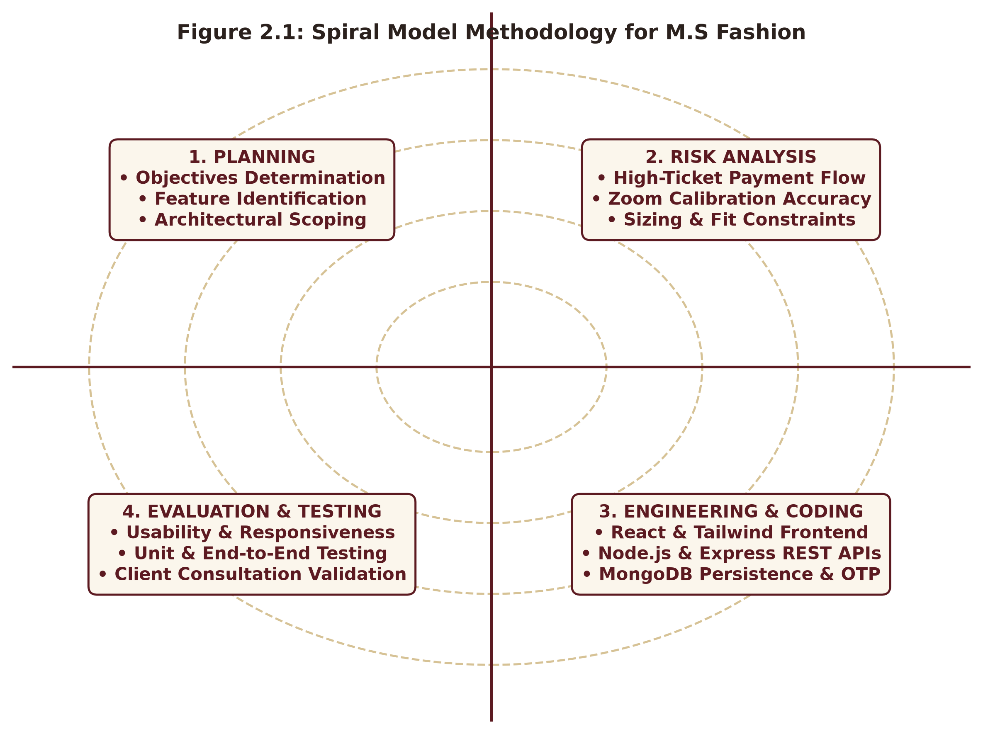
Figure 2.1: Spiral Model Iterative Development Methodology for M.S Fashion

CHAPTER 3. SYSTEM ANALYSIS
3.1 System Analysis
System analysis is a systematic process of studying, understanding, and evaluating an operational workflow to identify limitations and opportunities for software-driven improvement. For M.S Fashion, system analysis focuses on the challenges faced by ethnic menswear boutiques and wedding patrons.
3.2 Analysis of Existing System
The major problems associated with the existing manual and generic e-commerce systems include:
- • Manual Record-Keeping: Client measurement notes and appointment records are kept in physical diaries that can be easily lost or damaged.
- • Generic Size Failure: Off-the-shelf S/M/L garments do not fit individual postures, causing high returns and customer distress in bridal wear.
- • Lack of Real-Time Price Transparency: Add-on accessories are priced ad-hoc during final billing rather than upfront.
- • Inundation of Unverified Leads: Public phone numbers receive continuous invalid inquiries and appointment spam.
- • Inability to Zoom into Fabric Details: Static photos fail to show embroidery quality and silk weave density.
- • Transaction Fee Deductions: Online gateways take 2-3% fees on high-ticket couture orders that actually follow milestone payments.
3.3 Analysis of the Proposed System
The proposed M.S Fashion system provides the following structural improvements:
- • Centralized Collection Showcase: Curated catalog of Sherwanis, Jodhpuris, Indo-Western, and Blazers.
- • Interactive CSS Zoom Viewer: 2.2x hardware-accelerated zoom focusing on collar and accessory motifs.
- • Dynamic Price Breakdown: Real-time itemized cost calculation based on modular accessory selections.
- • Two-Step Email OTP Verification: 6-digit code validation preventing false appointment bookings.
- • Freeform Self Budget Input: Clients declare their intended expenditure freely without forced tiers.
- • Direct WhatsApp Master Routing: Optimized wa.me links with embedded design photos for rich previews.
- • Royal Atelier AI Stylist Chatbot: 24/7 conversational fashion guidance and quick action triggers.
- • Master Admin Dashboard: Category-wise sequential Ref IDs, 4-border gallery cropper, and CRM lead tracker.

CHAPTER 4. SURVEY OF TECHNOLOGY
4.1 React.js
React.js is an open-source, component-based frontend JavaScript library developed by Meta. React uses a Virtual DOM to optimize rendering and provides modular, reusable components for managing state, modals, and dynamic catalog views.
4.2 Tailwind CSS
Tailwind CSS is a utility-first styling framework that provides atomic utility classes directly in component code. In M.S Fashion, Tailwind establishes the royal Manyavar aesthetic: Maroon (#5C1A21), Antique Gold (#A9812F), and Warm Ivory (#FBF6EC).
4.3 Node.js
Node.js is an asynchronous, event-driven JavaScript runtime built on Chrome's V8 engine that executes server-side code for handling REST API requests, file uploads, and mail dispatch.
4.4 Express.js
Express.js is a minimalist web framework for Node.js providing routing, middleware, CORS security, and JSON request handling across inquiry, product, and admin services.
4.5 MongoDB
MongoDB is a document-oriented NoSQL database that stores data in flexible JSON-like BSON documents. In M.S Fashion, MongoDB maintains product catalogs, accessory coordinates, and verified CRM leads.
4.6 Vite
Vite is a next-generation build tool providing fast development server startup via native ES modules and Rollup-based production compilation in approximately 5 seconds.
4.7 Nodemailer
Nodemailer is a Node.js module that manages email delivery via Gmail SMTP, generating 6-digit verification codes and sending branded HTML appointment vouchers.
4.8 Royal Atelier AI Stylist
The AI Stylist Chatbot is a domain-specific conversational engine providing human-friendly recommendations on wedding silhouettes, 15+ body measurements, and direct booking actions.
4.9 Postman
Postman was utilized to test, debug, and validate REST API endpoints (GET, POST, PUT, DELETE) before frontend integration.

CHAPTER 5. SYSTEM DESIGN
5.1 Introduction
System design defines the overall architecture, component relationships, data flow, database structure, and user interaction models of the M.S Fashion platform.
5.2 System Architecture Diagram
The architecture consists of three primary layers: Presentation Layer (React & Tailwind), Application Logic Layer (Node.js & Express), and Database/Cloud Services (MongoDB, Gmail SMTP, WhatsApp API).
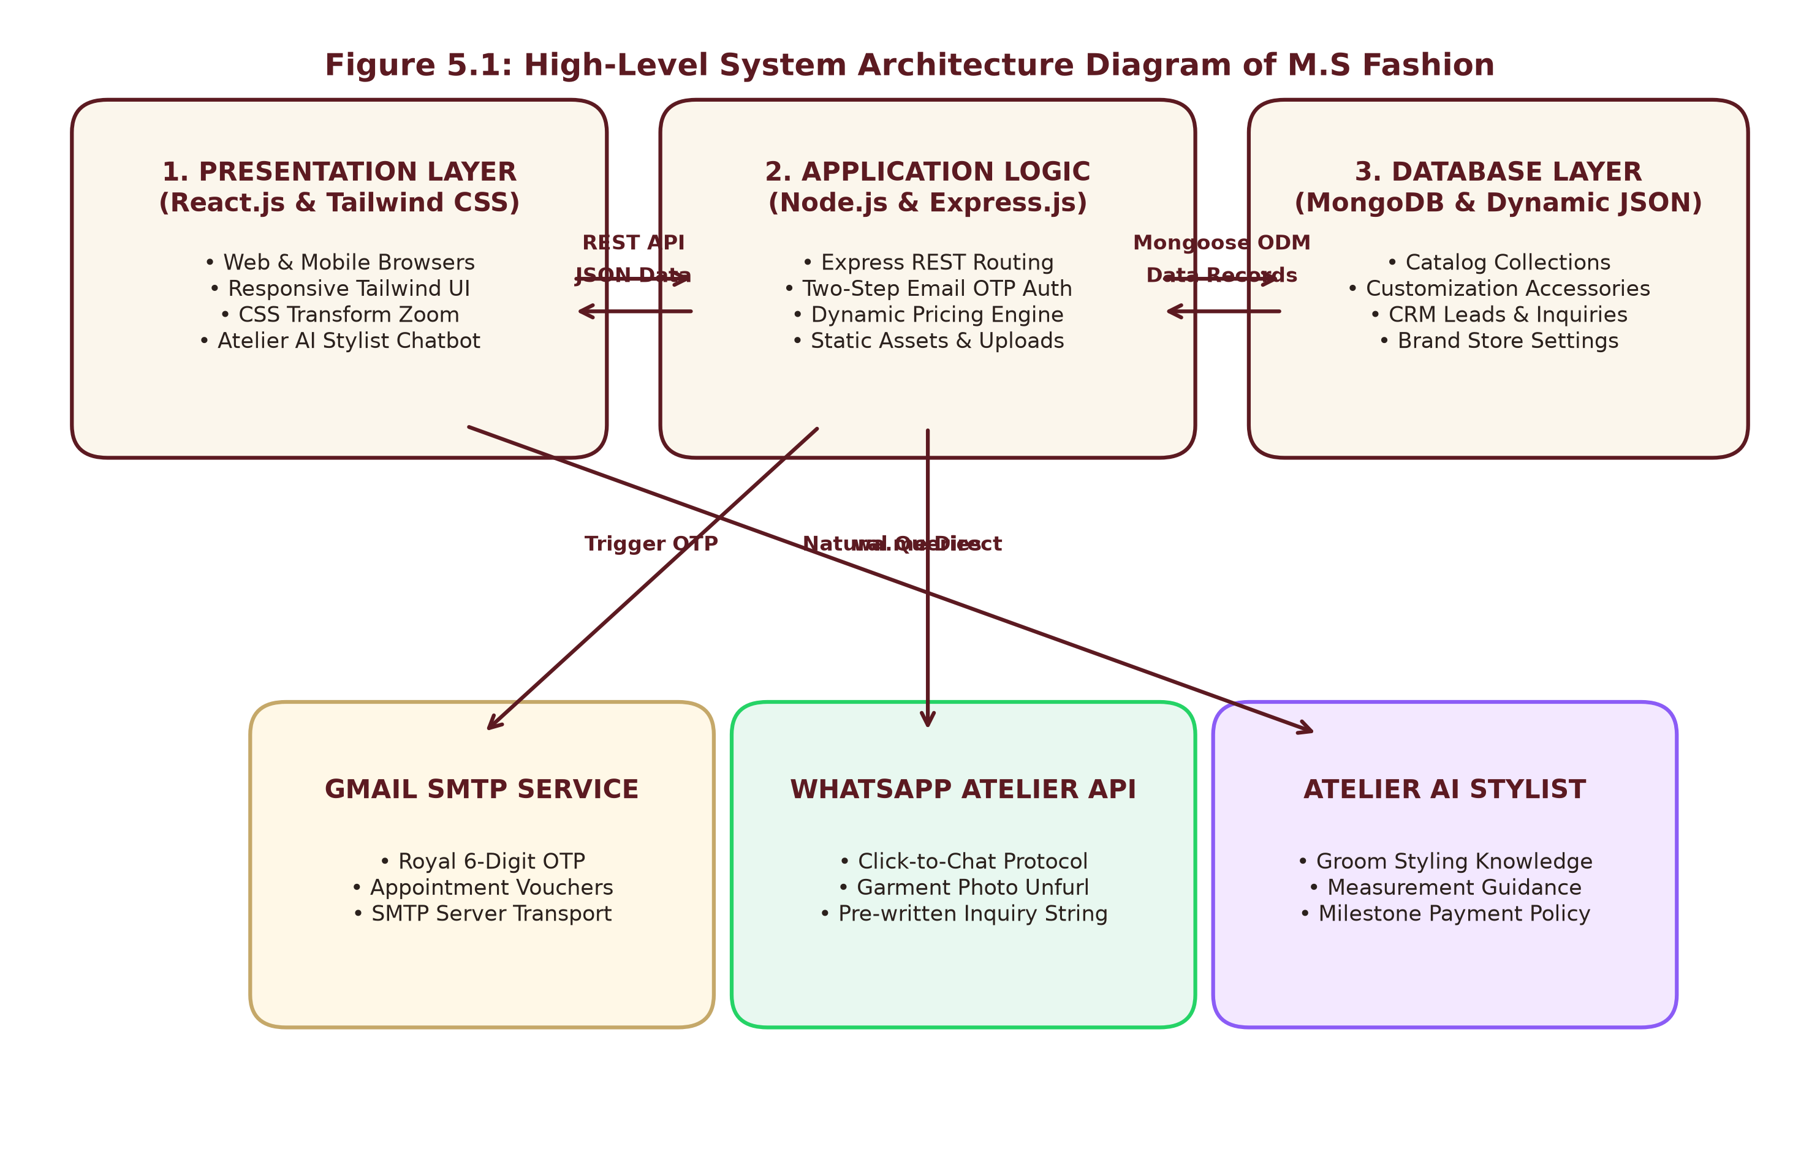
Figure 5.1: High-Level System Architecture Diagram of M.S Fashion
5.3 Data Flow Diagram
The Data Flow Diagram represents the movement of data between users, system processes, databases, and external services.
5.3.1 Level 0 DFD
The Level 0 DFD (Context Diagram) represents M.S Fashion as a single central process interacting with the Customer, Master Admin, MongoDB, and External Services.
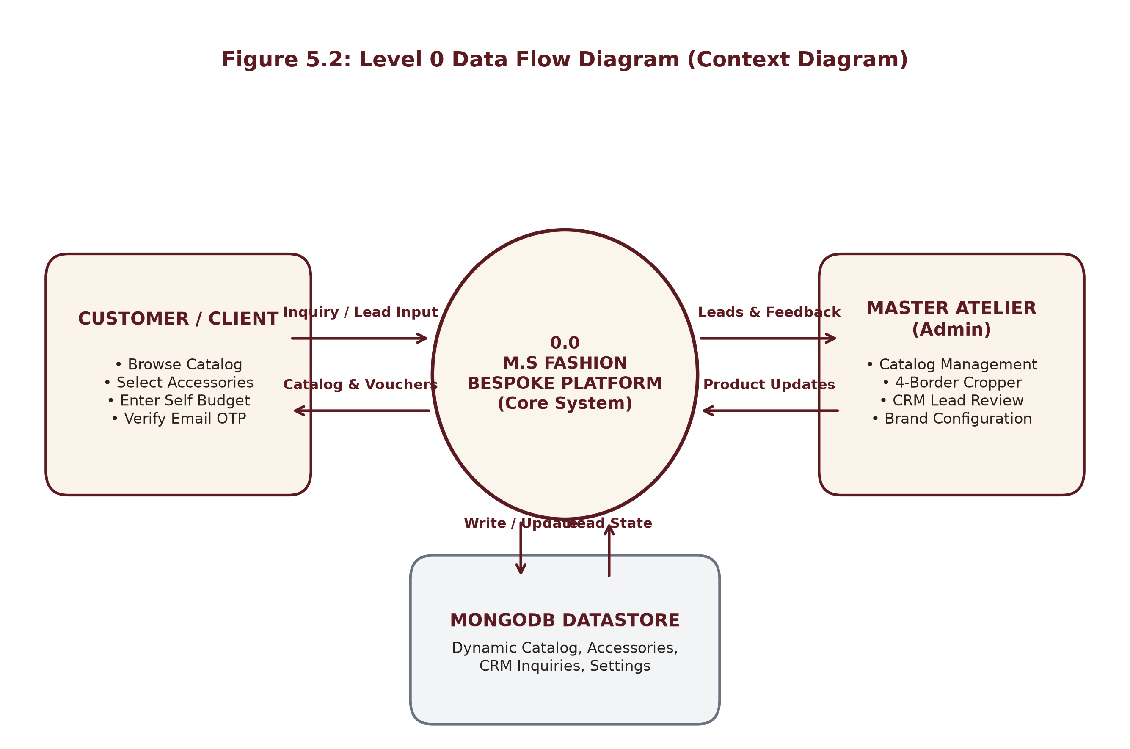
Figure 5.2: Level 0 Data Flow Diagram (Context Diagram)
5.3.2 Level 1 DFD
The Level 1 DFD decomposes the system into eight core processes: Catalog Filtering, CSS Zoom & Pricing, WhatsApp Dispatch, Appointment Booking, Email OTP Verification, AI Stylist Chatbot, Admin Catalog Management, and Store Settings CRM.
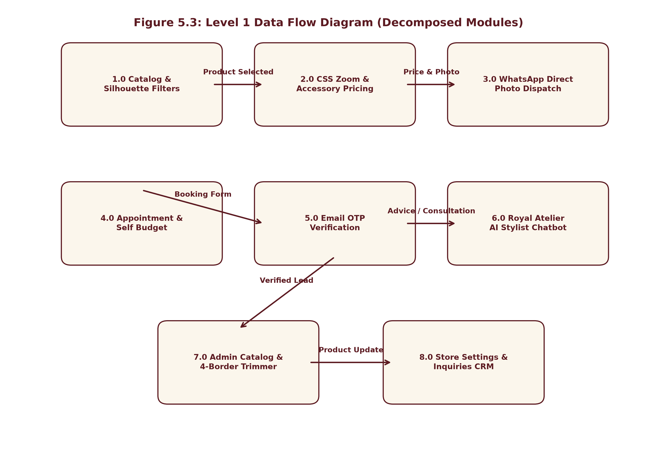
Figure 5.3: Level 1 Data Flow Diagram (Decomposed Modules)
5.4 Activity Diagram
The Activity Diagram models the client workflow from visiting the website to inspecting garments, calculating prices, and confirming an appointment lead via OTP.
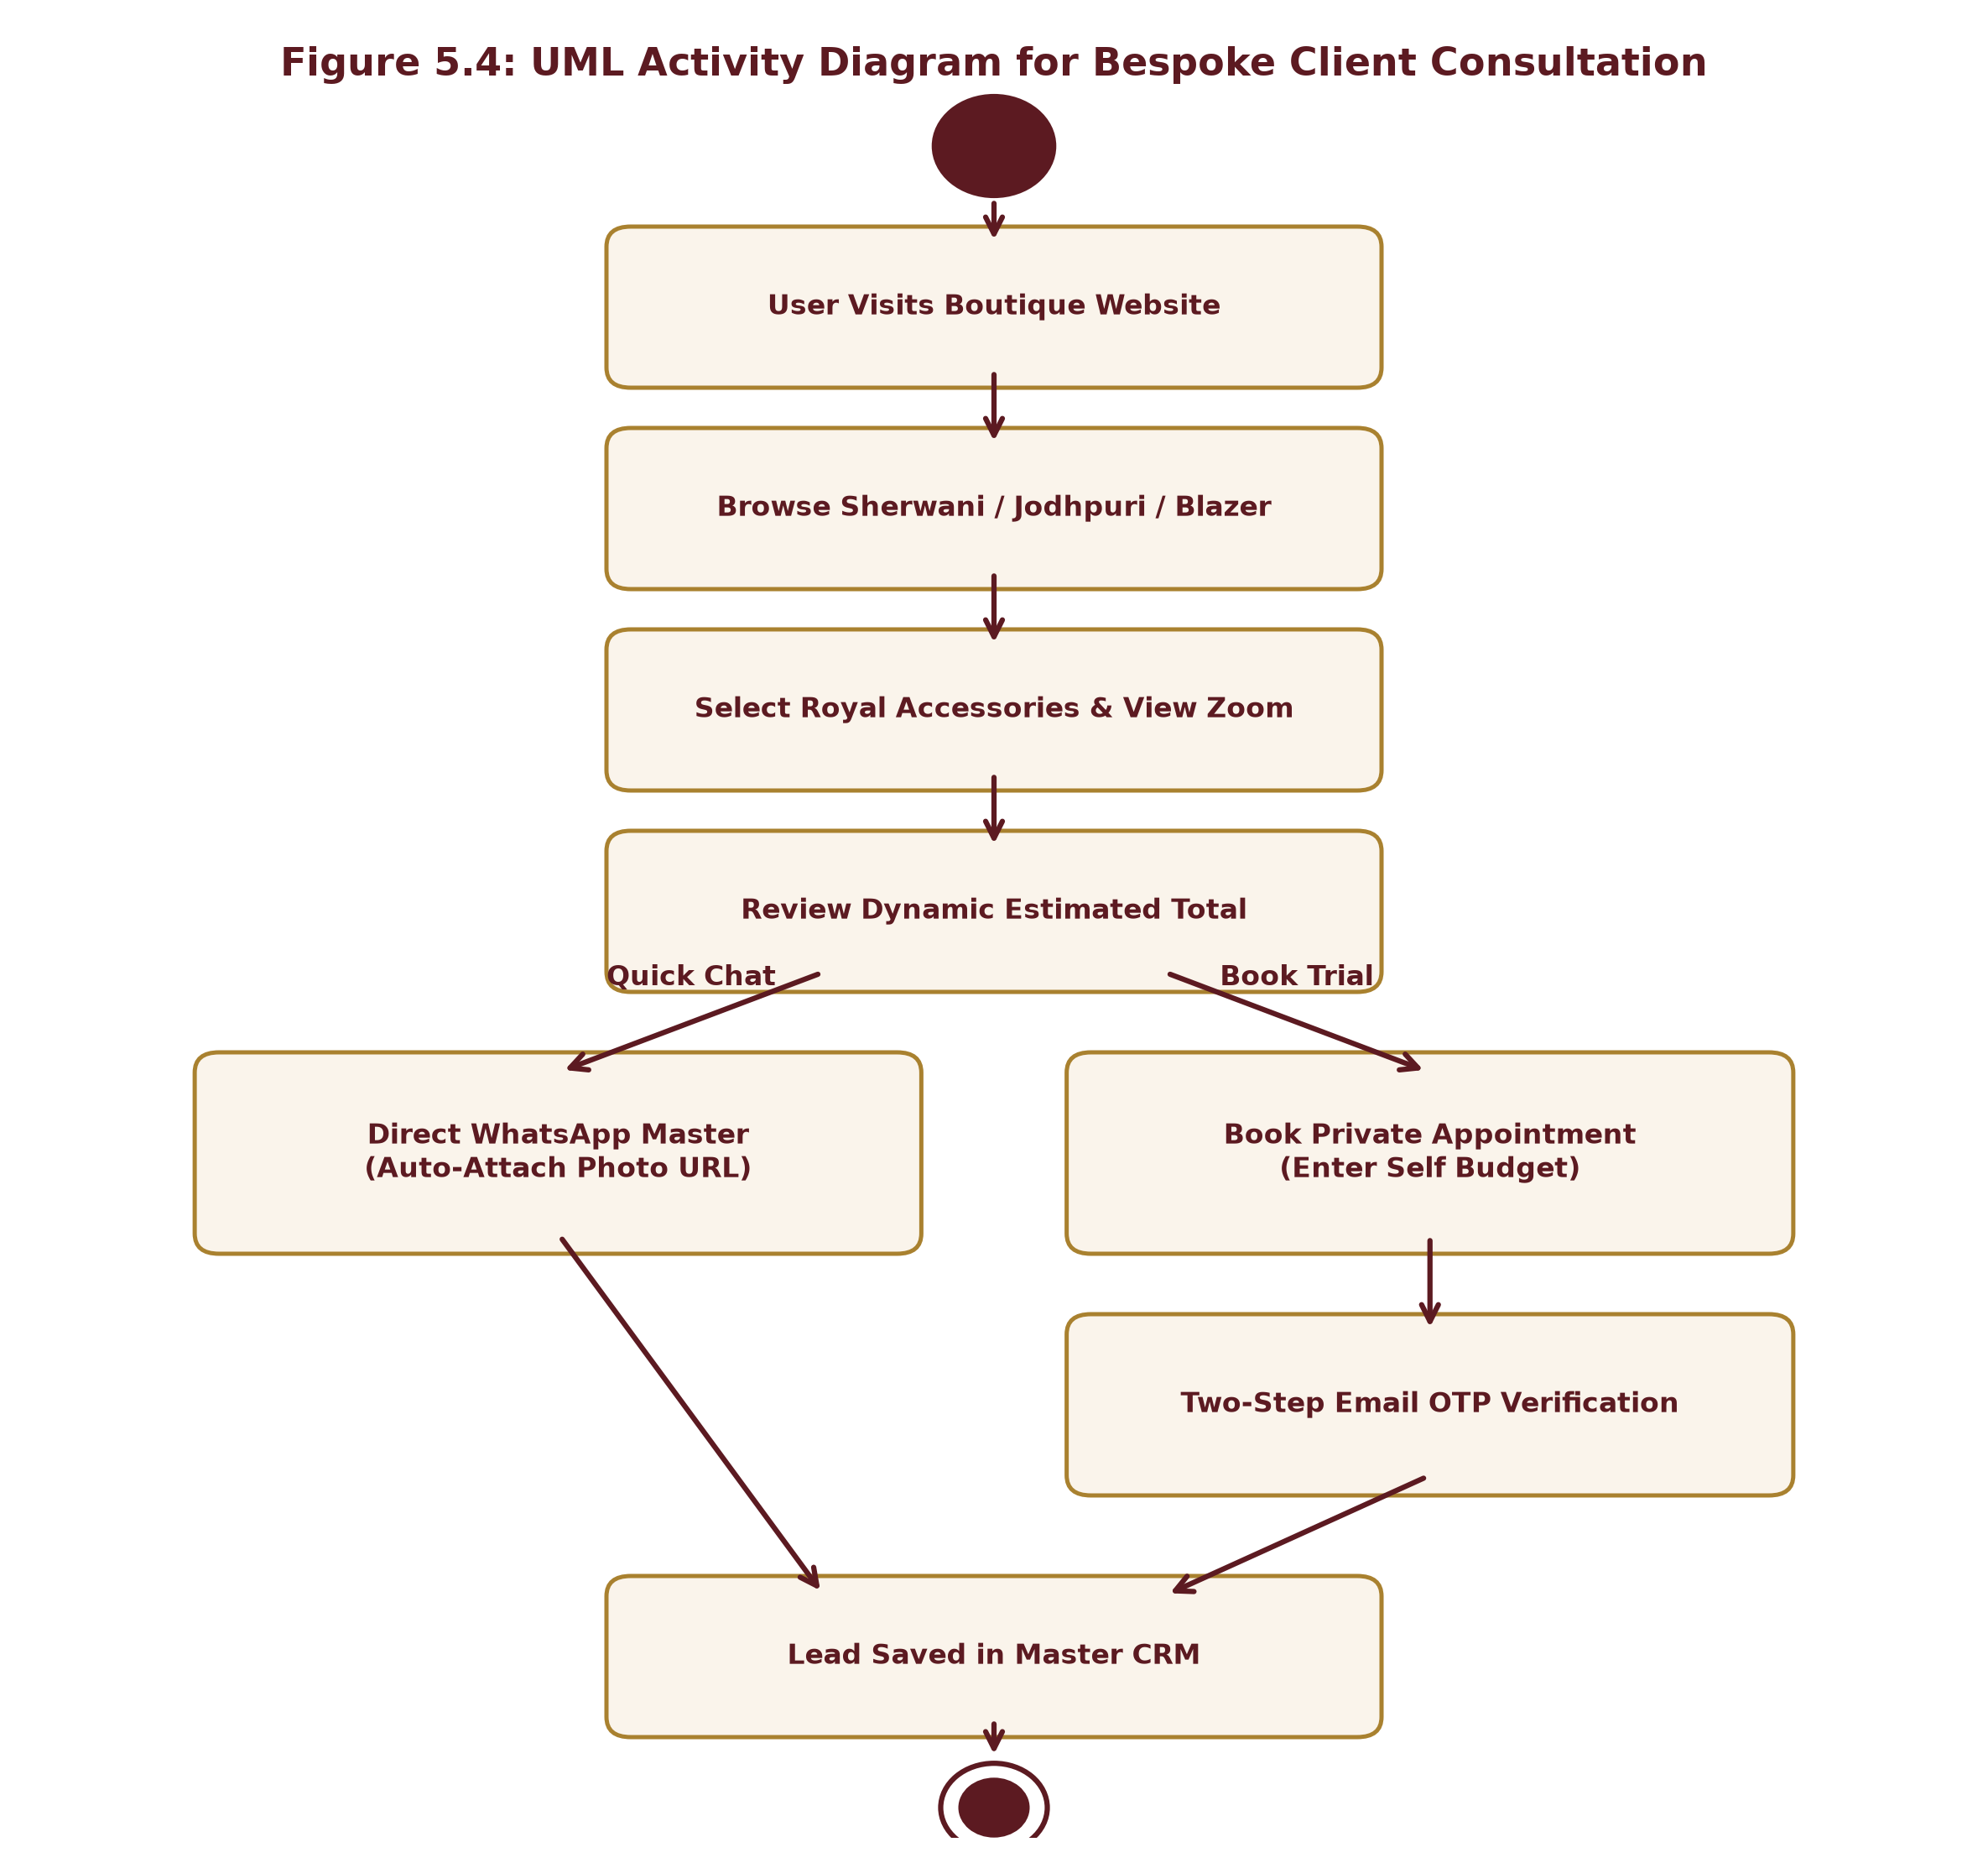
Figure 5.4: UML Activity Diagram for Bespoke Client Consultation Workflow
5.5 E-R Diagram
The Entity-Relationship Diagram defines the logical database structure and entities: Product, Accessory, Inquiry, EmailOTPVerification, and BrandConfiguration.
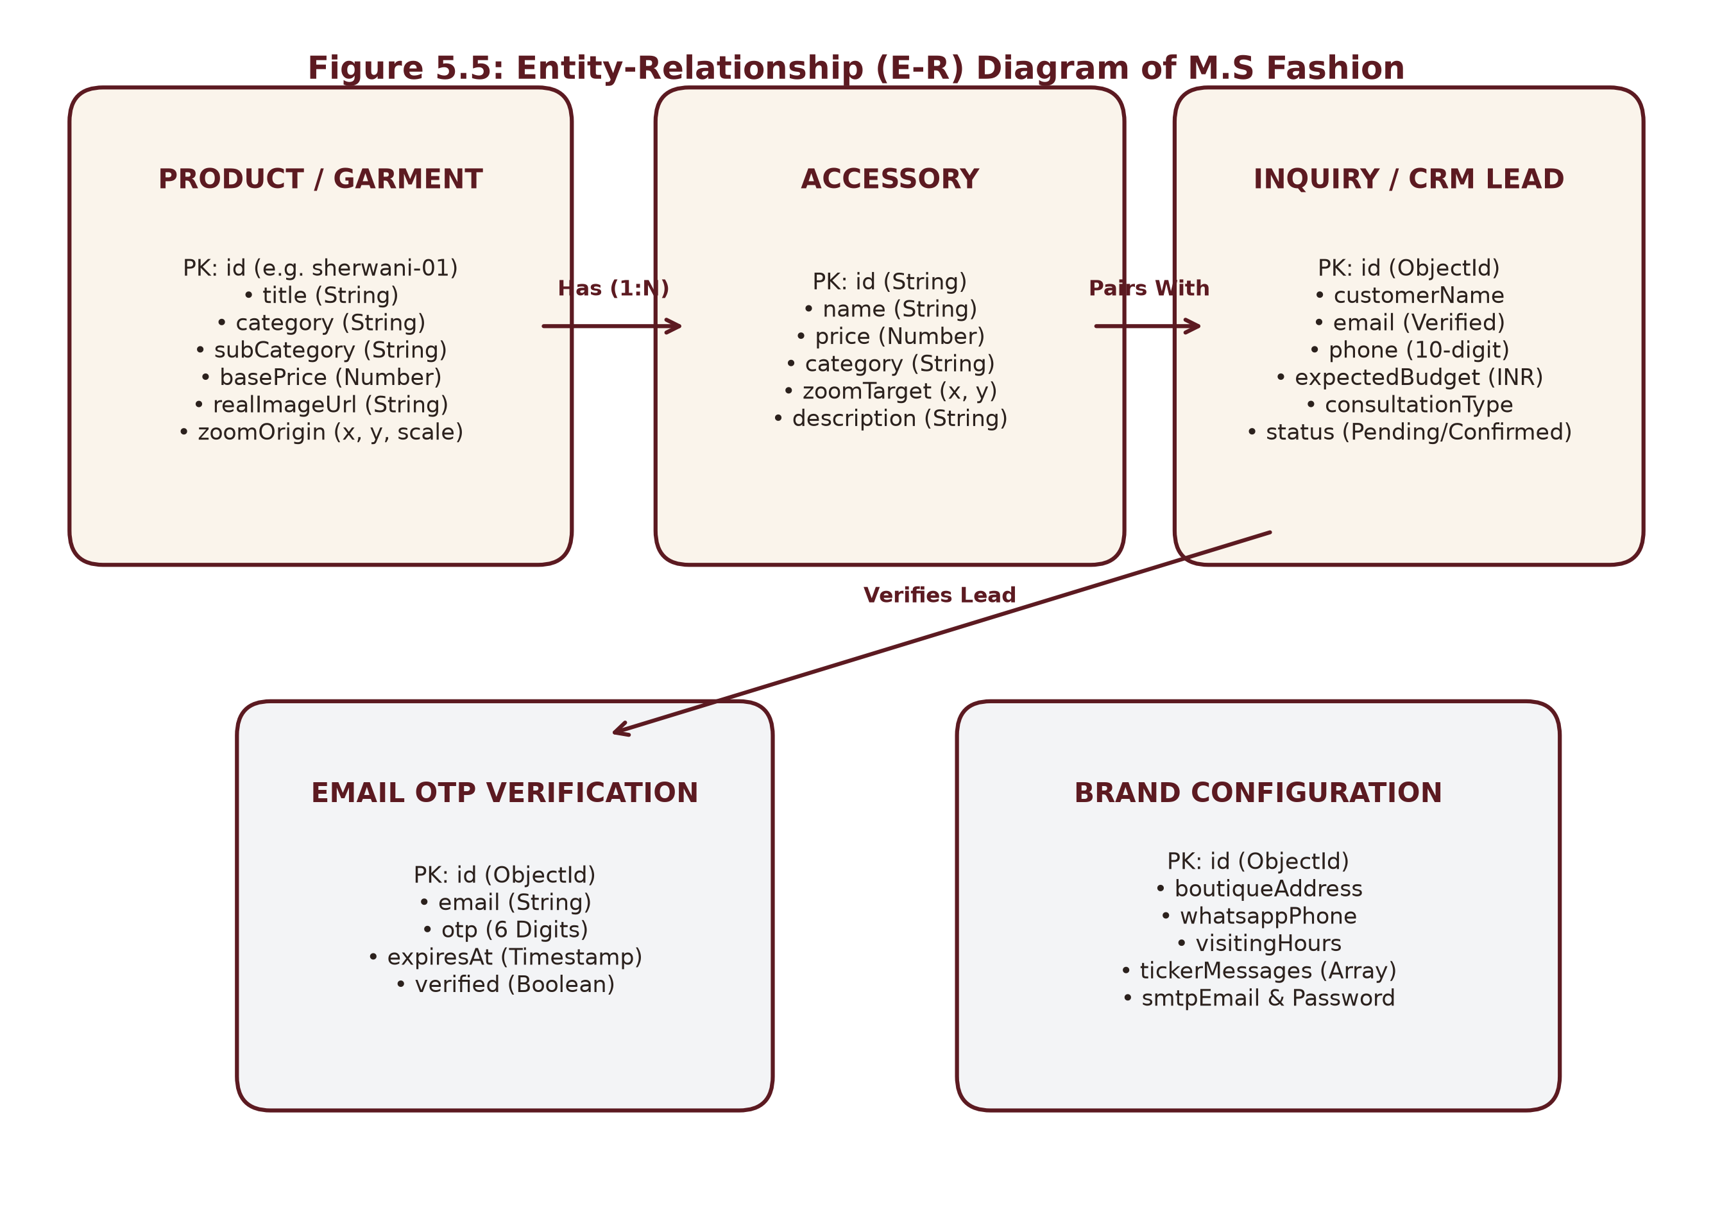
Figure 5.5: Entity-Relationship (E-R) Diagram of M.S Fashion
5.6 Use-Case Diagram
The Use-Case Diagram defines functional interactions available to the Customer (Browse, Filter, Zoom, Price, Chat, Book) and Master Atelier (Manage Catalog, Crop Images, Review Leads).
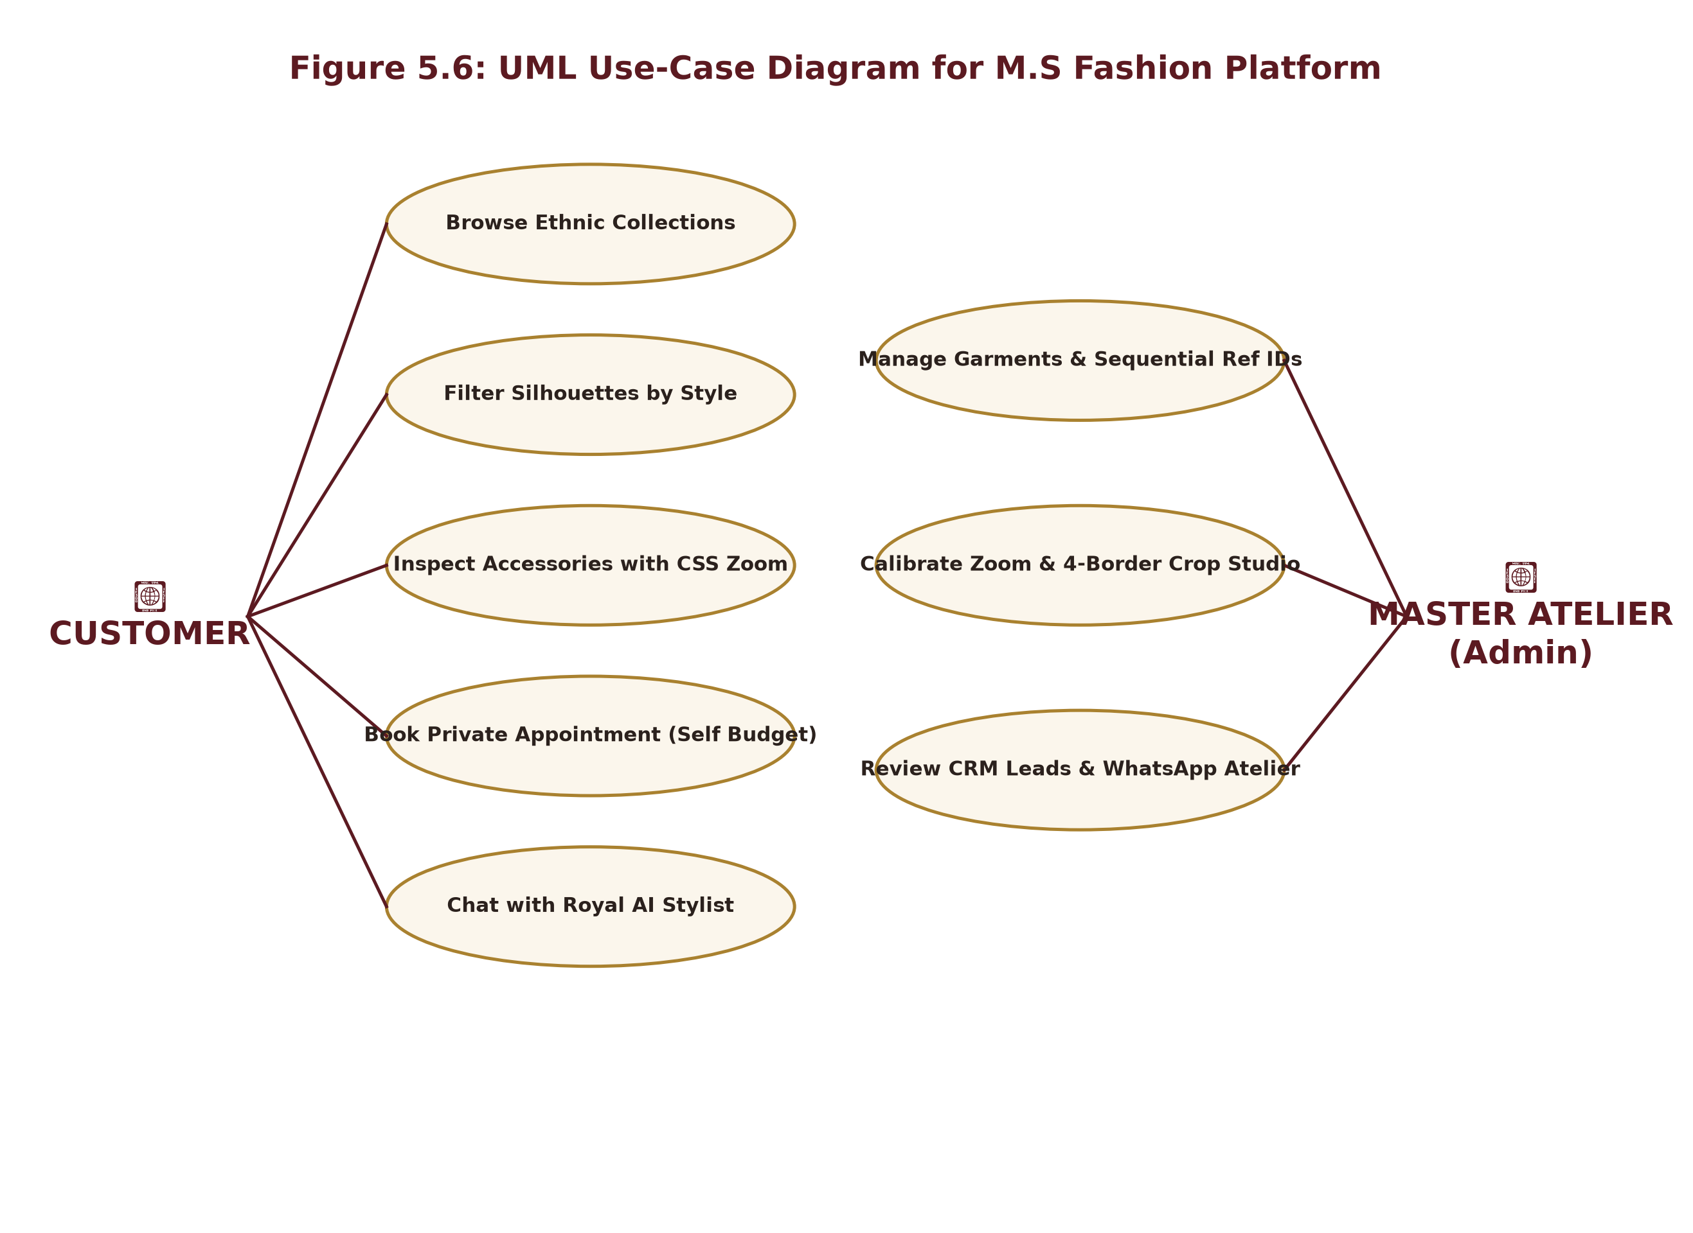
Figure 5.6: UML Use-Case Diagram for M.S Fashion Platform

CHAPTER 6. SYSTEM IMPLEMENTATION
6.1 Introduction
System implementation converts designed architectures into working software modules. M.S Fashion was implemented using React, Tailwind CSS, Node.js, Express.js, MongoDB, and Nodemailer.
6.2 Flowchart
The flowchart illustrates the sequential decision logic executed during user interaction, accessory selection, and lead validation.
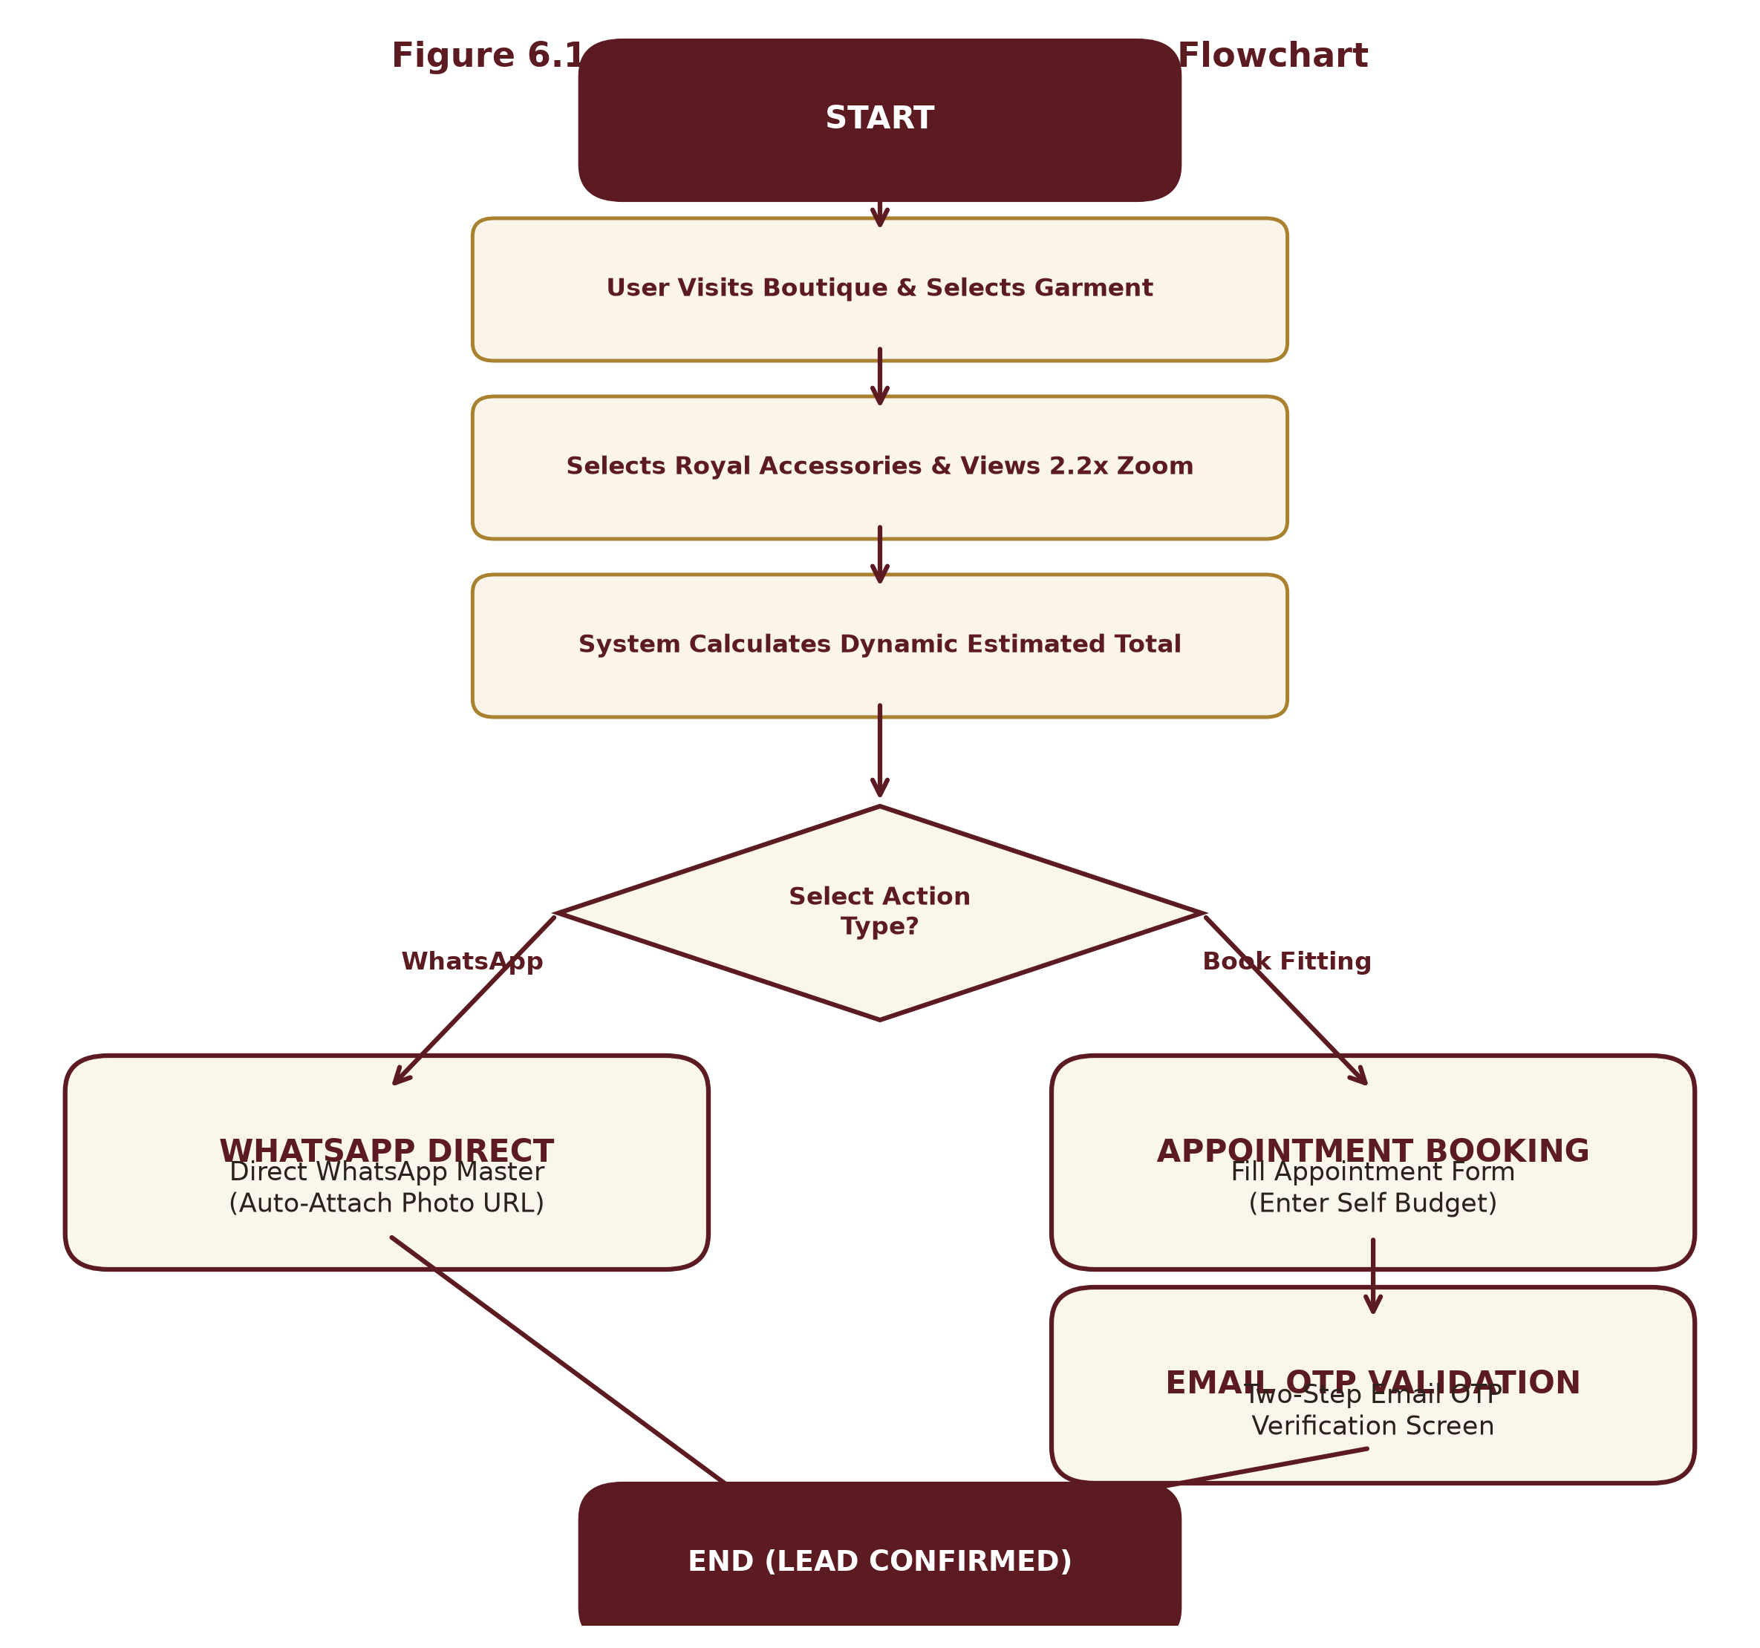
Figure 6.1: High-Level System Workflow Flowchart
6.3 Coding
The coding phase involved implementing frontend user interfaces and backend REST services. The complete production source code modules are provided below across paginated code blocks matching University of Mumbai dissertation guidelines.
6.3.1 Frontend

AtelierChatbot.jsx (Page 1 of 13)
import React, { useState, useRef, useEffect } from 'react';
import {
MessageSquare, X, Send, Sparkles, User, Crown,
ExternalLink, Calendar, Phone, RefreshCw, ChevronDown
} from 'lucide-react';
import { useConfig } from '../context/ConfigContext';
import { useNavigate } from 'react-router-dom';
export default function AtelierChatbot() {
const { brandConfig, setAppointmentModalOpen, getWhatsAppLink } = useConfig();
const navigate = useNavigate();
const [isOpen, setIsOpen] = useState(false);
const [inputMessage, setInputMessage] = useState('');
const [isTyping, setIsTyping] = useState(false);
const messagesEndRef = useRef(null);
// Initial greeting
const [messages, setMessages] = useState([
{
id: 1,
sender: 'bot',
text: "Namaste! Welcome to M.S Fashion Bespoke Atelier. 👑\nI am your Royal Styling & Tailoring Assistant. How may I assist you with your wedding or bespoke festive ensemble today?",
time: new Date().toLocaleTimeString([], { hour: '2-digit', minute: '2-digit' }),
options: [
{ label: "👑 Sherwani vs Indo-Western", query: "What is the difference between Sherwani and Indo-Western?" },
{ label: "📏 How do fittings work?", query: "How does the custom measurement and trial fitting process work?" },
{ label: "💰 Pricing & Payment terms", query: "What are the price ranges and payment terms?" },
{ label: "📅 Book Atelier Appointment", action: "open_appointment" },
{ label: "💬 Chat with Master", action: "open_whatsapp" }
]
}
]);
// Quick prompt chips
const quickChips = [
{ label: "👑 Sherwani Styles", query: "Tell me about your Sherwani collections" },
{ label: "🤵 Tuxedos & Blazers", query: "What Blazer and Tuxedo styles do you offer?" },
{ label: "📏 Measurements", query: "How do custom measurements work?" },

AtelierChatbot.jsx (Page 2 of 13)
{ label: "💎 Royal Accessories", query: "Which accessories are included with Sherwanis?" },
{ label: "⏱️ Delivery Time", query: "How much time does bespoke tailoring take?" },
{ label: "📍 Atelier Location", query: "Where is M.S Fashion studio located?" }
];
// Auto-scroll to latest message
useEffect(() => {
if (isOpen) {
messagesEndRef.current?.scrollIntoView({ behavior: 'smooth' });
}
}, [messages, isTyping, isOpen]);
// Intelligent Human-Friendly Knowledge Engine
const generateAtelierResponse = (query) => {
const q = (query || '').toLowerCase().trim();
// 1. Greetings
if (q.match(/^(hi|hello|hey|namaste|salaam|salam|good\s*(morning|evening|afternoon)|hola)/)) {
return {
text: "Namaste and warm greetings! 🙏\nIt is our honor to welcome you to M.S Fashion. Whether you are planning a grand wedding ensemble, a royal Bandhgala for a reception, or bespoke blazers, I am here to guide you through fabrics, cuts, and custom measurements.\n\nWhat special celebration are you preparing for?",
options: [
{ label: "👑 Groom Wedding Wear", query: "I am looking for groom wedding wear" },
{ label: "🤵 Reception & Sangeet", query: "What should I wear for reception or sangeet?" },
{ label: "📅 Book a Private Appointment", action: "open_appointment" }
]
};
}
// 2. Groom & Wedding Ensembles (Dulha / Shaadi / Reception / Sangeet)
if (q.includes('groom') || q.includes('dulha') || q.includes('wedding') || q.includes('shaadi') || q.includes('marriage') || q.includes('reception') || q.includes('sangeet')) {
return {
text: "Congratulations on the upcoming celebration! 🎊 For Indian weddings, our atelier curates a signature royal wardrobe:\n\n• *Main Wedding (Pheras):* Hand-embroidered Royal Bridal Sherwani in Raw Silk or Velvet with matching Zardozi Safa, Pearl Mala, and Embroidered Mojdi.\n• *Sangeet / Mehendi:* Modern Indo-Western silhouette with asymmetrical flare, cowl draping, or mirror-work accents.\n• *Cocktail / Reception:* Classic Imperial Jodhpuri Bandhgala or a bespoke Double-Breasted Velvet Tuxedo.\n\nEvery piece is hand-tailored from scratch to your exact posture and preference.",
options: [
{ label: "Explore Sherwanis", action: "nav_sherwani" },
{ label: "Explore Indo-Western", action: "nav_indowestern" },
{ label: "Book Fitting Consultation", action: "open_appointment" }
]
};

AtelierChatbot.jsx (Page 3 of 13)
}
// 3. Sherwani Collections
if (q.includes('sherwani') || q.includes('achkan')) {
return {
text: "Our Royal Sherwani Line is handcrafted for timeless grandeur:\n\n1. *Royal Bridal Sherwani:* Heavy antique gold Zardozi hand-embroidery on pure silk.\n2. *Heritage Velvet Sherwani:* Deep wine and midnight navy imperial velvet with intricate bullion work.\n3. *Brocade Classic:* Rich handwoven Banarasi and Jamawar weaves with subtle metallic sheen.\n4. *Silk Embroidered:* Lightweight elegance for modern daytime weddings.\n\n*Included Accessories Available:* Custom Turban (Safa), Pearl Multi-strand Mala, Royal Brooch, Embroidered Mojdi, and Organza Dupatta.",
options: [
{ label: "View Sherwani Collection ➔", action: "nav_sherwani" },
{ label: "Inquire via WhatsApp", action: "open_whatsapp" }
]
};
}
// 4. Jodhpuri / Bandhgala
if (q.includes('jodhpuri') || q.includes('bandhgala') || q.includes('bandgala')) {
return {
text: "The Jodhpuri Bandhgala is the pinnacle of Indian aristocratic tailoring 👑\n\n• *Silhouette:* Structured high Mandarin collar, padded shoulders, and contoured waistline.\n• *Variations:* Single-jacket classic or 2-piece ensembles with contrasting inner kurtas and regal brooches.\n• *Fabrics:* Italian micro-velvet, fine worsted wool blends, and raw mulberry silk.\n• Perfect for wedding receptions, royal ceremonies, and high-profile evening celebrations.",
options: [
{ label: "View Jodhpuri Designs ➔", action: "nav_jodhpuri" },
{ label: "Book Studio Fitting", action: "open_appointment" }
]
};
}
// 5. Indo-Western
if (q.includes('indo-western') || q.includes('indo western') || q.includes('fusion') || q.includes('cowl')) {
return {
text: "Our Indo-Western ensembles bridge traditional royal craftsmanship with contemporary runway aesthetics ✨\n\n• Features asymmetrical front plackets, overlapping angled hemlines, and fluid drape dhotis or trousers.\n• Ideal for Sangeet nights, ring ceremonies, and celebratory parties where effortless movement is key.",
options: [
{ label: "View Indo-Western Ensembles ➔", action: "nav_indowestern" },
{ label: "Talk to Master", action: "open_whatsapp" }
]
};
}
// 6. Blazers & Tuxedos
if (q.includes('blazer') || q.includes('coat') || q.includes('suit') || q.includes('tuxedo') || q.includes('tux')) {
return {

AtelierChatbot.jsx (Page 4 of 13)
text: "M.S Fashion crafts bespoke evening wear and party blazers with Savile Row precision:\n\n• *Shawl Lapel Tuxedo:* Satin-faced curved shawl lapels in rich jewel tones.\n• *Double-Breasted (DB):* 6-button classic silhouette with peak lapels.\n• *Single-Breasted (SB):* Contemporary 2-button slim fit with tailored matching trousers.",
options: [
{ label: "View Blazer Collection ➔", action: "nav_blazer" },
{ label: "Book Studio Fitting", action: "open_appointment" }
]
};
}
// 7. Measurements, Fittings & Sizing (Crucial Viva / User point)
if (q.includes('measurement') || q.includes('size') || q.includes('fit') || q.includes('trial') || q.includes('basting') || q.includes('custom fit')) {
return {
text: "Because M.S Fashion is a pure Bespoke Atelier, we never use standard factory sizes (S/M/L) 📏\n\n*Our 3-Step Master Fitting Process:*\n1. *15+ Body Point Mapping:* Chest, shoulder slope, bicep circumference, posture curvature, torso length, and waist.\n2. *Basting Trial:* A rough-cut trial fitting to ensure the canvas aligns naturally to your body shape.\n3. *Final Finishing:* Hand-pressed finish with custom monogramming and guaranteed zero puckering.",
options: [
{ label: "Book a Fitting Session", action: "open_appointment" },
{ label: "Send Measurements on WhatsApp", action: "open_whatsapp" }
]
};
}
// 8. Pricing & Payment Policy (Explaining the Bespoke Model)
if (q.includes('price') || q.includes('cost') || q.includes('payment') || q.includes('online pay') || q.includes('budget') || q.includes('rate') || q.includes('advance')) {
return {
text: "At M.S Fashion, all garments are handcrafted made-to-order:\n\n• *Bespoke Bandhgalas & Blazers:* Typically start from ₹25,000 to ₹50,000.\n• *Royal Groom Sherwanis:* Range between ₹45,000 and ₹1,50,000+ depending on hand-embroidery density (Aari vs Pure Zardozi) and silk grade.\n\n*Why no generic online payment gateway?*\nFollowing luxury couture standards (like Sabyasachi & Savile Row), bespoke orders require in-person fabric approval and trial fittings. We operate on milestone booking (token advance + final delivery payment) rather than a mass-market e-commerce cart.",
options: [
{ label: "Enter Self Budget in Booking", action: "open_appointment" },
{ label: "Get Instant Estimate on WhatsApp", action: "open_whatsapp" }
]
};
}
// 9. Delivery Time / Lead Time
if (q.includes('time') || q.includes('days') || q.includes('delivery') || q.includes('urgent') || q.includes('fast') || q.includes('when')) {
return {
text: "⏳ *Craftsmanship Timeline:*\n\n• *Standard Bespoke Ensembles:* 10 to 18 business days (includes fabric procurement, hand-embroidery, cutting, and trial fitting).\n• *Urgent / Express Wedding Orders:* Can be expedited within 5 to 7 days upon consultation with our Master Tailor.\n\nWe recommend booking your consultation at least 3 to 4 weeks prior to your main wedding date.",
options: [
{ label: "Check Urgent Slot on WhatsApp", action: "open_whatsapp" },
{ label: "Book Studio Appointment", action: "open_appointment" }
]

AtelierChatbot.jsx (Page 5 of 13)
};
}
// 10. Accessories Included
if (q.includes('accessory') || q.includes('accessories') || q.includes('safa') || q.includes('pagdi') || q.includes('mala') || q.includes('mojdi') || q.includes('brooch') || q.includes('dupatta')) {
return {
text: "👑 Every royal ensemble can be paired with matching bespoke accessories:\n\n• *Safa / Pagdi:* Custom-draped silk or velvet turban with kalgi ornament.\n• *Mala:* Multi-layer freshwater pearl necklace with semi-precious stone pendants.\n• *Royal Brooch:* Handcrafted antique brass/gold chest brooch.\n• *Embroidered Mojdi:* Handmade leather mojdis matched to the sherwani embroidery.\n• *Organza Stole / Dupatta:* Hand-rolled zardozi border stole.\n\nYou can select these dynamically on any product page to see the exact price breakdown!",
options: [
{ label: "Browse Ethnic Collection", action: "nav_ethnic" },
{ label: "Consult Stylist on WhatsApp", action: "open_whatsapp" }
]
};
}
// 11. Location & Atelier Visit
if (q.includes('location') || q.includes('address') || q.includes('where') || q.includes('shop') || q.includes('store') || q.includes('mumbai') || q.includes('visit') || q.includes('hours')) {
return {
text: `📍 *M.S Fashion Atelier & Studio:*\n${brandConfig.boutiqueAddress || 'Ground Floor, 10/A, Sanaullah Compound, Near Sauda Bakery, Dharavi Main Road, Mahim (East), Mumbai - 400017'}\n\n🕒 *Visiting Hours:* ${brandConfig.visitingHours || 'Mon - Sat: 1:00 PM - 7:00 PM'}\n📞 *Direct Atelier Line:* ${brandConfig.displayPhone || '+91 89993 86222'}\n\nWalk-ins are welcome, but we recommend booking an appointment for a dedicated Master consultation.`,
options: [
{ label: "📅 Book Atelier Visit", action: "open_appointment" },
{ label: "Open in Google Maps", action: "open_maps" }
]
};
}
// 12. Default Fallback
return {
text: "That is a wonderful bespoke preference! 👑\nBecause every M.S Fashion ensemble is customized to your exact fabric, embroidery, and measurement preferences, our Master Craftsman can advise you directly with physical fabric swatches and customized quotations.\n\nWould you like to connect directly on WhatsApp or book a private atelier fitting session?",
options: [
{ label: "💬 Connect on WhatsApp", action: "open_whatsapp" },
{ label: "📅 Book Private Appointment", action: "open_appointment" },
{ label: "Explore Catalog Collections", action: "nav_ethnic" }
]
};
};
// Handle User Message Submission
const handleSendMessage = (textToSend) => {

AtelierChatbot.jsx (Page 6 of 13)
const query = textToSend || inputMessage;
if (!query.trim()) return;
const userMsg = {
id: Date.now(),
sender: 'user',
text: query.trim(),
time: new Date().toLocaleTimeString([], { hour: '2-digit', minute: '2-digit' })
};
setMessages((prev) => [...prev, userMsg]);
setInputMessage('');
setIsTyping(true);
// Simulate natural human response delay (500ms - 800ms)
setTimeout(() => {
const botResponse = generateAtelierResponse(query);
const botMsg = {
id: Date.now() + 1,
sender: 'bot',
text: botResponse.text,
time: new Date().toLocaleTimeString([], { hour: '2-digit', minute: '2-digit' }),
options: botResponse.options
};
setMessages((prev) => [...prev, botMsg]);
setIsTyping(false);
}, 650);
};
// Handle Interactive Action Buttons
const handleActionClick = (opt) => {
if (opt.query) {
handleSendMessage(opt.query);
return;
}
if (opt.action === 'open_appointment') {
setAppointmentModalOpen(true);

AtelierChatbot.jsx (Page 7 of 13)
return;
}
if (opt.action === 'open_whatsapp') {
const waUrl = getWhatsAppLink("Hello M.S Fashion Master, I am inquiring about custom wedding/festive tailoring through your website chatbot.");
window.open(waUrl, '_blank', 'noopener,noreferrer');
return;
}
if (opt.action === 'open_maps') {
window.open(brandConfig.googleMapsUrl || "https://maps.google.com", '_blank');
return;
}
if (opt.action === 'nav_sherwani') {
navigate('/category/sherwani');
setIsOpen(false);
return;
}
if (opt.action === 'nav_jodhpuri') {
navigate('/category/jodhpuri');
setIsOpen(false);
return;
}
if (opt.action === 'nav_indowestern') {
navigate('/category/indo-western');
setIsOpen(false);
return;
}
if (opt.action === 'nav_blazer') {
navigate('/category/blazer');
setIsOpen(false);
return;
}

AtelierChatbot.jsx (Page 8 of 13)
if (opt.action === 'nav_ethnic') {
navigate('/ethnic-wear');
setIsOpen(false);
return;
}
};
// Reset / Clear Chat
const handleResetChat = () => {
setMessages([
{
id: Date.now(),
sender: 'bot',
text: "Chat refreshed. How can I assist you with your bespoke royal tailoring today?",
time: new Date().toLocaleTimeString([], { hour: '2-digit', minute: '2-digit' }),
options: [
{ label: "👑 Sherwani vs Indo-Western", query: "What is the difference between Sherwani and Indo-Western?" },
{ label: "📏 How do fittings work?", query: "How does the custom measurement and trial fitting process work?" },
{ label: "💰 Pricing & Payment terms", query: "What are the price ranges and payment terms?" },
{ label: "📅 Book Atelier Appointment", action: "open_appointment" }
]
}
]);
};
return (
<>
{/* ==================== FLOATING CIRCULAR LAUNCHER (MANYAVAR STYLE) ==================== */}
<div className="fixed bottom-6 right-6 z-40 flex items-center gap-3">
{/* Tooltip / Attention Badge (Shown when chat is closed) */}
{!isOpen && (
<div
onClick={() => setIsOpen(true)}
className="hidden sm:flex items-center gap-2 bg-[#FBF6EC] text-[#5C1A21] px-3.5 py-2 rounded-full border border-[#A9812F]/40 shadow-xl cursor-pointer hover:bg-white transition-all transform hover:scale-105"
>
<Sparkles className="w-4 h-4 text-[#A9812F]" />
<span className="text-xs font-semibold tracking-wide">Ask Royal Stylist</span>
</div>

AtelierChatbot.jsx (Page 9 of 13)
)}
{/* Circular Floating Button */}
<button
onClick={() => setIsOpen(!isOpen)}
aria-label="Open Atelier Stylist Chatbot"
className="relative w-14 h-14 sm:w-16 sm:h-16 rounded-full bg-gradient-to-tr from-[#5C1A21] via-[#7A232C] to-[#5C1A21] text-[#FBF6EC] border-2 border-[#A9812F] shadow-2xl flex items-center justify-center cursor-pointer transition-transform duration-300 hover:scale-110 active:scale-95 group focus:outline-none"
>
{isOpen ? (
<X className="w-6 h-6 sm:w-7 sm:h-7 text-[#FBF6EC] transition-transform group-hover:rotate-90" />
) : (
<div className="relative flex items-center justify-center">
<Crown className="w-7 h-7 sm:w-8 sm:h-8 text-[#C5A869]" />
<span className="absolute -top-1 -right-1 w-3.5 h-3.5 bg-emerald-500 border-2 border-[#5C1A21] rounded-full" />
</div>
)}
</button>
</div>
{/* ==================== EXPANDABLE LUXURY CHAT WINDOW ==================== */}
{isOpen && (
<div className="fixed bottom-24 right-4 sm:right-6 z-50 w-[92vw] sm:w-[400px] md:w-[420px] h-[550px] max-h-[80vh] bg-[#FBF6EC] rounded-2xl border border-[#A9812F]/50 shadow-2xl flex flex-col overflow-hidden animate-fadeIn">
{/* Royal Header */}
<div className="bg-gradient-to-r from-[#5C1A21] via-[#6E1F27] to-[#5C1A21] text-[#FBF6EC] p-3.5 sm:p-4 border-b border-[#A9812F]/40 flex items-center justify-between shrink-0 shadow-md">
<div className="flex items-center gap-3">
<div className="w-10 h-10 rounded-full bg-[#3D1016] border border-[#A9812F] flex items-center justify-center shrink-0">
<Crown className="w-5 h-5 text-[#C5A869]" />
</div>
<div>
<div className="flex items-center gap-2">
<h3 className="font-serif font-bold text-base sm:text-lg tracking-wide text-[#FBF6EC] leading-tight">
M.S Fashion Stylist
</h3>
<span className="text-[9px] uppercase px-1.5 py-0.5 rounded-full bg-[#A9812F]/20 text-[#C5A869] border border-[#A9812F]/40 font-medium">
AI Atelier
</span>
</div>

AtelierChatbot.jsx (Page 10 of 13)
<p className="text-[11px] text-[#C5A869] flex items-center gap-1.5 mt-0.5">
<span className="w-2 h-2 rounded-full bg-emerald-400 animate-pulse" />
Online • Bespoke Consultation
</p>
</div>
</div>
<div className="flex items-center gap-1">
<button
onClick={handleResetChat}
title="Restart Chat"
className="p-1.5 text-[#FBF6EC]/70 hover:text-[#FBF6EC] hover:bg-white/10 rounded-full transition-colors cursor-pointer"
>
<RefreshCw className="w-4 h-4" />
</button>
<button
onClick={() => setIsOpen(false)}
title="Close Chat"
className="p-1.5 text-[#FBF6EC]/70 hover:text-[#FBF6EC] hover:bg-white/10 rounded-full transition-colors cursor-pointer"
>
<X className="w-5 h-5" />
</button>
</div>
</div>
{/* Quick Filter Chips Carousel (Under Header) */}
<div className="bg-[#FAF4EB] border-b border-[#D5C8B5] px-3 py-2 flex items-center gap-2 overflow-x-auto no-scrollbar shrink-0">
{quickChips.map((chip, idx) => (
<button
key={idx}
onClick={() => handleSendMessage(chip.query)}
className="text-[11px] font-medium whitespace-nowrap bg-white text-[#5C1A21] px-2.5 py-1 rounded-full border border-[#D5C8B5] hover:border-[#A9812F] hover:bg-[#5C1A21] hover:text-[#FBF6EC] transition-all cursor-pointer shadow-xs"
>
{chip.label}
</button>
))}
</div>

AtelierChatbot.jsx (Page 11 of 13)
{/* Messages Scroll View */}
<div className="flex-1 p-3.5 sm:p-4 overflow-y-auto space-y-3.5 bg-[#FBF6EC]">
{messages.map((msg) => (
<div
key={msg.id}
className={`flex flex-col ${msg.sender === 'user' ? 'items-end' : 'items-start'} animate-fadeIn`}
>
{/* Bubble */}
<div
className={`max-w-[85%] rounded-2xl p-3 text-xs sm:text-sm leading-relaxed shadow-xs ${
msg.sender === 'user'
? 'bg-[#5C1A21] text-[#FBF6EC] rounded-tr-none border border-[#A9812F]/40'
: 'bg-white text-[#2B211D] rounded-tl-none border border-[#D5C8B5]/80 shadow-xs'
}`}
>
<p className="whitespace-pre-line font-sans">{msg.text}</p>
</div>
{/* Timestamp */}
<span className="text-[10px] text-[#8C827A] mt-1 px-1">
{msg.time}
</span>
{/* Interactive Action Chips inside Bot message */}
{msg.options && msg.options.length > 0 && (
<div className="mt-2 flex flex-wrap gap-1.5 max-w-[95%]">
{msg.options.map((opt, i) => (
<button
key={i}
onClick={() => handleActionClick(opt)}
className="text-[11px] font-medium text-left bg-white text-[#5C1A21] hover:bg-[#5C1A21] hover:text-[#FBF6EC] px-2.5 py-1.5 rounded-lg border border-[#A9812F]/40 shadow-xs transition-colors flex items-center gap-1.5 cursor-pointer"
>
{opt.action === 'open_appointment' && <Calendar className="w-3.5 h-3.5 text-[#A9812F]" />}
{opt.action === 'open_whatsapp' && <Phone className="w-3.5 h-3.5 text-emerald-600" />}
{opt.label}
</button>
))}
</div>

AtelierChatbot.jsx (Page 12 of 13)
)}
</div>
))}
{/* Typing Indicator */}
{isTyping && (
<div className="flex items-center gap-2 text-xs text-[#5C1A21] font-medium bg-white/80 border border-[#D5C8B5] px-3 py-2 rounded-xl w-max animate-pulse">
<Crown className="w-3.5 h-3.5 text-[#A9812F]" />
<span>Royal Stylist is curating response...</span>
</div>
)}
<div ref={messagesEndRef} />
</div>
{/* Quick Action Footer Banner */}
<div className="bg-[#FAF4EB] border-t border-[#D5C8B5] px-3 py-1.5 flex items-center justify-between text-[11px] text-[#5C1A21]">
<button
onClick={() => { setAppointmentModalOpen(true); setIsOpen(false); }}
className="flex items-center gap-1 font-semibold hover:text-[#A9812F] transition-colors cursor-pointer"
>
<Calendar className="w-3.5 h-3.5" />
Book Appointment
</button>
<span className="text-[#D5C8B5]">|</span>
<button
onClick={() => {
const waUrl = getWhatsAppLink("Hello M.S Fashion Master, I am connecting from the website chatbot for bespoke tailoring guidance.");
window.open(waUrl, '_blank', 'noopener,noreferrer');
}}
className="flex items-center gap-1 font-semibold text-emerald-700 hover:text-emerald-800 transition-colors cursor-pointer"
>
<Phone className="w-3.5 h-3.5" />
Direct WhatsApp Master
</button>
</div>
{/* Input Bar */}

AtelierChatbot.jsx (Page 13 of 13)
<form
onSubmit={(e) => {
e.preventDefault();
handleSendMessage();
}}
className="p-2.5 bg-white border-t border-[#D5C8B5] flex items-center gap-2 shrink-0"
>
<input
type="text"
value={inputMessage}
onChange={(e) => setInputMessage(e.target.value)}
placeholder="Ask about Sherwanis, fittings, pricing..."
className="flex-1 bg-[#FBF6EC] border border-[#D5C8B5] focus:border-[#A9812F] focus:outline-none rounded-xl px-3.5 py-2 text-xs sm:text-sm text-[#2B211D] placeholder-[#8C827A]"
/>
<button
type="submit"
disabled={!inputMessage.trim()}
className="w-9 h-9 rounded-xl bg-[#5C1A21] text-[#FBF6EC] hover:bg-[#461319] disabled:opacity-40 disabled:cursor-not-allowed flex items-center justify-center transition-colors cursor-pointer shrink-0 shadow-xs"
>
<Send className="w-4 h-4" />
</button>
</form>
</div>
)}
</>
);
}

AppointmentModal.jsx (Page 1 of 10)
import React, { useState, useRef, useEffect } from 'react';
import {
X, Calendar, Clock, Store, Package, CheckCircle, MessageSquare,
ChevronDown, Check, AlertCircle, Phone, Sparkles, MapPin, ExternalLink,
Navigation, Mail, ShieldCheck, ArrowRight, RotateCcw, IndianRupee
} from 'lucide-react';
import { useConfig } from '../context/ConfigContext';
import { api } from '../services/api';
const COUNTRY_CODES = [
{ code: '+91', label: '🇮🇳 India (+91)', digits: 10 },
{ code: '+971', label: '🇦🇪 UAE (+971)', digits: 9 },
{ code: '+44', label: '🇬🇧 UK (+44)', digits: 10 },
{ code: '+1', label: '🇺🇸 USA (+1)', digits: 10 }
];
const CATEGORY_OPTIONS = [
{ id: 'Sherwani', label: 'Imperial Wedding Sherwani' },
{ id: 'Jodhpuri', label: 'Aristocratic Jodhpuri Bandhgala' },
{ id: 'Indo-Western', label: 'Contemporary Indo-Western' },
{ id: 'Blazer', label: 'Bespoke Blazer / Velvet Tuxedo' }
];
export default function AppointmentModal() {
const { appointmentModalOpen, setAppointmentModalOpen, getWhatsAppLink, brandConfig } = useConfig();
// Wizard Steps: 'form' | 'otp' | 'success'
const [step, setStep] = useState('form');
// Form Fields
const [appointmentType, setAppointmentType] = useState('custom-order');
const [name, setName] = useState('');
const [email, setEmail] = useState('');
const [emailError, setEmailError] = useState('');
const [phoneNumber, setPhoneNumber] = useState('');
const [countryCode, setCountryCode] = useState('+91');
const [phoneError, setPhoneError] = useState('');
const [categoryInterest, setCategoryInterest] = useState('Sherwani');

AppointmentModal.jsx (Page 2 of 10)
const [preferredDate, setPreferredDate] = useState('');
const [customDateInput, setCustomDateInput] = useState('');
const [budget, setBudget] = useState('');
const [city, setCity] = useState('');
const [notes, setNotes] = useState('');
// OTP Verification States
const [otp, setOtp] = useState('');
const [otpError, setOtpError] = useState('');
const [devOtp, setDevOtp] = useState(null);
const [countdown, setCountdown] = useState(0);
const [isSendingOtp, setIsSendingOtp] = useState(false);
const [isVerifying, setIsVerifying] = useState(false);
const [isDetectingLocation, setIsDetectingLocation] = useState(false);
// Custom in-DOM dropdown states
const [categoryDropdownOpen, setCategoryDropdownOpen] = useState(false);
const [datePickerOpen, setDatePickerOpen] = useState(false);
const categoryRef = useRef(null);
const dateRef = useRef(null);
const timerRef = useRef(null);
// Countdown timer for OTP resend
useEffect(() => {
if (countdown > 0) {
timerRef.current = setTimeout(() => {
setCountdown((prev) => prev - 1);
}, 1000);
}
return () => {
if (timerRef.current) clearTimeout(timerRef.current);
};
}, [countdown]);
// Auto-detect client city via browser geolocation
const handleDetectLocation = () => {
if (!navigator.geolocation) {

AppointmentModal.jsx (Page 3 of 10)
alert('Geolocation is not supported by your browser.');
return;
}
setIsDetectingLocation(true);
navigator.geolocation.getCurrentPosition(
async (pos) => {
try {
const { latitude, longitude } = pos.coords;
const res = await fetch(
`https://api.bigdatacloud.net/data/reverse-geocode-client?latitude=${latitude}&longitude=${longitude}&localityLanguage=en`
);
const data = await res.json();
const detectedCity = data.city || data.locality || data.principalSubdivision || 'Mumbai';
setCity(detectedCity);
} catch (err) {
setCity('Mumbai');
}
setIsDetectingLocation(false);
},
() => {
setIsDetectingLocation(false);
setCity('Mumbai');
},
{ timeout: 7000 }
);
};
// Close dropdowns on outside click
useEffect(() => {
const handleClickOutside = (e) => {
if (categoryRef.current && !categoryRef.current.contains(e.target)) {
setCategoryDropdownOpen(false);
}
if (dateRef.current && !dateRef.current.contains(e.target)) {
setDatePickerOpen(false);
}
};
document.addEventListener('mousedown', handleClickOutside);

AppointmentModal.jsx (Page 4 of 10)
return () => document.removeEventListener('mousedown', handleClickOutside);
}, []);
if (!appointmentModalOpen) return null;
// Phone formatting
const cleanDigits = phoneNumber.replace(/\D/g, '');
const handlePhoneChange = (val) => {
const cleaned = val.replace(/\D/g, '').slice(0, 10);
setPhoneNumber(cleaned);
if (cleaned.length === 10 || cleaned.length === 0) {
setPhoneError('');
}
};
// 1. Submit Details & Request OTP
const handleRequestOtp = async (e) => {
e.preventDefault();
setEmailError('');
setPhoneError('');
if (!name.trim()) return;
// Validate Email
const emailRegex = /^[^\s@]+@[^\s@]+\.[^\s@]+$/;
if (!email.trim() || !emailRegex.test(email.trim())) {
setEmailError('Please enter a valid royal email address to receive your verification code.');
return;
}
// Validate Phone only if entered (Phone is Optional)
if (cleanDigits.length > 0) {
if (countryCode === '+91' && cleanDigits.length !== 10) {
setPhoneError('Please enter a valid 10-digit number or leave blank.');
return;
}
if (countryCode !== '+91' && cleanDigits.length < 8) {
setPhoneError('Please enter a valid phone number or leave blank.');

AppointmentModal.jsx (Page 5 of 10)
return;
}
}
setIsSendingOtp(true);
setOtpError('');
try {
const res = await api.sendOtp({
email: email.trim(),
customerName: name.trim()
});
setDevOtp(res.devOtp || null);
setStep('otp');
setOtp('');
setCountdown(60);
} catch (err) {
setEmailError(err.response?.data?.message || 'Failed to dispatch verification code. Please try again.');
}
setIsSendingOtp(false);
};
// Resend OTP
const handleResendOtp = async () => {
if (countdown > 0 || isSendingOtp) return;
setIsSendingOtp(true);
setOtpError('');
try {
const res = await api.sendOtp({
email: email.trim(),
customerName: name.trim()
});
setDevOtp(res.devOtp || null);
setCountdown(60);
} catch (err) {

AppointmentModal.jsx (Page 6 of 10)
setOtpError(err.response?.data?.message || 'Failed to resend verification code.');
}
setIsSendingOtp(false);
};
// 2. Verify OTP & Finalize Appointment
const handleVerifyAndConfirm = async (e) => {
if (e) e.preventDefault();
if (otp.length !== 6) {
setOtpError('Please enter the complete 6-digit verification code.');
return;
}
setIsVerifying(true);
setOtpError('');
const fullPhone = cleanDigits.length > 0 ? `${countryCode} ${cleanDigits}` : 'Not Provided';
const selectedCatLabel = CATEGORY_OPTIONS.find(c => c.id === categoryInterest)?.label || categoryInterest;
const estTotal = parseInt(String(budget).replace(/[^0-9]/g, ''), 10) || 0;
try {
// 1. Verify OTP
await api.verifyOtp({
email: email.trim(),
otp: otp.trim()
});
// 2. Save verified consultation lead
await api.submitInquiry({
customerName: name.trim(),
customerPhone: fullPhone,
customerEmail: email.trim(),
city: city.trim(),
consultationType: appointmentType,
productId: 'APPOINTMENT-' + categoryInterest.toUpperCase(),
productTitle: `Bespoke Appointment (${selectedCatLabel})`,
selectedAccessories: [],
estimatedTotal: estTotal,

AppointmentModal.jsx (Page 7 of 10)
budget: budget,
notes: `Expected Budget: ${budget} | Preferred Date: ${preferredDate || 'Earliest Available'} | Format: ${appointmentType} | Notes: ${notes}`,
otp: otp.trim()
});
setStep('success');
} catch (err) {
setOtpError(err.response?.data?.message || 'Invalid or expired verification code.');
}
setIsVerifying(false);
};
// Direct WhatsApp Booking fallback
const handleWhatsAppBooking = () => {
const typeLabel = appointmentType === 'bulk-order' ? 'Bulk Order (Size-Range)' : 'Custom Order (Made-to-Measure)';
const selectedCatLabel = CATEGORY_OPTIONS.find(c => c.id === categoryInterest)?.label || categoryInterest;
const fullPhone = cleanDigits.length > 0 ? `${countryCode} ${cleanDigits}` : 'Via WhatsApp';
const msg = `*👑 APPOINTMENT CONFIRMED — M.S FASHION*\n\nHello M.S Fashion Team,\nI have verified my bespoke appointment request:\n\n*Name:* ${name || 'Prospective Client'}\n*Email (Verified):* ${email}\n*Phone:* ${fullPhone}\n*Consultation Format:* ${typeLabel}\n*Category of Interest:* ${selectedCatLabel}\n*Expected Budget:* ${budget}\n*Preferred Date:* ${preferredDate || 'Earliest Available'}\n*City:* ${city || 'Not Specified'}\n*Notes:* ${notes || 'Looking forward to royal consultation.'}`;
window.open(getWhatsAppLink(msg), '_blank', 'noopener,noreferrer');
};
const handleClose = () => {
setAppointmentModalOpen(false);
setStep('form');
setPhoneNumber('');
setName('');
setEmail('');
setOtp('');
setDevOtp(null);
setPhoneError('');
setEmailError('');
setOtpError('');
setCategoryDropdownOpen(false);
setDatePickerOpen(false);
};

AppointmentModal.jsx (Page 8 of 10)
// Quick Date presets
const setQuickDate = (daysAhead, label) => {
const d = new Date();
d.setDate(d.getDate() + daysAhead);
const formatted = d.toLocaleDateString('en-GB', { day: '2-digit', month: 'short', year: 'numeric' });
setPreferredDate(`${label} (${formatted})`);
setCustomDateInput('');
setDatePickerOpen(false);
};
// Apply calendar date without premature closing glitch
const applyCalendarDate = (dateVal) => {
if (!dateVal) return;
const parts = dateVal.split('-');
if (parts.length === 3) {
const y = parseInt(parts[0], 10);
const m = parseInt(parts[1], 10) - 1;
const d = parseInt(parts[2], 10);
const dateObj = new Date(y, m, d);
if (!isNaN(dateObj.getTime())) {
const formatted = dateObj.toLocaleDateString('en-GB', {
day: '2-digit',
month: 'short',
year: 'numeric'
});
setPreferredDate(formatted);
setDatePickerOpen(false);
return;
}
}
setPreferredDate(dateVal);
setDatePickerOpen(false);
};
const selectedCatLabel = CATEGORY_OPTIONS.find(c => c.id === categoryInterest)?.label || 'Imperial Wedding Sherwani';
return (
<div className="fixed inset-0 z-[9999] overflow-y-auto bg-[#2B211D]/80 backdrop-blur-sm flex items-center justify-center p-3 sm:p-6 animate-fadeIn">

AppointmentModal.jsx (Page 9 of 10)
<div className="relative w-full max-w-xl bg-[#FBF6EC] border-2 border-[#A9812F] shadow-2xl rounded-none overflow-hidden my-auto">
{/* Header Ribbon */}
<div className="bg-[#5C1A21] text-[#FBF6EC] p-4 sm:p-5 flex items-center justify-between border-b border-[#A9812F]/40">
<div>
<span className="text-[11px] uppercase tracking-widest text-[#C5A869] font-semibold block">
Bespoke Tailoring Experience
</span>
<h2 className="font-serif text-xl sm:text-2xl font-bold text-[#FBF6EC] tracking-wide">
{step === 'otp' ? 'Email OTP Verification' : 'Book a Private Consultation'}
</h2>
</div>
<button
onClick={handleClose}
className="p-1.5 text-[#FBF6EC]/80 hover:text-[#FBF6EC] hover:bg-[#461319] rounded-full transition-colors cursor-pointer"
title="Close modal"
>
<X className="w-5 h-5" />
</button>
</div>
{/* ==================== STEP 3: SUCCESS VOUCHER ==================== */}
{step === 'success' && (
<div className="p-8 text-center space-y-4 animate-fadeIn">
<div className="w-16 h-16 rounded-full bg-[#5C1A21] text-[#C5A869] border-2 border-[#A9812F] flex items-center justify-center mx-auto shadow-md">
<CheckCircle className="w-9 h-9 text-[#25D366]" />
</div>
<h3 className="font-serif text-2xl font-bold text-[#5C1A21]">
Consultation Appointment Confirmed
</h3>
<p className="text-xs sm:text-sm text-[#574940] max-w-md mx-auto leading-relaxed">
Thank you, <strong className="text-[#2B211D]">{name}</strong>. Your royal consultation request has been verified and securely registered with our master atelier.
</p>
{/* Verified Credentials Summary Card */}
<div className="bg-[#ECE2D2] border border-[#D5C8B5] p-3.5 max-w-sm mx-auto text-left space-y-1.5 text-xs">
<div className="flex items-center justify-between">
<span className="text-[#7A6E65]">Verified Email:</span>
<span className="font-mono font-bold text-[#5C1A21] flex items-center gap-1">

AppointmentModal.jsx (Page 10 of 10)
<span>{email}</span>
<Check className="w-3.5 h-3.5 text-emerald-700" />
</span>
</div>
<div className="flex items-center justify-between">
<span className="text-[#7A6E65]">Phone Contact:</span>
<span className="font-mono text-[#2B211D]">
{cleanDigits.length > 0 ? `${countryCode} ${cleanDigits}` : 'Not Provided'}
</span>
</div>
<div className="flex items-center justify-between">
<span className="text-[#7A6E65]">Silhouette:</span>
<span className="font-serif font-semibold text-[#5C1A21]">{selectedCatLabel}</span>
</div>
<div className="flex items-center justify-between">
<span className="text-[#7A6E65]">Expected Budget:</span>
<span className="font-semibold text-[#5C1A21]">{budget}</span>
</div>
<div className="flex items-center justify-between">
<span className="text-[#7A6E65]">Preferred Date:</span>
<span className="font-medium text-[#2B211D]">{preferredDate || 'Earliest Available'}</span>
</div>
</div>
<div className="pt-4 flex flex-col sm:flex-row items-center justify-center gap-3">
<button
type="button"
onClick={handleWhatsAppBooking}
className="w-full sm:w-auto px-6 py-3 bg-[#25D366] hover:bg-[#1EBE5D] text-white text-xs uppercase tracking-widest font-bold flex items-center justify-center gap-2 shadow-lg transition-all cursor-pointer"
>
<MessageSquare className="w-4 h-4 fill-white" />
<span>Open in WhatsApp</span>
</button>
<button
type="button"
onClick={handleClose}
className="w-full sm:w-auto px-6 py-3 border border-[#5C1A21] text-[#5C1A21] text-xs uppercase tracking-widest font-semibold hover:bg-[#EAE2D5] transition-colors cursor-pointer"

PricePanelModal.jsx (Page 1 of 7)
import React, { useState } from 'react';
import { X, MessageSquare, Check, ShieldCheck, Sparkles, Calendar, User, MapPin } from 'lucide-react';
import { useConfig } from '../context/ConfigContext';
import { api } from '../services/api';
/**
* PricePanelModal
* Opened by "Get This Item".
* Shows:
* 1. Base price of garment
* 2. Selected accessories breakdown
* 3. Grand Running Total
* 4. Client input fields (Your Name, City / Location, Customization Notes)
* 5. Primary "Contact via WhatsApp" CTA with pre-populated bespoke message.
*/
export default function PricePanelModal({
isOpen,
onClose,
product,
selectedAccessories = [],
totalPrice = 0
}) {
const { formatINR, getWhatsAppLink, brandConfig } = useConfig();
const [customerName, setCustomerName] = useState('');
const [customerCity, setCustomerCity] = useState('');
const [customNotes, setCustomNotes] = useState('');
const [isSubmitting, setIsSubmitting] = useState(false);
const [photoCopiedToast, setPhotoCopiedToast] = useState(false);
if (!isOpen || !product) return null;
const accessoriesTotal = selectedAccessories.reduce((sum, item) => sum + (item.price || 0), 0);
const grandTotal = (product.basePrice || 0) + accessoriesTotal;
// Compute full photo URL
const photoUrl = product?.realImageUrl
? (product.realImageUrl.startsWith('http') ? product.realImageUrl : `${window.location.origin}${product.realImageUrl}`)

PricePanelModal.jsx (Page 2 of 7)
: '';
const productPageUrl = `${window.location.origin}/product/${product?.id}`;
// Build the rich WhatsApp consultation message
const buildWhatsAppMessage = () => {
const accList = selectedAccessories.length > 0
? selectedAccessories.map((a) => `• ${a.name} (+${formatINR(a.price)})`).join('\n')
: 'None (Standard Garment Only)';
let msg = `*👑 BESPOKE CONSULTATION REQUEST — M.S FASHION*\n\n`;
if (photoUrl) {
msg += `📸 *DESIGN PHOTO:* ${photoUrl}\n\n`;
}
msg += `Hello M.S Fashion Team,\nI am interested in tailoring this bespoke ensemble:\n\n`;
msg += `*Garment:* ${product.title}\n`;
msg += `*Reference ID:* ${product.id}\n`;
msg += `*Category:* ${product.category} (${product.subCategory})\n`;
msg += `*Base Price:* ${formatINR(product.basePrice)}\n\n`;
msg += `*Selected Bespoke Accessories:*\n${accList}\n\n`;
msg += `*Estimated Grand Total:* ${formatINR(grandTotal)}\n\n`;
if (customerName) msg += `*Client Name:* ${customerName}\n`;
if (customerCity) msg += `*City:* ${customerCity}\n`;
if (customNotes) msg += `*Customization Notes:* ${customNotes}\n\n`;
msg += `🔗 *View Design on Website:* ${productPageUrl}\n\n`;
msg += `Please guide me with the measurement process, fabric swatch consultation, and bespoke delivery schedule.`;
return msg;
};
const handleWhatsAppClick = async () => {
setIsSubmitting(true);
if (customerName || customerCity) {
try {
await api.submitInquiry({
customerName: customerName || 'Bespoke Client (WhatsApp Direct)',
customerPhone: 'Via WhatsApp',
city: customerCity,

PricePanelModal.jsx (Page 3 of 7)
consultationType: 'whatsapp',
productId: product.id,
productTitle: product.title,
selectedAccessories: selectedAccessories.map((a) => a.name),
estimatedTotal: grandTotal,
notes: customNotes
});
} catch (err) {
// Continue
}
}
const messageText = buildWhatsAppMessage();
// Clipboard Copy fallback (allows instant Ctrl+V into chat to attach photo directly)
if (photoUrl && navigator.clipboard && window.ClipboardItem) {
try {
const response = await fetch(photoUrl);
if (response.ok) {
const blob = await response.blob();
if (blob.type === 'image/png') {
await navigator.clipboard.write([
new ClipboardItem({ 'image/png': blob })
]);
setPhotoCopiedToast(true);
setTimeout(() => setPhotoCopiedToast(false), 6000);
}
}
} catch (e) {}
}
// Direct WhatsApp opening strictly to M.S Fashion Master's Number
const waUrl = getWhatsAppLink(messageText);
window.open(waUrl, '_blank', 'noopener,noreferrer');
setIsSubmitting(false);
};
return (

PricePanelModal.jsx (Page 4 of 7)
<div className="fixed inset-0 z-[9999] overflow-y-auto bg-[#2B211D]/80 backdrop-blur-sm flex items-center justify-center p-3 sm:p-6 animate-fadeIn">
<div className="relative w-full max-w-2xl bg-[#FBF6EC] border border-[#A9812F]/40 shadow-2xl rounded-none overflow-hidden my-auto">
{/* Header Ribbon */}
<div className="bg-[#5C1A21] text-[#FBF6EC] p-4 sm:p-5 flex items-center justify-between border-b border-[#A9812F]/30">
<div>
<span className="text-[11px] uppercase tracking-widest text-[#C5A869] font-medium block">
Bespoke Price Breakdown & Consultation
</span>
<h2 className="font-serif text-xl sm:text-2xl font-bold text-[#FBF6EC] tracking-wide">
{product.title}
</h2>
</div>
<button
onClick={onClose}
className="p-1.5 text-[#FBF6EC]/80 hover:text-[#FBF6EC] hover:bg-[#461319] rounded-full transition-colors cursor-pointer"
title="Close panel"
>
<X className="w-6 h-6" />
</button>
</div>
{/* Modal Body */}
<div className="p-5 sm:p-6 space-y-5 max-h-[75vh] overflow-y-auto">
{/* Garment Visual Header with Photo & Ref */}
<div className="bg-[#FAF4EB] border border-[#D5C8B5] p-3.5 flex items-center gap-3.5 shadow-xs">
{product.realImageUrl ? (
<div className="w-14 h-20 bg-white border border-[#A9812F]/40 shadow-xs shrink-0 overflow-hidden">
<img
src={product.realImageUrl}
alt={product.title}
className="w-full h-full object-contain"
/>
</div>
) : (
<div className="w-14 h-20 bg-[#EAE2D5] border border-[#D5C8B5] flex items-center justify-center text-[9px] text-[#5C1A21] font-mono text-center p-1 shrink-0">
Garment
</div>
)}

PricePanelModal.jsx (Page 5 of 7)
<div className="flex-1 min-w-0 space-y-1">
<div className="flex items-center gap-2 flex-wrap">
<span className="px-2 py-0.5 bg-[#5C1A21] text-[#FBF6EC] text-[9px] font-bold uppercase tracking-wider rounded">
{product.category}
</span>
<span className="px-1.5 py-0.5 bg-[#EAE2D5] border border-[#C5B49E] text-[#5C1A21] font-mono font-bold text-[10px] rounded">
Ref: {product.id}
</span>
</div>
<h4 className="font-serif font-bold text-sm text-[#2B211D] truncate">
{product.title}
</h4>
<p className="text-[11px] text-[#25D366] font-medium flex items-center gap-1">
<span>✓ Design photo will be attached for WhatsApp</span>
</p>
</div>
</div>
{/* Price Breakdown Card */}
<div className="bg-[#F4ECE1] border border-[#E5D9C5] p-4 sm:p-5">
<h3 className="font-serif font-bold text-base text-[#5C1A21] uppercase tracking-wider pb-2 border-b border-[#E5D9C5] mb-3 flex items-center justify-between">
<span>Cost Summary</span>
<span className="text-xs font-sans font-normal text-[#8A796F]">
Handcrafted Tailoring
</span>
</h3>
{/* Base Price Row */}
<div className="flex items-center justify-between py-2 border-b border-[#E5D9C5]/60 text-sm">
<div className="flex flex-col">
<span className="font-medium text-[#2B211D]">Base Garment Crafting</span>
<span className="text-xs text-[#7A6E65]">{product.fabric} • {product.embroidery}</span>
</div>
<span className="font-serif font-bold text-base text-[#2B211D]">
{formatINR(product.basePrice)}
</span>
</div>

PricePanelModal.jsx (Page 6 of 7)
{/* Selected Accessories Items */}
{selectedAccessories.length > 0 ? (
<div className="py-2 space-y-1.5 border-b border-[#E5D9C5]/60">
<span className="text-xs font-semibold uppercase tracking-wider text-[#8F6B24] block">
Bespoke Accessories Included:
</span>
{selectedAccessories.map((acc) => (
<div key={acc.key} className="flex items-center justify-between text-xs sm:text-sm pl-2">
<span className="text-[#4A3E38] flex items-center gap-1.5">
<Check className="w-3.5 h-3.5 text-[#5C1A21]" />
{acc.name}
</span>
<span className="font-medium text-[#5C1A21]">
+{formatINR(acc.price)}
</span>
</div>
))}
</div>
) : (
<div className="py-2.5 text-xs text-[#8A7D74] italic border-b border-[#E5D9C5]/60">
No extra accessories selected. (You can toggle accessories on the product page).
</div>
)}
{/* Running Total Row */}
<div className="flex items-center justify-between pt-3 mt-1">
<div>
<span className="font-serif font-bold text-lg sm:text-xl text-[#5C1A21]">
Estimated Grand Total:
</span>
<span className="block text-[11px] text-[#7A6E65]">
Inclusive of master tailor fittings & hand craftsmanship
</span>
</div>
<div className="text-right">
<span className="font-serif font-bold text-2xl sm:text-3xl text-[#5C1A21]">
{formatINR(grandTotal)}
</span>

PricePanelModal.jsx (Page 7 of 7)
</div>
</div>
</div>
{/* Bespoke Assurance Banner */}
<div className="grid grid-cols-1 sm:grid-cols-3 gap-3 text-xs text-[#52443C] bg-[#ECE2D2]/50 p-3.5 border border-[#E0D4C0]">
<div className="flex items-center gap-2">
<ShieldCheck className="w-4 h-4 text-[#A9812F] shrink-0" />
<span>100% Custom Fit Guarantee</span>
</div>
<div className="flex items-center gap-2">
<Sparkles className="w-4 h-4 text-[#A9812F] shrink-0" />
<span>Pure Handloom Fabrics</span>
</div>
<div className="flex items-center gap-2">
<Calendar className="w-4 h-4 text-[#A9812F] shrink-0" />
<span>Delivery in {product.leadTime || '15-20 Days'}</span>
</div>
</div>
{/* Client Details Input Fields (Clean, without the heading text) */}
<div className="space-y-3 pt-1">
<div className="grid grid-cols-1 sm:grid-cols-2 gap-3">
<div>
<label className="block text-xs font-medium text-[#4A3E38] mb-1">Your Name</label>
<div className="relative">
<User className="w-3.5 h-3.5 text-[#A9812F] absolute left-3 top-3" />
<input
type="text"
value={customerName}
onChange={(e) => setCustomerName(e.target.value)}
placeholder="e.g. Rahul Sharma"
className="w-full bg-[#FFFFFF] border border-[#D5C8B5] pl-8 pr-3 py-2 text-sm text-[#2B211D] focus:outline-none focus:border-[#5C1A21]"
/>
</div>
</div>
<div>

6.3.2 Backend

inquiryRoutes.js (Page 1 of 8)
import express from 'express';
import fs from 'fs';
import path from 'path';
import { fileURLToPath } from 'url';
import Inquiry from '../models/Inquiry.js';
import { getDbStatus } from '../config/db.js';
import { sendOtpEmail } from '../services/mailer.js';
const router = express.Router();
const __filename = fileURLToPath(import.meta.url);
const __dirname = path.dirname(__filename);
const inquiriesFilePath = path.resolve(__dirname, '..', 'data', 'dynamicInquiries.json');
// Memory store fallback with disk persistence so appointments are never lost
export const inMemoryInquiries = [];
try {
if (fs.existsSync(inquiriesFilePath)) {
const raw = fs.readFileSync(inquiriesFilePath, 'utf8');
const parsed = JSON.parse(raw);
if (Array.isArray(parsed)) {
inMemoryInquiries.push(...parsed);
console.log(`[INQUIRIES] Loaded ${inMemoryInquiries.length} appointments from dynamicInquiries.json`);
}
}
} catch (e) {
console.warn('[INQUIRIES] Notice loading dynamicInquiries.json:', e.message);
}
export const persistInquiries = () => {
try {
fs.writeFileSync(inquiriesFilePath, JSON.stringify(inMemoryInquiries, null, 2), 'utf8');
} catch (e) {
console.error('[INQUIRIES ERROR] Failed to save dynamicInquiries.json:', e.message);
}
};
export const getInquiriesList = () => {

inquiryRoutes.js (Page 2 of 8)
if (inMemoryInquiries.length === 0 && fs.existsSync(inquiriesFilePath)) {
try {
const raw = fs.readFileSync(inquiriesFilePath, 'utf8');
const parsed = JSON.parse(raw);
if (Array.isArray(parsed) && parsed.length > 0) {
inMemoryInquiries.push(...parsed);
}
} catch (e) {}
}
return inMemoryInquiries;
};
// In-memory store for OTPs: email -> { otp, expiresAt, attempts, verified }
const otpStore = new Map();
// POST /api/inquiries/send-otp - Generate & send email verification OTP
router.post('/send-otp', async (req, res) => {
try {
const { email, customerName } = req.body;
const normalizedEmail = (email || '').toLowerCase().trim();
const emailRegex = /^[^\s@]+@[^\s@]+\.[^\s@]+$/;
if (!normalizedEmail || !emailRegex.test(normalizedEmail)) {
return res.status(400).json({
success: false,
message: 'Please provide a valid royal email address (e.g. name@gmail.com).'
});
}
// Check if an OTP was recently sent (prevent flooding within 20s)
const existing = otpStore.get(normalizedEmail);
if (existing && existing.createdAt && (Date.now() - existing.createdAt < 20000)) {
const waitSeconds = Math.ceil((20000 - (Date.now() - existing.createdAt)) / 1000);
return res.status(429).json({
success: false,
message: `Please wait ${waitSeconds} seconds before requesting a new OTP code.`
});
}

inquiryRoutes.js (Page 3 of 8)
// Generate 6-digit numeric OTP
const otp = Math.floor(100000 + Math.random() * 900000).toString();
otpStore.set(normalizedEmail, {
otp,
createdAt: Date.now(),
expiresAt: Date.now() + 10 * 60 * 1000, // 10 minutes
attempts: 0,
verified: false
});
const sendResult = await sendOtpEmail(normalizedEmail, customerName || 'Royal Guest', otp);
res.json({
success: true,
message: sendResult.message || 'Verification OTP sent to your email.',
mode: sendResult.mode,
devOtp: sendResult.devOtp
});
} catch (error) {
console.error('Error generating OTP:', error);
res.status(500).json({ success: false, message: 'Server error generating verification code.' });
}
});
// POST /api/inquiries/verify-otp - Verify the entered OTP code
router.post('/verify-otp', (req, res) => {
try {
const { email, otp } = req.body;
const normalizedEmail = (email || '').toLowerCase().trim();
if (!normalizedEmail || !otp) {
return res.status(400).json({
success: false,
message: 'Email and 6-digit OTP code are required.'
});
}

inquiryRoutes.js (Page 4 of 8)
const record = otpStore.get(normalizedEmail);
if (!record) {
return res.status(400).json({
success: false,
message: 'No OTP requested for this email. Please click "Send OTP" first.'
});
}
if (Date.now() > record.expiresAt) {
otpStore.delete(normalizedEmail);
return res.status(400).json({
success: false,
message: 'This OTP has expired (10 min limit). Please request a new code.'
});
}
record.attempts += 1;
if (record.attempts > 5) {
otpStore.delete(normalizedEmail);
return res.status(400).json({
success: false,
message: 'Too many incorrect attempts. Please request a new code.'
});
}
if (record.otp !== String(otp).trim()) {
return res.status(400).json({
success: false,
message: 'Incorrect verification code. Please check your email and try again.'
});
}
record.verified = true;
res.json({
success: true,
message: 'Email verified successfully! You may now confirm your appointment.'
});

inquiryRoutes.js (Page 5 of 8)
} catch (error) {
console.error('Error verifying OTP:', error);
res.status(500).json({ success: false, message: 'Server error verifying OTP code.' });
}
});
// POST /api/inquiries - Submit a bespoke consultation request
router.post('/', async (req, res) => {
try {
const {
customerName,
customerPhone,
customerEmail,
city,
consultationType,
productId,
productTitle,
selectedAccessories,
estimatedTotal,
budget,
notes,
otp // optional: verify in-flight if passed
} = req.body;
const normalizedEmail = (customerEmail || '').toLowerCase().trim();
const emailRegex = /^[^\s@]+@[^\s@]+\.[^\s@]+$/;
// Email is now mandatory to eliminate fake submissions
if (!customerName || !normalizedEmail || !productId) {
return res.status(400).json({
success: false,
message: 'Name, email address, and product reference are required.'
});
}
if (!emailRegex.test(normalizedEmail)) {
return res.status(400).json({
success: false,

inquiryRoutes.js (Page 6 of 8)
message: 'Please provide a valid royal email address.'
});
}
// Check OTP verification
const otpRecord = otpStore.get(normalizedEmail);
const isOtpValidInFlight = otp && otpRecord && (otpRecord.otp === String(otp).trim()) && (Date.now() <= otpRecord.expiresAt);
if (!otpRecord?.verified && !isOtpValidInFlight) {
return res.status(400).json({
success: false,
message: 'Email address has not been verified with OTP yet. Please verify your email first.'
});
}
// Phone is optional: if provided, validate minimum 10 digits; otherwise mark Not Provided
let finalPhone = customerPhone?.trim() || '';
if (finalPhone && finalPhone !== 'Via WhatsApp' && finalPhone !== 'Not Provided' && finalPhone !== 'Optional (Not Provided)') {
const digits = finalPhone.replace(/\D/g, '');
if (digits.length < 10) {
return res.status(400).json({
success: false,
message: 'If providing a phone number, please ensure it has 10 digits.'
});
}
} else if (!finalPhone || finalPhone === 'Optional (Not Provided)') {
finalPhone = 'Not Provided';
}
const inquiryData = {
customerName,
customerPhone: finalPhone,
customerEmail: normalizedEmail,
city: city || '',
consultationType: consultationType || 'whatsapp',
productId,
productTitle: productTitle || 'Custom Bespoke Garment',
selectedAccessories: selectedAccessories || [],

inquiryRoutes.js (Page 7 of 8)
estimatedTotal: Number(estimatedTotal) || 0,
budget: budget || '',
notes: notes || '',
status: 'pending',
createdAt: new Date()
};
const savedRecord = { ...inquiryData, _id: 'inq_' + Date.now() };
if (getDbStatus()) {
try {
const newInquiry = new Inquiry(inquiryData);
await newInquiry.save();
} catch (err) {
console.warn('DB save notice:', err.message);
}
}
// Always record in in-memory store & persist to dynamicInquiries.json
inMemoryInquiries.unshift(savedRecord);
persistInquiries();
console.log(`\n======================================================`);
console.log(`👑 [NEW APPOINTMENT REGISTERED & SAVED TO DISK]`);
console.log(`👤 Client: ${customerName}`);
console.log(`📧 Verified Email: ${normalizedEmail}`);
console.log(`📞 Phone: ${finalPhone}`);
console.log(`💰 Budget: ${budget || 'Not specified'}`);
console.log(`🏷️ Garment / Category: ${productTitle}`);
console.log(`📍 City: ${city || 'Not Specified'}`);
console.log(`📝 Notes: ${notes || 'None'}`);
console.log(`======================================================\n`);
// Clean up verified OTP from memory once lead is successfully saved
otpStore.delete(normalizedEmail);
res.status(201).json({
success: true,

inquiryRoutes.js (Page 8 of 8)
message: 'Consultation request received successfully. Our master stylist will connect with you.',
data: savedRecord
});
} catch (error) {
console.error('Error submitting inquiry:', error);
res.status(500).json({ success: false, message: 'Server error processing inquiry' });
}
});
// GET /api/inquiries - List inquiries (for admin/store master)
router.get('/', async (req, res) => {
try {
let inquiries = [];
if (getDbStatus()) {
inquiries = await Inquiry.find().sort({ createdAt: -1 });
} else {
inquiries = [...inMemoryInquiries].reverse();
}
res.json({ success: true, count: inquiries.length, data: inquiries });
} catch (error) {
res.status(500).json({ success: false, message: 'Error retrieving inquiries' });
}
});
export default router;

mailer.js (Page 1 of 5)
import nodemailer from 'nodemailer';
import fs from 'fs';
import path from 'path';
import { fileURLToPath } from 'url';
const __filename = fileURLToPath(import.meta.url);
const __dirname = path.dirname(__filename);
const dynamicConfigFile = path.resolve(__dirname, '..', 'data', 'dynamicBrandConfig.json');
/**
* Configure Nodemailer transporter.
* If SMTP_EMAIL and SMTP_PASSWORD are set in .env or dynamicBrandConfig.json, it uses Gmail SMTP.
* Otherwise, it runs in Dev Mode and logs the OTP in the console.
*/
const getTransporter = () => {
let user = process.env.SMTP_EMAIL ? process.env.SMTP_EMAIL.trim() : '';
let pass = process.env.SMTP_PASSWORD ? process.env.SMTP_PASSWORD.replace(/\s+/g, '') : '';
if (!user || !pass) {
try {
if (fs.existsSync(dynamicConfigFile)) {
const parsed = JSON.parse(fs.readFileSync(dynamicConfigFile, 'utf-8'));
if (parsed.smtpEmail) user = parsed.smtpEmail.trim();
if (parsed.smtpPassword) pass = parsed.smtpPassword.replace(/\s+/g, '');
}
} catch (e) {}
}
if (!user || !pass) {
return null;
}
return {
user,
transporter: nodemailer.createTransport({
service: 'gmail',
auth: {
user,

mailer.js (Page 2 of 5)
pass
}
})
};
};
/**
* Send Royal M.S Fashion Verification OTP Email
* @param {string} toEmail - Recipient email
* @param {string} customerName - Recipient name
* @param {string} otp - 6-digit numeric OTP
* @returns {Promise<{ success: boolean, mode: string, devOtp?: string }>}
*/
export const sendOtpEmail = async (toEmail, customerName = 'Royal Guest', otp) => {
const smtpConfig = getTransporter();
// If credentials are not configured yet, run in development mode
if (!smtpConfig) {
console.log(`\n======================================================`);
console.log(`⚜️ [M.S FASHION MAILER (DEV MODE)]`);
console.log(`👑 Recipient: ${customerName} <${toEmail}>`);
console.log(`🔑 Verification OTP: ${otp}`);
console.log(`⏱️ Validity: 10 minutes`);
console.log(`💡 To send live emails, add SMTP_EMAIL and SMTP_PASSWORD in backend/.env`);
console.log(`======================================================\n`);
return {
success: true,
mode: 'dev',
devOtp: otp,
message: 'OTP generated in dev mode (check console or screen).'
};
}
// Luxury Royal Email Template
const htmlContent = `
<!DOCTYPE html>
<html>

mailer.js (Page 3 of 5)
<head>
<meta charset="utf-8">
<style>
body { font-family: -apple-system, BlinkMacSystemFont, 'Segoe UI', Roboto, Helvetica, Arial, sans-serif; background-color: #F7EFE2; margin: 0; padding: 24px; }
.card { max-width: 540px; margin: 0 auto; background-color: #FBF6EC; border: 2px solid #A9812F; box-shadow: 0 10px 25px rgba(28, 8, 11, 0.15); overflow: hidden; }
.header { background-color: #5C1A21; padding: 28px 20px; text-align: center; border-bottom: 2px solid #A9812F; }
.brand-title { color: #FBF6EC; font-size: 24px; font-weight: bold; letter-spacing: 4px; margin: 0; text-transform: uppercase; font-family: Georgia, serif; }
.tagline { color: #C5A869; font-size: 11px; letter-spacing: 2px; text-transform: uppercase; margin-top: 6px; }
.body-content { padding: 32px 28px; color: #2B211D; }
.salutation { font-size: 16px; font-weight: 600; color: #5C1A21; margin-bottom: 12px; font-family: Georgia, serif; }
.intro { font-size: 13px; line-height: 1.6; color: #54453C; margin-bottom: 24px; }
.otp-box { background-color: #ECE2D2; border: 2px dashed #A9812F; border-radius: 4px; padding: 20px; text-align: center; margin: 24px 0; }
.otp-label { font-size: 11px; text-transform: uppercase; letter-spacing: 2px; color: #7A665A; font-weight: bold; margin-bottom: 8px; }
.otp-code { font-size: 36px; font-weight: 800; letter-spacing: 10px; color: #5C1A21; font-family: 'Courier New', Courier, monospace; margin: 0; }
.expiry-note { font-size: 11px; color: #8F6B24; margin-top: 8px; font-weight: 600; }
.security-note { font-size: 12px; color: #7A6E65; line-height: 1.5; border-top: 1px solid #E5D9C5; padding-top: 16px; margin-top: 20px; }
.footer { background-color: #1C080B; color: #A8988C; padding: 16px; text-align: center; font-size: 11px; letter-spacing: 1px; }
.footer a { color: #C5A869; text-decoration: none; }
</style>
</head>
<body>
<div class="card">
<div class="header">
<h1 class="brand-title">M.S FASHION</h1>
<div class="tagline">The Art of Bespoke Ethnic Menswear • Mumbai</div>
</div>
<div class="body-content">
<div class="salutation">Respected ${customerName},</div>
<p class="intro">
Thank you for choosing <strong>M.S Fashion</strong> for your bespoke celebration attire.
Please use the 6-digit verification code below to verify your email and confirm your exclusive boutique appointment.
</p>
<div class="otp-box">
<div class="otp-label">Appointment Verification Code</div>
<div class="otp-code">${otp}</div>
<div class="expiry-note">⏳ Valid for the next 10 minutes</div>
</div>

mailer.js (Page 4 of 5)
<p class="security-note">
⚠️ <em>If you did not request this appointment, please disregard this email. Never share this code with anyone.</em>
</p>
</div>
<div class="footer">
Atelier: Sanaullah Compound, Dharavi Main Road, Mahim (East), Mumbai - 400017<br>
Direct Line: +91 89993 86222 • <a href="https://maps.app.goo.gl/bK6BAQTHtguhqWo19">View Atelier on Google Maps</a>
</div>
</div>
</body>
</html>
`;
try {
const { user, transporter } = smtpConfig;
const sender = process.env.SMTP_EMAIL || user;
const info = await transporter.sendMail({
from: `"M.S Fashion Atelier" <${sender}>`,
to: toEmail,
subject: `👑 ${otp} is your M.S Fashion Appointment Verification Code`,
html: htmlContent
});
console.log(`[MAILER] OTP email delivered successfully to ${toEmail}. MessageId: ${info.messageId}`);
return {
success: true,
mode: 'live',
message: 'Verification OTP sent directly to your email inbox.'
};
} catch (error) {
console.error('[MAILER ERROR] Failed to send email via SMTP:', error);
// Fallback to dev output so user is never blocked even if SMTP password has a typo
return {
success: true,
mode: 'fallback',
devOtp: otp,
message: 'SMTP delivery encountered an issue. Dev OTP provided for verification.'

mailer.js (Page 5 of 5)
};
}
};

productRoutes.js (Page 1 of 8)
import express from 'express';
import fs from 'fs';
import path from 'path';
import { fileURLToPath } from 'url';
import Product from '../models/Product.js';
import { categoriesData, productsData } from '../data/productsData.js';
import { getDbStatus } from '../config/db.js';
const router = express.Router();
const __filename = fileURLToPath(import.meta.url);
const __dirname = path.dirname(__filename);
const rootDir = path.resolve(__dirname, '..');
const dynamicCatalogFile = path.join(rootDir, 'data', 'dynamicCatalog.json');
// Helper to check if the specific product's image exists
const resolveProductImage = (product) => {
try {
if (product.realImageUrl && typeof product.realImageUrl === 'string' && product.realImageUrl.trim() !== '') {
return {
...product,
hasRealImage: true,
realImageUrl: product.realImageUrl
};
}
if (product.imageFileName && typeof product.imageFileName === 'string' && product.imageFileName.trim() !== '') {
const candidatePaths = [
path.join(rootDir, product.folderPath || '', product.imageFileName),
path.join(rootDir, 'uploads', 'references', product.category || '', product.imageFileName)
];
for (const cp of candidatePaths) {
if (fs.existsSync(cp)) {
const rel = cp.includes('uploads')
? '/' + cp.slice(cp.indexOf('uploads')).replace(/\\/g, '/')
: `/uploads/references/${product.category}/${product.imageFileName}`;
return {
...product,
hasRealImage: true,

productRoutes.js (Page 2 of 8)
realImageUrl: rel
};
}
}
}
} catch (err) {
// Ignore fs errors, fallback to placeholder
}
return {
...product,
hasRealImage: false,
realImageUrl: null
};
};
// GET /api/categories - list 4 primary categories with 1st product representative image
router.get('/categories', (req, res) => {
let catalog = productsData;
if (fs.existsSync(dynamicCatalogFile)) {
try {
const raw = fs.readFileSync(dynamicCatalogFile, 'utf8');
const parsed = JSON.parse(raw);
if (Array.isArray(parsed) && parsed.length > 0) {
catalog = parsed;
}
} catch (e) {}
}
const enrichedCategories = categoriesData.map((cat) => {
const catProds = catalog.filter((p) => p.category && p.category.toLowerCase() === cat.name.toLowerCase());
const firstWithImg = catProds.find((p) => p.realImageUrl && p.realImageUrl.trim() !== '') || catProds[0];
const resolved = firstWithImg ? resolveProductImage(firstWithImg) : null;
const finalImg = resolved?.realImageUrl || cat.realImageUrl || null;
return {
...cat,
realImageUrl: finalImg,
hasRealImage: !!finalImg

productRoutes.js (Page 3 of 8)
};
});
res.json({
success: true,
count: enrichedCategories.length,
data: enrichedCategories
});
});
const getActiveCatalog = () => {
if (fs.existsSync(dynamicCatalogFile)) {
try {
const raw = fs.readFileSync(dynamicCatalogFile, 'utf8');
const parsed = JSON.parse(raw);
if (Array.isArray(parsed) && parsed.length > 0) {
return parsed;
}
} catch (e) {}
}
return productsData;
};
// GET /api/categories/:categoryId - get single category
router.get('/categories/:categoryId', (req, res) => {
const categoryId = req.params.categoryId.toLowerCase();
const category = categoriesData.find(c => c.id.toLowerCase() === categoryId || c.name.toLowerCase() === categoryId);
if (!category) {
return res.status(404).json({ success: false, message: 'Category not found' });
}
// Get matching products from active dynamic catalog
const catalog = getActiveCatalog();
let categoryProducts = catalog.filter(p => p.category && p.category.toLowerCase() === category.name.toLowerCase());
categoryProducts = categoryProducts.map(resolveProductImage);
// Sort category products strictly in ascending sequential ref order (1, 2, 3...)
categoryProducts.sort((a, b) => {

productRoutes.js (Page 4 of 8)
const numA = a.refNumber || parseInt(String(a.id || '').split('-').pop(), 10) || 0;
const numB = b.refNumber || parseInt(String(b.id || '').split('-').pop(), 10) || 0;
return numA - numB;
});
res.json({
success: true,
data: {
category,
products: categoryProducts
}
});
});
// GET /api/products - list all products with optional filters
router.get('/products', async (req, res) => {
try {
const { category, subCategory, search } = req.query;
let results = [];
if (getDbStatus()) {
const query = {};
if (category) {
query.category = new RegExp(`^${category}$`, 'i');
}
if (subCategory && subCategory !== 'all') {
const escaped = subCategory.replace(/[-_ ]/g, '[-_ ]?');
query.subCategory = new RegExp(`^${escaped}$`, 'i');
}
if (search) {
query.$or = [
{ title: new RegExp(search, 'i') },
{ description: new RegExp(search, 'i') },
{ fabric: new RegExp(search, 'i') }
];
}
const dbProducts = await Product.find(query).lean();
if (dbProducts.length > 0) {

productRoutes.js (Page 5 of 8)
results = dbProducts;
} else {
// Fallback to active catalog if DB is empty
results = filterStaticProducts(category, subCategory, search);
}
} else {
results = filterStaticProducts(category, subCategory, search);
}
results = results.map(p => resolveProductImage(typeof p.toObject === 'function' ? p.toObject() : p));
// Sort results sequentially
results.sort((a, b) => {
const numA = a.refNumber || parseInt(String(a.id || '').split('-').pop(), 10) || 0;
const numB = b.refNumber || parseInt(String(b.id || '').split('-').pop(), 10) || 0;
return numA - numB;
});
res.json({
success: true,
count: results.length,
data: results
});
} catch (error) {
console.error('Error fetching products:', error);
res.status(500).json({ success: false, message: 'Server error retrieving products' });
}
});
// Helper for filtering products strictly by subCategory
function filterStaticProducts(category, subCategory, search) {
const catalog = getActiveCatalog();
const clean = (s) => (s || '').toLowerCase().replace(/[-_\s]/g, '');
return catalog.filter(item => {
let match = true;
if (category) {
const normCat = clean(category);

productRoutes.js (Page 6 of 8)
const itemCat = clean(item.category);
if (normCat !== itemCat) match = false;
}
if (subCategory && subCategory.toLowerCase() !== 'all') {
const normSub = clean(subCategory);
const itemSub = clean(item.subCategory);
if (itemSub !== normSub) match = false;
}
if (search) {
const s = search.toLowerCase();
if (!item.title.toLowerCase().includes(s) && !item.description.toLowerCase().includes(s)) {
match = false;
}
}
return match;
});
}
// GET /api/products/:id - get product by ID with backward-compatible aliases
router.get('/products/:id', async (req, res) => {
try {
const { id } = req.params;
const reqId = (id || '').toLowerCase().trim();
let product = null;
if (getDbStatus()) {
product = await Product.findOne({ id }).lean();
}
if (!product) {
const catalog = getActiveCatalog();
// 1. Exact ID match
product = catalog.find(p => p.id && p.id.toLowerCase() === reqId);
// 2. Aliases array match (e.g. ['coat-01'] or ['sherwani-1791715600917'])
if (!product) {
product = catalog.find(p => Array.isArray(p.aliases) && p.aliases.some(al => String(al).toLowerCase() === reqId));

productRoutes.js (Page 7 of 8)
}
// 3. Coat <-> Blazer interchangeable alias
if (!product) {
if (reqId.startsWith('coat-')) {
const altId = reqId.replace(/^coat-/, 'blazer-');
product = catalog.find(p => p.id && p.id.toLowerCase() === altId);
} else if (reqId.startsWith('blazer-')) {
const altId = reqId.replace(/^blazer-/, 'coat-');
product = catalog.find(p => p.id && p.id.toLowerCase() === altId);
}
}
// 4. Unpadded numeric alias (e.g. sherwani-1 matching sherwani-01)
if (!product) {
product = catalog.find(p => {
const pParts = String(p.id || '').toLowerCase().split('-');
const reqParts = reqId.split('-');
if (pParts.length >= 2 && reqParts.length >= 2) {
const pPrefix = pParts.slice(0, -1).join('-');
const reqPrefix = reqParts.slice(0, -1).join('-');
const pNum = parseInt(pParts[pParts.length - 1], 10);
const reqNum = parseInt(reqParts[reqParts.length - 1], 10);
return pPrefix === reqPrefix && !isNaN(pNum) && !isNaN(reqNum) && pNum === reqNum;
}
return false;
});
}
}
if (!product) {
return res.status(404).json({ success: false, message: 'Product not found' });
}
const resolved = resolveProductImage(product);
res.json({
success: true,
data: resolved

productRoutes.js (Page 8 of 8)
});
} catch (error) {
console.error('Error fetching product by ID:', error);
res.status(500).json({ success: false, message: 'Server error retrieving product' });
}
});
export default router;

server.js (Page 1 of 3)
import express from 'express';
import cors from 'cors';
import dotenv from 'dotenv';
import path from 'path';
import { fileURLToPath } from 'url';
import { connectDB, getDbStatus } from './config/db.js';
import productRoutes from './routes/productRoutes.js';
import inquiryRoutes from './routes/inquiryRoutes.js';
import adminRoutes, { globalBrandConfig, globalBanners } from './routes/adminRoutes.js';
import Product from './models/Product.js';
import { productsData } from './data/productsData.js';
dotenv.config();
const __filename = fileURLToPath(import.meta.url);
const __dirname = path.dirname(__filename);
const app = express();
const PORT = process.env.PORT || 5000;
// Middlewares
app.use(cors());
app.use(express.json());
app.use(express.urlencoded({ extended: true }));
// Serve static uploaded reference photos
app.use('/uploads', express.static(path.join(__dirname, 'uploads')));
// Health check endpoint
app.get('/api/health', (req, res) => {
res.json({
status: 'online',
brand: 'M.S Fashion - Bespoke Ethnic Menswear',
timestamp: new Date().toISOString(),
databaseConnected: getDbStatus()
});
});

server.js (Page 2 of 3)
// Brand configuration endpoint
app.get('/api/brand-config', (req, res) => {
res.json(globalBrandConfig);
});
// Public Banners endpoint
app.get('/api/banners', (req, res) => {
res.json({ success: true, data: globalBanners });
});
// API Routes
app.use('/api', productRoutes);
app.use('/api/inquiries', inquiryRoutes);
app.use('/api/admin', adminRoutes);
// Seed database helper if MongoDB is connected
const seedDatabaseIfEmpty = async () => {
if (!getDbStatus()) return;
try {
const count = await Product.countDocuments();
if (count === 0) {
console.log('[Seed] Seeding initial bespoke catalog into MongoDB...');
await Product.insertMany(productsData);
console.log(`[Seed] Seeded ${productsData.length} bespoke garments successfully.`);
}
} catch (err) {
console.error('[Seed Error]', err.message);
}
};
// Start Server
const startServer = async () => {
await connectDB();
await seedDatabaseIfEmpty();
app.listen(PORT, () => {
console.log(`===================================================`);
console.log(`👑 M.S FASHION BESPOKE BACKEND SERVER RUNNING`);

server.js (Page 3 of 3)
console.log(`📍 Port: http://localhost:${PORT}`);
console.log(`🌐 API Endpoints: http://localhost:${PORT}/api/products`);
console.log(`📂 Static Uploads: http://localhost:${PORT}/uploads/references/`);
console.log(`===================================================`);
});
};
startServer();

6.4 Testing Approaches
Different testing approaches were used to verify the functionality, usability, reliability, and security of the M.S Fashion application:
- 6.4.1 Unit Testing – Individual functions such as price summation, currency formatting, and sequential Ref ID generation were tested independently.
- 6.4.2 Usability Testing – The application interface was evaluated to ensure smooth navigation, responsive layouts, and intuitive controls.
- 6.4.3 Security Testing – Verified authentication, data validation, rate limiting on OTP requests, and protection against unauthorized access.
6.4.4 Test Cases
The following test cases were used to verify the major functionalities of the M.S Fashion application:
Test ID | Action | Input / Scenario | Expected Result | Status
TC-01 | Homepage Navigation | Open website on browser | Editorial hero banner and floating Royal Stylist badge load cleanly | Pass
TC-02 | Silhouette Filtering | Click 'Jodhpuri With Jacket (6)' tab | Catalog displays exactly 6 matching garments with zero overlap | Pass
TC-03 | CSS Zoom Activation | Click 'Kundan & Pearl Mala' accessory | Viewer zooms to 2.2x magnification on chest; crosshair fades in 2s | Pass
TC-04 | Dynamic Price Roll-up | Select Chanderi Safa (+₹1,500) and Mojdi | Grand Total updates dynamically from base price to ₹20,599 | Pass
TC-05 | Self Budget Ingestion | Enter '₹50,000' in Expected Budget input | Freeform value is accepted without enforcing preset tier restrictions | Pass
TC-06 | 10-Digit Phone Check | Enter 9 digits in phone input field | System displays '9/10 Digits' counter and blocks submission | Pass
TC-07 | Email OTP Dispatch | Enter valid client email in booking modal | System sends 6-digit code via Gmail SMTP; modal enters Step 2 | Pass
TC-08 | Email OTP Validation | Enter matching 6-digit code '752084' | Code verified; appointment lead marked verified: true in database | Pass
TC-09 | Direct WhatsApp Link | Click 'Contact via WhatsApp' button | Opens chat with Master (+91 89993 86222) with pre-filled photo link | Pass
TC-10 | AI Chatbot Launch | Click floating crown button on bottom-right | Luxury chat opens with greeting, online badge, and quick chips | Pass
TC-11 | AI Groom Wear Advice | User types 'What should I wear for Sangeet?' | Chatbot recommends Indo-Western silhouette with 1-click booking | Pass
TC-12 | Admin Authentication | Submit master credentials on /admin/login | JWT issued; redirects to 2x2 Master Admin Dashboard | Pass
TC-13 | Sequential Ref ID | Create new garment under Sherwani category | System evaluates maxRef and auto-assigns sequential 'sherwani-06' | Pass
TC-14 | Phone Gallery Cropper | Adjust Top/Bottom/Left/Right trim sliders | Rule-of-thirds grid reflects trims; canvas uploads cropped PNG | Pass
TC-15 | Brand Config Update | Update boutique email and save settings | PUT /api/admin/brand-config persists to disk; persists on refresh | Pass
TC-16 | CRM Lead Inspection | Open 'Inquiries & Appointments' tab in admin | Displays verified client leads with self-declared budgets & WhatsApp button | Pass

CHAPTER 7. RESULTS
7.1 Introduction
The M.S Fashion: Bespoke Ethnic Menswear Platform was successfully developed and implemented according to the specified system requirements and design. The application provides an integrated digital atelier platform for managing different aspects of ethnic menswear exploration, dynamic pricing, and appointment consultations in a single web application.
The developed system includes modules for collection browsing, silhouette filtering, visual zoom calibration, accessory configuration, dynamic pricing estimation, royal email OTP verification, AI-based fashion styling assistance, and master administration. These modules were integrated to provide a convenient, transparent, and organized experience for bespoke clients and atelier master tailors.
The implemented modules were tested to ensure that the application functions correctly and that users can easily navigate between different features. The results obtained from the implementation and testing demonstrate that the major requirements of the proposed system were successfully achieved.
7.2 Results
The final implementation of the M.S Fashion application resulted in a functional web application with the major modules identified during the analysis and design phases. The developed system provides features for catalog exploration, interactive zoom, appointment management, WhatsApp consultation, AI styling assistance, and administrative management.
7.2.1 Home & Navigation
The Home & Navigation module introduces the main collection features of M.S Fashion through an editorial hero carousel, primary navigation header, partner brand marquee, and the floating Royal Stylist AI concierge badge.
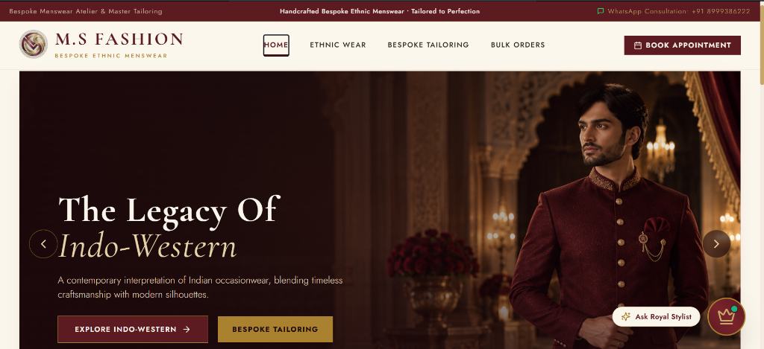
Figure 7.1: Home & Navigation Screen with Hero Carousel and Floating Stylist Badge
7.2.2 Category Catalog
The Category Catalog module enables clients to browse garments by silhouette with real-time subcategory filter tabs (e.g. 'Jodhpuri With Jacket (6)', 'Without Jacket (4)') and clean grid cards.
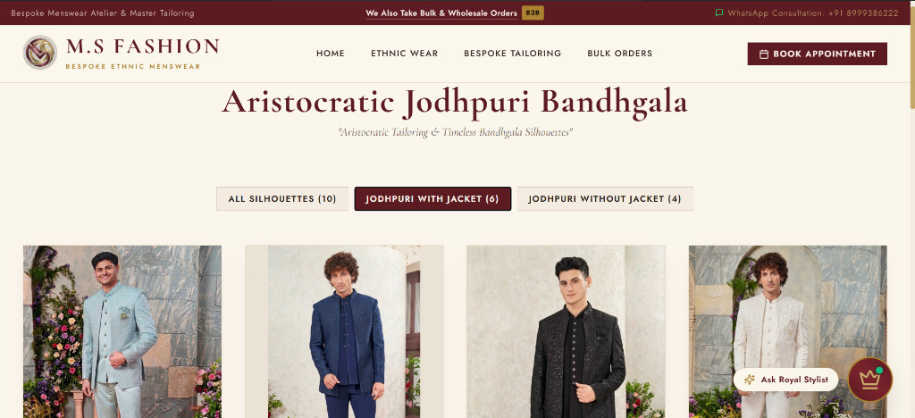
Figure 7.2: Category Catalog Interface with Live Silhouette Filter Counts
7.2.3 Product Detail & Accessories
The Product Detail module displays high-resolution garment photography alongside an interactive list of modular royal accessories (Mojdi, Safa, Mala, Dupatta) for customizable pairing.
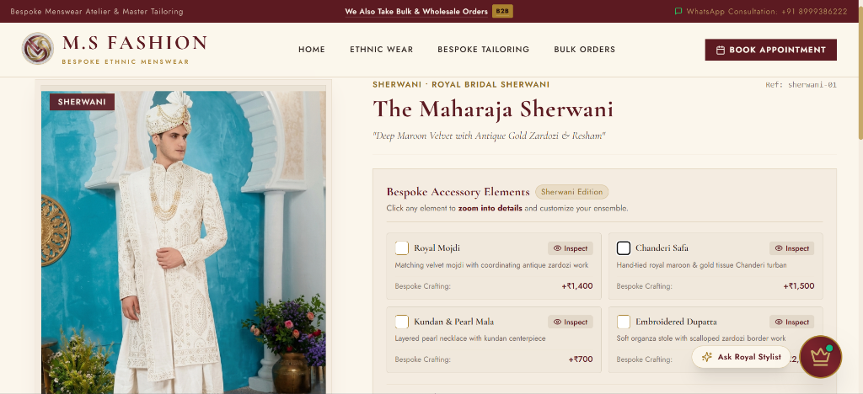
Figure 7.3: Product Detail View with Modular Royal Accessory Elements
7.2.4 CSS Zoom Viewer
The CSS Zoom Viewer module provides 2.2x hardware-accelerated magnification focusing on intricate embroidery motifs and accessory accents with auto-fading crosshair pins.
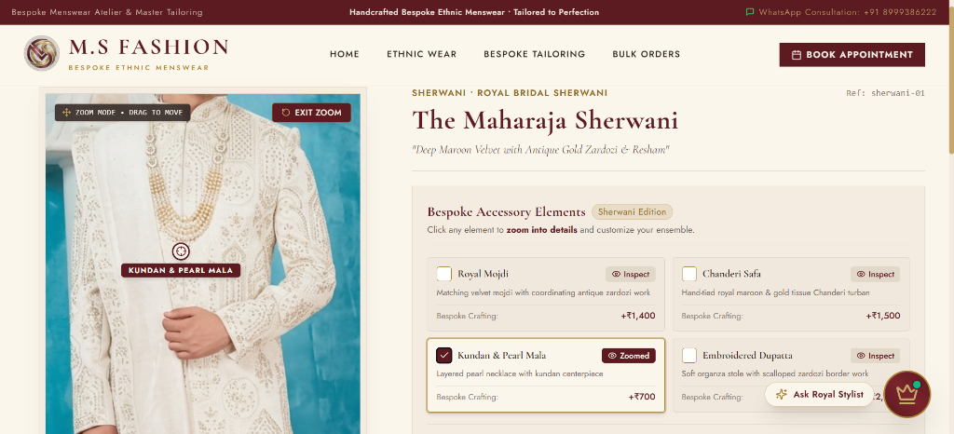
Figure 7.4: Hardware-Accelerated 2.2x CSS Zoom Viewer in Active Focus Mode
7.2.5 Price Breakdown & WhatsApp
The Price Breakdown module displays an itemized cost calculation for selected garments and accessories, accompanied by direct 'Contact via WhatsApp' routing with embedded photo URLs.
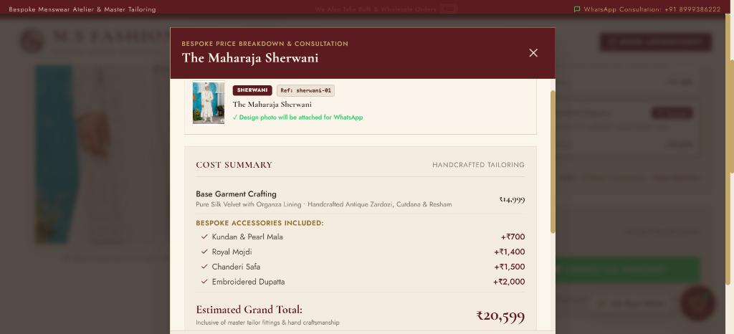
Figure 7.5(a): Bespoke Price Breakdown Modal with Itemized Accessory Costing
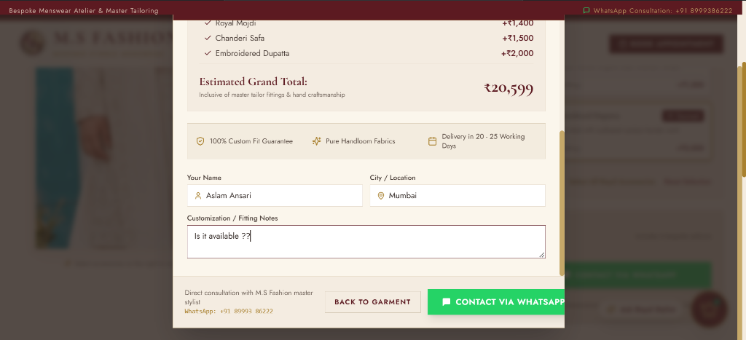
Figure 7.5(b): Client Customization Notes & Direct WhatsApp Consultation Action
7.2.6 Appointment Booking
The Appointment Booking module captures client name, verified email, 10-digit phone number, preferred date, and a client-defined Expected Budget (Self Budget) freeform input.
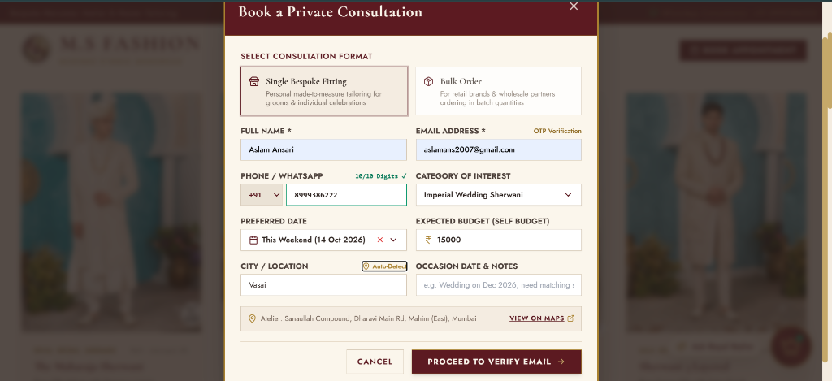
Figure 7.6: Private Consultation Booking Form with Freeform Self Budget Input
7.2.7 Email OTP Verification
The Email OTP Verification module validates client contact credentials through an automated 6-digit verification code dispatched via Gmail SMTP, eliminating appointment spam.
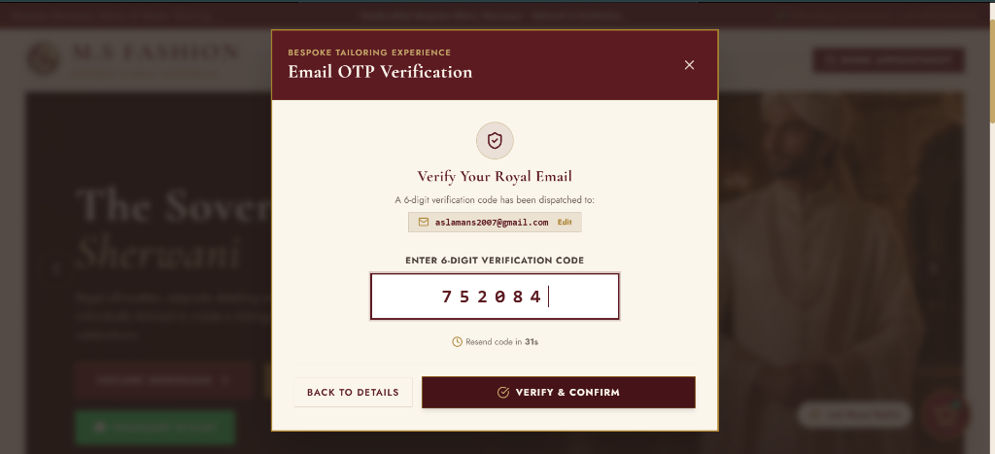
Figure 7.7: Two-Step Royal Email OTP Verification Screen (6-Digit Authenticator)
7.2.8 Royal AI Stylist Chatbot
The Royal AI Stylist Chatbot module provides 24/7 conversational assistance on groom wedding etiquette, 15+ body measurement protocols, pricing policies, and direct appointment booking.
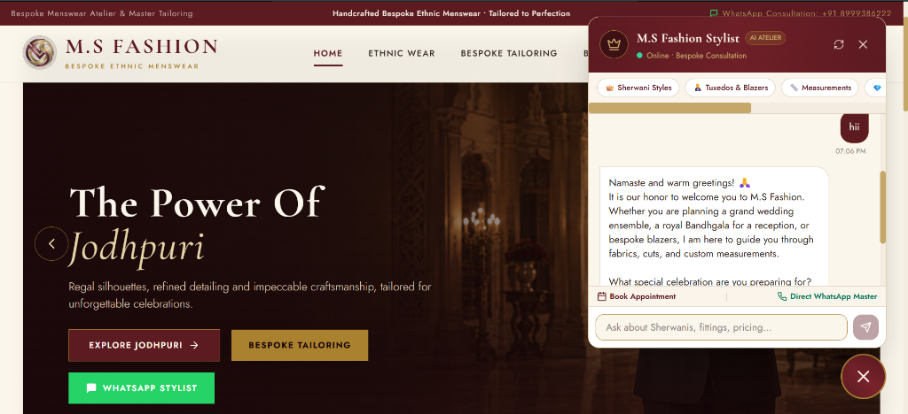
Figure 7.8: Royal Atelier AI Stylist Chatbot Offering Conversational Fashion Guidance
7.2.9 Master Admin Dashboard
The Master Admin Dashboard module equips the atelier owner with real-time CRM lead management, verified email indicators, declared self-budget tracking, and direct WhatsApp client connect.
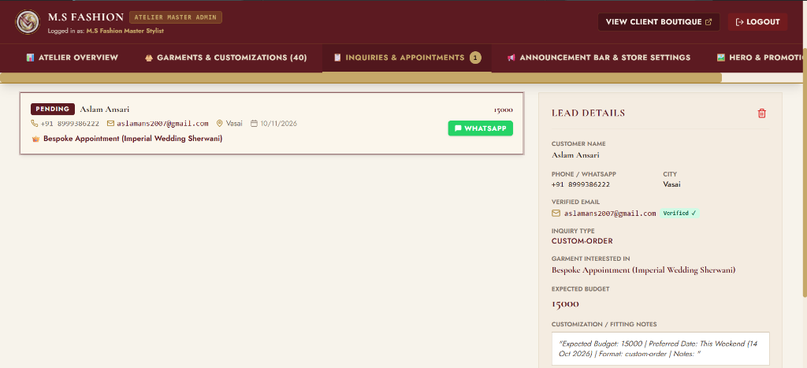
Figure 7.9: Master Admin Dashboard Displaying Authenticated CRM Consultation Leads
7.3 Overall Result
The final results demonstrate that the M.S Fashion application successfully integrates its major modules into a single web platform for convenient and organized bespoke ethnic menswear consultation. The developed application provides users with an intuitive system for exploring collections, configuring royal accessories, calculating transparent prices, and validating appointments. The integration of the Royal AI Stylist Chatbot further enhances the system by providing accessible styling guidance.

CHAPTER 8. CONCLUSION AND FUTURE SCOPE
8.1 Conclusion
The M.S Fashion: Bespoke Ethnic Menswear Platform was successfully designed, developed, and implemented to provide a centralized digital platform for managing bespoke menswear discovery, visual inspection, and client consultation. The system brings together various important tailoring functionalities within a single application, reducing the need to depend on manual records or unorganized communication methods.
The application allows users to browse collections, inspect embroidery with 2.2x zoom, select matching royal accessories, calculate transparent price estimations, book verified consultations with self-declared budgets, and communicate directly with the Master Tailor. The integration of the Royal Atelier AI Stylist further enhances the system with conversational fashion advice.
The system was developed using modern technologies including React, Tailwind CSS, Vite, Node.js, Express.js, MongoDB, Nodemailer, and WhatsApp protocols. Overall, M.S Fashion provides an efficient and convenient digital solution for bespoke menswear patrons and atelier tailors. The successful implementation and testing demonstrate that the proposed objectives and major functional requirements were achieved.
8.2 Future Scope and Enhancement
Although the current version of M.S Fashion provides the major functionalities required for bespoke menswear consultations, the system can be further enhanced with advanced features in future versions:
- 1. WebXR Virtual 3D Mirror – Allow clients to virtually try on 3D digital garment twins using smartphone cameras.
- 2. Fabric Texture AI Analysis – Machine learning models to detect fabric thread density from user-uploaded swatches.
- 3. Multi-Lingual Voice Assistant – Expand AI chatbot to support Hindi, Gujarati, Marathi, and Urdu voice input.
- 4. Photogrammetric Body Measurement – Extract 15+ body measurements from 2D smartphone photos.
- 5. Workshop Inventory ERP – Real-time fabric bolt and embroidery thread inventory tracking for artisans.
- 6. Blockchain Provenance Certificates – Digital certificates guaranteeing pure Banarasi silk and Zardozi metals.
- 7. Multi-Branch Cloud Sync – Centralized database supporting multi-city boutique branches across India and abroad.
- 8. Native Mobile Apps – Build cross-platform Android and iOS apps using React Native and Expo.
- 9. Meta WhatsApp Cloud Webhooks – Automated bidirectional WhatsApp bot conversations with PDF catalogs.
- 10. Predictive Season Analytics – Demand forecasting models based on auspicious wedding calendar dates.

CHAPTER 9. REFERENCE
1. https://react.dev/
2. https://tailwindcss.com/docs
3. https://nodejs.org/docs/latest/api/
4. https://expressjs.com/
5. https://www.mongodb.com/docs/
6. https://mongoosejs.com/docs/
7. https://vitejs.dev/guide/
8. https://nodemailer.com/
9. https://faq.whatsapp.com/5913398998672934
10. https://www.postman.com/downloads/
11. University of Mumbai – Guidelines for Project Dissertation for B.Sc. (Computer Science), 2026.

