AWS Cloud based Home Automation

Prof. Suhas Bhise   
suhas.bhise@vit.edu

Shubham Damale  
shubham.damale19@vit.edu Ali Aslam  
aslam.ali20@vit.edu

Deven Nalawade  
deven.nalawade20@vit.edu

C. Lalhmangaihi  
c.lalhmangaihi19@vit.edu

Department of Electronics and Telecommunication, Vishwakarma Institute of Technology, Pune, India

*Abstract— With the advent of the Internet of Things (IoT), a large number of devices are being connected to each other every day. Each connectivity opens the door to new possibilities to make a person’s life easier and convenient. A smart home is one such area impacted by IoT which greatly improves a person’s life. Objective of the proposed work is to implement home automation using AWS cloud. It uses various AWS services such as AWS Lambda, S3, API Gateway and IoT Core to achieve the objective. Various sensors such as rain sensor, LDR and temperature sensor are used to control fan, light etc. Some parts of the system are automated and some can be controlled through a user-friendly website. This system is cost and energy efficient.*

Keywords— Home Automation, Cloud, AWS, ESP32, Sensors.

# Introduction

Automated systems are becoming increasingly popular in today's world thus reducing the need for human intervention. This paper mainly focuses on a system that provides features of Home Automation relying on Internet of Things to operate easily. It can configure itself independently and run without human intervention. As a technology, home automation provides comfort, security, convenience and energy efficiency within the home environment for its users. Real-time control and monitoring of domestic appliances is part of the concept of home automation. The automation part controls home appliances, such as fans and lights. Some home automation systems are built on microcontrollers, where the microcontroller serves as a server and Android apps are used to access the system online.

The reduction of energy expenditures is a key component of the smart home. It is feasible to put in place a smart home module that automatically adjusts the lights based on the available natural light. The use of light sensors automatically limits the electricity consumption of commercial buildings by substituting daylight for electricity.

The project includes the rain sensor and temperature sensor where a rain sensor is a switching device activated by rainfall. Water droplets are detected by the device, which closes the windows automatically after rain and opens again once the rain has stopped. Temperature sensor works when the outside temperature increases resulting in turning on the fan.

# Literature Survey

In this technology world, smart homes are a growing trend. There have been a number of sensors based and cloud-based proposals for home automation systems. There is a wide variety of specifications and functionality in literature. This section gives a brief overview of recent work done in the field of home automation.

For implementing home automation system, an Arduino UNO, IR remote, Bluetooth and GSM based approach was proposed. An android application was also developed for using Bluetooth and GSM features [6]. The ZigBee wireless sensor can help with the issue of human-computer interaction, cost, power consumption, and other factors as the use of smart home comfort increases. The proposed system monitors indoor temperature and humidity to control devices and the development of an intelligent home remote monitoring system is based on embedded web gateways and cloud servers [7]. A fully functional home automation system was designed by integration of multi-touch mobile devices, cloud networking, wireless communication, and power-line communication. It allows the user to control various appliances and lights within their home from any location in the world through Pachube cloud network [8]. A smart home automation system was proposed in which all the components are connected to local area network, from which data is send to different smart devices such as smartphones. All the threshold data is stored on webpage. This system compares current input with the data which is stored on web page. By comparing both the data, this system automatically controls components such as bulb [9]. Some systems for home security have also been proposed. AES encryption is used for security over network. Raspberry pi is used as a server and controller. It controls electrical appliances and provides authentication and security to user. Notifications regarding trespassing are sent to the owner on the android app [10]. In a paper two models for home automation were proposed: first one was home automation utilizing Bluetooth which has little range region to associate and second method using cloud which has boundless range to associate. The system consists of the following basic components: Automatic Speech Recognition System, Control Unit, Wireless system, Application and Home appliances [11]. To detect malicious activity or privacy violation, an Unauthorized Human Entry Detection system was proposed, which detect any intrusion or breach and typically report to the homeowner. The project includes an Anomaly based technique for unauthorized entry detection and signature analysis using face recognition algorithm running on AWS cloud to differentiate between an authorized person and intruder [12]. A NodeMCU is used in this system as a Wi-Fi-based gateway to link various sensors and update their data on an Adafruit IO cloud server which sent to the IoT server updated data. The MQTT Dash mobile application and Adafruit IO Web on laptops and PCs can be used to monitor the sensor data (temperature, humidity, motion, gas, and RFID). The user receives alerts about any unusual conditions at home via the IFTTT server on their mobile phones for security and safety reasons. All these things are easy to control using GUI with voice command using google assistance for end user [13]. A paper proposed IoT based home automation system using Arduino and ThingSpeak, this proposed system based on Lan communication uses MQTT protocol. A mobile application was developed to control home appliances like fans, light, curtains. The services of ThingSpeak cloud were data visualization, improved security, and data management [14]. In this paper the author presented security and vulnerabilities for smart home devices, for security AHP protocol is discussed. In an explicit and quantitative manner, the derived AHP model demonstrated the importance of various security factors in current home consumer devices [15]. A paper dealing with the design and implementation of a cost-efficient smart home system focusing on remote surveillance, monitoring different aspects (movement detections, surveillance and temperature and humidity) of a home with notification alerts was implemented [16]. This system uses NodeMCU (ESP8266) microcontroller along with Relays to control electrical switches remotely from the server which is built on Node.js. User can control switches using a Web Application after authenticating. With the help of the proposed system the user can control all of its home appliances from his/her mobile/computer remotely from one place [17]. A technique was explored using the AWS services to control the light intensity and control fan speed over the AWS IOT cloud and MQTT protocol over web socket server also. This proposed system was implemented and analyzed on the basis of performance [18].

The existing systems have certain limitations such as high cost and lack of user-friendly UI. Through our proposed system we have tried to make improvements on the same.

# Methodology

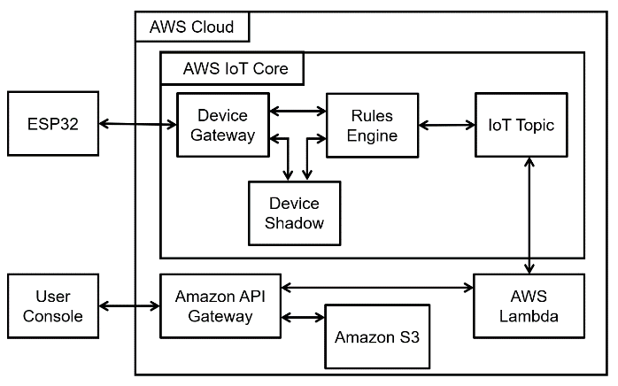

Fig. 1. Block diagram of proposed system

Fig. 1. illustrates the proposed design for smart home automation system integrated with the sensors and other devices with AWS IoT core. As shown in the figure, the devices are directly connected with ESP32. It collects data from the device and displays it to user with the help of Amazon API Gateway, Amazon S3, AWS Lambda and AWS IoT core.

The AWS services used for integrating hardware and software is explained in further sub headings:

1. **AWS Cloud**

* **Amazon API Gateway:** It is a highly managed service from Amazon that simplifies the development of APIs, maintaining them, monitoring them, and securing them.
* **Amazon S3:** Amazon Simple Storage Service (Amazon S3) offers scalability, availability, security, and performance that are industry-leading.
* **AWS Lambda:** The AWS Lambda service is a serverless, event-driven computing service that lets applications run without requiring server provisioning or management.
* **AWS IoT core:** Managing infrastructure is not necessary with AWS IoT Core, which connects billions of IoT devices to AWS services. The core of Amazon Web Services IoT is Device Gateway, Device Shadow, Rules Engine and IoT Topic.

1. **Sensors:**

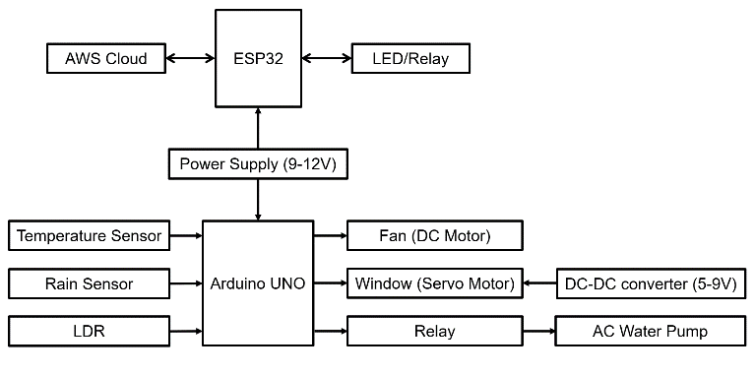

Fig. 2. Block diagram of sensors and actuators

* **Temperature sensor:** To check the temperature of the surrounding environment, this sensor is used. So, when the value of temperature increases and reaches a set limit, the fan will automatically turn on to lower down the temperature of the room.
* **Rain sensor:** To check the rain level this sensor is used. It senses the droplet of water resulting in closing and opening the window of a particular room. So, mainly the rain sensor works in detecting the rain which has a control over the windows of the rooms, it closes when rain heavily pours and ends up opening again when the rain stops.

1. **ESP32:**

The ESP32 is a powerful low-cost microcontroller that integrates Bluetooth and Wi-Fi capabilities. The sensor data is posted to the AWS IOT cloud through a connection to the local Wi-Fi network. Data is not only posted to AWS, but is also received from AWS dashboard, so the ESP32 works for both side receiving and sending out.

In the Amazon AWS IoT core, after creating an account on the AWS IOT dashboard, a ‘thing’ is created where a thing name is related to the project. The ‘thing’ properties are specified, device certificates are generated and after all policies are attached, the certificates and keys are downloaded for further use in the project. To work hand in hand with the arduino, arduino libraries: JSON, PubSubClient and DHT11 sensor are downloaded and code is written in Arduino IDE. The code is modified according to the ‘thing’, the Wi-Fi name and password are included. After Wi-Fi and password are connected, the AWS IoT endpoint, Amazon root, device certificate and device private key are inserted. Once all the modifications are done, ESP32 is connected to the computer and the code is uploaded to the board. Once it is done, the ESP32 connects to the Wi-Fi network and then connects to the AWS IoT server, where the sensor values are displayed. The same thing is repeated to the AWS server and after subscribing, the data from ESP32 are uploaded to the AWS dashboard and the data are published to the serial monitor.

1. **Working**

System resembles the use of AWS services with Esp32 and Arduino UNO to carry out tasks.

**State manipulation:** When a user clicks the button present on the website, it invokes the GET and POST methods to change the state. The invoked URL (uniform resource locator) calls the specified lambda function. The code fetches Thing Name and desired state of the device. The delta is calculated from the reported state and desired state of the device and finally, the reported state is reflected in device shadow. The device shadow of the specified thing is the publishing topic. The JSON string is passed as a payload to ESP32. Payload is received via callback function fed to ESP32. Finally, the changes are reflected in hardware (LED connected to digital-pin 15).

**Temperature Sensor and Dc motor:** An analog temperature sensor (connected to analog pin A1), fetches the temperature around it and prints over the serial monitor. If the temperature is below 30 degrees Celsius, the DC motors (connected to digital pins 4, 5, 8, 9) remain off. If the temperature lies between 30 to 50 degrees Celsius, one DC motor turns on. If the temperature exceeds 50 degrees Celsius, both DC motors turn on.

**LDR, LED and water pump:** The LDR sensor (connected to analog pin A0), fetches the intensity of light. If the intensity is below 300 units, it indicates darkness in the surrounding area. Hence, LED is turned on. If the intensity exceeds 400 units, it indicates too much exposure to light in the surrounding area. Hence, LED is turned off. While intensity exceeds 400 units, if the temperature is above 50 degree Celsius, the water pump (connected at digital pin 10 via relay module) is turned on.

**Rain sensor and servo motor:** The rain sensor (connected to analog pin A3 and digital pin 12) checks if there is water over the provided panel. If water is detected, the servo motor (connected to digital PWM pin 6) turns to 0 degrees angle, indicating that the window is closed. Else, motor is set to 180 degrees angle, indicating that the window is open.

# Result

The proposed system uses MQTT protocol to transmit data from AWS Cloud server to end device. The component parts, protocols, and cloud service have been chosen to make the system easily expandable to further developments, resilient to failure and secure. Each part of the system has been explained in depth to support our claim. Newly developed capabilities in AWS and the dynamic features of MQTT protocol have been laid out. The prototype illustrated has several scopes of future expansion.

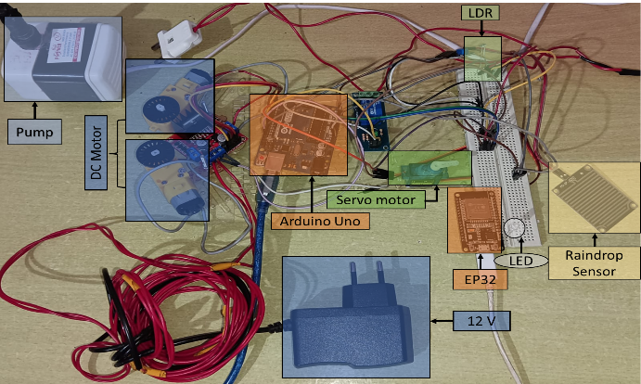

Fig. 3. Hardware Setup

Fig. 3 shows hardware components used to build the system. Operations are mainly carried out by Arduino Uno and ESP32 boards. All of the sensors and actuators used are connected to respective digital and analog pins.

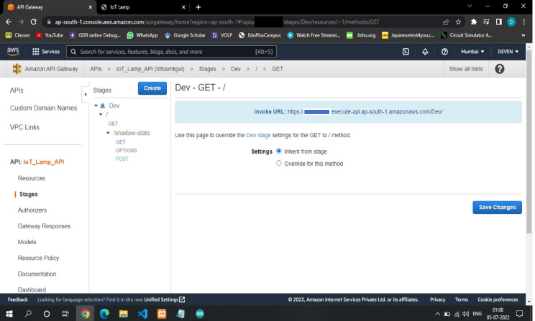

Fig. 4. API Gateway Configuration

Fig 4 shows deployment of API at DEV stage with default settings. Before deployment, root and shadow-state resources were created. Under the shadow-state resource, 2 main methods named Get and Post are created at default settings to retrieve the state of device and change the state of device respectively. The methods are linked with lambda functions, which are called when these method links are invoked.

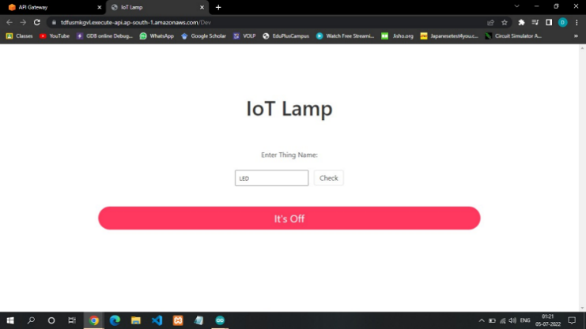

Fig. 5. Website deployed over Amazon S3

Fig. 5 shows the website deployed under S3 bucket object. The design contains JavaScript along with HTML and CSS, which invokes Get and Post methods when clicked over the button. A thing name has to be entered in order to change its state. If not, then the thing name is set to LED.

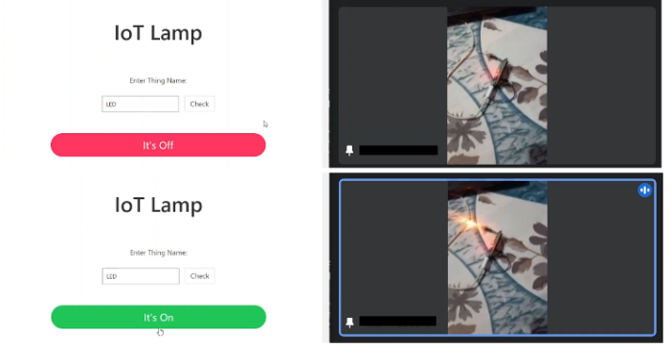

Fig. 6. Controlling LED using Website over AWS IOT Core

Fig. 6 shows testing of LED. The website was operated from a remote location and LED was present on another location. Manipulation of LED state was carried out successfully.

# Conclusion

We have implemented cloud-based home automation where users can easily have a control over the devices in their home. Controlling fans and windows is time consuming for the user especially when the user is in a difficult situation where they are not able to do it manually all by themselves. Introducing AWS cloud in this project is more helpful as it makes it easily accessible. This system is cost and energy efficient. Future implementations can include using voice automation and machine learning.

##### References

1. “Implementation and Recent Progress in Cloud-based Smart Home Automation Systems”: Norliza Katuk, Ku Ruhana Ku-Mahamud, and Nur Haryani Zakaria School of Computing, Universiti Utara Malaysia, Sintok, Kedah, Malaysia Mohd Aizaini Maarof Faculty of Computing, Universiti Teknologi Malaysia, Skudai, Johor, Malaysia, ( April 2018).
2. “Home Automation Systems - A Study”- Satish Palaniappan, Naveen Hariharan, Naren T Kesh, Vidhyalakshimi S, Angel Deborah S. (International Journal of Computer Applications (0975 – 8887) Volume 116 – No. 11, April 2015)
3. “Smart Home Systems Based on Internet of Things”- Menachem Domb
4. International Research Journal of Engineering and Technology (IRJET) Volume: 04 Issue: 05 | May -2017 “Smart Homes System Using Internet-of-Things: Issues, Solutions and Recent Research Directions”- Mrs.Jyotsna P. Gabhane, Ms. Shradha Thakare, Ms.Monika Craig.
5. International Journal of Scientific Research and Management Studies (IJSRMS). “A REVIEW PAPER ON SMART HOME AUTOMATION” , Pankaj Bhardwaj (Assistant Professor), Paras Manchanda, Prashant Chahal, Prashant Chaudhary, Robin Singh. Department of ECE, Moradabad Institute of Technology (U.P), India.
6. A. Shinde, S. Kanade, N. Jugale, A. Gurav, R. A. Vatti and M. M. Patwardhan, "Smart Home automation system using IR, bluetooth, GSM and android," 2017 Fourth International Conference on Image Information Processing (ICIIP), 2017, pp. 1-6, doi: 10.1109/ICIIP.2017.8313770.
7. Mao, Xiaobo, Keqiang Li, Zhiqiang Zhang, and Jing Liang. "Design and implementation of a new smart home control system based on internet of things." In 2017 international smart cities conference (ISC2), pp. 1-5. IEEE, 2017.
8. N. Dickey, D. Banks and S. Sukittanon, "Home automation using Cloud Network and mobile devices," 2012 Proceedings of IEEE Southeastcon, 2012, pp. 1-4, doi: 10.1109/SECon.2012.6197003.
9. K. Agarwal, A. Agarwal and G. Misra, "Review and Performance Analysis on Wireless Smart Home and Home Automation using IoT," 2019 Third International conference on I-SMAC (IoT in Social, Mobile, Analytics and Cloud) (I-SMAC), 2019, pp. 629-633, doi: 10.1109/I-SMAC47947.2019.9032629.
10. S. Somani, P. Solunke, S. Oke, P. Medhi and P. P. Laturkar, "IoT Based Smart Security and Home Automation," 2018 Fourth International Conference on Computing Communication Control and Automation (ICCUBEA), 2018, pp. 1-4, doi: 10.1109/ICCUBEA.2018.8697610.
11. K. K. Kumar, S. Rachamalla, P. Sindhu and V. S. Laxmi, "Cloud Based Home Automation: Surveillance with Mobile Phones," 2018 3rd International Conference on Communication and Electronics Systems (ICCES), 2018, pp. 596-601, doi: 10.1109/CESYS.2018.8724106.
12. M. Mehra, V. Sahai, P. Chowdhury and E. Dsouza, "Home Security System using IOT and AWS Cloud Services," 2019 International Conference on Advances in Computing, Communication and Control (ICAC3), 2019, pp. 1-6, doi: 10.1109/ICAC347590.2019.9089839.
13. Jabbar, Waheb A., Tee Kok Kian, Roshahliza M. Ramli, Siti Nabila Zubir, Nurthaqifah SM Zamrizaman, Mohammed Balfaqih, Vladimir Shepelev, and Soltan Alharbi. "Design and fabrication of smart home with internet of things enabled automation system." IEEE access 7 (2019): 144059-144074.
14. Ali, Mubashir, Zarsha Nazim, Waqar Azeem, Muhammad Haroon, Aamir Hussain, Khadija Javed, and Maria Tariq. "An IoT based approach for efficient home automation with ThingSpeak." International Journal of Advanced Computer Science and Applications 11, no. 6 (2020).
15. Allifah, Naba M., and Imran A. Zualkernan. "Ranking Security of IoT-Based Smart Home Consumer Devices." IEEE Access 10 (2022): 18352-18369.
16. S. Kayastha and P. Upadhyaya, "Design and Implementation of a Cost-Efficient Smart Home System with Raspberry Pi and Cloud Services," 2019 Artificial Intelligence for Transforming Business and Society (AITB), 2019, pp. 1-7, doi: 10.1109/AITB48515.2019.8947439.
17. H. K. Singh, S. Verma, S. Pal and K. Pandey, "A step towards Home Automation using IOT," 2019 Twelfth International Conference on Contemporary Computing (IC3), 2019, pp. 1-5, doi: 10.1109/IC3.2019.8844945.
18. Jaya, Nadia Imtiaz, and Md Farhad Hossain. "A prototype air flow control system for home automation using mqtt over websocket in aws iot core." In 2018 International Conference on Cyber-Enabled Distributed Computing and Knowledge Discovery (CyberC), pp. 111-1116. IEEE, 2018.