SYNOPSIS

Corporate Website:

A website that is used to represent a company officially on the Internet, and that is also used as the advertisement material landing page. Beyond a pure presence of testimonials, a corporate website is a business tool if the choice is to make transactions and should preferably also be designed as a means of making contact with consumers or other visitors; Whereby users are provided with product or service information, and can find valuable content such as novelties or special offers promoting loyalty.

This type of tool requires special care: it is essential that all contents conform to the principles of the company and facilitate its global focus by being fully integrated within the structure of the company and its overall strategy.

A company website may not be enough in today's world of Web 2.0: several businesses have expanded their online presence by creating profiles on social networks and online communities.

Every company needs an efficient website in today's marketplace. Of course, each company's site's goals and needs would be special, but each company should have a site that provides visitors with a professional image. That image should also be an accurate representation of the company and should work with other branding efforts to present consistent messages to customers.

We have several modules in this to prepare a corporate company website.

Modules:

.Database

.Code

.System Design

.DFD, ER-Diagram, Flow Chart

.Implementation

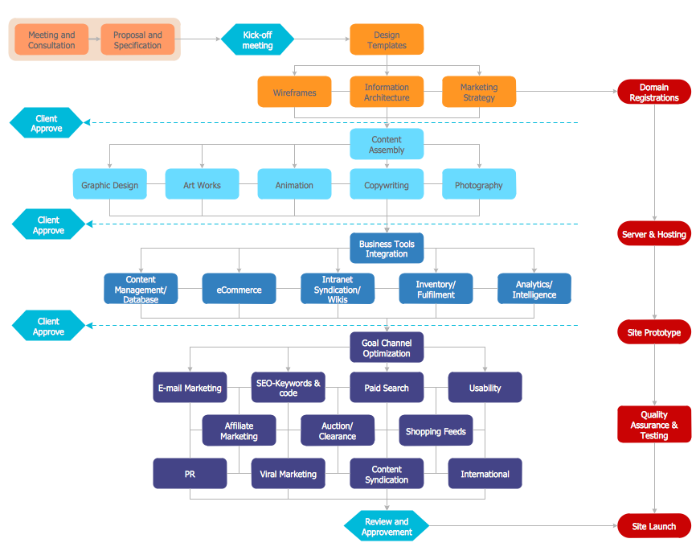

Flowchart of a corporate company website

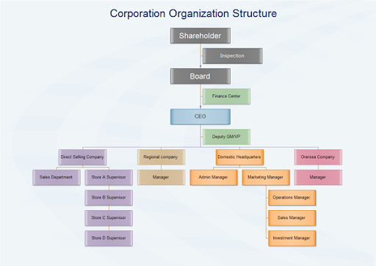

Basic flowchart of a company