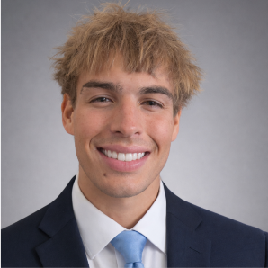
Aiden Slayne
Tucson, AZ
(520) 979-8004 | aidenwslayne15@gmail.com | www.linkedin.com/in/aiden-slayne-36906b404
EDUCATION
University of Arizona, Eller College of Management Tucson, AZ Grad 05/2027
- Major: Business Management
- Minor: Real Estate
PROFESSIONAL EXPERIENCE
OV Community Rec Center Tucson, AZ
Lifeguard 08/2022 – 02/2026
- Handled medical incidents and high-pressure situations with professionalism
- Resolved conflicts with agitated patrons while maintaining a safe and positive environment
Red Lobster Tucson, AZ
Host/Cook/Busser/Dishwasher 05/2020 – 05/2022
- Performed multiple operational roles, demonstrating adaptability and strong work ethic
- Collaborated with kitchen and front-of-house staff to improve efficiency and guest satisfaction and developed strong communication skills by working with diverse teams and management styles
LEADERSHIP EXPERIENCE
OV CRC Camp Counselor Tucson, AZ
Group Lead 06/2022 – 08/2025
- Planned and coordinated team building games, schedules and events while mentoring junior counselors and communicating effectively with parents and camp leadership
- Led and supervised groups of 15-25 campers ages 6-14, organizing daily activities, resolving conflicts, and maintain a safe, positive environment for campers and staff
Neighborhood Help Tucson, AZ
Gardener/Assistant 05/2022 – 02/2026
- Marketed personal services within the neighborhood to generate recurring clients
- Built strong interpersonal and customer service skills through direct client interaction
SKILLS, ACTIVITIES & INTERESTS
Skills:
- Leadership & team coordination
- Problem-solving under pressure
- Customer Service
- Adaptability in fast-paced environments
- Video editing & digital content creation (YouTube content with 10,000+ views)
- Basic Microsoft Office Suite (Excel, Word, PowerPoint) and Adobe applications
- Social Media Advertising

